VOL I: GENERAL PROBLEMS

EDUCATION AND
NATIONAL DEVELOPMENT

REPORT OF THE EDUCATION COMMISSION, 1964-66

NATIONAL COUNCIL OF EDUCATIONAL RESEARCH AND TRAINING 1970

First Edition 1966 Reprint Edition May 1970
Vaisakkha 1892

© Ministry of Education, 1966

Reprinted by the National Council of Educational Research and Training with the permission of the Ministry of Education and Youth Services, Government of India

Rs. 11.00 18 s. $2.20

TEXT SET IN 12 PT. BEMBO TYPE AND PRINTED ON CREAM WOVE INDIAN PAPER 73 GSM

Published at the Publication Unit by S.A. Abidin, Secretary, National Council of Educational Research and Training, NIE Campus, Sri Aurobindo Marg, New Delhi 16, and printed at Sree Saraswaty Press Ltd., Cacutta 9

New Delhi 29 June 1966
Asadha 8, 1888

Dear Shri Chagla,

I have much pleasure in submitting the Report of the Education Commission.

I would like to take this occasion to express to you my own and my colleagues' sincere gratitude for the support and encouragement you have always so generously extended to us in our work. The appointment of the Commission is largely due to your initiative and vision.

Education has always been important but perhaps never more so in man's history than today. In a science-based world, education and research are crucial to the entire developmental process of a country, its welfare, progress and security. It is characteristic of a world permeated by science that in some essential ways the future shape of things is unpredictable. This emphasizes all the more the need for an educational policy which contains a built-in flexibility so that it can adjust to changing circumstances. It underscores the importance of experimentation and innovation. If I may say so, the single most important thing needed now is to get out of the rigidity of the present system. In the rapidly changing world of today, one thing is certain: yesterday's educational system will not meet today's, and even less so, the need of tomorrow.

It is difficult, and it is certainly so for us, to say to what extent the Report will actually help in the reconstruction of the educational system which is so urgently necessary. We trust, however, that the Report will provide some basic thinking and framework for taking at least the first step towards bringing about what may be called an educational revolution in the country. The Report makes recommendations about various sectors and aspects of education. The main points that immediately come to my mind are:

Introduction of work-experience (which includes manual work, production experience, etc.) and social service as integral parts of general education at more or less all levels of education;

Stress on moral education and inculcation of a sense of social responsibility. Schools should recognize their responsibility in facilitating the transition of youth from the world of school to the world of work and life;

Vocationalization of secondary education;

The strengthening of centres of advanced study and the setting up of a small number of major universities which would aim to achieve the highest international standards;

Special emphasis on the training and quality of teachers for schools; Education for agriculture and research in agriculture and allied sciences should be given a high priority in the scheme of educational reconstruction. Energetic and imaginative steps are required to draw a reasonable proportion of talent to go in for advanced study and research in the agricultural sciences;

Development of quality or pace-setting institutions at all stages and in all sectors.

I apologize for the size of the Report. It could have been shorter, but that would have cost more money and time, and delayed action. What the situation urgently calls for is action, and this is what you have always stressed.

With regards,

Yours sincerely,

D. S. KOTHARI

SHRI M. C. CHAGLA

Minister for Education Government of India New Delhi

MEMBERS OF THE EDUCATION COMMISSION

Chairman

- PROFESSOR D. S. KOTHARI, Chairman, University Grants Commission, New Delhi.

Members

- Sum A. R. DAWOOD, formerly Officiating Director, Directorate of Extension Programmes for Secondary Education, New Delhi.

- MR. H. L. ELVIN, Director, Institute of Education, University of London, London.

- SHRI R. A. GOPALASWAMI, Director, Institute of Applied Manpower Research. New Delhi (since retired).

- PROFESSOR SADATOSHI IHARA, School of Science and Engineering, Waseda University, Tokyo.

- DR. V. S. JHA, formerly Director of the Commonwealth Education Liaison Unit, London.

- SHRI P. N. KIRPAL, Educational Adviser and Secretary to the Government of India, Ministry of Education, New Delhi.

- PROFESSOR M. V. MATHUR, Professor of Economics and Public Administration, University of Rajasthan, Jaipur (now Vice-Chancellor, Rajasthan University).

- DR. B. P. PAL, Director, Indian Agricultural Research Institute, New Delhi (now Director-General, and Vice-President, Indian Council of Agricultural Research and Additional Secretary to the Government of India, Ministry of Food and Agriculture).

- KUMARI S. PANANDIKAR, Head of the Department of Education, Karnatak 'University, Dharwar (since retired).

- PROFESSOR ROGER REVELLE, Director, Centre for Population Studies, Harvard School of Public Health, Harvard University, Cambridge, USA.

- DR. K. G. SAIYIDAIN, former Educational Adviser to the Government of India (now Director, Asian Institute of Educational Planning and Administration, New Delhi).

- DR. T. SEN, Vice-Chancellor, Jadavpur University, Calcutta.

- PROFESSOR S. A. SHUMOVSKY, Director, Methodological Division, Ministry of Higher and Special Secondary Education, RSFSR, and Professor of Physics, Moscow University, Moscow.

- M. JEAN THOMAS, Inspector-General of Education, France, and formerly Assistant Director-General of UNESCO, Paris.

Member-Secretary

- SHRI J. P. NAIK, Head of the Department of Educational Planning, Administration and Finance, Gokhale Institute of Politics and Economics, Poona.

Associate Secretary

- MR. J. F. MCDOUGALL, Assistant Director, Department of School and Higher Education, UNESCO, Paris.

FOREWORD

The Education Commission was appointed by the Government of India by a Resolution, dated 14 July 1964, to advise the Government on the national pattern of education and on the general principles and policies for the development of education at all stages and in all aspects.*

We began our task twenty-one months ago, on October 2, 1964, Mahatma Gandhi's birthday. From the very beginning we have been conscious of the immensity and inherent difficulties of the task assigned to us. No task in our view could be more challenging, more vital and relevant to India's progress and development-economic, cultural and spiritual. In facing a task of such colossal magnitude and complexity, there is always a danger that the approach and recommendations may not be sufficiently radical. There is also the other possibility that the recommendations may go beyond the capacity and resources of the nation. The difficulties are greatly accentuated because educational plans are long-term plans, and long-term projections of needs and resources are beset with serious uncertainties. We hope our assumptions about the total resources of the nation over the next 20 years and the proportion to be invested in education are reasonable.

It cannot be gainsaid that the recommendations are inevitably circumscribed by the limits of our knowledge and experience, and by our capacity for bold, constructive and imaginative thinking. We would not claim that the recommendations made by us in the Report are necessarily the best, nor can we be completely certain about the validity of every recommendation that we have made. Again, many of the proposals we make would require investigation and revision in the light of experience. We therefore, lay considerable emphasis on a built-in flexibility in the system of education to facilitate adjustment to changing situations and requirements. There is, of course, one thing about which we feel no doubt or hesitation: education, science-based and in coherence with Indian culture and values, can alone provide the foundation-as also the instrument-for the nation's progress, security and welfare.

Indian education needs a drastic reconstruction, almost a revolution. We need to bring, about major improvement in the effectiveness of primary education; to introduce work experience as an integral element of general education; to vocationalize secondary education; to improve the quality of teachers at all levels and to provide teachers in sufficient strength; to liquidate illiteracy; to strengthen centres of advanced study and

*Legal and medical education were excluded from the purview of the Commission, but it was authorized to look into "such aspects of these problems as are necessary for its comprehensive enquiries".

strive to attain, in some of our universities at least, higher international standards; to lay special emphasis on the combination of teaching and research; and to pay particular attention to education and research in agriculture and allied sciences. All this calls for a determined and large-scale action. Tinkering with the existing situation and moving forward with faltering steps and lack of faith can make things worse than before.

In view of the urgency of the situation, we felt impelled to keep the time-table originally set for the submission of the Report, even if it meant some limitations on the scope of our studies and on the depth and perspicacity of our presentation. If we had more time, the Report could have been shorter and more readable.

The Commission set up twelve Task Forces on (1) School Education; (2) Higher Education; (3) Technical Education; (4) Agricultural Education; (5) Adult Education; (6) Science Education and Research; (7) Teacher Training and Teacher Status; (8) Student Welfare; (9) New Techniques and Methods; (10) Manpower; (11) Educational Administration; and (12) Educational Finance. In addition, it set up seven Working Groups on (1) Women's Education; (2) Education of Backward Classes; (3) School Buildings; (4) School-Community Relations; (5) Statistics; (6) Pre-Primary Education; and (7) School Curriculum. The Task Forces and the Working Groups made a detailed study of many specific problems. Some of these studies will be published separately. The Reports of the Task Forces and the Working Groups have been of great help to us in our work and have enabled us to examine some of the important issues in a depth and detail which would not have been possible otherwise.

We spent about one hundred days in going round all the States and some Union Territories. We visited universities, Colleges and schools and held discussions with teachers, educationists, administrators and students. We convened two conferences of university students' representatives to have the advantage of personal discussion with them about student welfare and discipline. We found these conferences of real value.

We interviewed men and women distinguished in public life, scientists, industrialists and scholars in different fields and others interested in education. Altogether we interviewed about 9,000 persons. We invited written evidence, memoranda and replies to our questionnaires, organized seminars and conferences, commissioned a number of special studies and also conducted a few special enquiries such as the socio- economic background of students admitted to educational institutions, and working days in schools and colleges. The total number of memoranda and notes sent to the Commission was over 2,400.

We had the benefit of valuable consultations with a number of internationally well- known educationists and scientists. We are particularly grateful to Prof P. M. S. Blackett, President of the Royal Society, UK; Lord Robbins, Chairman of the Committee on Higher Education (1961-63), UK; Sir Christopher Cox, Educational Adviser, Ministry of Overseas Development, UK; Sir Willis Jackson, Professor of Electrical Engineering, Imperial College of Science and Technology, University of London; Professor C. A. Moser, London School of Economics; Professor Frederick Spitz, President, National

Academy of Sciences, USA; Dr. James E. Allen Jr., Commissioner, State Education Department and President, University of the State of New York, USA; Professor Edward Shils, University of Chicago, USA; Professor S. Dedijer, University of Lund, Sweden; Recteur J. Capelle, formerly Director-General of Education in France; Professor C. E. Beeby, Harvard University; and Academician A. D. Alexandrov, Rector, University of Leningrad; and Academician O. A. Reutov, Academy of Sciences, USSR.

We had the honour and privilege of meetings with the President, the Vice-President and the Prime Minister. We had most useful discussions with the Minister for Education and some of his Cabinet colleagues and with the Deputy Chairman, Member (Education) and some other members of the Planning Commission. During our visits to the States, the Chief Ministers and Education Ministers as also their colleagues gave us their time generously. Discussions with them were of great value and benefit to us. We had useful discussions with the Secretaries to State Governments concerned with Education, Local Government, Agriculture and Finance. We also had most useful meetings with a large number of educationists, scientists, the President of the Indian National Congress, Members of Parliament and State Legislatures, industrialists and journalists. To all of them, we are deeply grateful.

In setting up the Commission, the Government of India decided to associate with it a number of distinguished educationists and scientists from other countries. Professors H.
L. Elvin (UK), jean Thomas (France), Roger Revelle (USA), S. A. Shumovsky (USSR) and Sadatoshi Ihara (Japan) served as full members of the Commission. Mr. J. F. McDougall (UNESCO Secretariat) served as Associate Secretary throughout the work of the Commission. The Indian members of the Commission would like to record their deep gratitude to the foreign members and to the Associate Secretary. It has enabled us to add considerably to our expertise and insight. While the foreign members have been fully and wholeheartedly associated with the work of the Commission and with the general trend of its conclusions, the responsibility rests primarily with the Indian members in cases where we make recommendations pertaining specifically to Indian problems.

Our Report is divided into three parts.

The first part covers Chapters I-VI. It deals with general aspects of educational reconstruction common to all stages and sectors of education. These include reorientation of the educational system to national objectives, structural reorganization, improvement of teachers, enrolment policies and equalization of educational opportunity.

The second part covers Chapters VII-XVII. It deals with the different stages and sectors of education. Chapters VII-X deal with some aspects of school education such as problems of expansion, curriculum, teaching methods, textbooks, guidance, evaluation, administration and supervision. Chapters XI-XIII deal with problems of higher education which include, amongst others, the establishment of major universities, programmes of qualitative improvement, enrolment and university governance. Chapters XIV and XV deal respectively with education for agriculture and technical and vocational education.

Chapter XVI discusses programmes of science education and research. Chapter XVII deals with problems of adult education.

The third part deals with problems of implementation. It covers two chapters-Chapter XVIII which deals with educational planning and administration and Chapter XIX which deals with educational finance. We realize that many of the things we say here have been said before, notably by the University Education Commission (1948-49). It is worth recalling, for instance, that the Commission laid great stress on education for agriculture and its improvement, yet nothing significant happened. The real need is action. The poignancy of the situation and the grim times we are passing through underscore this simple but vital fact.

We record our gratitude to the State Governments for their generous cooperation in our work through organizing our visits, making the time of busy senior officials fully available to us, readily answering all our questions, preparing memoranda on their educational progress and problems, opening their institutions to our visits and for their hospitality in making our stay in their States useful and pleasant in every way.

We thank the members of our Task Forces and Working Groups and the Secretary, UGC, for their most willing and devoted efforts to deal with complex problems in a realistic and professional manner. Theirs has been a contribution of inestimable value. We are equally grateful to all those who have given evidence, sent memoranda, replied to the questionnaires, and discussion papers and participated in seminars and conferences and given us the privilege of visiting their institutions.

We thank the agencies which carried out special studies and enquiries for us and in particular the National Council of Educational Research and Training, the Institute of Applied Manpower Research, the Indian Law Institute, the State Institutes of Education, and the several Teachers' Associations. These added background to our enquiries which we otherwise would have lacked.

Many educational institutions collaborated in a number of special enquiries which the Secretariat of the Commission carried out. Many more opened their doors to our visits and provided the time and experience of their staff to our discussions. We express our gratitude to all of them.

We owe a special debt to the UGC and the Indian Institute of Public Administration who, at considerable inconvenience to themselves, provided us with the necessary accommodation.

It is a pleasure to record our thanks to the UNESCO, the British Council and the USAID for the services of members and consultants and to the Asia Foundation for a gift of books. We have to thank also the UNESCO International Institute of Educational Planning and the Governments of France, the Federal Republic of Germany and the USSR for financial and other assistance to our team which went abroad for comparative studies.

We thank our Secretariat for their selfless and devoted collaboration. A particular word of thanks goes here to the State Liaison Officers for their unstinted help.

We cannot conclude our acknowledgements without expressing our indebtedness to Shri
J. P. Naik, Member-Secretary of the Commission. His unrivalled knowledge of educational problems and statistics and his indefatigable energy have been a source of unfailing strength and inspiration; and we owe more to him than to any one else that the work of the Commission could be brought to completion within the allotted time.

We are grateful to Mr. J. F. Mc Dougall, Associate Secretary of the Commission, for his assistance at all stages of our work.

NATIONAL POLICY ON EDUCATION

The Resolution issued by the Government of India on the Report of the Education Commission is reproduced below for ready reference.

Education has always been accorded an honoured place in Indian society. The great leaders of the Indian freedom movement realized the fundamental role of education and throughout the nation's struggle for independence, stressed its unique significance for national development. Gandhiji formulated the scheme of Basic Education seeking to harmonize intellectual and manual work. This was a great step forward in making education directly relevant to the life of the people. Many other national leaders likewise made important contributions to national education before independence.

- In the post- Independence period, a major concern of the Government of India and of the States has been to give increasing attention to education as a factor vital to national progress and security. Problems of educational reconstruction were reviewed by several commissions and committees, notably the University Education Commission (1948-49) and the Secondary Education Commission (1952-53). Some steps to implement the recommendations of these Commissions were taken; and with the passing of the Resolution on Scientific Policy under the leadership of Jawaharlal Nehru, the development of science, technology and scientific research received special emphasis. Towards the end of the Third Five Year Plan, a need was felt to hold a comprehensive review of the educational system with a view to initiating a fresh and more determined effort at educational reconstruction; and the Education Commission (1964-66) was appointed to advise the Government on the national pattern of education and on the general principles and policies for the development of education at all stages and in all aspects". The Report of the Education Commission has since been widely discussed and commented upon. The Government is happy to note that a general consensus on the national policy on education has emerged in the course of these discussions.

- The Government of India is convinced that a radical reconstruction of education on the broad lines recommended by the Education Commission is essential for economic and cultural development of the country, for national integration and for realizing the ideal of a socialistic pattern of society. This will involve a trans- formation of the system to relate it more closely to the life of the people; a continuous effort to expand educational opportunity; a sustained and intensive effort to raise the quality of education at all stages; an emphasis on the development of science and technology; and the cultivation of moral and social values. The educational system must produce young men and women of character and ability committed to national service and development. Only then will education be able to play its vital role in promoting national progress, creating a sense of common citizenship and culture, and strengthening national integration. This is necessary if the country is to attain its rightful place in the comity of nations in conformity with its great cultural heritage and its unique potentialities.

- The Government of India accordingly resolves to promote the development of education in the country in accordance with the following principles:

Free and Compulsory Education

Strenuous efforts should be made for the early fulfillment of the Directive Principle under Article 45 of the Constitution seeking to provide free and compulsory education for all children up to the age of 14. Suitable programmes should be developed to reduce the prevailing wastage and stagnation in schools and to ensure that every child who is enrolled in school successfully completes the prescribed course.

Status, Emoluments and Education of Teachers

    - Of all factors which determine the quality of education and its contribution to national development, the teacher is undoubtedly the most important. It is on his personal qualities and character, his educational qualifications and professional competence that the success of all educational endeavour must ultimately depend. Teachers must, therefore, be accorded an honoured place in society. Their emoluments and other service conditions should be adequate and satisfactory, having regard to their qualifications and responsibilities.

    - The academic freedom of teachers to pursue and publish independent studies and researches and to speak and write about significant national and international issues should be protected.

    - Teacher education, particularly in-service education, should receive due emphasis.

  - Development of Languages (a) Regional Languages: The energetic development of Indian languages and literature is a sine qua non for educational and cultural development. Unless this is done, the creative energies of the people will not be released, standards of education will not improve, knowledge will not spread to the people, and the gulf between the intelligentsia and the masses will remain, if not widen further. The regional languages are already in use as media of education at the primary and secondary stages. Urgent steps should now be taken to adopt them as media of education at the university stage.

- Three-Language Formula: At the secondary stage, the State Governments should adopt, and vigorously implement, the three-language formula which 'includes the study of a modern Indian language, preferably one of the southern languages, apart from Hindi and English in the Hindi-speaking States, and of Hindi along with the regional language and English in the non-Hindi speaking States. Suitable courses in Hindi and/or English should also be available in universities and colleges with a view to improving the proficiency of students in these languages up to the prescribed university standards.

- Hindi: Every effort should be made to promote the development of Hindi. In developing Hindi as the link language, due care should be taken to ensure that it will

serve, as provided for in Article 351 of the Constitution, as a medium of expression for all the elements of the composite culture of India. The establishment in non-Hindi States, of colleges and other institutions of higher education which use Hindi as the medium of education should be encouraged.

- Sanskrit : Considering the special importance of Sanskrit to the growth and development of Indian languages and its unique contribution to the cultural unity of the country, facilities for its teaching at the school and university stages should be offered on a more liberal scale. Development of new methods of teaching the language should be encouraged, and the possibility explored of including the study of Sanskrit in those courses (such as modern Indian languages, ancient Indian history, Indology and Indian philosophy) at the first and second degree stages, where such knowledge is useful.

- International Languages: Special emphasis needs to be laid on the study of English and other international languages. World knowledge is growing at a tremendous pace, especially in science and technology. India must not only keep up this growth but should also make her own significant contribution to it. For this purpose, study of English deserves to be specially strengthened.

  - Equalization of Educational Opportunity Strenuous efforts should be made to equalize educational opportunity. (a) Regional imbalances in the provision of educational facilities should be corrected and good educational facilities should be provided in rural and other backward areas.

- To promote social cohesion and national integration the Common School System as recommended by the Education Commission should be adopted. Efforts should be made to improve the standard of education in general schools. All special schools like Public Schools should be required to admit students on the basis of merit and also to provide a prescribed proportion of free-studentships to prevent segregation of social classes. This will not, however, affect the rights of minorities under Article 30 of the Constitution.

- The education of girls should receive emphasis, not only on grounds of social justice, but also because it accelerates social transformation.

- More intensive efforts are needed to develop education among the backward classes and especially among the tribal people.

- Educational facilities for the physically and mentally handicapped children should be expanded and attempts should be made to develop integrated programmes enabling the handicapped children to study in regular schools.

Identification of Talent

For the cultivation of excellence, it is necessary that talent in diverse fields should be identified at as early an age as possible, and every stimulus and opportunity given for its full development.

Work-experience and National Service

The school and the community should be brought closer through suitable programmes of mutual service and support. Work-experience and national service, including participation in meaningful and challenging programmes of community service and national reconstruction, should accordingly become an integral part of education. Emphasis in these programmes should be on self-help, character formation and on developing a sense of social commitment.

Science Education and Research
With a view to accelerating the growth of the national economy, science education and research should receive high priority. Science and mathematics should be an integral part of general education till the end of the school stage.

Education for Agriculture and Industry

Special emphasis should be placed on the development of education for agriculture and industry.

    - There should be at least one agricultural university in every State. These should, as far as possible, be single campus universities; but where necessary, they may have constituent colleges on different campuses. Other universities may also be assisted, where the necessary potential exists, to develop strong departments for the study of one or more aspects of agriculture.

    - In technical education, practical training in industry should form an integral part of such education. Technical education and research should be related closely to industry, encouraging the flow of personnel both ways and providing for continuous cooperation in the provision, design and periodical review of training programmes and facilities.

    - There should be a continuous review of the agricultural, industrial and other technical manpower needs of the country and efforts should be made continuously to maintain a proper balance between the output of the educational institutions and employment opportunities.

Production of Books

The quality of books should be improved by attracting the best writing talent through a liberal policy of incentives and remuneration. Immediate steps should be taken for the production of high quality textbooks for schools and universities. Frequent changes of textbooks should be avoided and their prices should be low enough for students of ordinary means to buy them.

The possibility of establishing autonomous book corporations on commercial lines should be examined and efforts should be made to have a few basic textbooks common

throughout the country. Special attention should be given to books for children and to university- level books in regional languages.

Examinations

A major goal of examination reforms should be to improve the reliability and validity of examinations and to make evaluation a continuous process aimed at helping the student to improve his level of achievement rather than at 'certifying' the quality of his performance at a given moment of time.

Secondary Education

    - Educational opportunity at the secondary (and higher) level is a major instrument of social change and transformation. Facilities for secondary education should accordingly be extended expeditiously to the areas and classes which have been denied these in the past.

    - There is a need to increase facilities for technical and vocational education at this stage. Provision of facilities for secondary and vocational education should conform broadly to the requirements of the developing economy and real employment opportunities. Such linkage is necessary to make technical and vocational education at the secondary stage effectively terminal. Facilities for technical and vocational education should be suitably diversified to cover a large number of fields, such as agriculture, industry, trade and commerce, medicine and public health, home management, arts and crafts, secretarial training, etc.

University Education
    - The number of wholetime students to be admitted to a college or university department should be determined with reference to the laboratory, library and other facilities and to the strength of the staff.

    - Considerable care is needed in establishing new universities. These should be started only after an adequate provision of funds has been made for the purpose and due care has been taken to ensure proper standards.

    - Special attention should be given to the organization of postgraduate courses and to the improvement of standards of training and research at this level.

    - Centres of advanced study should be strengthened and a small number of 'clusters of centres' aiming at the highest possible standards in research and training should be established.

    - There is a need to give increased support to research in universities generally. The institutions for research should, as far as possible, function within the fold of universities or in intimate association with them.

  - Part-time Education and Correspondence Courses Part-time education and correspondence courses should be developed on a large scale at the university stage. Such facilities should also be developed for secondary school students, for teachers and for agricultural, industrial and other workers. Education through part-time and correspondence courses should be given the same status as full-time education. Such facilities will smoothen transition from school to work, promote the cause of education and provide opportunities to the large number of people who have the desire to educate themselves further but cannot do so on a full-time basis.

Spread of Literacy and Adult Education

    - The liquidation of mass illiteracy is necessary not only for promoting participation in the working of democratic institutions and for accelerating programmes of production, especially in agriculture, but for quickening the tempo of national development in general. Employees in large commercial, industrial and other concerns should come from the industrial undertakings in the public sector. Teachers and students should be actively involved in organizing literacy campaigns, especially as part of the social and National Service Programme.

    - Special emphasis should be given to the education of young practising farmers and to the training of youth for self- employment.

Games and Sports

Games and sports should be developed on a large scale with the object of improving the physical fitness and sportsmanship of the average student as well as of those who excel in this department. Where playing field and other facilities for developing a nation-wide programme of physical education do not exist, these should be provided on a priority basis.

Education of Minorities

Games and sports should be made not only to protect the rights of minorities but to promote their educational interests as suggested in the statement issued by the conference of the Chief Ministers of States and Central ministers held in August 1961.

The Educational Structure

It will be advantageous to have a broadly uniform educational structure in all parts of the country. The ultimate objective should be to adopt the 10+2+3 pattern, the higher secondary stage of two years being located in schools, colleges or both according to local conditions.

- The reconstruction of education on the lines indicated above will need additional outlay. The aim should be gradually to increase the investment in education so as to reach a level of expenditure of 6percent of the national income as early as possible.

- The Government of India recognizes that reconstruction of education is no easy task. Not only are the resources scare but the problems are exceedingly complex. Considering the key role which education, science and research play in developing the material and human resources of the country, the Government of India will, in addition to undertaking programmes in the Central sector, assist the State Governments for the development of programmes of national importance where coordinated action on the part of the States and the Centre is called for.

- The Government of India will also review, every five years, the progress made and recommend guidelines for future development.

CONTENTS

CHAIRMAN'S LETTER TO THE UNION MINISTER

FOR EDUCATION iii
MEMBERS OF THE EDUCATION COMMISSION v
FOREWORD vii
NATIONAL POLICY ON EDUCATION xii
PART ONE: GENERAL PROBLEMS
CHAPTER 1: EDUCATION AND NATIONAL OBJECTIVES 2-37
Some Problems of National Development 3
Education : the Main Instrument of Change 5
The Educational Revolution 7
Relating Education to the Life, Needs and Aspirations
of the People 8
Education and Productivity 9
Education and Social and National Integration 13
Education and Modernization 25
Social, Moral and Spiritual Values 27
A Challenge and a Faith 30
Summary 33
CHAPTER II: THE EDUCATIONAL SYSTEM: STRUCTURE
AND STANDARDS 38-73
General Approach 38
Structure and Duration 39
Reorganization of School Education 46
Reorganization at the University Stage 54
Utilization of Facilities 57
Dynamic and Evolving Standards 61
General 66
Summary 70
CHAPTER III: TEACHER STATUS 74-112
Remuneration 74
Retirement Benefits 95
Conditions of Work and Service 97
Summary 105
CHAPTER IV: TEACHER EDUCATION 113-148
General 113
Removing the Isolation of Teacher Education 114
Improving the Quality of Teacher Education 119
Improving the Quality of Training Institutions 127
Continuing Professional Education of Teachers 138
Maintenance of Standards in Teacher Education 142
Summary 144
CHAPTER V: ENROLMENT AND MANPOWER 149-180
A National Enrolment Policy 149
Enrolment Policies at Different Stages of Education 150
A Forecast of Manpower Needs 153
Educational Implications of the Estimates 160
Relating Manpower Estimates to Enrolments 169
General 174
Summary 176
CHAPTER VI: TOWARDS EQUALIZATION OF
EDUCATIONAL OPPORTUNITY 181-239
Tuition Fees and Other Private Costs 182
Scholarships 190
Handicapped Children 204
Regional Imbalances 208
Education of Girls 221
Education of Scheduled Tribes 225
Summary 232
A P P E N D I C E S
- An Explanatory Note on Enrolment
Statistics included in the Report 240
- Resolution of the Government of India setting up the
Education Commission 258
- Consultants to the Education Commission. 262
- Task Forces and Working Groups 264

TABLES

  - Pattern of School and College Classes in
Different States (1965-66) 41
  - Average Annual Salaries of Teachers in
India (1950-51 to 1965-66) 75
  - Pay Scales for Teachers in Government and Non- Government
Schools in Some States 79
  - Recommended Pay Scales for School Teachers 81
  - Emoluments of School Teachers in 29 Districts (1965) 89
  - Women Teachers (1950-65) 100
  - General Education of Primary Teachers
(1950-51 to 1965-66) 131
  - Number and Percentage of Trained
Teachers in the States (1965-66) 134
  - Untrained Teachers, by Age-Groups (1965) 137
  - Matriculates, Intermediates, Graduates and Total Workers,
by industry: India (1961) 155
  - Estimated Requirement of Matriculates and above,
by Industry Group: India (1960-61 to 1985-86) 157
  - Estimates of Required Workers, Stock and Out-turn
of Matriculates and above: India (1960-61 to 1985-86) 158
  - Enrolments Proposed (1960-61 to 1985-86) 159
  - Enrolments in Education (1960-85) 165
5.6(A) Estimated Total Future
Employment in India (1961-86) 167
5.6(B) Matriculates and above as Percentage of Total
Estimated Employment (1960-61 to 1985-86) 168
5.7 Educational Level of Working Population
in Japan and USA 169
  - Total Revenue from Fees (1950-51 to 1965-66) 183
  - Fees in Education (1960-61) 184
  - Private Costs of Education (Annual)(1965-66) 189
  - Socio-economic Conditions of Students admitted to Vocational, Technical and Professional Institutions
in 1965 . 199
  - Expenditure on Scholarships/Stipends,
by Sources (1960-61) 203
  - Estimated Number of Handicapped Children . 205
  - Educational Ability, Effort and
Achievement in States (1960-61) 209
  - Districts with Lowest and Highest Total Enrolment
at Lower primary Stage 212
  - Districts with Lowest and Highest Enrolment of
Girls at Lower Primary Stage 212

6.10 Districts with Lowest and Highest Total Enrolment  at Higher Primary Stage | 213
6.11 Districts with Lowest and Highest Enrolment of Girls  at Higher Primary Stage | 213
6.12 Districts with Lowest and Highest Total Enrolment  at Secondary Stage | 214
6.13 Districts with Lowest and Highest Enrolment of Girls  at Secondary Stage | 219
6.14 Districts with Lowest and Highest  Educational Expenditure | 219
6.15 Education of Girls (1950-65) | 222
6.16 Education among the Scheduled Tribes (1961) | 227
CHARTS
1. Pattern of Education (1965-66) : States | 43
2. Pattern of Education (1965-66) : Union Territories | 44
3. Equivalence of School Classes I-X (1965-66) | 48
4. Equivalence of Higher Secondary and First Degree  Courses in General Education (1965-66) | 56
5. School Teachers, by Qualifications  (1950-51 and 1965-66) | 133
6. Percentage of Trained Teachers (1960-61) | 136
7. Educational Level of Working Population  (India) 1961 & 1986. | 171
8. Expenditure on Education per  capita 1960-61 (State-wise) | 210
9. Distribution of Districts according to per  capita Expenditure on Education (1960-61) | 211
10. Enrolment at Lower Primary Stage (Classes I-V)  per Thousand Population (1960-61) | 215
11. Distribution of Districts according to Enrolment  in Lower Primary Schools (1960-61) | 216
12. Enrolment at Higher Primary Stage (Classes VI-VIII)  per Thousand Population (1960-61) | 217
13. Distribution of Districts according to Enrolment  in Higher Primary Schools (1960-61) | 218
14. Distribution of Districts according to Enrolment  in Secondary Schools (1960-61) | 220

PART ONE GENERAL PROBLEMS

The programmes of educational reconstruction proposed in the Report of the Education Commission fall into three broad categories:

    - internal transformation of the educational system so as to relate it to the life, needs and aspirations of the nation;

    - qualitative improvement of education so that the standards achieved are adequate, keep continually rising and, at least in a few sectors, become internationally comparable; and

    - expansion of educational facilities broadly on the basis of manpower needs and with an accent on equalization of educational opportunities.

The general aspects of these programmes have been dealt with in this part of the Report.

Chapter I deals with a few major programmes which will relate education to the life, needs and aspirations of the people.

Chapters II, III and IV deal with some general aspects of qualitative improvement. Chapter II deals with the reorganization of educational structure and sonic broad programmes for the improvement of standards. Chapter III deals with programmes for raising the status of teachers, such as improvement in remuneration, retirement benefits, conditions of work and service, and prospects of profession- al advancement. Chapter IV deals with programmes of teacher education-both pre-service and in-service.

Chapters V and VI deal with problems of expansion and equalization of educational opportunities. Chapter V deals with the broad principles on which a national enrolment policy should be based during the next 20 years and the manner in which the output of the educational system call be related to manpower needs or employment opportunities. Chapter VI deals with programmes of equalization such as free education, supply of books and writing materials, scholarships, education of handicapped children, reduction in regional imbalances in educational development, education of women, and education of the backward classes, especially of tribal people.

CHAPTER I

EDUCATION AND NATIONAL OBJECTIVES

  - The destiny of India is now being shaped in her classrooms. This, We believe, is no mere rhetoric. In a world based on science and technology it is education that determines the level of prosperity, welfare and security of the people. On the quality and number of persons coming out of our schools and colleges will depend our success in the great enterprise of national reconstruction the principal objective of which is to raise the standard of living of our people. in this context, it has become urgent

    - to re-evaluate the role of education in the total programme of national development;

    - to identify the changes needed in the existing system of education if it is to play its proper role, and to prepare a programme of educational development based on them; and

    - to implement this programme with determination and vigour.

  - The task is neither unique nor quite new. But its magnitude, gravity and urgency have increased immensely and it has acquired a new meaning and importance since the attainment of independence and the adoption of the policy and techniques of planned development of the national economy. If the pace of national development is to be accelerated, there is need for a well'-defined, bold and imaginative educational policy and for determined and vigorous action to vitalize, improve and expand education.

  - The population of India is now about 500 million, and half of it is below the age of 18 years-India today is essentially a land of youth. Over the next 20 years, the population is likely to increase by 230 million. The total number of educational institutions in the country is over 500,000. The number of teachers exceeds two million. The total student population, which is now about 70 million, will be more than doubled in the next twenty years; and by 1985, it will become about 170 million or about equal to the total population of Europe. The size and complexity of these problems argue the need for rapid action in evolving an appropriate educational policy; given this, the numbers involved constitute a rich promise for education's contribution to national development.

  - This Report is concerned with a synoptic appraisal of the existing educational situation in the country and presentation of an overall programme of educational development. But education cannot be considered in isolation or planned in a vacuum. It has to be used as a powerful instrument of social, economic and political change and will therefore, have to be related to the long-term national aspirations, the programmes of national development on which the country is engaged and the difficult short-term problems it is called upon to face.

SOME PROBLEMS OF NATIONAL DEVELOPMENT

  - Self-sufficiency in Food. The first and the most important of these is food. Mahatma Gandhi said: 'If God were to appear in India, He will have to take the form of a loaf of bread'. Even at its present level of population, the country is in short supply for food. Every five years, the addition to the population is greater than the entire population of the U.K. During the next two decades, there will be an addition of about 230 million persons (or 46 per cent of the population of 1966) even on the assumption that the existing birth- rate of 40 per thousand persons is reduced to half by 1986. If it is not, this increase may be 320 million or 65 per cent of the present population. On the basis of present trends, in another 10-15 years, no country is likely to have a surplus of food to export. Even if such surpluses existed, we would have no resources to import the huge quantities of food required, or even to import the fertilizers needed. Self-sufficiency in food thus becomes not merely a desirable goal but a condition for survival.

  - Economic Growth and Full Employment. Allied to this is the colossal poverty of the masses and the large incidence of underemployment or unemployment among the people, particularly among the educated. India is one of the poorest countries of the world. The national income per capita, which was practically stationary for some decades, rose from Rs. 256.5 in 1950-51 to Rs. 348.6 in 1964-65-an increase of 2.2 per cent per year (at 1960-61 prices). Both the rate of growth as well as the level of national income are unsatisfactory. What is worse, even this income is very unevenly distributed. It has been suggested that our immediate objective should be to assure a minimum consumption of Rs. 35 per month to every citizen, sufficient to cover the balanced diet recommended by the Nutrition Advisory Committee and leave a modest allowance for other essential items (at 1960-61 prices). This, by itself, is no high standard. But at present, only the top 20 per cent of the population can afford it. The lowest 30 per cent have a monthly income of less than Rs. 15 and the lowest ten per cent, of less than Rs.
10. If this minimum standard of Rs. 35 per month is to be reached by 1986, great effort will have to be made on three fronts. The first is to secure a rapid rate of economic growth, at not less than six per cent per year and if possible at about seven percent per year. The second is to distribute income more equitably so that the more deprived sections of the population could have a comparatively larger share in the total national income. The third is to control the growth of population so that the birth-rate is reduced at least by one-third and preferably by half. The least to be at- tempted would be to double the national income per capita (at constant prices) in the next twenty years. Similarly, steps will have to be taken to provide full employment to the people, especially to the educated.

  - Social and National Integration. Even more important is the role of education in achieving social and national integration. Indian society is hierarchical, stratified and deficient in vertical mobility. The social distance between the different classes, particularly between the rich and the poor, the educated and the uneducated, is large and is tending to widen. Our people profess a number of different religions; and the picture becomes even more complicated because of caste, an undemocratic institution which is still powerful and which, strangely enough, seems to have extended its sphere of

influence under the very democratic processes of the Constitution itself. The situation, complex as it was, has been made critical by recent developments which threaten both national unity and social progress. As education is not rooted in the traditions of the people, the educated persons tend to be alienated from their own culture. The growth of local, regional, linguistic and state loyalties tends to make the people forget 'India'. The old values, which held society together, are disappearing, and as there is no effective programme to replace them by a new sense of social responsibility, innumerable signs of social disorganization are. evident everywhere and are continually on the increase. These include strikes, increasing lawlessness and a disregard for public property, corruption in public life, and communal tensions and troubles. Student unrest, of which so much is written, is only one, and probably a minor one, of these symptoms. Against this background, the task to be attempted-the creation of an integrated and egalitarian society- is indeed extremely difficult and challenging.

  - Political Development. The political challenge has many aspects, but three stand out. The first is the need to strengthen democracy. In spite of all odds, Indian democracy has given a fairly good account of itself so far. But it will not be permanently viable unless its foundations are deepened by the creation of an educated electorate, and a dedicated and competent leadership, and the cultivation of essential values like self- control, tolerance, mutual goodwill and consideration for others, all of which make democracy not only a form of government, but a way of life. The second is related to the defence of the country's freedom. The overriding priority of this challenge is recognized, for one must live before one can grow. But it cannot be met only by maintaining a large and efficient army or training all able-bodied youth for military service. The defence of freedom is a national concern, to which every citizen contributes his best in order to achieve self-sufficiency in food and other essentials, to strength- en the country's economy, and to create a secular, united and strong democratic State. The third is the growing awakening among the masses who, suppressed for centuries, have now awakened to a sense of their rights and are demanding education, equality, higher standards of living and better civic amenities. This 'explosion of expectations' has also to be met through a planned programme of national development.

  - Internationally, the country is facing another equally significant and urgent challenge. The gap between the standards of living in India and those of industrialized nations is very large. The first scientific industrial revolution which developed in the West over the last 200 years almost passed us by. The agro-industrial revolution which is even more crucial for us has yet to begin in our country. The world is now at the beginning of the second scientific industrial revolution of automation and cybernetics, which is likely to be in full swing before the close of the century. It is difficult to visualize the changes it will make in man's life. One thing, however, is certain: unless proper steps are taken right from now, the gap between us and the industrialized countries following this second revolution may become too wide to be bridged.

  - There is still another aspect to the challenge. It is true that knowledge is international and that there can be no barriers, except those of our own creation, to its free import. But India cannot for ever remain at the receiving end of the pipeline. She must

make her own contribution as an intellectual and cultural equal to the eternal human endeavour to extend the frontiers of knowledge. This demands a large-scale programme for the discovery and development of talent and the creation of centres of excellence in higher education which can compare favourably with the best of their kind in the world.

  - The difficulty of these problems is equalled only by the complexity of the situation, the gravity and urgency of the challenge, and the magnitude of the stakes involved. The Indian situation with its federal constitution (wherein several constituent States are larger than many European nations), its multi-party system of democratic government, its multi- religious and mixed society consisting of highly sophisticated groups who live side by side with primitive ones, its mixed economy which includes modern factories as well as traditional agriculture, and its multiplicity of languages, presents such a complex picture that it almost resembles a miniature world. In India's attempts at national development, the welfare of one-seventh of the world's population is at stake and the future of democracy and free societies is in the balance. She is heir to an ancient and great civilization which can make a contribution to human progress by striving to create what Acharya Vinobaji has described as the 'age of science and spirituality'. She has to raise herself from her present standards of living which are amongst the lowest in the world and to take her rightful place in the comity of nations as soon as possible-a task to be accomplished within a generation at the most. Obviously, the solution of these problems makes large demands on us, the Indian people of this generation-we need a clear focus, deeper understanding, collective discipline, hard and sustained work, and dedicated leadership. The solution of these problems also needs the cooperation and assistance of the richer industrialized nations which share India's faith in democratic socialism and sympathize with her struggle to create a new social order.

EDUCATION: THE MAIN INSTRUMENT OF CHANGE

  - Development of Human Resources. These difficult, complex, significant and urgent problems are all interdependent, and the shortest and most effective way to their solution is obviously to make a simultaneous attack on all fronts. This will have to be attempted through two main programmes:

- The development of physical resources through the modernization of agriculture and rapid industrialization. This requires the adoption of a science-based technology, heavy capital formation and investment, and the provision of the essential infrastructure of transport, credit, marketing and other institutions; and

- The development of human resources through a properly organized programme of education.

It is the latter programme, namely, the development of human resources through education, which is the more crucial of the two. While the development of physical resources is a means to an end, that of human resources is an end in itself; and without it, even the adequate development of physical resources is not possible.

  - The reason for this is clear. The realization of the country's aspirations involves changes in the knowledge, skills, interests and values of the people as a whole. This is basic to every programme of social and economic betterment of which India stands in need.

For instance, there can be no hope of making the country self- sufficient in food unless the farmer himself is moved out of his age- long conservatism through a science-based education, becomes interested in experimentation, and is ready to adopt techniques that increase yields. The same is true of industry. The skilled manpower needed for the relevant research and its systematic application to agriculture, industry and other sectors of life can only come from a development of scientific and technological education. Similarly, economic growth is not merely a matter of physical resources or of training skilled workers; it needs the education of the whole population in new ways of life, thought and work. Robert Heilbroner describes the journey to economic development undertaken by a traditional society as 'the great ascent' and points out that the essential condition for its success is human 'change on a grand scale'. He observes: 'The mere lay- in of a core of capital equipment, indispensable as that is for further economic expansion, does not yet catalyse a tradition-bound society into a modern one. For that catalysis to take place, nothing short of a pervasive social transformation will suffice; a wholesale metamorphosis of habits, a wrenching reorientation of values concerning time, status, money, work; and an unweaving and reweaving of the fabric of daily existence itself.'¹ These observations are applicable to advances on the social, political and cultural fronts as well.

  - Education as Instrument of Change. If this 'change, on a grand scale' is to be achieved without violent revolution (and even for that it would be necessary) there is one instrument, and one instrument only, that can be used: EDUCATION. Other agencies may help, and can indeed sometimes have a more apparent impact. But the national system of education is the only instrument that can reach all the people. It is not, however, a magic wand to wave wishes into existence. it is a difficult instrument, whose effective use requires strength of Will, dedicated work and sacrifice. But it is a sure and tried instrument, which has served other countries well in their struggle for development. It can, given the will and the skill, do so for India.

  - This emphasis on the social purposes of education, on the need to use it as a tool for the realization of national aspirations or for meeting national challenges, does not imply any underestimation of values for the individual. In a democracy, the individual is an end in himself and the primary purpose of education is to provide him with the widest opportunity to develop his potentialities to the full. But the path to this goal lies through social reorganization and emphasis on social perspectives. In fact, one of the important principles to be emphasized in the socialistic pattern of society, which the nation desires to create, is that individual fulfillment will come, not through selfish and narrow loyalties to personal or group interests, but through the dedication of all to the wider loyalties of national development in all its parameters.

¹1Robert Heilbroner, The Great Ascent, Harper and Row, Inc., New York, 1963, p. 66.

THE EDUCATIONAL REVOLUTION

  - This direct link between education, national development and prosperity which we have emphasized and in which we deeply believe, exists only when the national system of education is properly organized, both qualitatively and quantitatively. The naive belief that all education is necessarily good, both for the individual and for society, and that it will necessarily lead to progress, can be as harmful as it is misplaced. Quantitatively, education can be organized to promote social justice or to retard it. History shows numerous instances where small social groups and elites have used education as a prerogative of their rule and as a tool for maintaining their hegemony and perpetuating the values upon which it has rested. On the other hand, there are cases in which a social and cultural revolution has been brought about in a system where equality of educational opportunity is provided and education is deliberately used to develop more and more potential talent and to harness it to the solution of national problems. The same is even more true of the quality of education. A system of university education which produces a high proportion of competent professional manpower is of great assistance in increasing productivity and promoting economic growth. Another system of higher education with the same total output but producing a large proportion of indifferently educated graduates of arts, many of whom remain unemployed or are even unemployable, could create social tensions and retard economic growth. It is only the right type of education, provided on an adequate scale, that can lead to national development; when these conditions are not satisfied, the opposite effect may result.

  - judged from this point of view, it becomes evident that the present system of education, designed to meet the needs of ail imperial administration within the limitations set by a feudal and traditional society, will need radical changes if it is to meet the purposes of a modem democratic and socialistic society-changes in objectives, in content, in teaching methods, in programmes, in the size and composition of the student body, in the selection and professional preparation of teachers, and in organization. In fact, what is needed is a revolution in education which in turn will set in motion the much desired social, economic and cultural revolution. The main concern of this Report is to identify the major programmes that can bring about this educational revolution which has three main aspects:

    - internal transformation so as to relate it to the life, needs and aspirations of the nation;

    - qualitative improvement so that the standards achieved are adequate, keep continually rising and, at least in a few sectors, become internationally comparable; and

    - expansion of educational facilities broadly on the basis of manpower needs and with an accent on equalization of educational opportunities.

it is with the first group of the above programmes, namely, the transformation of the system to reflect the needs and aspirations of the Indian people, that this chapter is mainly concerned.

RELATING EDUCATION TO THE LIFE, NEEDS AND ASPIRATIONS OF THE PEOPLE

  - As is well known, the existing system of education is largely unrelated to life and there is a wide gulf between its content and purposes and the concerns of national development. For instance,

-the educational system does not reflect the supreme importance of agriculture which is neglected at all stages and does not attract an adequate share of the top talent in the country; enrolment in the agricultural faculties of universities is extremely low; and agricultural colleges are comparatively weak and underdeveloped;

    - the main task before the nation is to secure rapid economic development. If this is to be successfully accomplished, education must be related to productivity. The present system is too academic to be of material help in increasing national wealth;

-the schools and colleges are largely unconcerned with the great national effort at reconstruction and teachers and students generally remain uncommitted to it. They are often even unaware of its principles and very rarely have opportunities to participate ill its programmes;

-instead of promoting social and national integration and making an active effort to promote national consciousness, several features of the educational system promote divisive tendencies; caste loyalties are encouraged in a number of private educational institutions; the rich and the poor are segregated, the former attending the better type of private schools which charge fees while the latter are forced, by circumstances, to attend free government or local authority schools of poor quality; and - at a time when the need to cultivate a sense of moral and social responsibility in the rising generation is paramount, education does not emphasize character-formation and makes little or no effort to cultivate moral and spiritual values, particularly the interests, attitudes and values needed for a democratic and socialistic society.

  - There is hardly any need to multiply such instances. The nature of the transformation needed in our educational system is generally recognized. What we wish to emphasize is its urgency. Traditional societies which desire to modernize themselves have to transform their educational system before trying to expand it, because the greater the expansion of the traditional system of education, the more difficult and costly it becomes to change its character. This truth has been lost sight of and, during recent years, we have greatly expanded a system which continues to have essentially the same features it had at its creation about a century ago.

  - In our opinion, therefore, no reform is more important or more urgent than to transform education, to endeavour to relate it to the life, needs and aspirations of the people and thereby make it a powerful instrument of social, economic and cultural transformation necessary for the realization of our national goals. This can be done if education is related to productivity;

    - strengthens social and national integration; consolidates democracy as a form of government and helps the country to adopt it as a way of life;

    - hastens the process of modernization; and

    - strives to build character by cultivating social, moral and spiritual values.

All these aspects are interrelated and in the complex process of social change, we cannot achieve even one without striving for all.

EDUCATION AND PRODUCTIVITY

  - India is in transition from a society in which education is a privilege of a small minority to one in which it could be made available to the masses of the people. The immense resources needed for this programme can be generated only if education is related to productivity so that an expansion of education leads to an increase in national income which, in turn, may provide the means for a larger investment in education. Education and productivity call thus constitute a 'rising spiral' whose different parts sustain and support one another.

  - The link between education and productivity can be forged through the development of the following programmes which should receive high priority in the plans of educational reconstruction:

    - making science a basic component of education and culture;

    - making work-experience an integral part of general education;

    - vocationalization of education, especially at the secondary school level, to meet the needs of industry, agriculture and trade; and

    - improvement of scientific and technological education and research at the university stage with special emphasis on agriculture and allied sciences.

  - Science as a Basic Component of Education and Culture. A basic distinction between traditional and modem societies is the development and use by the latter of science-based technology which helps modernization of agriculture and the development of industries. In a traditional society, production is based largely on empirical processes, experience, and trial and error, rather than on science; in a modern society, it is basically rooted in science. The electrical industry was probably the first to become science-based; next came the chemical industry; and now, in industrialized countries, agriculture is fast becoming a branch of applied science. This close interlocking and interdependence between science and technology is a characteristic of the contemporary world. In recent years, several countries have been able to raise their GNP very rapidly because of their investment in basic science, technology and education. We are at a crucial stage ill the process of development and transformation; and in this context the role of science (using

the word in its broadest sense) is of the utmost importance. Science education must become an integral part of school education; and ultimately some study of science should become a part of all courses in the humanities and social sciences at the university stage, even as the teaching of science can be enriched by the inclusion of some elements of the humanities and social sciences. The quality of science teaching has also to be raised considerably so as to achieve its proper objectives and purposes, namely, to promote an ever deepening understanding of basic principles, to develop problem-solving and analytical skills and the ability to apply them to the problems of the material environment and social living, and to promote the spirit of enquiry and experimentation. Only then can a scientific outlook become part of our way of life and culture.

  - It is necessary to highlight this last point which is sometimes underestimated. Science strengthens the commitment of man to free enquiry and to the quest for truth as his highest duty and obligation. It loosens the bonds of dogmatism and acts as a powerful dispeller of fear and superstition, fatalism and passive resignation. By its emphasis on reason and free enquiry, it even helps to lessen ideological tensions which often arise because of adherence to dogma and fanaticism. Although it is largely occupied with the understanding of Nature at present, its development is tending more and more to help man to understand himself and his place ID the universe. In the developments that we envisage in the future, we hope that the pursuit of mere material affluence and power would be subordinated to that of higher values and the fulfillment of the individual. This concept of the mingling of 'science and spirituality' is of special significance for Indian education.

  - Work-experience. As another programme to relate education to life and productivity, we recommend that work-experience should be introduced as an integral part of all education-general or vocational. We define work-experience as participation in productive work in the school, in the home, in a workshop, on a farm, in a factory or in any other productive situation. In our opinion, all good and purposeful education should consist of at least four basic elements:

    - 'literacy' or a study of languages, the humanities and the social sciences;

    - 'numeracy' or a study of mathematics and the natural sciences; work-experience; and

    - social service.

In the present educational system, most of the time is taken up with the first, although even in this limited sphere, the attainments are not appreciable. The second, as indicated above, is still quite weak and needs a great deal of emphasis. But the third and fourth have been almost totally absent till recently and need to be highlighted-the former mainly for relating education to productivity, and the latter as a means of social and national integration.

  - The need to include work-experience as an integral part of education is to some extent inherent in the very nature and organization of formal education. Traditionally, an

individual grew up in society through participation in its activities, and work-experience formed the bulk of his education. While this method had several advantages, its weakness consisted in that it was not essentially dynamic and forward-looking and tended to perpetuate traditional patterns of behaviour. Formal education, on the other hand, tended to withdraw the child temporarily from participation in community activities and to train him, in an artificial environment for his anticipated future role in society. This created a cleavage between the world of work and the world of study. This defect is particularly conspicuous in our system of education which tends to strengthen the tradition of denigrating work and alienates the students, particularly the first-generation learners, from their homes and communities. The introduction of work- experience is intended to overcome, to some extent, these weaknesses and to combine the advantages of the formal and informal systems of education.

  - Work-experience is thus a method of integrating education with work. This is not only possible but essential in modern societies which adopt science-based technology. In all traditional societies, an antithesis between education and work is usually postulated, partly because the techniques of production are primitive and do not necessarily require formal education, special skills or high intellectual ability, and partly because the work is generally manual, low-paid, akin to drudgery and confined mostly to the uneducated 'lower' classes. As against this, education is generally the privilege of the upper classes who are interested, not in working for a living, but in the cultivation of interests which may help them in the enjoyment of life. The educated elite thus become largely parasitical in character and the real productive workers-at a low level of efficiency, generally-are the unlettered peasants and artisans. The complex techniques of production (including those in agriculture) adopted in modern societies, on the other hand, require higher forms of general or technical education and a comparatively higher level of intellectual ability. High talent is required for research in technology, and even at the lower levels of work, brains become more important than physical strength. The traditional resistance of educated persons to engage themselves in productive work tends to disappear because, with the adoption of the new technology, work in industry or on the farm becomes more productive and remunerative and ceases to be looked down upon socially. The educated person thus becomes an important source of production and the uneducated person, an unproductive burden on society. This process, which has already started in our country, needs to be accelerated and therefore the inclusion of work- experience as an integral part of all education acquires an urgent significance.

  - The need to provide some such corrective to the over- academic nature of formal education has been widely recognized. In the curricula of most contemporary school systems, particularly in the socialist countries of Europe, a place is found for what is variously called 'manual work' or 'work-experience'. In our country, a revolutionary experiment was launched by Mahatma Gandhi in the form of basic education. The concept of work-experience is essentially similar. It may be described as a redefinition of his educational thinking in terms of a society on the road to industrialization.

  - In addition to being an effective educational tool, work- experience can, in our view, serve some other important purposes. It can help to make the distinction between

intellectual and manual work less marked as also the social stratification based on it. It could make the entry of youth into the world of work and employment easier by enabling them to adjust themselves to it. It could contribute to the increase of national productivity both by helping students to develop insights into productive processes and the use of science, and by generating in them the habit of hard and responsible work. And it might help social and national integration by strengthening the links between the individual and the community and by creating bonds of understanding between the educated persons and the masses.

  - In providing work-experience, every attempt should be made to link programmes realistically to technology, to industrialization and to the application of science to productive processes, including agriculture. This 'forward look' in work-experience is important for a country which has embarked on a programme of industrialization. These problems will be discussed in detail elsewhere.²

  - In a well-organized programme, work-experience, at least from the higher primary stage, should also result in some earning for the student-either in cash or in kind. This would meet, to some extent, the expenditure which the students have to incur on their education or on their maintenance while at study. The amount of this earning will naturally increase as the students go up the educational ladder and it becomes possible to organize work-experience in a manner that would enable them to 'earn and learn'. The ultimate objective should be to move towards a situation in which the education. of a student is not held to be complete unless he participates in some type of work-experience in real-life conditions and earns some amount, however small, towards his own maintenance. This will also help to develop in him values which promote economic growth, such as appreciating the importance of productive work and manual labour, willingness and capacity for hard work, and thrift. We realize that this is no easy task. But it will pay adequate dividends in the long run.

  - Vocationalization. Another programme which can bring education into closer relationship with productivity is to give a strong vocational bias to secondary education and to increase the emphasis on agricultural and technological education at the university stage. This is of special significance in the Indian situation. where, as we have pointed out, the educational system has been training young persons so far mostly for government services and the so-called white- collar professions. The introduction of practical subjects in secondary schools so as to divert them into different walks of life was first recommended, as far back as in 1882, by the Indian Education Commission. But little or no effective action was taken to implement the recommendations and even today the enrolment in the vocational courses at the secondary stage is only nine per cent of the total enrolment, which is among the lowest in the world. Even at the university stage, vocational education (other than for law, medicine, or teaching) was mostly ignored throughout the last century. Even as late as in 1917, the Calcutta University Commission pointed out that the great majority of university students about 22,000 out of 26,000-
² Vol.II, Chapter VIII

pursue purely literary courses which do not fit them for any but administrative, clerical, teaching and (indirectly) legal careers.³ About fifty years later, we find that the overall picture has improved only slightly and the proportion of students at the university stage enrolled in all courses of professional education is only 23 per cent of the total enrolment. Our proposals on this subject are discussed elsewhere.⁴ But it may be briefly stated here that we visualize the future trend of school education to be towards a fruitful mingling of general and vocational education-general education containing some elements of pre- vocational and technical education, and vocational education, in its turn, having an element of general education. In the kind of society in which we will be living in the coming years, a complete separation between the two will not only be undesirable but impossible. We also expect a considerable expansion of professional education at the university stage, especially in the agricultural and technological fields.

  - Improvement of Scientific and Technological Education and Research at University Stage with Special Emphasis on Agriculture and Allied Sciences. For the planned development of the national economy we need a large-scale expansion of enrolment in engineering and agriculture, and at the postgraduate level, in pure science subjects. The increase has to be several times the present enrolments. The quality of education and research needs a radical improvement. We propose to discuss these matters at some length in the subsequent chapters.⁵

EDUCATION AND SOCIAL AND NATIONAL INTEGRATION

  - Social and national integration is crucial to the creation of a strong, united country, which is an essential pre-condition for all progress. It has a varied content-economic, social, cultural and political-and its different facets are closely interconnected. It needs:

    - confidence in the nation's future;

    - a continuous rise in the standard of living for the masses and the reduction in unemployment and in the disparities in development between different parts of the country, all of which are essential to promote a sense of equality of opportunity in political, economic and social terms;

    - a deep sense of the values and obligations of citizenship and a growing identification of the people, not with sectional loyalties but with the 'nation' as a whole;

    - assurance of good and impartial administration, equal treatment for every citizen, in fact and not merely in law, based on the integrity of the public services; and

    - mutual understanding of and respect for the culture, traditions and ways of life of different sections of the nation.

³Report of the Calcutta University Commission, Vol. 1, p. 21. ⁴Chapters VII, XII, XIV and XV. ⁵Chapters XIV, XV and XVI.

To make this social and psychological revolution possible, it is necessary to deal with the short-term problems facing the country in this field, particularly in regard to the growing and dangerous symptoms of social disorganization. These express themselves as the widening gulf between the rich and the poor, the privileged and the unprivileged, the urban and the rural, the educated and the uneducated. They are reflected in the general weakening of the feeling of national solidarity under the increasing impact of local, regional, linguistic, religious and other sectional or parochial loyalties. Effective steps must be taken to bridge these dangerous gulfs and strengthen national consciousness and unity.

  - Social and national integration is a major problem which will have to be tackled on several fronts, including education. In our view, education can and should play a very significant role in it by

    - introducing a common school system of public education;

    - making social and national service an integral part of education at all stages;

    - developing all modem Indian languages, and taking necessary steps to enrich Hindi as quickly as possible so that it is able to function effectively as the official language of the Union; and

    - promoting national consciousness.

We propose to discuss these briefly in the paragraphs that follow.

  - The Common School. In a situation of the type we have ill India, it is the responsibility of the educational system to bring the different social classes and groups together and thus promote the emergence of an egalitarian and integrated society. But at present instead of doing so, education itself is tending to increase social segregation and to perpetuate and widen class distinctions. At the primary stage, the free schools to which the masses send their children are maintained by the government and local authorities and are generally of poor quality. Some of the private schools are definitely better; but since many of them charge high fees, they are availed of only by the middle and the higher classes. At the secondary stage, a large proportion of the good schools are private but many of them also charge high fees which are normally beyond the means of any but the top ten per cent of the people, though some of the middle class parents make great sacrifices to send their children to them. There is thus segregation in education itself-the minority of private, fee-charging, better schools meeting the needs of the upper classes and the vast bulk of free, publicly maintained, but poor schools being utilized by the rest. What is worse, this segregation is 'increasing and tending to widen the gulf between the classes and the masses.

  - This is one of the major weaknesses of the existing educational system. Good education, instead of being available to all children, or at least to all the able children from every stratum of society, is available only to a small minority which is usually

selected not on the basis of talent but on the basis of its capacity to pay fees. The identification and development of the total national pool of ability is greatly hampered. The position is thus undemocratic and inconsistent with the ideal of an egalitarian society. The children of the masses are compelled to receive sub- standard education and, as the programme of scholarships is not very large sometimes even the ablest among them are unable to find access to such good schools as exist, while the economically privileged parents are able to 'buy' good education for their children. This is bad not only for the children of the poor but also for the children from the rich and privileged groups. It gives them a short-term advantage in so far as it enables them to perpetuate and consolidate their position. But it must be realized that, in the long run, their self-interest lies in identifying themselves with the masses. By segregating their children, such privileged parents prevent them from sharing the life and experiences of the children of the poor and coming into contact with the realities of life. In addition to weakening social cohesion, they also render the education of their own children anemic and incomplete.

  - If these evils are to be eliminated and the educational system is to become a powerful instrument of national development in general, and social and national integration in particular, we must move towards the goal of a common school system of public education

    - which will be open to all children, irrespective of caste, creed, community, religion, economic conditions or social status;

-where access to good education will depend not oil wealth or class but on talent;

-Which will maintain adequate standards in all schools and provide at least a reasonable proportion of quality institutions;

    - in which no tuition fee will be charged; and

-which would meet the needs of the average parent so that he would not ordinarily feel the need to send his children to expensive schools outside the system.

Such an educational system has, for instance, been built up in the USSR and is one of the major factors which have contributed to its progress. It has also been developed, in different forms and to varying degrees, in other nations like the USA, France and the Scandinavian countries. The traditional English system has been different and has allowed good education, under private management, to be largely reserved for those who have the capacity to pay the necessary fees. But recently, the so-called Public Schools have come in for strong criticism in England itself and it is not unlikely that a radical change may be initiated to make them more democratic. A somewhat similar system was transplanted in India by British administrators and we have clung to it so long because it happened to be in tune with the traditional hierarchical structure of our society. Whatever its past history may be, such a system has no valid place in the new democratic and

socialistic society we desire to create. We examine more fully elsewhere⁶ how this programme can be implemented.

  - Social and National Service. The present educational system, as we have mentioned earlier, is also responsible for increasing the gulf between the educated and the uneducated classes, between the intelligentsia and the masses. The intelligentsia should try to become a real service-group striving to uplift the masses and should resist the temptation to become a parasitical group living for itself and perpetuating its own privileged position. Our traditional 'elite' as a whole-with some noble exceptions-had no close ties with the masses, and the new 'elite' created by modern education also remained largely aloof from the people, except during the struggle for freedom under Mahatma Gandhi when he was able to inspire large numbers of educated and even well-to-do persons to identify themselves with the interests of the masses and the country as a whole. But from the time the struggle for freedom came to an end with the attainment of independence, they have again tended to move away from the people. This is a great danger and, with a view to meeting it, suitable programmes to help in the evolution of a well-knit and united nation have to be devised.

  - For this purpose, we recommend that some form of social and national service should be made obligatory for all students and should form an integral part of education at all stages. This can become an instrument to build character, improve discipline, inculcate a faith in the dignity of manual labour and develop a sense of social responsibility

  - Programmes of social and national service can be organized in one of two ways: they can either be carried out occasionally on a part-time basis during the period of education, or organized as a period of full-time service in addition to the present period of education. The second approach was recommended by the National Service Committee appointed under the chairmanship of Dr. C. D. Deshmukh. It was suggested that national service should be a full- time programme of nine to twelve months for all young persons (except for those allowed deferment on valid academic or other grounds) after passing out of higher secondary schools or the pre-university course and before entering employment or the university. The programme was to include some military training, social service, manual labour and general education. These proposals have not been adopted so far; nor have the public reactions to them been very favourable. Instead, at the time of the national emergency (1962), the scheme of compulsory National Cadet Corps (NCC) was introduced at the university stage.

  - About the same time, the Ministry of Education, sponsored a study of national service in several countries including Yugoslavia, Czechoslovakia, Germany, Norway, Sweden, the UK, the USA, Japan and the Philippines. The report of this study has been published under the title National Service for Youth. Apart from discussing the salient features of such service in different countries, it made a number of recommendations

⁶ Vol. II, Chapter X.

about what could be done in India to develop a practicable scheme. It did not favour the 'introduction of compulsion, which has not been tried or favoured in any of these countries, but recommended that national or social service should be introduced, at least to begin with, on a voluntary basis and extended as widely as possible and that it should provide a rich and varied programme of activities which will make an imaginative approach to youth. We believe that it would be more realistic and practicable to introduce the idea of social or national service broadly on the lines recommended in this study.

  - Instead of adding one year to the total span of education for the purpose, a more feasible plan may be to develop, as an integral part of education, a programme which would run concurrently with academic studies in school and college. The programme should begin from the upper primary stage and continue up to the university so that the right attitudes are developed from an early age and every young person is ultimately brought within its ambit.

  - There are two main forms in which such service can be organized:

-encouraging and enabling students to participate in community living on the school or college campus; and

    - providing opportunities of participation in programmes of community development and national service.

  - Community Living in Schools and Colleges. Every educational institution should try to develop a rich community life of its own and provide adequate and satisfying opportunities for students to participate in it and help in organizing it. Various opportunities for such work exist in the classroom, on the campuses of the schools and the colleges. in the hostels and on the playgrounds. For instance, instead of utilizing servants and hired labour for educational institutions and their hostels, it is possible to have much of the work done by students, not primarily to save money, but to provide valuable experience. Japan has followed this Practice in her national system, and many schools in India (including some schools for well-to-do children) are also doing so to some extent. This type of work-experience would cultivate in students the habit of work and a sense of the dignity of labour. If this is done on a nation-wide scale, it will incidentally effect some saving in expenditure which could be utilized for providing certain basic amenities for students. The training institutions for basic teachers have tried to develop such traditions of community living by eliminating the use of servants to a large extent. We recommend that this pattern of hostel life should be introduced in all schools and colleges so far as possible. The practice of making self-help and manual work a part of the daily life and training in all types of educational institutions-as was the case in many of the old Ashrams and Academies-would yield good educational results. We cannot totally recreate the conditions of the past in our educational institutions; but we can certainly profit from the useful elements in past experience.

  - Participation in Programmes of Community Development. In addition to these institutional programmes, it is essential to make participation in meaningful programmes

of community service an integral part of all education from the primary to the undergraduate stage. Such participation can help to create positive attitudes towards social service and to develop closer ties between the educated persons and the rest of the people. It can also help in building up a sense of social purpose and self-confidence and giving students a sense of participation in community life and activities.

  - The organization of the programmes will naturally vary from stage to stage:

- At the primary stage, it will take the form of bringing the school closer to the community with an accent on serving the community in suitable ways.

- At the secondary stage, such programmes can be more ambitiously designed, and have a greater impact on young minds. Every secondary school should develop carefully planned programmes for promoting good school-community relations and suitable forms of service to the community. We recommend that about ten days a year (or a total of 30 days at the lower secondary stage and 20 days at the higher secondary stage) may be fully devoted to such programmes. Where this is not possible, it should be obligatory for the students to participate in the Labour Service Camps for secondary school students to be organized by the State Education Departments on a district basis. The programme is discussed more fully elsewhere.⁷

- Similarly, it should be obligatory for every college student, before he is awarded his first degree, to put in at least 60 days of national service in one to three stretches. Each college should develop its own programme, suited to its objectives, its resources and the age and competence of its students. Participation in Labour and Social Welfare Camps or the NCC should also be regarded as alternative forms of such service.

  - The NCC programme, which has been made compulsory at the university stage during the last three years, has shown some good results. It has possibilities of promoting national development by building up closer ties between the people and the defence services. It also helps to lessen the difference between the so-called 'martial' and other classes and inculcates the idea of the defence of freedom in all classes of people. As it has been started comparatively recently, we think (and the NCC authorities have also pressed this point) that it should be continued on its present basis for some time longer, say, till the end of the Fourth Five Year Plan. We would, however, recommend that the authorities concerned explore the possibility of organizing this training, not throughout the period of three years as at present, but in a concentrated and whole-time programme spread over about 60 days which, as stated earlier, could be completed by students in one to three stretches according to their convenience. As alternative forms of social service come into being, NCC should be made voluntary, leaving the students free to opt for it or any other form of social service provided.

⁷ Chapter VIII.

  - Evolution of a Language Policy. The development of a proper language policy can also assist materially in social and national integration. Of the many problems which the country has faced since independence, the language question has been one of the most complex and intractable, and it still continues to be so. Its early and satisfactory solution is imperative for a variety of reasons- educational, cultural and political.

  - Development of Modern Indian Languages. It is hardly necessary to emphasize that the development of the Indian languages is both urgent and essential for the development of the Indian people and as a way of bringing together the elite and the masses. It can make scientific and technical knowledge more easily accessible to the people in their own languages and thus help not only in the progress of industrialization but also in the wider dissemination of science and the scientific outlook. Energetic action is needed to produce books and literature, particularly scientific and technical, in the regional languages. This should be regarded as a specific and imperative responsibility of the universities; and the UGC should provide general guidance and allot adequate funds for the programme.

  - Medium of Education in Schools and Colleges. The development of the modem Indian languages is inextricably linked with the importance given to them in the educational system, specially at the university stage. The medium selected should enable students to acquire knowledge with facility, to express themselves with clarity and to think with precision and vigour. From this point of view, the claims of the mother-tongue are preeminent. About thirty years ago, delivering the convocation address of the Calcutta University, Rabindra Nath Tagore had expressed Ms views in this matter in no uncertain terms:

In no country in the world, except India, is to be seen this divorce of the language of education from the language of the pupil. Full hundred years have not elapsed since Japan took its initiation into Western culture. At the outset she had to take recourse to textbooks written in foreign languages, but from the very first, her objective had been to arrive at the stage of ranging freely over the subjects of study in the language of the country. It was because Japan had recognized the need of such studies, not as an ornament for a select section of her citizens, but for giving power and culture to all of them, that she deemed it to be of prime importance to make them universally available to her people. And in this effort of Japan to gain proficiency in the Western arts and sciences, which was to give her the means of self-defence against the predatory cupidity of foreign powers, to qualify her to take an honoured place in the comity of nations, no trouble or expense was spared. Least of all was there the miserly folly of keeping such learning out of easy reach, within the confines of a foreign language.

Learning through a foreign medium compels the students to concentrate on cramming instead of mastering the subject-matter. Moreover, as a matter of sound educational policy, the medium of education in school and higher education should generally be the same. Prior to 1937, the position was at least consistent. English was the medium both in the upper stages of school and college education. As we have rightly adopted the regional

languages as the media of education at the school stage, it follows that we should adopt them increasingly at the higher stage also.

  - This proposal has also been supported strongly as a measure to promote social and national integration. The Emotional Integration Committee was of the view that the use of regional languages as media of education from the lowest to the highest stage of education was a matter of 'profound importance for national integration'. This was supported by the National Integration Council (June 1962) which said:

The change in the medium of instruction is justified not so much by cultural or political sentiments as on the very important academic consideration of facilitating grasp and understanding of the subject-matter. Further, India's university men will be unable to make their maximum possible contribution to the advancement of learning generally, and science and technology in particular, unless there is a continuous means of communication in the shape of the region- al languages between its masses, its artisans and technicians and its university men. The development of the talent latent in the country will also, in the view of the Council, be retarded unless regional languages are employed as media of instruction at the university stage. We generally agree with these observations.

  - It has been sometimes argued that there should be a single medium of education at the university stage-English for the time being, to be ultimately replaced by Hindi-on the ground that it would promote mobility of teachers and students from one part of the country to another, provide for easy communication between academic and professional men and administrators, further intellectual cooperation amongst the universities and help in other ways in developing a corporate intellectual life in the country. We are inclined to think, on a balance of considerations, that this solution is not feasible. In practice, it will probably mean the indefinite continuance of English as the only medium of higher education, a development that we cannot support in the larger interests of the country. The adoption of Hindi as a common medium of education in all parts of India is not possible for some years to come, and in non-Hindi areas it will still have some of the disadvantages associated with the use of a foreign medium and is likely to be resisted. It would, therefore, be unwise to strive to reverse the present trend for the adoption of the regional languages as media of education at the university stage and to insist on the use of a common medium in higher education throughout the country.

  - To sum up:

- We are convinced of the advantages of education through the regional languages. We regard the development of regional languages as vital to the general progress of the country, and as an important step towards the improvement of quality in education. To avoid any misunderstanding we would emphasize that this does not mean the shutting out of English, or other world languages. In fact we will profit from these languages all the more when our education becomes more effective and useful.

- in view of the importance of the problem, we suggest that the UGC and the universities carefully work out a feasible programme suitable for each university or group of universities. The change-over should take place as early as possible, and, in any case, within about ten years, since the problem will only become more complex and difficult with the passage of time. A large programme of producing the needed literature in the Indian languages will have to be undertaken, and adequate arrangements will have to be made for the training and re-training of teachers.

- What is required is to formulate a clear policy, to express it in unambiguous terms, and to follow it up with firm, bold and imaginative action. We should avoid a policy of drift which will only be harmful. Nor should we get involved in the vicious circle of no production because no demand' and 'no demand because no production'.

- We recognize that suitable safeguards would have to be devised, in the transitional stage, to prevent any lowering of standards during the process of change-over because of inadequate preparation. In fact the desirability and success of the change should be judged in terms of the contribution it makes to raising the quality of education. But caution should not be equated with delay or procrastination. It is meaningful only if it is part of a policy of determined, deliberate and vigorous action.

  - There will, however, be one important exception to this general rule, namely, all- India institutions which admit, in considerable numbers, students from different parts of the country. These now use English as the medium of education, which should continue undisturbed for the time being. A change-over to Hindi may be considered in due course provided two conditions are fulfilled. The first is the effective development of Hindi as a medium of education at this level. This is a matter which can be left to the UGC and the institutions concerned to decide. The second is the equally important political consideration that, in such a change-over, the chances of students from non-Hindi areas should not be adversely affected and that the proposal should have the support of the non- Hindi States. The latter Principle has been already conceded by the Government of India even in the larger sphere of the use of Hindi in official communications between the States and the Centre.

  - Simultaneously, it is necessary to make the regional languages the official languages of the regions concerned as early as possible so that higher services are not de facto barred to those who study in the regional medium. The acceptance of the regional languages as media at the university is much more likely when good employment, which now depends largely on a knowledge of English and is more easily open to students who have studied through English, becomes available to those who have studied through the regional medium. We might also add here that, though Urdu is not a regional language in the ordinary sense of the word, it has an all-India significance since it is spoken by certain sections of the people in different parts of the country. Due encouragement must be given to it at all stages not only because of this peculiar character but also because of its close links with the official language, Hindi.

  - Channels of International Communication. The introduction of the regional languages as media of education should not be interpreted to mean underrating the importance of English in the university. For a successful completion of the first degree course, a student should possess an adequate command over English, be able to express himself in it with reasonable case and felicity, understand lectures in it and avail himself of its literature. Therefore, adequate emphasis will have to be laid on its study as a language right from the school stage. English should be the most useful 'library language' in higher education and our most significant window on the world. It is also important to encourage the study of other foreign languages on a more extensive scale for a variety of academic and practical purposes, Russian has a special significance for the study of science and technology in the present-day world.⁸ In addition, French, German, Japanese, Spanish and Chinese are important world languages for communication and for acquiring knowledge and culture. We recommend that all universities, some selected colleges, and also a small proportion of carefully selected schools should provide for the teaching of these languages. The knowledge of another foreign language (especially Russian) besides English should be a requirement for a doctorate degree, and in certain subjects, even for the Master's degree.

  - The country will need in increasing numbers a group of persons, small but extremely proficient in important foreign languages and their literature. From this point of view, it would be necessary to establish a few schools which will begin teaching, right from an early age, the important foreign languages referred to above and will use them also as media of education. The admission to these schools should be on a selective basis and there should be an adequate provision of scholarships.

  - It would be an important step towards the general development of higher education, and also towards international cooperation and understanding, if there were established a small number of institutions, at university level, with some of the important 'world languages' as media of education. A beginning has already been made with the Institute of Russian Studies at New Delhi. It would be desirable to set up, during the Fourth Plan, institutions on somewhat similar lines for German, French, Spanish and Japanese languages. We could also establish one or two more institutions for Russian. The institutions will have to be largely residential. It will be an advantage to have them as constituent units of universities in their neighbourhood.

  - Channels of Internal Communication. Hindi (or any other Indian language for that matter) must be greatly developed and enriched before it can attain the status of a library language, that is, a language which can serve as a vehicle for acquiring a substantial part of the current and rapidly expanding stock of world knowledge. This has to be taken into account fully in determining our language policy. This implies, as stated earlier, that every graduate will need to acquire a reasonable proficiency in a library language, which will be English for most students. It will thus serve as a link- language in higher education for academic work and intellectual inter- communication.

⁸It is interesting to note that the number of students studying Russian in the UK is larger than that of the students studying Russian in India.

  - It is, however, equally obvious that English cannot serve as the link-language for the majority of our people. It is only Hindi which can and should take this place in due course. As it is the official language of the Union and the link-language of the people, all measures should be adopted to spread it in the non-Hindi areas. The success of this programme will largely depend on the extent to which it is voluntarily accepted by the people of these areas. We were interested to know that in the Kerala University, where students can take Hindi in place of Malayalam at the undergraduate stage, a large proportion of students choose to study Hindi. We have also seen increasing evidence on the part of non-Hindi areas to take to the study of Hindi. AR their efforts in this matter, particularly in the non-official sector, should receive encouragement.

  - In addition to Hindi, it is essential to provide multiple channels of inter-State communication in all modem Indian languages. In every linguistic region, there should be a number of persons who know all the other modem Indian languages and some who are familiar with their literatures and able to contribute to them. For this purpose, we recommend that there should be adequate arrangements, both in schools and colleges, for teaching different modern Indian languages. In addition, steps should be taken to establish efficient departments in some of the modern Indian languages in every university. It may also be advisable to create a Small Dumber of special institutes (or advanced centres) for the comparative study of different languages and their linguistic problems. At the B.A. and M.A. levels, it should be possible to combine two modern Indian languages. This will incidentally supply the bilingual persons needed for language teaching in schools and colleges.

  - Promoting National Consciousness. India is a land of diversities of different castes, peoples, communities, languages, religions and cultures. What role can the schools and universities play in enabling their students to discover the 'unity in diversity' that India essentially is, and in fostering a sense of national solidarity transcending narrower loyalties ?

  - Unfortunately, our school system as a whole has had no strong tradition of striving to develop a sense of national unity and national consciousness. Under the British administration, the schools were expected to teach loyalty to the British rule rather than instil love for the motherland. Consequently, the effort to develop national consciousness was made largely outside the educational system, particularly during the struggle for freedom which developed between 1900 and 1947. Its foundation was a renewed belief in the value of national culture and traditions and a pride in India's past achievements. It recognized that, in the cultural exchange between India and the West, India also had something worth while to give in return for the gift of modern science and technology, and that Indians should strive to maintain the valuable elements in their own traditional culture while accepting all that is good in the West. This was not meant as an attempt at revivalism, though it was certainly so interpreted by some sections. It was an attempt, as Gandhiji put it, to refuse to be blown off one's feet even when all the windows of one's house were thrown open to fresh winds from every corner of the world.

  - With the attainment of Independence, the situation has changed greatly. The one rallying point which had kept many diverse elements together ceased to exist, and as the schools have been unable to inculcate and strengthen national consciousness, the sentiment itself seems to be wearing thin, particularly in the new generation now coming of age. We saw something similar to the old spirit reviving in recent years-in the wake of the Chinese invasion of 1962 and during the recent conflict with Pakistan. Obviously, such unfortunate international conflicts cannot be considered the normal ways to awaken and strengthen the national spirit. The only enduring solution to the problem is to place this responsibility on the educational system and to make it an effective instrument for the purpose. There is much evidence in the world to show that schools and universities can play a major and helpful part in the regeneration and advancement of a people and in generating the psychological energy needed for the purpose. If rightly, oriented, this approach is not, and should not be incompatible with the wider loyalties to mankind as a whole which we have also emphasized.

  - The deepening of national consciousness can be fostered specially by two programmes: (1) the understanding and reevaluation of our cultural heritage, and (2) the creation of a strong driving faith in the future towards which we aspire. The first would be promoted by well-organized teaching of the languages and literatures, philosophy, religions and history of India, and by introducing the students to Indian architecture, sculpture painting, music, dance and drama. In addition, it would be desirable to promote greater knowledge, under- standing and appreciation of the different parts of India by including their study in the curricula, by the exchange of teachers wherever possible, by the development of fraternal relations between educational institutions in different parts of the country, and by the organization of holiday camps and summer schools on an inter- State basis designed to break down regional or linguistic barriers. It would further be necessary to establish and maintain all-India institutions which will admit students from different parts of the country. Faith in the future would involve an attempt, as a part of the course in citizenship, to bring home to the students the principles of the Constitution, the great human values referred to in its preamble, the nature of the democratic and socialistic society which we desire to create and the five-year plans of national development. At the higher stages of education the students should learn to assess the value of modern movements and tendencies so that they may learn which of them can and should be usefully assimilated into our culture. We should, however, take care to avoid identifying all 'modern' with 'western' values.

  - Education for International Understanding. There is no essential contradiction, as we have pointed out earlier, between this objective and the development of international understanding for the 'one-world' towards which we are moving. On the whole, textbooks used in national school systems perhaps contain fewer untrue or hostile remarks about other countries than they did in the past, thanks partly to the work Of UNESCO, under whose auspices multi-national and bi-national efforts have been made for their revision. The sins are more often now of omission than of active commission. We should, however, guard ourselves against this also, for ignorance is often not less dangerous than hostility. Our studies in the humanities and social sciences should be so oriented that, while helping students to become good and active citizens of their own

country, these will also enable them to acquire a knowledge and understanding of the essential features of the outside world, particularly of our neighbouring and Afro-Asian countries. Indian culture has had a strong and honourable tradition of international understanding, of valuing, on the whole with an open mind, the contributions of different countries and races to human civilization. For this purpose, the fact that she is a country with many communities but of one common citizenship should actually prove to be an advantage. The constitution Of UNESCO speaks of 'the fruitful diversity of the cultures of mankind'. If through the schools and universities, a person learns to appreciate the basic rightness of that phrase in his own federal and multi-community country, he is less likely to forget it on the international plane where he deals with persons belonging to different nations but enjoying equal membership in the community of mankind. The programme of social and national integration which will minimize the internal barriers and suspicions which exist today will not only be a national gain, but may even make an impact on international relations and the international situation as a whole. This was one of the great inspirations of Jawaharlal Nehru's policy.

  - Democratic Values. In this context, Special emphasis has to be laid on the development of values such as a scientific temper of mind, tolerance, respect for the culture of other national groups, etc., which will enable us to adopt democracy, not only as a form of government, but also as a way of life. As stated earlier, the population of India consists of persons who profess different religions, speak different languages, belong to different races, castes, classes and communities. It is precisely in such a situation that democracy can make its most significant contribution. A healthy development of democratic trends will help to soften the impact of this division into social, economic and cultural groups. The task is admittedly difficult; but it can convert the differences of language, cultural pattern, religion, etc., into the warp and woof of a very rich and rewarding social and cultural life. The problem of national integration is essentially one of harmonizing such differences, of enabling different elements of the population to live peacefully and cooperatively and to utilize their varied gifts for the enrichment of the national life as a whole. We have to cultivate a spirit of large- hearted tolerance, of mutual give and take, of the appreciation of ways in which people differ from one another. This is a very exacting experiment in living' that we have launched and no education will be worthwhile if the educated mind is unable to respond to this situation with intelligence and imagination.

EDUCATION AND MODERNIZATION

  - We have already stated that the most distinctive feature of a modern society, in contrast with a traditional one, is in its adoption of a science-based technology. It is this which has helped such societies to increase their production so spectacularly. It may be pointed out, however, that science-based technology has other important implications for social and cultural life and it involves fundamental social and cultural changes which are broadly described as 'modernization'. We shall briefly discuss the impact of this modernization on programmes of educational reconstruction.

  - Explosion of Knowledge. There has been a great explosion of knowledge during the last few decades. In a traditional society, the stock of knowledge is limited and grows slowly so that the main aim of education is interpreted to be its preservation. In a modern society, on the other hand, the stock of knowledge is far greater and the pace of its growth is infinitely quicker. One of the main tasks of education ill a modern society is to keep pace with this advance in knowledge. In such a society, knowledge inevitably ceases to be something to be received passively; it is something to be actively discovered. If this is rightly understood, it would involve a revolution in traditional education where 'to know' has come to mean 'to know by heart', where respect for all inherited knowledge is assiduously cultivated and where the assimilative faculties tend to be emphasized to the neglect of the critical and creative ones. In India, as in other countries where similar conditions prevail, this would require, among other things, a new approach to the objectives and methods of education, and changes in the training of teachers. Unless they are trained in new ways of teaching and learning, the students in schools and colleges will not be able to receive the type of education needed for the new society.

  - Rapid Social Change. Another feature of a modern society is the quick, almost breath-taking rate at which social change takes place. In a traditional society, change is so slow that the conservatism of the educational system does comparatively little harm. ID a modern society, on the other hand, change is so rapid that the school must always be alert if it is to keep abreast of significant changes. There is, therefore, an imperative need for adopting a dynamic policy in such a situation. An educational system which does not continually renovate itself, becomes out of date and hampers progress because it tends to create a lag between its operative purposes and standards and the new imperatives of development, both in quality and quantity. The very aim of education has to be viewed differently-it is no longer taken as concerned primarily with the imparting of knowledge or the preparation of a finished product, but with the awakening of curiosity, the development of proper interests, attitudes and values and the building up of such essential skills as independent study and the capacity to think and judge for oneself without which it is not possible to become a responsible member of a democratic society.

  - Need for Rapid Advance. Two other aspects of modernization need emphasis. The first is that once a society launches itself upon a programme of modernization, there is no turning back, no half-way house where we can arrest the process. In the initial stages, such a change must disturb the traditional equilibrium reached and maintained over centuries which, though it had its obvious disadvantages, had some built-in redeeming factors as well. The attempt to create a new social order naturally creates a host of unexpected social, economic, cultural and political problems. But if one tinkers with the problems involved or tries to march with faltering steps, if one's commitments and convictions are half-hearted and faith is lacking, the new situation may turn out to be worse than the old one. The only solution to these transitional problems is to move rapidly forward and create a new equilibrium, based on the full implications of the process of modernization.

  - Modernization and Educational Progress. The progress of modernization will, therefore, be directly related to the pace of educational advance and the one sure way to

modernize quickly is to spread education, produce educated and skilled citizens, and train an adequate and competent intelligentsia. The Indian society of today is heir to a great culture. Unfortunately, however, it is not an adequately educated society, and unless it becomes one, it will not be able to modernize itself and to respond appropriately to the new challenges of national reconstruction or take its rightful place in the comity of nations. The proportion of persons who have so far been able to receive secondary and higher education is very small at present-less than two per cent of the entire population. This will have to be increased to at least ten per cent to make any significant impact. The composition of the intelligentsia must also be changed; it should consist of able persons, both men and women, drawn from all strata of society. There must also be changes in the skills and fields of specialization to be cultivated. At present, the intelligentsia consists predominantly of the white-collar professions and students of the humanities, while the proportion of scientists and technical workers in its ranks is quite small. To change this, greater emphasis must be placed, as we have argued earlier, on vocational subjects, science education and research. The average level of competence is not at all satisfactory, due mainly to inadequate standards maintained in the universities. This is damaging to Indian academic life and its reputation. In order to change this situation radically, it will be necessary to establish a few 'major' universities in the country which attain standards comparable to the best in any part of the world, and which will gradually spread their influence to others. This is one of the basic reforms needed in our system of higher education.⁹

SOCIAL, MORAL AND SPIRITUAL VALUES

  - Modernization does not mean-least of all in our national situation-a refusal to recognize the importance of or to inculcate necessary moral and spiritual values and self- discipline. Modernization, if it is to be a living force, must derive its strength from the strength of the spirit. Modernization aims, amongst other things, at creating an economy of plenty which will offer to every individual a larger way of life and a wider variety of choices. While this freedom to choose has its own advantages, it also means that the future of society will depend increasingly upon the type of choice each individual makes. This would naturally depend upon his motivation and sense of values, for he might make the choice either with reference entirely to his own personal satisfaction or in a spirit of service to the community and of furthering the common good. The expanding: knowledge and the growing power which modernization places at the disposal of society must, therefore, be combined with the strengthening and deepening of the sense of social responsibility and a keener appreciation of moral and spiritual values. While a combination of ignorance with goodness may be futile, that of knowledge with a lack of essential values may be dangerous. The weakening of social and moral values in the younger generation is creating many serious social and ethical conflicts in western societies and there is already a desire among some great western thinkers to balance the knowledge and skills which science and technology bring with the values and insights associated with ethics and religion at Its best, viz., a search for the knowledge of the Self,

⁹See Chapter XI for details. 3

of the meaning of life, of the relationship of man to other human beings and to the ultimate reality in the situation that is developing it is equally important for us to give a proper value- orientation to our educational system.

  - It is not our purpose to enumerate a list of values to be inculcated. What we would like to emphasize is the need to pay attention to the inculcation of right values in the students, at all stages of education. We are happy to note that an awareness of this responsibility has been growing since independence. The University Education Commission (1948) considered both its philosophical and practical aspects and made certain valuable proposals for reform. However, except in a small Dumber of 'institutions, they were not implemented. In 1959 the Central Advisory Board of Education appointed a special committee on Religious and Moral Instruction (the Sri Prakasa Committee). The Report of this Committee has been before the country for five years, but the response from educational institutions has been neither active nor enthusiastic. This is having a very undesirable effect on the character of the rising generation. It has, therefore, become necessary and urgent to adopt active measures to give a value-orientation to education. From this point of view, we make the following recommendations:

- The Central and State Governments should adopt measures to introduce education in moral, social and spiritual values in all institutions under their direct control on the lines recommended by the University Education Commission on religious and moral instruction.

- The privately-managed institutions should also be expected to follow suit.

- Apart from education in such values being made an integral part of school programmes generally, some periods should be set apart in the time-table for this purpose. They should be taken, not by specially recruited teachers but by general teachers, preferably from different communities, considered suitable for the purpose. it should be one of the important objectives of training institutions to prepare teachers for it.

- We also suggest that the University Departments in Comparative Religion should be specially concerned with the ways in which these values can be taught wisely and effectively and should undertake preparation of special literature for use by students and teachers.

  - Our proposals for such instruction at the school stage are discussed elsewhere.¹⁰ For higher education, we agree with the suggestions made by the University Education Commission and the Sri Prakasa Committee. A general study of the different religions of the world should be a part of the first degree courses and a graded syllabus should be prepared for the purpose. For instance, in the first year, it can deal with the lives of great religious leaders; in the second, selections from the scriptures of the world with a

¹⁰ Vol.II, Chapter VIII.

universal appeal could be studied; and in the third year, the central problems of the philosophy of religions considered. We would also like to lay stress on the importance of encouraging students to meet in groups for silent meditation.

  - In the attempt to inculcate values through education, we should draw freely upon our own traditions as well as the traditions of other countries and cultures. There are strands within Indian thought itself which can lead to the new outlook appropriate for a modern society and which can prepare the people for a willing acceptance of life with all its joys and sorrows, its challenges and triumphs. In them, too, we can find inspiration for social service and a faith in the future. Mahatma Gandhi, for instance-and some other great leaders of thought-discovered the inspiration for their idealism and their passionate striving for social justice and social reconstruction largely from these sources. It is such re- interpretations and re-evaluations of the past that are now most needed. It is, however, specially important in the world of today that this effort should not be restricted to the national sources only. It would be necessary to draw upon the liberalizing forces that have arisen in the western nations and which have emphasized, among other things, the dignity of the individual, equality and social justice, e.g., the French Revolution, the concept of the welfare state, the philosophy of Marx and the rise of socialism.

A major weakness of the Indian, and particularly of the Hindu society, in the past has been a lack of equality and social justice. These balancing influences have, therefore, a great significance. Similar assimilations of whatever is significant should also be discriminatingly made from other important nations and cultures such as the Chinese, Japanese or Islamic.

  - Secularism and Religion. In a multi-religious society like ours, it is necessary to define the attitude of the State to religion, religious education and the concept of secularism. The adoption of a secularist policy means that in political, economic and social matters, all citizens, irrespective of their religious faith, will enjoy equality of rights, that no religious community will be favoured or discriminated against, and that instruction in religious dogmas will not be provided in State schools. But it is not an irreligious or anti-religious policy; it does not belittle the importance of religion as such. it gives to every citizen the fullest freedom of religious belief and worship. It is anxious to ensure good relations amongst different religious groups and to promote not only religious tolerance but also an active reverence for all religions.

  - In such a society, however, one has to make a distinction between religious education' and 'education about religions'. The former is largely concerned with the teaching of the tenets and practices of a particular religion, generally in the form in which the religious group envisages them, whereas the latter is a study of religions and religious thought from a broad point of view-the eternal quest of the spirit. it would not be practicable for a secular State with many religions to provide education in any one religion. It is, however, necessary for a multi-religious democratic State to promote a tolerant study of all religions so that its citizens can understand each other better and live amicably together. It must be remembered that, owing to the ban placed on religious instruction in schools and the weakening of the home influences which, in the past, often

provided such instruction, children are now growing up without any clear idea of their own religion and with no chance of learning about others. In fact, the general ignorance and misunderstanding in these matters are so widespread in the younger generation as to 'De fraught with great danger for the development of a democracy in which tolerance is rated high as a value. We suggest that a syllabus giving well-chosen information about each of the major religions should be included as a part of the course in citizenship or as part of the general education to be introduced in schools and colleges up to the first degree. It should highlight the fundamental similarities in the great religions of the world and the emphasis they place on the cultivation of certain broadly comparable moral and spiritual values. It would be a great advantage to have a common course on this subject in all parts of the country and common textbooks which should be prepared at the national level by competent and suitable experts on each religion. When these courses have been prepared, it would be worth while to have them scrutinized by a small committee of eminent persons belonging to different religions to ensure that nothing is included in them to which any religious group could take legitimate objection.

  - A vitalized study of science with its emphasis on open- mindedness, tolerance and objectivity would inevitably lead to the development of a more secular outlook, in the sense in which we use the word, amongst those who profess different religions. This process needs to be carefully and wisely encouraged. Simultaneously, there is a sense in which the walls between the secular and the spiritual are tending to break down and what is secular is seen to have spiritual roots. In the words of Dr. Iqbal, 'the spirit finds its opportunity in the material, the natural and the secular. All that is secular is, therefore, sacred in the roots of its being'. This is what we envisage as the direction of our future development. We believe that India should strive to bring science and the values of the spirit together and in harmony, and thereby pave the way for the eventual emergence of a society which would cater to the needs of the whole man and not only to a particular fragment of his personality.

A CHALLENGE AND A FAITH

  - India is on the move again-with the promise of a new renaissance in the making. After a long period of foreign rule she has emerged into freedom. That her means for the winning of freedom, adopted under Gandhi and Nehru, were as noble as the ends, is a signpost of profound historical significance.

  - Politically the land is free, but economically she has a long, way to go. The elimination of ignorance and of grinding poverty accumulated over centuries of inertia and exploitation is not an easy task. India today has half of the total illiterate population of the world. About fifty million of her people, a tenth of the total population, live on an yearly income of no more than Rs. 120. The problems are grave and immense. But this is only one side of the picture. During recent, years, great strides have been taken towards industrialization, towards modernization of agriculture, and to provide better health and life to the people.

  - The most powerful tool in the process of modernization is education based on science and technology. The one great lesson of the present age of science is that, with determination and the willingness to put in hard work, prosperity' within the reach of any nation which has a stable and progressive government. There is no doubt that in the years to come India's trade and commerce will grow: there will be more food for all, more education, better health; and a reasonable standard of living will be available. But India's contribution can and should be far more than these material gains. She should learn to harness science but she must also learn not to be dominated by science. In this respect India has a unique advantage with her great tradition of duty without self-involvement unacquisitive temperament tolerance, and innate love of peace and reverence for all living things. Too often are these precious assets forgotten and we tend to relapse into moods of pessimism, fears and forebodings, discord and destructive criticism. A new pride and a deeper faith expressed in living for the noble ideals of peace and freedom, truth and compassion, are now needed.

  - In our efforts to go in a big way for science-based industrialization, we have the advantage of drawing upon a great stock of knowledge accumulated by the western world over the last two hundred years. We also have another lesson to learn. The industrialization of the West was in some ways brought about at no small cost to the human spirit. The two world wars resulting in human killing on an unprecedented scale are a grim reminder of that suffering of the spirit. If we learn the lesson right, we can harness science to support rather than weaken our basic commitment to cultural and spiritual values. It should be our goal and obligation to re- interpret, and raise to a new level of understanding, the Insight gained by the ancient seers as regards the fundamental problems of life which in some ways is unique and 'represents the quintessence of deepest insight into the happenings of the world'.¹¹

  - The opening stanza of the Kena Upanishad is as challenging today to the scientific and seeking mind as it was thousands of years ago:
konaoiYatM ptit p`-iYtM mana:I kona p`aNa: p`qama: p`Oit yau@t:I konaoiYataM vaacaaimamaaM vadintI
caxau: Eaao~ k ] dovaaoyaunai@tII

By whom missioned falls the mind-shot to its mark? By whom yoked does the first life- breath move forward on its paths? By whom impelled is this word that men speak ? What god set eye and car to their workings ?'.¹²
11E. Schroedinger, What is Life, Cambridge University, 1944, ¹²Kena Upanishad, translated by Sri Aurobindo, Sri Aurobindo Ashram, Pondicherry, 1952.

  - Man's knowledge and mastery of outer space and of his own self are out of balance. It is this imbalance which mankind must seek to redress. Man now faces himself. He faces the choice of rolling down a nuclear abyss to ruin and annihilation or of raising himself to new heights of glory and fulfilment yet unimagined. India has made many glorious contributions to world culture, and perhaps the grandest of them all is the concept and ideal of non-violence and compassion, sought, expounded and lived by Buddha and Mahavira, Nanak and Kabir, and in our own times by Vivekananda, Ramana Maharishi and Gandhi, and which millions have striven to follow after them.

  - The greatest contribution of Europe doubtlessly is the scientific revolution. If science and ahimsa join together in a creative synthesis of belief and action, mankind will attain to a new level of purposefulness, prosperity and spiritual insight. Can India do something in adding a new dimension to the scientific achievement of the West? This poses a great challenge and also offers a unique opportunity to the men and women of India, and especially to the young people who are the makers of the future. In this context we cannot do better than to quote Pandit Jawaharlal Nehru:

Can we combine the progress of science and technology with this progress of the mind and spirit also? We cannot be untrue to science because that represents the basic fact of life today. Still less can we be untrue to those essential principles for which India has stood in the past throughout the ages. Let us then pursue our path to industrial progress with all our strength and vigour and, at the same time, remember that material riches without toleration and compassion and wisdom may well turn to dust and ashes.¹³

¹³India and the World, Azad Memorial Lectures, 1959, Indian Council for Cultural Relations, New Delhi, 1962.

SUMMARY

- The most important and urgent reform needed in education is to transform it, to endeavour to relate it to the life, needs and aspirations of the people and thereby make it the powerful instrument of social, economic and cultural transformation necessary for the realization of the national goals. For this purpose, education should be developed so as to increase Productivity, achieve social and national integration, accelerate the process of modernization and cultivate social, moral and spiritual values. 1.20*

- Education and Productivity. The following programmes are needed to relate education to productivity:

  - Science Education. Science education should become an integral part of school education and ultimately become a part of all courses at university stage also. 1.23-24

  - Work Experience. Work-experience should be introduced as an integral part of all education.

  - Every attempt should be made to orient work-experience to technology and industrialization and to the application of science to productive processes, including agriculture. 1.25-33

  - Vocationalization. Secondary education should be increasingly and largely vocationalized, and in higher education, a greater emphasis should be placed on agricultural and technical education. 1.32

- Social and National Integration. The achievement of social and national integration is an important objective of the educational system and the following steps should be taken to strengthen national consciousness and unity:

  - The Common School. The common school system of public education should be adopted as a national goal and effectively implemented in a phased programme spread over 20 years. 1.36-38

  - Social and National Service. Social and national service should be made obligatory for all students at all stages. These programmes should be organized concurrently with academic studies in schools and colleges:

    - At the primary stage, programmes of social service should be developed in all schools on the lines of those developed in basic education.

*The figures at the end of each recommendation indicate the chapter and para number.

    - At the secondary stage, social service for a total of 30 days at the lower secondary stage and 20 days at the higher secondary stage (10 days a year) should be obligatory for all students. it may be done in one or more stretches. (iii) At the undergraduate stage, social service for 60 days in total (to be done in one or more stretches) should be obligatory for all students.

- Every educational institution should try to develop a programme of social and community service of its own in which all its students would be suitably involved for periods indicated above.

- Labour and social service camps should be organized by creating a special machinery for them in each district. Participation in such camps should be obligatory for all students for whom no programmes of social service have been organized in the educational institutions they attend.

- N.C.C. should be continued on its present basis till the end of the Fourth Five Year Plan. The authorities concerned should explore the possibility of providing this training, on a whole-time basis, in a continuous programme of about 60 days at the undergraduate stage. In the meanwhile alternate forms of social service should be developed and as they conic into operation, NCC should be made voluntary. 1.39-48

  - Language Policy. The development of an appropriate language policy can materially assist in social and national 'integration.

  - Mother-tongue has a pre-eminent claim as the medium of education at the school and college stages. Moreover, the medium of education in school and higher education should generally be the same. The regional languages should, therefore, be adopted as the media of education in higher education.

  - The UGC and the universities should work out a programme for the adoption of these recommendations suitably for each University or groups of universities. The change-over should be completed within ten years.

  - Energetic action is needed to produce books and literature, particularly scientific and technical, in regional languages. This should be made a responsibility of the universities assisted by UGC.

  - All-India institutions should continue to use English as the medium of education for the time being. The eventual adoption of Hindi should, however, be considered in due course, subject to certain safeguards.

  - The regional languages should also be made the languages of administration for the regions concerned as early as possible so that the higher services are not barred to those who study in the regional medium.

  - The teaching and study of English should continue to be pro- moted. right from the school stage. Encouragement should be given also to the study of other languages of international communication. The study of Russian needs special attention.

  - It would be desirable to set up a few institutions, both at the school and university levels, with some of the important world languages as media of education.

  - English will serve as a link language in higher education for academic work and intellectual inter-communication. It is, however, equally obvious that English cannot serve as the link language for the majority of the people. It is only Hindi which can and should take this place in due course. As it is the official language of the Union and the link language of the people all measures should be adopted to spread it in the non-Hindi areas.

  - In addition to Hindi, it is essential to provide multiple channels of inter-State communication in all modern Indian languages. In every linguistic region, there should be a number of persons who know the other modern Indian languages and some who are familiar with their literature and able to contribute to them. For this purpose, there should be adequate arrangements, both in schools and colleges, for teaching different modern Indian languages. In addition, steps should be taken to establish efficient departments in some of the modern Indian languages in every university. At the B.A. and M.A. levels, it should be possible to combine two modern Indian languages. 1.49-62

  - Promotion of National Consciousness. Promoting national consciousness should be an important objective of the school system. This should be attempted through the promotion of understanding and re-evaluation of our cultural heritage and the creation of a strong driving faith in the future towards which we aspire:

- The first would be promoted by well-organized teaching of the languages and literatures, philosophy, religions and history of India, and by introducing the students to Indian architect-lure, sculpture, painting, music, dance and drama. in addition, it would be desirable to promote greater knowledge, understanding and appreciation of the different parts of India by including their study in the curricula, by the exchange of teachers wherever possible, by the development of fraternal relations between educational institutions in different parts of the country, and the organization of holiday camps and summer schools on all inter State basis designed to break down regional or linguistic barriers.

- Creation of a faith in the future would involve an attempt, as a part of the courses in citizenship, to bring home to the students the principles of the Constitution, the great human values referred to in its Preamble, the nature of the democratic socialistic society which we desire to create and the Five Year Plans of national development.

  - There is no contradiction between the promotion of national consciousness and the development of international understanding which education should simultaneously strive to promote.

  - The educational programme in schools and colleges should be designed to inculcate democratic values. 1.63-68

- Education and Modernization. (1) In a modern society, knowledge increases at a terrific pace and social change is very rapid. This needs a radical transformation in the educational system. Education is no longer taken as concerned primarily with the imparting of know- ledge or the preparation of a finished product, but with the awakening of curiosity, the development of proper interests, attitudes and values and the building up of such essential skills such as independent study and the capacity to think and judge for oneself. This also involves a radical alteration in the methods of teaching and in the training of teachers.

(2) To modernize itself, a society has to educate itself. Apart from raising the educational level of the average citizen, it must try to create an intelligentsia of adequate size and competence, which comes from all strata of society and whose loyalties and aspirations are rooted to the Indian soil. 1.69-73

- Social, Moral and Spiritual Values. The education system should emphasize the development of fundamental social, moral and spiritual values. From this point of view:

- the Central and State Governments should adopt measures to introduce education in moral, social and spiritual values in all institutions under their (or local authority) control on the lilies recommended by the University Education Commission and the Committee on Religious and Moral instruction;

- the privately managed institutions should also be expected to follow suit;

- apart from education in such values being made an integral part of school programmes generally, some periods should be set apart in the time-table for this purpose. They should be taken, not by specially recruited teachers but by general teachers, preferably from different communities, considered suitable for the purpose. It should be one of the important objectives of training institutions to prepare teachers for this:

- the university departments in Comparative Religion should be specially concerned with the ways in which these values can be taught wisely and effectively and should undertake preparation of special literature for use by students and teachers.

- Education about Religions. It is necessary for a multi- religious democratic State to promote a tolerant study of all religions so that its citizens can understand each other better and live amicably together. A syllabus Living well chosen information about each of the major religions should be included as a part of the course in citizenship or as part of general education to be introduced in schools and colleges up to the first degree. It should highlight the fundamental similarities in the great religions of the world and the emphasis they place on the cultivation of certain broadly comparable moral and spiritual values. It would be a great advantage to have a common course on this subject in all parts

of the country and common textbooks which should be prepared at the national level by the competent and suitable experts in each religion. 1.74-80

CHAPTER II

THE EDUCATIONAL SYSTEM STRUCTURE AND STANDARDS

  - In this chapter we shall deal mainly with the structure or the pattern of the educational course, the duration of the total course and of its different stages, better utilization of time and other educational facilities, the necessity of continually raising standards at all stages and the provision of all the three channels of education-full-time, part time and own-time'-on an adequate scale.

  - To begin with, we would like to state our approach to the problems of structure and standards. The standards in any given system of education at a given time depend upon four elements: (1) the structure or the division of the educational pyramid into different levels or stages and their interrelationships; (2) the duration or total period covered by the different stages; (3) the extent and quality of essential inputs such as teachers, curricula, methods of teaching and evaluation, equipment and buildings; and (4) the utilization of available facilities. All these elements are interrelated, but they are not of equal significance. For instance, the structure, which may be regarded as the skeleton of the educational system, is of the least importance. The duration or total period of education plays a more significant role; but it becomes crucial only when the available facilities are utilized to the full and no further improvement can be expected without the addition of time. The quality of different inputs is even more important, and with an improvement in these, it is possible to raise the standards considerably without affecting the structure or increasing the duration. But the utilization of available facilities is probably the most significant of all the elements on which standards depend. For any self-accelerating process of development, it is essential in the first place to improve efficiency at the level of the existing inputs and to add more inputs only if they are crucial to the process. An increase of inputs assumes significance only at a later stage.

  - In this context, it may be interesting to note that until recently, the general tendency everywhere has been to overrate the importance of the duration of the school course. There is a reason for this. When the quantum of knowledge covered in the school was not very large, the pace of school work was leisurely, and when one learnt more outside school than within school, it was natural to suppose that the longer one stayed at school the better one gained in knowledge and maturity. All this has changed now. The knowledge explosion has imposed an altogether new pressure on schools and colleges. Formal education now plays a much greater part than it did previously at any time in history and the efficiency of the educational system has become a very important factor. Machlup, in his monumental study on the Production and Distribution of Knowledge in the United States (The Princeton University Press, 1962) has observed that the learning process in school in the United States could and ought to be accelerated. He has vigorously argued that the educational objectives now attained in 12 years of schooling could be achieved in 9 or 10 years. This would mean a saving every year of tens of billions of dollars. Besides, it will save the precious time of students and teachers. This 'time- saving' is becoming increasingly important as there is so much more to learn in a

fast knowledge-expanding world. The compression of the school course would also help in the development of satisfactory working habits and powers of concentration and application. Machlup says that reducing the school duration from the present 12 to 9 or 10 years does not mean that the school course is to be cut down. 'Nothing is to be cut out; on the contrary, more is to be put 'into the curriculum. But the students have to get a faster start and a continuous stretch of their minds. 'We are informed that some schools in New York City are experimenting on the reduction of the school duration.

  - The observations of Jerome B. Weisner, former Science Adviser to the President of the USA, are pertinent in this context. He says¹⁴: Many people are impressed by the fact that the Soviet Union's ten-year cycle of primary and secondary education requires that all students must take five years of physics, six years of mathematics, three years of biology, and four years of chemistry, with the course content of the work during the last two years being comparable to that of the usual introductory courses in these subjects offered in our liberal arts colleges. By contrast our corresponding school period contains twelve rather than ten years but provides on the average only one-fifth as much training in mathematics and the sciences. There is insufficient evidence to show that the intensity of early Soviet scientific training is either necessary or desirable, particularly if it involves sacrifices of some emphasis on the humanities, but it is evident that the standard programme in our schools is far from optimum.

  - It has also to be noted that the broad pattern of education in our country, which was imported from abroad, is still in the nature of an exotic plant. There is hesitation and reluctance, and sometimes even fear, about making any radical changes unless these are on the model of what is happening abroad. We have to outgrow this attitude and to begin regarding the educational pattern as our own; and we should introduce changes in it on the basis of our own indigenous thinking, after taking into account what is happening outside but without being dominated by it.

  - It is in the light of these fundamental principles that the proposals made in this chapter should be viewed.

STRUCTURE AND DURATION

  - The questions on structure and duration were those on which the Commission received perhaps the largest volume of advice and suggestions. They are questions to which previous commissions and committees dealing with the problems of education on a national scale have devoted considerable attention. There are two principal reasons for

¹⁴Daedalus, 1965, p. 534.

this widespread and continuous concern about the structure of the educational system. One is the general desire that the present somewhat confusing variety of patterns of school and higher education should be ended. The other is the popular belief that the total period of the educational course and the duration of its different stages have a direct bearing on the quality of the education imparted. We have been repeatedly told that, if there is a uniformity in the educational pattern and an extension in the total period of schooling, it will be possible to bring about a general rise in the standards of attainment. These contentions are of considerable importance and merit close examination.

  - The Higher Secondary Pattern. It may be instructive in this connection to look briefly at the results of one serious effort made since Independence to carry out a plan for the reorganization of the educational structure. As a result of the Report of the Secondary Education Commission, a decision was taken to develop a national pattern of school classes covering eleven years-five years of lower primary, three years of upper primary and three years of higher secondary classes. This was to be followed by a three-year course for the first degree in arts and science and a further two-year course for the second degree. The upgrading of high schools in accordance with what is popularly known as the higher secondary pattern and the introduction of the three-year degree course in universities have been significant changes in the educational structure over the last ten years. But while the three-year degree course has been introduced everywhere except in the State of Uttar Pradesh¹⁵ and the University of Bombay, the same success has not attended the efforts to convert high schools into higher secondary schools. In spite of the offer of Central assistance, only five States have implemented the proposal so far, while the others have either not accepted it at all, or having decided to accept it in the first instance, have gone back on their earlier decision. Only about 25 per cent of the total number of secondary schools in the country were converted to the higher secondary pattern by the end of the third plan. Many of these conversions are purely notional in the sense that the necessary facilities in terms of teachers, libraries and laboratories have not yet been provided. What is particularly relevant to our discussion here is that no uniform pattern of school and college classes has emerged as a result of the reorganization and there is almost as great a variety of patterns today as there was when the scheme of reorganization was first launched. This will be seen from the data given in Table 2.1 and in the two charts on pages 50 and 51.

¹⁵Excluding Central Universities.

TABLE 2.1. PATTERN OF SCHOOL AND COLLEGE CLASSES IN DIFFERENT STATES (1965-66)

Duration of stage in years
State | Lower primary | Higher primary |  | Secondary | PUC | Higher secondary | First degree | Total
Andhra Pradesh | 5 |  | 3 | 3 | 1 | 4 | 3 | 15
Assam & Nagaland | 5 |  | 3 | 4 | 1 | 5 | 3 | 16
Bihar, Gujarat &
Maharashtra | 7(a) |  |  | 4 | 1 |  | 3(b) | 15
Jammu & Kashmir,
Punjab, Rajasthan
& West Bengal | 5 |  | 3 | 2 | 1 | 3 | 3 | 14
Kerala | 4 |  | 3 | 3 | 2 |  | 3 | 15
Madhya Pradesh | 5 |  | 3 |  |  | 3 | 3 | 14
Madras | 5 |  | 3 | 3 | 1 |  | 3 | 15
Mysore | 4 |  | 3 | 3 | 1 | 4 | 3 | 14
Orissa | 5 |  | 2 | 4 | 1 |  | 3 | 15
Uttar Pradesh | 5 |  | 3 | 2 |  | 2(c) | 2 | 14

(a) Integrated primary course, there being no separate middle schools. (b) In the University of Bombay there is a two-year intermediate course followed by a two-year degree course.

(c) Refers to Intermediate colleges.

N.B. (1) In totalling up the duration of each stage, please include (i) Secondary and PUC or (ii) Higher Secondary, but not both.

(2) Among the Union Territories, Delhi, Andaman and Nicobar Islands and Laccadive, Minicoy and Amindivi Islands have adopted the higher secondary pattern. The other Union Territories usually follow the pattern of the State with whose Secondary Board or Universities they coordinate their educational programmes (e.g., Himachal Pradesh follows Punjab).

  - Some witnesses who gave evidence before the Commission were of the view that the higher secondary pattern had not been given a fair trial. They believed that frequent changes of policy with regard to the educational structure were undesirable and that, instead of experimenting further with new patterns, it would be better to implement the higher secondary scheme itself more effectively all over the country. But a large majority were extremely critical of the scheme for the following reasons, among others:

- Specialization, which should not be introduced till after class X or the age of 16, begins too early in the pattern (after class IX or at the age of 13 or 14).

- The three-year integrated course in the higher secondary classes leads to a good deal of unnecessary and increase in expenditure, as a child, who might otherwise have stepped off into the world of work or a vocational course at the end of class V, is now forced to go up to class XI.

- The expectations that standards would improve as a result of the reorganization have not been generally realized. Qualified teachers are unwilling to work in higher secondary classes because of lower salaries, and even where salaries are equal, because of lower status. Moreover, for reasons other than educational, a number of high schools have been upgraded to the higher secondary pattern without any appreciable improvement in their accommodation and equipment or in the qualifications of their staff.

- The experiment which is costly in itself has led in certain areas to an increase in expenditure in other directions. For instance, it was found almost impossible in practice to downgrade an intermediate college to a higher secondary school, so that intermediate college had to be raised to the costlier degree Similarly, the decision to convert, over a period of time, all high schools to the higher secondary pattern created pressures. Even small rural high schools, which under the previous system would have been more efficient and economical as ten-class institutions, were upgraded to the higher secondary status and became both costly and less efficient.

  - Uniformity of Pattern. A number of different proposals for the reorganization of the educational structure were placed before the Commission. Most of these recommended a uniform pattern of school and college classes in all parts of the country. It may be pointed out in this connection that the Committee on Emotional Integration stated in their Report (1962) as follows:

We consider that in the overall interest of our student population there should be a common pattern of education in the country which will minimize confusion and coordinate and maintain standards. 4

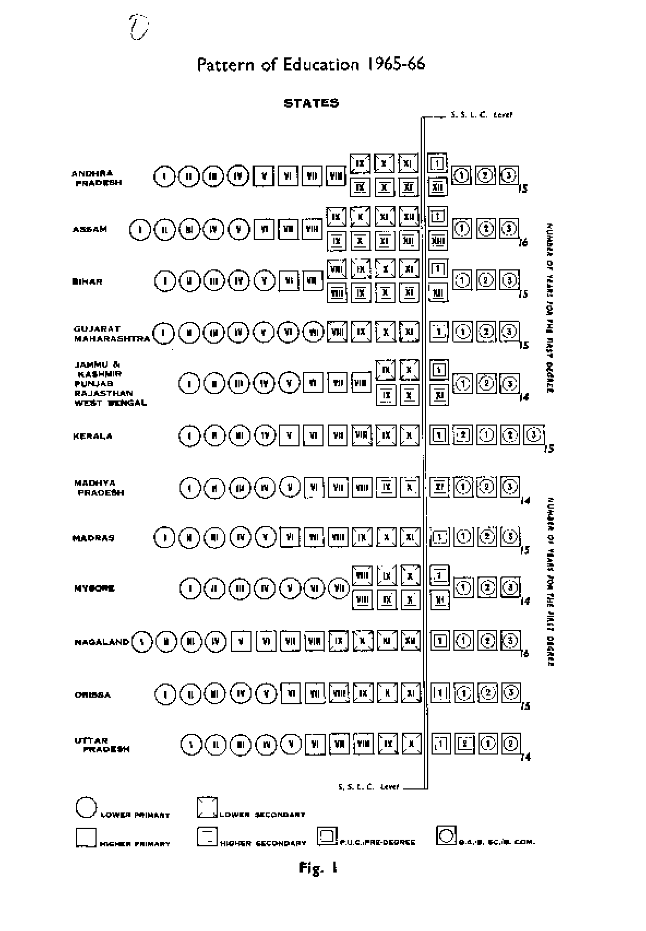

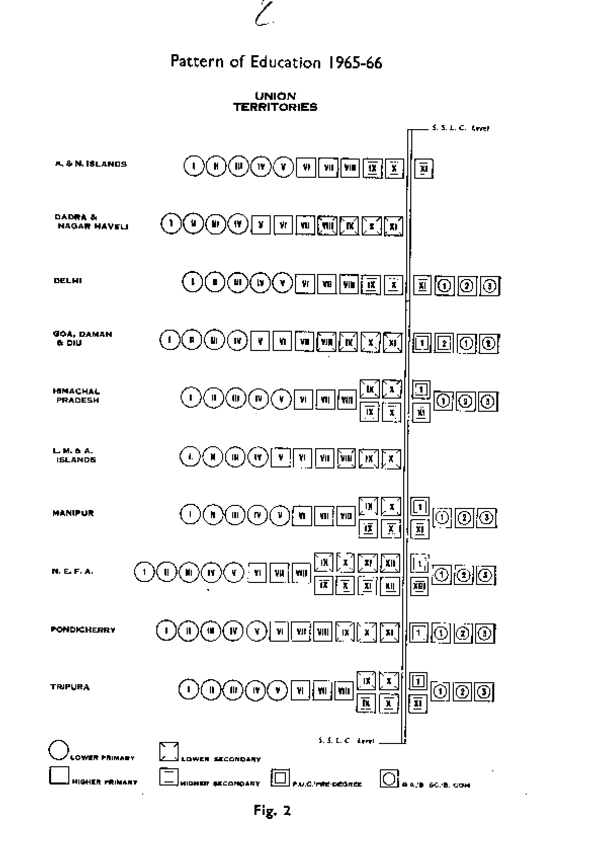

This view has been gaining considerable ground in recent years. The concept of a national system of education has been increasingly linked with the adoption of a uniform educational pattern, and a belief has grown that such uniformity is essential for raising standards.

  - We have recommended elsewhere¹⁶ certain steps that should be taken for the coordination of educational standards at the school stage in the different States. But we do not believe that it is necessary or desirable to impose a uniform pattern of school and college classes in all parts of the country. There are several characteristic features of the Indian situation, such as the vastness of the country and the immense diversity of local conditions and traditions, that demand a certain element of flexibility in the educational structure. We are aware of other national systems of education which have a variety of educational patterns. Even in a country of small size such as the United Kingdom, for example, the pattern in England (generally thirteen years of school education followed by a three-year course for the first degree) is different from that in Scotland (twelve years of school education followed by a four-year course for the first degree). In our country, where the different States are at unequal levels of development, a uniform pattern might be above the resources and real needs of the backward areas and below the capacity and requirements of the advanced areas and might operate to the disadvantage of both.

  - Lengthening the Duration of Schooling. A second popular demand that has been stressed in proposals for structural reorganization received by the Commission is related to lengthening the total duration of school and higher education. This demand, it may be pointed out, is not related to the professional degrees such as engineering or medicine, the total duration of the study for which is not less than 16 years and is about the same as in most of the educationally advanced countries. This demand 'only refers to the first degrees in arts and science, which are now taken four years after the matriculation or an equivalent examination (or three years after the higher secondary course of eleven years), and the contention put forward is that this duration should be lengthened to not less than five years after the matriculation (or four years after the higher secondary). This view, it must be pointed out, accords with the thinking of several expert bodies on the subject. As far back as in 1919, the Calcutta University Commission proposed that the dividing line between the university and the secondary school should be drawn at the intermediate examination, which came after twelve years of education. Similarly, the University Education Commission (1948) recommended that students should be admitted to the university after the completion of twelve years of study, and that the first degree course should be of three years' duration. According to the Committee on Emotional Integration (1962), the eleven-year period of school education was inadequate preparation for entrance to the university, and the lengthening of the course by one year was deemed necessary. At the conference of the State Education Ministers held in 1964, it was resolved that 'a twelve-year course of schooling before admission to the degree course was the goal towards which the country must work'. We are in full agreement with these recommendations.
16 Vol.II, Chapter X.

  - Reorganization of the Educational Structure. The kind of reorganization suggested above, which involves a lengthening of the duration of school education, cannot obviously be effected within a short period. The vastness of the country and the variety of its educational patterns make the task a formidable one, and the pressure of more urgent claims on the limited educational resources adds to the complexity of the problem. We recommend that the reorganization should be carried out through a phased programme spread over at least twenty years. The first step in this direction would be the abandon- ing of the present higher secondary pattern in which specialization begins in class IX, and the institution of a new higher secondary course beginning in class Xi. Along with this measure, which should be completed by the end of the Fourth Plan period, a systematic attempt should be made to transfer the pre-university course at present located in universities and affiliated colleges, where it tends to depress standards of higher education, to secondary schools, where it rightly belongs. The next step would be to lengthen the total duration by adding a year to the higher secondary course. All these measures are discussed in detail in a later section of this chapter.

  - We visualize a flexible educational structure covering

    - a pre-school stage of one to three years; - a primary stage of seven or eight years divided into two sub-stages-a lower primary stage of four or five years and a higher Primary stage of three years

    - a lower secondary or high school stage of three or two years in general education or of one to three years in vocational education;

    - a higher secondary stage of two years of general education or one to three years of vocational education; - a higher education stage having a course of three years or more for the first degree, followed by courses of varying durations for the second or research degrees. The organization of pre-primary education is dealt with separately in Chapter
VII. We shall now deal with details of the reorganization at the school and the higher education stages.

REORGANIZATION OF SCHOOL EDUCATION

  - The First Ten Years. The primary and secondary schools will be of various types. The largest single group amongst them will consist of lower primary schools. A smaller number-about one in three-will provide education up to the end of the higher primary stage and these would necessarily include the lower classes. When the present higher secondary pattern is abandoned, most of the secondary schools-about three-fourths-would provide education up to class X and may begin at any convenient point lower down; and the remaining one- fourth will be higher secondary schools providing education up to university entrance. The existing position, however, is quite different from this and shows considerable variations in the structure of the school system until the public examination at the end of the lower secondary stage is reached. A reference to chart on page 55 shows that this external examination, which is known by different names but which we shall call the high school examination, comes after ten to twelve years: two States (Assam and

Nagaland) have the examination after twelve years; six States (Andhra Pradesh, Bihar, Gujarat, Madras, Maharashtra and Orissa) have it after eleven years; and the remaining eight States (Jammu & Kashmir, Kerala, Madhya Pradesh¹⁷, Mysore, Punjab, Rajasthan, Uttar Pradesh and West Bengal) have it after ten years. No systematic study has yet been made for comparing the standards of attainment of the candidates at the examinations held in the different regions. But these are broadly comparable and, for administrative purposes, all these examinations are regarded as equivalent.

  - It will be seen from the chart that in Assam and Nagaland, the first two classes are called A and B, and it is the next ten classes that are numbered consecutively as classes I to X. Since the Governments of the two States themselves seem to treat classes A and B as Infant classes and separate them from the other ten classes, the school stage leading to the high school examination in these States may be regarded as covering a period of ten years. In the six States which have an eleven-year school course, it is more appropriate to regard class I as a pre-primary class, particularly where the age of admission is less than six years. We believe that this pre-primary class is an advantage which these States possess. We recommend that they should try to retain it as such, organize the learning experiences therein on the play-way pattern rather than on the formal pattern, and extend it downwards, wherever possible, to cover a period of two years. We also suggest that the other eight States may try to provide pre-primary education of one year or more below class I to the extent possible, subject to the availability of financial resources.

  - As we visualize, (1) the first ten years of schooling, covering a. primary stage of seven or eight years and a lower secondary stage of three or two years, will provide a course of general education without any specialization;

- the primary stage will be Preceded, wherever possible, by pre-primary education of one to three years;

- the age of admission to class I will ordinarily be not less than 6+;

- at the end of the primary stage, a proportion of students will step off the school system and enter working life (about 20 per cent); some more will step out off the stream of general education into different vocational courses whose duration may range from one to three years (about 20 per cent); and those remaining will continue further in the stream of general education (about 60 per cent);

- the ten years of school education will be followed by all external examination;

- the standard at the end of the ten years will be broadly comparable in respect of curriculum and level of attainment to the national standard laid down for the end of this stage; (7) at the end of the ten years of school education, a proportion of students will step off the school system and enter working life (about 40 per cent); some more will step
17This examination is not held at present in Madhya Pradesh where all the schools are of the higher secondary status. But it is proposed to reintroduce it in 1967.

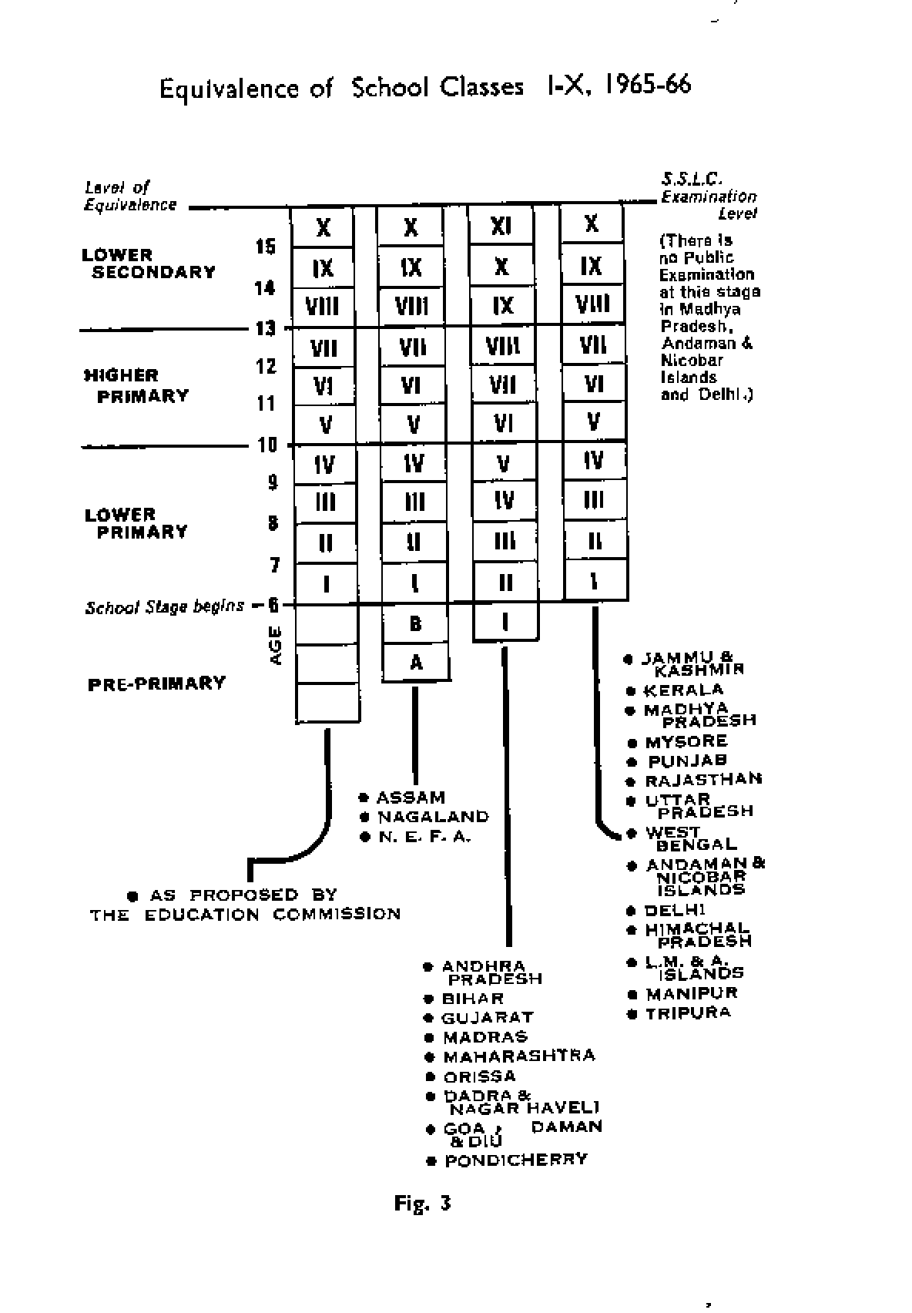

out off the stream of general education and enter vocational courses =duration will be one to three years (about 30 per cent); and those remaining will continue further in the stream of general education whose duration will be one, and ultimately two years (about 30 per cent).

  - Modifications of the Higher Secondary Pattern. We attach great significance to changes that have to be made in the existing higher secondary pattern in the light of the proposals for reorganization made above.

- As has already been stated, the system of 'streaming' in schools of general education, which now begins in class IX, should be given up and no attempt at specialization should be made till after class X. This will need a considerable reorganization of the existing curricula of the higher secondary schools.

- The idea that every secondary school should be raised to the higher secondary status should also be abandoned. It has been possible to upgrade all the high schools in Delhi because it is a metropolitan area. Such wholesale conversion of schools has also been carried out in Madhya Pradesh; but the cost has been very heavy in terms of deterioration of standards as well as of financial outlays. In a country where rural areas predominate, it is unwise to try to raise every high school to the higher secondary status. We visualize, as a permanent feature of the educational system, secondary schools of two types: high schools providing the ten-year course described above, and higher secondary schools which in due course will offer a twelve- year course of education. With a view to concentrating resources and raising standards effectively, it is only the bigger and better type of high school that should be upgraded. If one-fourth of the total number of high schools were raised to the higher secondary status, they would meet all the needs of the situation, even on the assumption that there would be no pre-university courses in the colleges in the future. An essential requirement is that the institutions should be large, centrally located and equitably distributed between the urban and the rural areas. It would also be desirable to review the status of all existing higher secondary schools, and where these are too small and uneconomic or of very poor quality, they may be reconverted into high schools.

- There should be, as a rule, no integrated course of studies beginning with class IX. Classes IX and X will now form part of the first ten years of general education, and classes XI and XII (and during the transitional period, class XI only), which will provide for specialized studies in different subjects at the higher secondary stage, will become an independent, self-contained unit like the Sixth Form in England.

- There will be an external examination at the end of class X to mark the termination of the first ten years of general education. Therefore, a student studying in a ten-year high school will have to appear for two external examinations at the end of classes X and XI-at the interval of one year. This handicap will be removed with the extension of the higher secondary course to two years.

- Existing higher secondary schools with a well-organized integrated course in classes IX to XI may be permitted to carry on, if they so desire, with such a course until they add class XII. It will not be obligatory for the students of such schools to appear for an examination at the end of class X. They may take one final examination at the end of class XI or take it in two parts at the end of classes X and XI.

  - Vocational Courses at the End of the Primary Stage. It has been stated above that about 20 per cent of the students will leave the educational system and join working life at the end of the primary stage and that about an equal proportion will step off from the stream of general education and join vocational courses. It will be necessary to provide adequate facilities for suitable forms of vocational education, either on a part-time or on a full-time basis, for these students. This problem will be discussed in greater detail elsewhere.¹⁸

  - Courses Corresponding to the Higher Secondary Stage. The name, duration, location and control of courses corresponding to the higher secondary stage vary from State to State. In Uttar Pradesh, the course is designated as 'Intermediate' and the duration is two years. It is located either in the top classes of secondary schools or in the bottom classes of degree colleges and its academic control is vested in the Board of High School and Intermediate Examinations. In Kerala, the course is provided in institutions called 'Junior Colleges', which are sometimes independent and sometimes attached to affiliated colleges, and its control vests with the university. In Madhya Pradesh, where all secondary schools have been raised to the higher secondary pattern, there is no course at this stage outside the higher secondary schools. In States where the higher secondary pattern is adopted but all high schools have not been raised to the higher secondary status, the stage is provided as class XI in the higher secondary schools and pre-university courses in colleges. All other States provide a pre-university course exclusively located in colleges and controlled by the universities.

  - In discussing the proposed reorganization of the educational structure, we pointed out that two main reforms were needed at this stage:

    - the transfer of the pre-university courses from the universities and the colleges to the schools; and - the lengthening of the duration of the courses of general education uniformly to two years.

In our view, the simpler and more efficient way of carrying out these reforms would be to take up their implementation in two successive stages. In the first stage, the pre- university, intermediate or junior college courses should be transferred from higher education to school education in a period of ten years (1966-75); in the second, their duration should be lengthened, in situ as it were, in a fifteen- year period beginning with the Fifth Plan (1971-85).

¹⁸Chapter VII

  - Transfer of the Pre-University Course. We attach great significance to the location, exclusively in the schools, of all the courses that form part of higher secondary education. When the higher secondary pattern was first recommended, the pre-university course was introduced only as a transitional measure. Unfortunately, the transition threatens to become permanent, and even today about 40 per cent of the total enrolment in the universities and affiliated colleges is in the intermediate or pre-university courses. This is a great evil from all points of view. It is bad for the universities and colleges as their resources and energies are being improperly utilized and even wasted in doing what is essentially the work of secondary schools. It is bad for the secondary schools because they are weakened by being deprived of a stage which could give them good teachers and facilities, with the result that they are obliged to do a good deal of work which ought to have been done at the primary stage. It is bad for the students because they are now required to enter universities at too early an age, and compelled to learn through methods of higher education which are beyond their capacity and more suited to maturer students. We, therefore, strongly recommend that the pre-university course, irrespective of its duration, should first be transferred to the school on a high priority basis-this transfer to be completed by the end of the Fifth Five Year Plan at the latest.

  - The following measures may be adopted to bring about this transfer:

- The responsibility for transferring all pre-university or intermediate work from the universities and affiliated colleges should be placed on the University Grants Commission, which should be asked to prepare a phased programme, to be spread over not more than ten years, for the purpose. A beginning should be made with the universities and the postgraduate colleges which should be required to shed this work as soon as practicable. This policy should then be extended to degree colleges, where the enrolments at this stage should be frozen at a certain time, after which the colleges would be required to taper them off as their enrolments at the undergraduate stage begin to grow. Beyond the Fourth Plan, the opening of new pre-university or inter- mediate classes in the universities and affiliated colleges should not be permitted. The University Grants Commission and the State Governments should be requested to reduce gradually their allotment of funds earmarked for this stage of education and to stop them completely by the end of the Fifth Plan.

- While these steps are being taken, arrangements should be made to start the higher secondary class or classes in selected schools. The responsibility for making these arrangements should be placed on the State Education Departments, which should work out a proper programme for the purpose in consultation with the universities in the State. Good high schools should be selected and given adequate grant-in-aid to start a higher secondary class or classes as a self-contained unit which is not to be integrated with the lower classes, so that students from other high schools may join it. A scheme of this type has been tried in Mysore and found to work well. Recurring grants for this purpose should be made available to each selected institution one year in advance so that the preliminary arrangements can be satisfactorily completed in time.

- Most of the Boards of Secondary Education will have to be reconstituted to accept the responsibility for the higher secondary stage, and in some cases, their Acts will have to be amended. We shall discuss this matter in detail in Chapter X.

  - This programme of transfer will not involve any wastage. The universities and the affiliated colleges from which the pre- university courses will disappear will be able to utilize the existing facilities so released for the purpose of expanded admissions in undergraduate classes. For creating the new facilities required at the school stage, however, a much larger investment of resources is needed. The nonrecurring expenditure will be much greater, because most of the secondary schools are in a very bad shape at present. Even with regard to recurring expenditure, there will be an overall increase, because the income from fees may show a fall after a transfer of these classes to the schools. But the advantage of this additional investment will be spread, to some extent, over a very large proportion of the student population at the secondary stage and the benefit to society in terms of a better output from secondary education, will be much greater. There should, therefore, be no hesitation in incurring the somewhat larger expenditure involved in the execution of this programme.

  - Programme for Lengthening of Duration. Our second proposal in this regard is that, in all the States except Uttar Pradesh and Kerala, the duration of the higher secondary course should be lengthened to two years through a phased programme spread over twenty years and divided into two stages. The first stage, covering a period of five years, should be devoted to securing a better utilization of existing facilities and to making the needed preparation for a successful implementation of this important reform. Even during this period, selected higher secondary schools should be permitted to add the twelfth year, and some high schools of good quality and possessing the necessary facilities may be allowed to introduce the two-year higher secondary course as pilot projects. The second stage will cover a span of fifteen years; the programme of extending the duration should begin in the Fifth Plan, gather momentum in the following decade, and be completed by the end of the Seventh Plan.

  - Some explanation is necessary for the first stage of implementation referred to above, which implies a postponement of the actual programme of lengthening the duration to the Fifth Plan. We recommend such postponement for three important reasons:

- The first reason is that of priority. There are three possible choices in school or higher education in the next five years: qualitative improvement of general education (with special emphasis on raising the salaries and qualifications of teachers); vocationalization of secondary and higher education; or lengthening of the duration of the total period of general education. in our opinion, the first two of these are of far greater urgency and may absorb all the additional resources likely to be available during the next five years.

- The second reason is our anxiety for improving the utilization of the time already available before the duration of the school course is lengthened. We would emphasize that a hasty addition of one year to secondary education will not lead to qualitative

improvement unless there is a proper climate of hard work in the educational institutions. Moreover, 'time' is only one of the 'inputs' that can bring about improvement in quality. There are several other 'inputs' that are necessary for raising standards, e.g., motivation of students, competence of teachers, upgraded curricula, better methods of teaching and evaluation, improved textbooks and teaching materials and adequate equipment, buildings and other physical facilities. Qualitative improvement will result from the cumulative effect of all these factors. If they are of the right kind, an increase in the duration will certainly add to the improvement in quality; but if they are not, the extension of the course by a year may only mean further wastage.

- The third reason is related to the need to make advance preparation for the lengthening of the duration. In our opinion, it will be nothing short of wasting scarce resources if State Governments embark on this programme without preparatory work. This requires (a) that State Governments should take the necessary steps, right from the moment the proposal is accepted, to expand postgraduate education and to prepare the needed teachers; and (b) that they should select, by way of a pilot project, good secondary or higher secondary schools and permit them to add two or one-year courses, as the case may be. On the completion of these courses, the students should be able to join the under- graduate courses at the appropriate points. This will be broadly equivalent to the 'advance placement programme in the USA. We think that it will be of considerable help to several students who would prefer to work for some time longer with their own school teachers and in their own school atmosphere rather than transfer themselves abruptly to a new and unfamiliar environment.

  - In this connection, it is 'interesting to note that the Committee on Higher Education in the United Kingdom, after considering a somewhat similar suggestion for lengthening the duration of the first degree course in the United Kingdom from three to four years, turned it down principally on the ground that a general extension of the course would not be justified while students were not making proper use of the vacations. This reinforces the view that the proper policy to be adopted in this matter, especially in a developing country, is to increase the duration only after all steps have been taken to maximize the utilization of the time available. It is for this reason that we have recommended the postponement of the programme of lengthening the duration to the Fifth Plan. But once the utilization is improved and necessary preparations made, the programme should be started on a big scale and completed by 1985.

  - Vocationalization at the Higher Secondary Stage. We must emphasize particularly the need to vocationalize higher secondary education and to expand the vocational courses to cover about half of the total enrolment at this stage. A large variety of terminal courses should be organized, varying in duration from one to three years. They will include courses for the training of primary and pre- primary teachers; courses conducted by the industrial training institutions for a large number of trades for which the completion of studies in class X is the minimum qualification; courses in agriculture and industry which will train the middle level of personnel needed; courses for training paramedical/health personnel; courses for secretariat work; and courses in home science.

It is such courses that will make secondary education mainly terminal. The problem is discussed in detail elsewhere.¹⁹

  - To Sum Up. We recommend that-

- the higher secondary stage should be extended to cover a period of two years and should be located exclusively in the schools;

- steps should be taken to implement this reform through a phased programme spread over the next 20 years (1966-85);

- as a first step in this direction, the pre-university course, irrespective of its duration, should be transferred from the colleges to the schools on a high priority basis within the next ten years;

- simultaneously, attempts should be made in the Fourth Five Year Plan for improving the utilization of the existing period to the best extent possible, for the preparation of teachers for the two-year course by expanding and improving the postgraduate stage, and for the working out of pilot projects with two-year higher secondary courses in selected secondary schools;

- with the beginning of the Fifth Five Year Plan (1971- 72), the implementation of the programme should start on a large scale and it should be completed by the end of the Seventh Plan (1985-86); and

- provision should also be made from the very outset for the introduction of different types of vocational courses at the higher secondary stage, varying in duration from one to three years, which would prepare young persons for employment.

The changes proposed here have been shown graphically in the chart on page 65.

REORGANIZATION AT THE UNIVERSITY STAGE

  - Prior to 1947, the pattern of higher education was largely uniform in all parts of the country. The duration of the course leading to the first degree in arts and science was two years, and this was followed by a two-year course leading to the second degree. But several changes have been introduced into the pattern since Independence. The most important is that the duration of the course for the first degree in arts, science and commerce has been lengthened to three years in all the universities except those in Uttar Pradesh and the University of Bombay, which still provide the two-year degree course after the Intermediate Examination. One or two universities have experimented with an honours course in certain subjects, covering a period of four years in the aggregate.

¹⁹Chapter XV.

Again, the degree courses in professional subjects are generally longer than the courses for the degrees in arts and science. The agricultural and the engineering courses extend to four and five years respectively after the pre- university course and the medical course has an even longer duration.

  - Proposals for Reorganization. Since progress in higher education lies through freedom to experiment, there can be no objection to this variety. The principal criticism of higher education is directed, however, not so much against the pattern of organization as against the comparatively low standards of the degrees awarded by the Indian universities in arts, commerce and science. The causes for these low standards are discussed in a later section.²⁰ We are concerned here only with the question of the structural reorganization necessary at the university stage for the improvement of standards. The following proposals are made in this connection:

- The duration of the first degree course should not be less than three years. Apart from this, there should be no rigidity about the duration of courses in higher education. These may vary from university to university, and even in the same university, from subject to subject. The duration of courses for the second degree may be two or three years.

- In some universities, strong 'graduate schools' providing a three-year M.A./M.Sc./M.Com. degree course may be established in certain subjects. For the sake of convenience, these courses may be designated as honours courses or they may be given some other suitable name. If they are properly organized and a careful selection of students is made, they will be able to produce excellent personnel for the teaching faculty and for high-grade research.

- A beginning should also be made with the organization of four-year special courses for the first degree in selected subjects. The first year of these courses will be the same as the first year of the present three-year degree course. But students will be selected, at the end of that year, for admission to a further three-year special course leading to the first (special) degree in, the subject. The experiment should be tried, in the first instance, in the university departments only and in subjects where teachers and facilities are available. In the light of the experience gained, it may be extended subsequently to other subjects and to good affiliated colleges doing postgraduate work.

- The above proposal will need to be modified in Uttar Pradesh, where the immediate problem is to raise the duration of the first degree course in arts, commerce and science from two to three years. Since large financial and personnel problems are involved, we suggest that this programme should be spread over 15 to 20 years. A beginning may be made with the establishment of graduate schools and challenging three- year courses to be introduced in selected subjects and selected universities; and as funds and teachers become available, the programme should be extended to affiliated postgraduate colleges doing good work and to other subjects.

²⁰Chapter XI,

- Suitable 'bridges' should be built between these new and longer courses and the existing courses of shorter duration.
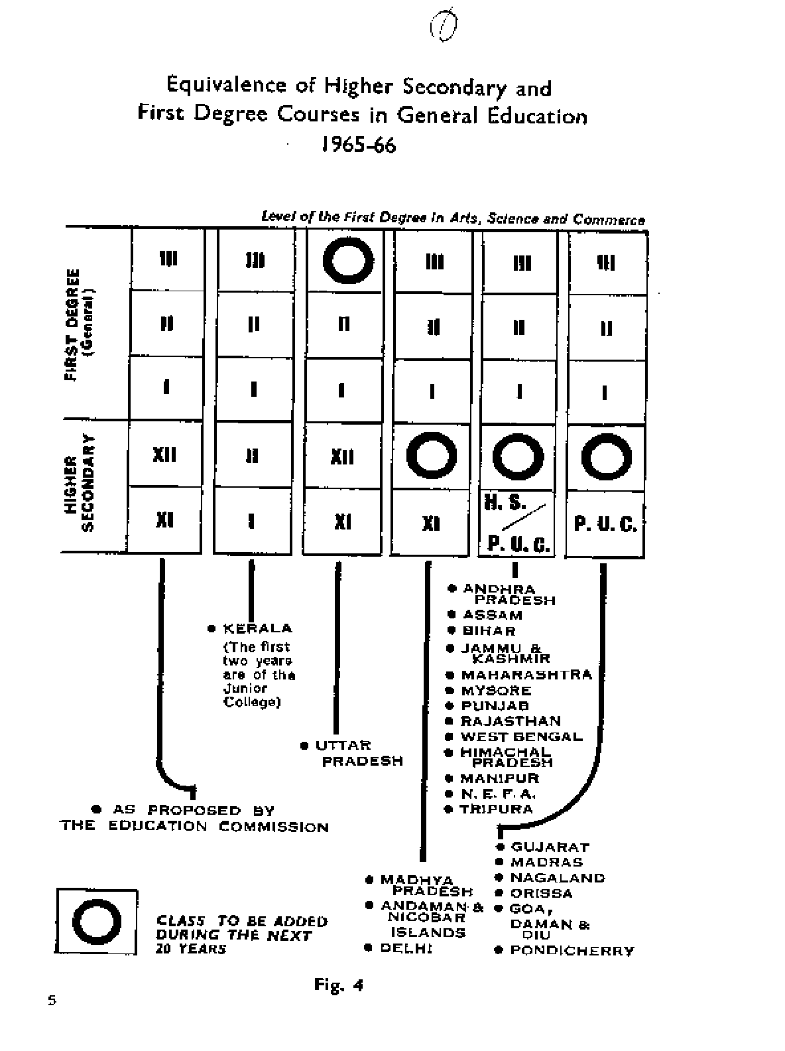

- Some incentives will have to be provided to students for undergoing these longer and higher level courses.²¹ For instance, a more liberal provision of scholarships should be made for these longer courses for the first and the second degrees. Students completing the courses should be entitled to advance increments in the usual scales. They should receive preferential consideration in recruitment; and as soon as the supply becomes adequate, the recruitment of teachers should be restricted to the holders of these degrees only. It need hardly be stressed that the admissions to these courses should be made on a highly selective basis.

  - Just as we laid considerable stress on the vocationalization of secondary education we would also like to emphasize the importance of professional education at the university stage. This is of particular urgency in the Indian context where the emphasis in higher education in the past has been on training persons mainly for white-collar jobs. Our proposals on this subject are discussed elsewhere.²²

UTILIZATION OF FACILITIES

  - The principal object of the changes in structure and duration which have been discussed above is to raise standards. In this context, however, it is essential to note that

    - structure and duration play a significant but secondary role in improving standards;

    - the changes proposed in structure and duration will be rather slow in making an impact on quality, because their full implementation has been spread over twenty years; and

    - the most serious weakness of the existing educational system lies, not in its structure, but in its feebleness. We are getting relatively much less than what we should from the system as it exists and the resources that go into it. No reorganization of structure or addition of time can remedy this basic weakness.

It is, therefore, necessary to place a much greater emphasis in all our plans of educational reconstruction on programmes of intensive utilization of facilities available, and on improving the extent and quality of the inputs other than time, and particularly on the improvement of teachers. These will yield immediate and far-reaching results.

  - It will be generally agreed that the facilities in our educational system, deficient as they are, are not utilized to their full advantage. There is much that can be done to improve standards even in existing circumstances by lengthening the school day, increasing the number of working days, making full use of the long vacations, and
21The three-year honours courses offered formerly by the universities in U.P. did not prove a Success for a variety of reasons, one of them being that the pass course had a duration of two years and admissions to postgraduate courses were open to honours as well as to pass graduates.

²²Chapters V, XII, XIV and XV.

generally creating a climate of hard and sustained work. The key to rapid national development is dedication and hard work. Educational institutions should give a lead to society in this matter and create the required climate, in the first instance, in the educational system itself.

  - Working and Instructional Days. At present, the total number of working days and hours prescribed for educational institutions at all levels is inadequate. What is far worse, a very large proportion of these working days is lost to education for a variety of reasons with the result that the total number of instructional days, i.e., days which are fully utilized for instructional purposes, is often reduced to an absurdly low figure. The details of a study conducted by the Commission to ascertain the number of working days and hours in schools and colleges in different parts of the country (as officially prescribed by the State Education Departments and universities) has been given elsewhere. It shows that there is considerable variation, from area to area, in the total number of working days in a year-these range from 172 to 309 at the school stage and from 120 to 240 at the university stage. The number of holidays given within a school year shows even larger variations- from 20 to 75 at the school stage and from 4 to 49 at the university stage. Similarly, the total duration of vacations varies from 36 to 84 days at the school stage and from 62 to 137 at the university stage. The days utilized for examinations (inclusive of preparatory leave) vary from 10 to 77 and the loss on account of celebrations such as foundation days, annual functions of societies, etc is sometimes as high as 40 to 60 days in a year. These facts are a sad reflection on the efficiency of the educational system, and the general under- utilization which they represent in a developing economy like ours is tantamount to an unpardonable waste of scarce resources. We, therefore, recommend that the number of instructional days in a year should be increased to about 234 (or 39 weeks) for schools and 216 (or 36 weeks) for colleges (and pre-primary schools).

  - Specimen Calendar. In addition, it may be useful to see how this recommendation will be reflected in terms of an academic calendar. For this purpose, we give below a specimen calendar for schools and colleges:

- For the schools, the calendar will be somewhat like the following:

July 15-Opening day. (Teachers will attend school one week earlier to make admissions and to prepare plans for the next year.) July 15 to November 30-First working term. (Not more than one week to be lost in admissions') December 1 to December 15-First vacation term of two weeks. December 16 to May 30-Second working term. Teaching to be over by April 15. April 16 to April 30-Guided studies by students to prepare for their examinations. Annual examinations in the first week of May and to be over by the 7th of May (if necessary, the preparatory period may be cut down). Second week of May- Vacation term of one week for students while teachers examine papers. May 15- Declaration of results. May 16 to May 30-Guidance classes to students for the new year. July 1 to July 14-Second vacation term of six weeks. (For students who have failed in the annual examinations, special tutorials to be organized during the vacation term, a re- examination to be held in the second week of July and the students to be promoted to the next class if they pass.)

Note: Some clarification may be given. The idea of vacation terms should be made secular and dissociated from religious festivals like Diwali, Christmas or Puja. The breaks needed for these holidays could be adjusted within the 10 holidays permitted in a year (or with the addition of 3-7 days which could be reduced from the break at the end of the first term).

For the students in Classes X and XII who will take an external examination, the time- table will be slightly different, as follows: July I to November 15-First working term. November 15 to November 22 (one week)-First vacation term. November 23 to January 31 (Teaching time)-Second working term.

February 1 to February 28-Guided preparation. March 1 to March 15-Examinations (may also be arranged from February 15 to February 28). May 30 to July 15-Declaration of results. The time allowed in this arrangement for the declaration of results varies from 1.5 to 3.5 months. There is, however, an urgent need to reduce this time to not more than 2.5 months (from March 15 to May 30) and steps should be taken from this point of view.

- For the colleges and universities, the time-table will be somewhat on the following lines: July 15 to November 30-First working term. December 1 to December 15-First vacation term (2 weeks). December 16 to April 30-Second working term. (Examinations to begin after April 1 and to be finished by April 30.) May 1 to July 14-Second vacation term (10 weeks). (All results to be declared by May 30. For shortening the time, the practice of the IITs of inviting all examiners to a central place may be adopted.)

  - The calendar given above is merely illustrative, and consultations with the agencies concerned will be necessary before it can be given a final shape. We recommend that this should be done by the Ministry of Education in consultation with the State Governments and by the University Grants Commission with the universities. We realize that, with the large variations in climate, the school calendar will have to vary from area to area. But whatever the calendar adopted, it should be ensured that the minimum number of instructional days should not be less than 234 a year for schools and 216 a year for colleges. This can be done by introducing two reforms:

- The first is to cut down other holidays which are now as many as 35 or even more in a year. The general experience is that they serve no useful purpose and merely disturb the work of educational institutions. We recommend, therefore, that these should be drastically cut down to ten (which also includes three days for 'unexpected' events). in our opinion, there is no need to close an educational institution on a religious holiday. Nor is it necessary, for instance, to close it on birthdays or death anniversaries of' great Indians; the time could be better utilized in working hard for national development.

- The second is to fix an upper limit, in each given year, for the loss of working days to instruction due to all causes including examinations-21 days in schools and 27 in colleges.

  - In our opinion, it is desirable to begin the academic year on the same day throughout India. Our discussions with educationists on this issue make us feel that it would be possible to do this if the opening day of the school year were placed in November. We recommend that this idea should be pursued by the Ministry of Education and the University Grants Commission.

  - Utilization of Vacations. In addition, steps should be taken to ensure that adequate use is made of vacations which are very often wasted. Even in advanced countries, where vacations are already being utilized much better than here, there is a growing feeling that they could be used even more intensively. A country like India cannot afford to waste vacation time. We would, therefore, prefer to call this period a 'vacation term' rather than a 'vacation' and recommend that all steps should be taken to utilize it fully. This is what teachers actively interested in research do; they use the vacations for pursuing their studies in a manner which it is not possible to follow during term time. A similar practice deserves to be adopted more widely by students as well as by teachers.

  - It is quite possible to organize interesting and challenging programmes for students, such as

    - participation in social service camps, NCC and work- experience; - earning for maintenance; - studies for the ensuing year, including general studies, with the help of school and college libraries and laboratories; - hikes, excursions, tours, cultivation of bobbies; and - participation in nation-building programmes such as literacy drives.

For these programmes, it will be essential to secure the assistance of a certain proportion of teachers. This could be done by the appointment of additional staff, by the payment of honorarium at prescribed rates to the existing staff, or by granting them compensatory leave in lieu of the vacation lost.

  - School Hours. It is not enough simply to increase the number of instructional days. For the best results, it is also essential to increase the duration of the working day as indicated below:

- At the school stage, the working hours per day should vary from four hours at the pre- primary stage to about six hours at the higher secondary stage. This total period does not include the time for co-curricular activities, but includes the time when the students would be working on their own (e.g., the library period), or on guided studies. In an academic year, the hours of instruction at the lower primary stage should be about 900, and at the higher primary and secondary stages, they should be not less than 1,000, and preferably raised to 1,100 or even 1,200 if conditions are favourable.

- At the university stage, the hours of work are already long enough for professional courses (e.g., engineering, medicine, agriculture) and also for science students. It is only the students in the humanities courses who do not seem to work hard enough. The more serious weakness of the situation, however, is the lack of adequate facilities for students to study on their own. We believe that the 'contact' hours at this stage should be about 15

to 20 a week; but that they should involve the student in working on his own for at least twice as much, so that his total work-load per week is about 50 to 60 hours. As one goes higher up, the contact hours could be less, and self-study periods even longer. At present, students and teachers come together in lectures, where there is hardly any personal contact, and there is no other way in which they can meet. The most urgent reform needed, therefore, is not to lengthen the working day in terms of the lectures delivered- these need to be cut down-but to increase the self-study facilities for students and to ensure that they work adequately. To make it possible, several additional facilities, now lacking in most of our educational institutions, will have to be provided. A well-kept and commodious library with an adequate number of 'reading seats' is necessary; teachers must have rooms, or, lacking this, separate desks of their own in the library; and canteens should be established to provide substantial meals prepared at a reasonable cost under hygienic conditions for students and teachers. Owing mainly to the financial implications involved, it may not be possible to adopt this reform in all institutions. But we feel that a beginning should be made, Wherever possible, and the programme should be expanded, on a priority basis, as resources become available.

  - Utilization of Institutional Facilities. One more aspect of the problem needs attention. Since it is very costly to provide and maintain the physical plant of educational institutions, it becomes necessary to utilize it as fully as possible, for the longest time on each day and for all the days in the year, by making suitable administrative arrangements. Teachers and students would continue to have their own hours of work and vacations as recommended above. The libraries, laboratories, workshops, craftsheds, etc., should be open all the year round and should be utilized for at least eight hours a day, if not longer. Special vacation programmes should be arranged to utilize institutional facilities for community service, adult education, temporary hostels for day students, enrichment programmes for gifted students and supporting programmes for retarded students. It is not necessary to indicate all the different ways in which the institutional facilities could be utilized all the year round. If an understanding is developed that educational institutions are like temples of learning and should never remain closed, and if a proper climate for sustained work is created, teachers, students and the local communities will themselves discover innumerable methods of utilizing school facilities to the maximum potential throughout the year. As it is difficult to expand educational facilities adequately and wasteful to under-utilize existing resources, such programmes demand urgent attention.

DYNAMIC AND EVOLVING STANDARDS

  - One of the common criticisms against the development of education in the post- Independence period is that there has been a fall in standards, and two main illustrations are given to support it: the increase in the number of sub-standard institutions of general education, and the increase in the number of students with sub- standard attainments. The first of these is far more serious and is largely the cause of the second. We admit that there is considerable force in this criticism and we do not wish to minimize its gravity. But we would not like to ignore the other side of the picture either. It has to be remembered that

    - a part of the increase in the number of students with 'sub- standard' attainments is due to the first generation learners, who depress the standards to some extent, but whose entry into secondary schools and colleges in large numbers, especially in rural areas, is also a sign of progress; - considerable improvements have been made in recent years in the teaching of several subjects;

    - good institutions and first-rate students are now more numerous and qualitatively as good as ever, if not better; and

    - the total amount of education in society is substantially higher at present than at any time in the past. The overall situation is thus a mixed picture of light and shade, of improvement as well as deterioration, and of a rise in standards in some areas accompanied by a comparative decline in others. While we fully support the need and urgency for raising standards, we would also like to recognize the qualitative achievements of the educational system in the last few years. They are a source of inspiration and guidance and can help us to face the task ahead with greater confidence.

  - Criteria for Evaluating Standards. In our opinion, the basic issue in educational reconstruction is not to compare the standards of today with those of the past or to determine whether they are rising or falling. On the other hand, we should judge them on the basis of three interrelated criteria: adequacy, dynamism, and international comparability. Standards must be:

    - adequate in relation to the tasks for which they are intended;

    - dynamic, and should keep on rising with the demands for the higher levels of knowledge, skills or character which a modernizing society makes; and

    - internationally comparable, at least in those key sectors where such comparison is important.

Judged on the basis of these criteria, the existing situation appears to be far from satisfactory. Our universities do a good deal of work which really belongs to the secondary school and the latter in its turn does a good deal of work of the primary school. Even where the standards have risen, the rise has not been adequate and better results would have been possible if the existing facilities had been intensively utilized. The main purpose of the first degree should be to bring students to the frontiers of knowledge and to the threshold of the world of research; and that of the second degree to provide a high level of specialization or to initiate the student into research itself. Our first and second degrees in arts, commerce and science do not generally come up to these standards. Moreover, our degrees should be internationally comparable in the sense that those given by our best centres should be as good as those of similar institutions in any part of the world. But by and large, it is our second degree in arts, commerce and science that introduces the student to the world of research and is comparable to the first degree in the educationally advanced countries.

  - A lower standard for these degrees was deliberately adopted in the early years of higher education, because universities had to institute a quick first degree in arts and science in order to produce the large number of graduates needed for the expanding administration.²³ The weakness of these degrees was pointed out by the Calcutta University Commission more than forty years ago. But the situation has not materially changed to this day. Meanwhile, advanced countries have made phenomenal progress in education, specially since the Second World War. The gap between our standards and theirs has widened further; and the holders of the first degree of our universities in arts and science are now generally equated with matriculates in the important universities of western countries and are eligible for admission only to the first year of their first degree course.

  - Recommendations. We recommend that an intensive effort should be made, through measures for reorganization of the structure, increase of duration, intensive utilization and improvement of the quality and extent of inputs other than time, to raise standards continually at all stages of education. The immediate programmes to be undertaken from this point of view should be the following:

- Standards at the End of the First Stage of School Education. The standards reached at the end of the first ten years of school education at present are far from satisfactory. We, therefore, recommend that for the next ten years the principal effort ill all the States and Union Territories should be directed towards the qualitative improvement of this stage of school education so that its wastage-which reaches appalling dimensions at present-is reduced to the minimum. Our proposals on this subject are discussed in detail elsewhere.²⁴ With a substantial reduction in wastage and with better inputs in terms of teachers, curricula, methods of teaching and evaluation, and facilities, we believe it is possible to raise within a decade or so the existing standard at the end of Class X to the standard now being attained on the completion of the higher secondary course. In other words, the schools will add, not one year of time, but one year of content, and achieve in a period of ten years what is now being done in eleven.
23It is interesting that this proposal of a 'half-way' degree which was adopted in our country about a century ago, is now coming into favour, although for entirely different reasons, in sonic of the educationally advanced countries. On the continent of Europe, the first degree course (in arts, science and technology) is of about 5 years. In the USA the courses are of 4 years, whereas in the UK the period is 3 years. With rapidly expanding enrolment it is increasingly recognized that there is a need to reduce by about half the duration of some of the undergraduate courses and provide 'half- way' degrees of the Bachelor level. This will serve to screen students going up to the frill Bachelor's degree, and will help in maintaining and raising the standard of the full degree. (OECD Ministerial Meeting in Science: Fundamental Research and the Policies of Government, Paris, 1966.)

²⁴Chapter VII.

2) Standards at the University Stage. Beyond Class X, we have proposed the addition of at least one year of time. If we intensify utilization and improve other inputs, it may be possible to add a year of content to this stage also. The total gain would thus be equal to two years of content and this would raise the standards of our degrees considerably. When the standard at the end of the first stage of school education is raised by one year of content, the standards of our degrees will rise even higher. Against this background, with the adoption of the programme of developing a few major universities which we shall discuss elsewhere,²⁵ we could make the standards of some of our universities comparable to the best institutions of their type in any part of the world.

  - We have referred earlier to the popular misconception that it is essential to have a uniform pattern of school and higher education in order to improve or maintain standards. But while we are opposed to uniformity of pattern, we do very much share the general concern over the necessity for a continual improvement of standards and their comparability between different parts of the country. In our opinion, this objective can be better secured at the school stage through the creation of an adequate and efficient machinery at the State and the national levels, for defining, revising and evaluating national standards at the end of the primary, high school and the higher secondary stages. We shall discuss these problems in detail in a later part of the Report.²⁶

  - Proper Articulation between the Different Stages of Education. Still another way in which standards can be raised is by securing better coordination between the different stages of education and by making the educational institutions function in small groups instead of in isolation. At present, there is little practical coordination between educational institutions functioning at different levels of education. The people at the university stage criticize those at the secondary stage for a fall in standards; and those at the secondary stage pass the blame on to the persons at the primary stage. This situation of mutual recrimination has to be changed into one of mutual help, and this can be done by making each higher stage of education take the responsibility for improving standards at the lower stages.

  - The Role of Universities and Colleges. The universities and colleges, for example, should assist the secondary schools in improving their efficiency. The following are some of the programmes which can be undertaken:

    - Each college can be functionally related to a number of secondary schools in the neighbourhood and enabled to provide extension services and guidance to them to improve their standards. A similar programme for the colleges themselves could be developed through the universities.

    - The universities can conduct special diploma courses, either pre-service or in-service, for improving the competence of secondary teachers. These can preferably be correspondence courses, requiring only short-term personal attendance.

²⁵Chapter XI. ²⁶Chapter X.

    - The universities can conduct experimental secondary or primary schools to evolve improved techniques of teaching and organization.

    - The university and college teachers can take upon themselves the responsibility for improving school textbooks and providing better types of instructional materials.

    - The universities and colleges could select talented students from the schools in different subjects at an appropriate stage, say, in the age-group 13-15, and help them to develop their knowledge in special fields through individual guidance, provision of laboratory facilities, etc., over and above regular school work.

These programmes have been cited merely as illustrations. Once the principle that the universities should assist in the improvement of standards at lower stages is accepted, it will be possible to devise many other programmes.

  - The School Complex. What was stated above for the relationship between universities, colleges and secondary schools, could be easily extended further to secondary and primary schools. There are about 26,000 secondary schools at the beginning of the Fourth Plan and about 14,000 of these are in rural areas. In addition, the rural areas have about 65,000 higher primary schools and about 360,000 lower primary schools. In other words, in a rural area having a radius of five to ten miles, there are: one secondary school, about five higher primary schools and 28 lower primary schools. The total number of teachers may be about 80 to 100. This is a fairly small and manageable group which can function in a face-to-face relationship within easily accessible distance. It has also a good potential for planning and guidance, since there will be at least five or six trained graduates in the group. Moreover, it is possible to provide new aids like a projector, a good library, a good laboratory in each secondary school as a unit and make them functionally available to all the schools in the area. This group built round a secondary school should, in our opinion, be adopted as the minimum viable unit of educational reform and developed accordingly.

  - The linking of secondary and primary schools under this programme can be done in two tiers. In the first tier, each higher primary school should be integrally related to the eight to ten lower primary schools that exist in its neighbourhood so that they form one complex' of educational facilities. The headmaster of the higher primary school should provide an extension service to the lower primary schools in his charge, and it will be his responsibility to see that they function properly. For this purpose, there would be a committee under his chairmanship (of which the headmaster of every lower primary school in his area would be a member) which would be responsible for planning and developing all the schools as a single 'complex'. The second tier would be a committee under the chairmanship of the head- master of the secondary school (all headmasters of the higher and lower primary schools in the area being members) which will plan the work and give guidance to all the schools in the area, in the light of which each higher primary school complex (with its associated lower primary schools) would carry on its work. This group of schools and teachers can be given a good deal of freedom to develop their own programmes, subject to the general guidance of the inspecting staff. The group

should also be requested to coordinate its work with the local communities and to derive as much help from this source as possible.

  - Such an organization will have several advantages in helping to promote educational advance. It will break the terrible isolation under which each school functions at present. It will enable a small group of schools working in a neighbourhood to make a cooperative effort to improve standards. It will enable the Education Department to devolve authority with comparatively less fear of its being misused and to provide the necessary stock of talent at the functional level to make use of this freedom.

GENERAL

  - Three Channels of Education. One of the major weaknesses of the existing educational system is that it places an almost exclusive reliance on full-time instruction and does not develop adequately the two alternative channels of part-time education and private study or own-time education. It has to be remembered that reliance on fulltime education as the sole channel of instruction often divides the life of an individual into three water-tight and sharply divided stages: a pre-school stage of no formal education or work, a school stage of full-time education and no work, and a post-school stage of full- time work and no education. In a modernizing and rapidly changing society, education should be regarded, not as a terminal but as a life-long process. It should begin informally in the home itself; and thereafter, it should be the ultimate objective of national policy to strive to bring every Individual under the influence of the formal system of education as early as possible, and to keep him under it, directly or indirectly, throughout his life. Similarly, there should be no water-tight separation between work and education at any stave of a man's life, but only a relative shift of emphasis. An 'individual under full-time education should have some work-experience as an integral part of his education itself; and every full-time worker should have the inclination, leisure and means of continuing his education still further. In the same way, the transition from one stage to another should not be abrupt. For example, the transfer of an individual from the infant's play- dominated world to formal school should include a transitional phase of gentle preparation and orientation to schooling. A young person should not be compelled to pass abruptly from a stage of full-time education to another of full-time work; it would be desirable to interpose a period of part-time education and part-time work between the two.

  - If these objectives are to be attained, it is necessary to abandon the present policy of placing an almost exclusive reliance on full-time education, and the two alternative channels of part-time and own-time education should be developed on a larger scale at every stage and in every sector of education and should be given the same status as fulltime education. Secondly, adult and continuing education, which is almost totally neglected at present, should be emphasized to a very great extent. Taken together, these two reforms would

    - enable those who have not completed a stage of education to complete it and, if they wish, to proceed to the next;

    - help every educated person to have further education with or without formally enrolling himself in an educational institution.;

    - enable a worker to acquire knowledge, ability and vocational skill in order to be a better worker and to improve his chances of earning more; and

    - help to refresh the knowledge of the educated person and enable him to keep pace with the new knowledge in the field of his interest.

Programmes of this type, which are being developed even in educationally advanced and affluent countries, cannot be ignored in an underdeveloped and poor country like India. They will smoothen the transition from school to life, reduce the cost of education to the State, and bring under the influence of the educational system a large number of persons who desire to educate themselves but cannot do so on economic grounds.

  - Nomenclature. At present, there is an almost bewildering variety of nomenclatures used in the States and Union Territories to denote the various stages and sub-stages of education. We realize the need for a uniform system of nomenclatures and recommend that it should be evolved by the Government of India, in consultation with the State Governments. Pending the finalization of such a system, we have used the nomenclatures shown on page 79 throughout the Report.

EXISTING AND PROPOSED NOMENCLATURES FOR VARIOUS STAGES OF EDUCATION

Nomenclatures Proposed Existing Nomenclatures

SCHOOL EDUCATION

- Pre-primary 1 Pre-primary
- Pre-basic
- Kindergarten
- Montessori, etc.

- Primary (Classes I-VII or I-VIII)

  - Lower Primary 1 Primary in some States (e.g. Punjab)
Classes I-IV or VI-VIII 2 Lower Primary in some States (e.g. Gujarat)
- junior Basic
- Lower Elementary in some States (e.g. Madras)

  - Higher Primary
Classes V-VII or VI-VIII 1 Middle in some States(e.g.
Punjab)
- junior High School (e.g. Uttar Pradesh)
- Upper Primary in some States (e.g. Gujarat)
- Senior Basic
- Higher Elementary in some States (e.g. Madras)
- Secondary

Classes VIII-XII or IX-XII High School; Higher Secondary School

  - Lower Secondary Education High School Classes VIII-X or IX-X

  - Higher Secondary Education This will include Class XI
Classes XI-XII or PUC in some States
(e.g. Rajasthan). It will include junior Colleges in Kerala.
It will include intermediate Classes in Uttar Pradesh.
It will also include term like pre-engineering.

HIGHER EDUCATION

- Professional Degrees All degrees which lead to a professional qualification M.B.,B.S.;B.T.;LL.B.; B.Ag.,
etc.)

- General Degrees All degrees other than professional ones

- Undergraduate All courses leading to the first degree

- Postgraduate All courses beyond the first degree (excluding certain

 |  | first degrees given after the first degree, e.g.B.Ed.)
 | GENERAL
First Level of Education Second Level of Education  Third Level of Education |  | This will include pre-school and primary education.  This will include high school and higher secondary education.  This will include undergraduate and postgraduate education and research.

SUMMARY

- Structure and Duration. (1) The standards in any given system of education at a given time depend upon four essential elements: (a) the structure or the division of the educational pyramid into different levels or stages and their interrelationships; (b) the duration or total period covered by the different stages; (c) the quality of teachers, curricula, methods of teaching and evaluation, equipment and buildings; and (d) the utilization of available facilities. All these elements are interrelated, but they are not of equal significance.

- The structure which may be regarded as the skeleton of the educational system, is of the least importance.

- The duration or total period of education plays a more significant role; but it becomes crucial only when the available facilities are utilized to the full and no further improvement can be expected without the addition of time.

- The quality of different inputs is even more important, and with an improvement in these, it is possible to raise the standards considerably without affecting the structure or increasing duration.

- But probably the most important is utilizing available facilities and obtaining the maximum return at the existing level of inputs.

- The immediate efforts on which attention should be concentrated at the school stage are two: increasing the intensity of utilization and improving the quality of inputs, other than time. With these, it is possible to add about a year of content to the school course. In addition, it is also necessary to increase the duration of the higher secondary stage to two years under a phased programme which will begin in the Fifth Plan and be completed by 1985.

- The new educational structure should consist of

  - one to three years of pre-school education;

  - a ten-year period of general education which may be subdivided into a primary stage of 7 to 8 years (a lower primary stage of 4 or 5 years and a higher primary stage of 3 or 2 years) and lower secondary stage of 3 or 2 years of general education or one to three years of vocational education (the enrolment in vocational courses being raised to 20 per cent of the total);

  - a higher secondary stage of two years of general education or one to three years of vocational education (the enrolment in vocational education being raised to 50 per cent of the total);

  - a higher education stage having a course of three years or more for the first degree and followed by courses of varying duration for the second or research degrees.

- The age of admission to class I should ordinarily be not less than 6+.

- The first public external examination should come at the end of the first ten years of schooling.

- The system of streaming in schools of general education from class IX should be abandoned and no attempt at specialization made until beyond class X.

- Secondary schools should be of two types-high schools providing a ten-year course and higher secondary schools providing a course of 11 or 12 years.

- Attempts to upgrade every secondary school to the higher secondary stage should be abandoned. Only the bigger and more efficient schools-about one-fourth of the total number-should be upgraded. The status of the existing higher secondary schools should be reviewed from this point of view and, if necessary, those that do not deserve the higher secondary status should be downgraded.

- A new higher secondary course, beginning in class XI, should be instituted. Classes XI and XII (and, during the transitional period, class XI only) should provide specialized studies in different, subjects. Where, however, existing higher secondary schools with integrated course in classes IX, X and XI are running satisfactorily, the arrangement may continue until class XII is added. 2.01-21

- Transfer of the Pre-University Course. (1) The pre-university course should be transferred from the universities and affiliated colleges to secondary schools by 1975-76, and the duration of the course should be lengthened to two years by 1985-86.

- The UGC should be responsible for effecting the transfer of all pre-university or intermediate work from university and affiliated colleges to schools.

- Simultaneously higher secondary class or classes should be started in selected schools by State Education Departments, as self- contained units, and assisted with adequate recurring grants.

- Boards of Secondary Education should be reconstituted to accept the responsibility for the higher secondary stage also. 2.22-24

- Lengthening the Duration of the Higher Secondary Stage. (1) In the Fourth Plan, efforts should be concentrated on securing a better utilization of existing facilities, on making the necessary preparation for implementing the programme and on lengthening the duration of the course in a few selected institutions as pilot projects.

(2) The programme of lengthening the duration of the higher secondary stage should begin in the Fifth Plan and be completed by the end of the Seventh Plan. 2.25-29

- Reorganization of the University Stage. (1) The duration of the first degree should not be less than three years. The duration of the second degree may be 2 to 3 years.

- Some universities should start graduate schools with a three-year Master's degree course in certain subjects.

- Three-year special courses for the first degree which begin at the end of the first year of the present three-year degree courses should be started in selected subjects and in selected 'institutions.

- Suitable bridges should be built between the existing courses and the new (longer) courses.

- Incentives in the form of scholarships, etc., should be provided for those who take the longer courses.

- in Uttar Pradesh, the lengthening of the first degree course should begin with the establishment of three-year graduate schools in selected subjects and in selected universities. The first degree courses in other colleges should be raised to 3 years in a period of 15-20years. 2.30-32

- Utilization of Facilities. (1) Emphasis should be laid, in plans of educational reconstruction, on programmes of intensive utilization of existing facilities.

- The number of instructional days in the year should be increased to about 39 weeks for schools and 36 weeks for colleges and pre-primary schools.

- A standard calendar should be worked out by the Ministry of Education and the UGC in consultation with the State Governments and universities respectively. The number of other holidays should be cut down to ten in the year. Loss of instructional days due to examinations and other reasons should not exceed 21 days in the case of schools and 27 days in the case of colleges.

- Vacations should be utilized fully through participation in studies, social service camps, production experience, literacy drives, etc.

- The duration of the working day should be increased at the school stage. At the university stage, adequate facilities for self-study should be provided.

- Steps should be taken to ensure full utilization of institutional facilities such as libraries, laboratories, workshops, craft-sheds, etc., all the year round. 2.33-42

- Dynamic and Evolving Standards. (1) An intensive effort should be made to raise standards continually for all stages of education. The first ten years of school education should be qualitatively improved so that the wastage at this stage is reduced to the minimum. Within a period Of ten years, the standards reached at the end of class X should be that now attained at the end of the higher secondary course. Similar efforts should be made to raise the standard of the university degrees by adding one year of content.

- A continual improvement of standards and their comparability between different parts of the country should be secured at the school stage through the creation of an adequate and efficient machinery at the State and National levels which will define, revise and evaluate national standards at the end of the primary and the lower and higher secondary stages.

- In order to raise standards, it is necessary to secure better coordination between different stages of education and to break the isolation in which educational institutions generally function. From this point of view-

  - universities and colleges should assist secondary schools in improving their efficiency through a variety of measures; and

  - school complexes should be formed. Each complex should consist of a secondary school and all the lower and higher primary schools within its neighbourhood. AR the schools in such a complex should form a cooperative group working for improvement. 2.43-52

- Part-time Education. Part-time and own-time education should be developed on a larger scale at every stage and in every sector of education and should be given the same status as full-time education. 2.53-54

- Nomenclature. A uniform system of nomenclature for the different stages and sub- stages of education should be evolved by the Government of India in consultation with State Governments. 2.55

CHAPTER III TEACHER STATUS

  - Of all the different factors which influence the quality of education and its contribution to national development, the quality, competence and character of teachers are undoubtedly the most significant. Nothing is more important than securing a sufficient supply of high quality recruits to the teaching profession, providing them with the best possible professions preparation and creating satisfactory conditions of work in which they can be fully effective. In view of the rapid expansion of educational facilities expected during the next three Plans, and specially in view of the urgent need to raise standards to the highest level and to keep them continually improving, these problems have now acquired unprecedented importance and urgency.

  - A programme of high priority in the proposed educational reconstruction, therefore, is to feed back a significant proportion of the talented men and women from schools and colleges into the educational system. For this purpose, it is necessary to make an intensive and continuous effort to raise the economic, social and professional status of teachers in order to attract young men and women of ability to the profession, and to retain them in it as dedicated, enthusiastic and contented workers. This can be done, to a very limited extent only, through appealing to motives such as love of children or of teaching, interest in academic work or research, idealism and desire for social service, which attract a small proportion of able young: persons to the teaching profession. There can, however, be no doubt that the provision of adequate remuneration, opportunities for professional advancement and favourable conditions of service and work, are the major programmes which will help to initiate and maintain this 'feedback' process. We propose to discuss some important aspects of these programmes in the course of this chapter and the next.

REMUNERATION

  - The Post-Independence Period. In the post-Independence period, continuous efforts have been made to improve the remuneration of teachers at all levels and schemes for this purpose have figured prominently in all the Plans. But the net results achieved have not been adequate, particularly in respect of primary school teachers. This will be seen from Table 3.1.

TABLE 3.1. AVERAGE ANNUAL SALARIES OF TEACHERS IN INDIA

(1950-51 to 1965-66)

Type of institutions Average annual salary of teachers Average
(at current prices)in annual
salary in
1950-51 1955-56 1960-61 1965-66 1965-66
at 1950-51
prices
A. Higher Education
1. University departments | 3,759 | 5,456 | 5,475 | 6,500 | 3,939
2. Colleges of arts | (100) | (145) | (146) | (173) | (105)
and science | 2,696 | 3,070 | 3,659 | 4,000 | 2,424
3. Professional | (100) | (114) | (136) | (148) | (90)
colleges | 3,948 | 3,861 | 4,237 | 6,410 | 3,885
 | (100) | (98) | (107) | (162) | (98)
B. Schools  4. Secondary schools1 | 258 | 1,427 | 1,681 | 1,959 | 1,187
5. Higher primary | (100) | (113) | (134) | (156) | (94)
schools | 682 | 809 | 1,058 | 1,228 | 741
(100) (119) (155) |  |  |  | (180) | (109)
6. Lower primary  schools | 545 | 652 | 873 | 1,046 | 634
7. Pre-primary | (100) | (120) | (160) | (192) | (116)
schools | 914 | 770 | 925 | 1,083 | 656
8. Vocational | (100) | (84) | (101) | (118) | (72)
schools | 1,705 | 1,569 | 2,041 | 2,887 | 1,750
 | (100) | (92) | (120) | (169) | (103)
ALL TEACHERS | 769 | 919 | 1,218 | 1,476 | 895
 | (100) | (120) | (158) | (192) | (116)
9. Cost of living index for working classes | 100 | 95 | 123 | 165

10. National income per head of population
(at current prices) 267 255 326 424
(100) (96) (122) (159)
Source: Ministry of Education, Form A. The figures for 1965-66 are estimates made in the Commission Secretariat.
N.B. The figures within brackets give the index of growth on the basis of 1950-51 = 100.

  - It will be seen that the increase in the remuneration of the different categories of teachers is far from uniform. The largest proportional increase has taken place in the salaries of teachers in primary schools. But owing to the very low levels of remuneration which obtained in 1950-51, these are still far from satisfactory. The improvement in the salaries of teachers in the universities, vocation- al schools and colleges is also noticeable. But in the colleges of arts and science and in secondary schools, there has been an actual decrease in remuneration in real terms. The picture is worst at the pre- primary stage because the salaries in pre-primary schools are governed, not so much by departmental regulations, as by market conditions. This is because most of the pre-school institutions are unaided and located in urban areas where an over-abundant supply of women teachers is available.

  - It will also be noted that a good deal of the effect of the increase in remuneration at all stages has been offset by the rise in the cost of living which has taken place during this period-the remunerations in the various types of institutions have risen by 18 to 92 per cent while the cost of living has risen by 65 per cent. It is only in four types of institutions-vocational schools (69 per cent), universities (73 per cent), higher primary schools (80 per cent) and lower primary schools (92 per cent) that the rise in remuneration has exceeded that in the cost of living. In some sectors, e.g., pre- primary, the increase in the cost of living has been greater than that in remuneration. On the whole, there was some improvement in the remuneration of teachers in real terms up to 1960-61. This has since been almost completely neutralized by the sharp increase in prices that has taken place in the last two or three years. This has, we are afraid, adversely affected the morale of teachers. In our opinion, the most urgent need is to upgrade the remuneration of teachers substantially, particularly at the school stage.

  - The Commission made a study of the remuneration of teachers in all the States and Union Territories. It revealed two major weaknesses:

- Inter-State Differences. There are substantial differences in the remuneration of teachers from State to State, particularly at the school stage; and

- Intra-State Differences. Even within a State, there are variations in remuneration. At the university stage, salaries vary from faculty to faculty. The teachers in affiliated colleges do not have the same scales of pay as those in universities. At the school stage, there are often substantial differences in the remuneration of teachers working in institutions under different managements.

There has been a strong demand for the abolition of these variations. It has been suggested that the first type of variation can be eliminated or reduced to the minimum by adopting national scales of pay with adjustment in allowances for inevitable local variations in the cost of living and that the second should be offset by adopting the principle of parity. Both these proposals need a closer examination.

  - National Scales of Pay. The demand for the introduction of national scales of pay for all categories of teachers is supported unanimously by teachers' organizations. We found that the proposal had a ready acceptance in higher education because of the developments in the post-Independence period. The University Education Commission recommended that the multiplicity of scales of pay which then existed in the universities and colleges Should be reduced to the minimum and that an attempt should be made to adopt national scales of pay for teachers in higher education. This recommendation was broadly accepted and some action to implement it has since been taken. The UGC is attempting to introduce common scales of pay for different categories of teachers in the universities and similar scales of pay for teachers in affiliated colleges. Attempts for the 'introduction of common scales of pay are also being made, with a fair amount of success, in respect of engineering institutions. It is true that, in spite of all that has been done during the last ten years, there are still considerable variations in the scales of pay of teachers in higher education. But the important point is that the general principle of adopting national scales of pay has been broadly accepted; and all that is needed is to make a more determined effort to move forward on the lines already set. This is a comparatively simpler issue.

  - At the school stage, however, the problem is more difficult because the desirability of introducing national scales of pay at this stage is itself challenged. It is argued, for instance, that as the cost of living varies from one part of the country to another, a common national scale of pay would really imply unequal payment and cause considerable hardship to school teachers with lower levels of 'income. It is also pointed out that the supply and demand position for the different categories of teachers varies considerably from one part of the country to another. Women teachers, for instance, are readily available in some areas and are very difficult to obtain in others. Under these circumstances, it is pointed out that a common scale of pay would make it more difficult to recruit them in just those areas where they are most needed. There is some force in these arguments. But in our opinion, they only make out a case for providing local allowances in addition to basic national scales of pay rather than disprove the need to adopt minimum national scales of pay to reduce the large disparities that now exist in the salaries of school teachers in different States. We, therefore, recommend that, at the school stage, the Government of India should lay down the minimum scales of pay for

school teachers. The States and Union Territories should then adopt equivalent or higher scales of pay to suit their local conditions.

  - The Principle of Parity. With regard to the intra-State differences, we recommend that the remuneration of teachers working under different managements should also be the same and that all teachers having the same qualifications and the same responsibilities should have the same, or at least similar, remuneration and conditions of work and service. The problem will have to be discussed separately for higher and school education.

- Higher Education. There is a good deal of disparity in the remuneration of teachers of different categories in higher education. For instance, the remuneration of teachers in different faculties is not the same: the teachers in the faculties of engineering and medicine are paid higher than those in the humanities. There is also a difference, in most parts of the country, between the salaries given to teachers in universities and those given to teachers in affiliated colleges. In many States, teachers in government colleges do not get the scales of pay given to university teachers, although their remuneration is often much better than that of teachers in affiliated colleges. We recommend that these differences should be reduced to the minimum and efforts made to eliminate them gradually.

- School Teachers. We recommend that the scales of pay of school teachers belonging to the same category but working under different managements such as government, local bodies or private organizations, should be the same. The existing variations are purely historical in origin. The administrative authorities under the British did not wish to reduce the salaries of government servants; at the same time, they were anxious to keep salary costs down to a level which the economy could afford. Hence the salaries 'of teachers in local authority schools were deliberately fixed at a point lower than that for government teachers and those for teachers in private schools were fixed at a still lower point. This policy has had two unfortunate results: it has lowered the average wage for teachers in general, as teachers in government service were a very small minority; it has also introduced an undesirable 'caste' system among them. It is time to eliminate these relics of the past.

We are happy to note that a move in this direction has already been initiated and is well on the way. The principle of parity has been accepted at all levels of school education in seven States (Andhra Pradesh, Kerala, Madhya Pradesh, Madras, Mysore, Punjab and Rajasthan). In three States (Assam, Gujarat and Maharashtra) it has been accepted at the primary level, but not at the secondary for all categories of teachers. In five States (Bihar, Jammu and Kashmir, Orissa, Uttar Pradesh and West Bengal) it has not been accepted at any stage and the scales of pay prescribed for teachers in non-government schools are different and much lower. Some illustrations of this are given in Table 3.2.

TABLE 3.2. PAY SCALES FOR TEACHERS IN GOVERNMENT AND NON- GOVERNMENT SCHOOLS IN SOME STATES

State and category of teachers | Government institutions | Non-government institutions
Assam
1. Principal of a higher secondary school | Rs. 350-1000 | Rs. 250-600
 | (starting salary of Rs. 450) | (starting salary of  Rs. 390)
2. Assistant teacher in high school (trained graduate) | Rs 250-700 | Rs.125-270
Bihar |  | (starting salary of Rs.140)
Matriculate trained teacher in  a primary school | Rs. 115-200 | Rs. 50-90
Orissa | (D.A. Rs. 5) | (D.A. Rs. 30)
Assistant teacher (trained graduate)in a secondary school | Rs. 185-325 | Rs. 175-300
West Bengal  1. Headmaster of a secondary school | Rs. 325-1000 | Rs. 350-525
2. Assistant teacher in a secondary school with M.A./M.Sc  ./M. Corn. & B.T. | Rs. 225- 475 | Rs. 210-450
3. Assistant teacher in a secondary school with B.A./B.Sc., & B.T. | Rs. 175-325 | Rs. 160-295

It will be seen that, in some cases, the differences are marginal while in others, they are serious and glaring.

Three main arguments are put forward for retaining this disparity in remuneration. The first is that the teachers in non-government schools are not well-qualified and not properly selected. We cannot accept this contention. Instead of perpetuating unequal

remuneration on these grounds, it is essential to adopt the principle of parity in remuneration, and simultaneously to prescribe the same qualifications for teachers in all types of schools and to introduce a similar machinery for their recruitment. The second is that teachers in government service have certain handicaps such as liability to transfer, application of conduct and discipline rules, etc., and that parity in remuneration would tilt the balance materially in favour of teachers in private schools. We do not agree with this view either. We are opposed to the idea of frequent transfers in government schools and have recommended that their teachers should, as far as possible, be localized. We do not support the restrictions on the academic freedom of teachers in government educational institutions and instead of compensating them for it in monetary terms, we have recommended the grant of academic freedom. There are bound to be some differences in conditions of service in government and non-government institutions. For instance, private educational institutions call provide a more satisfying experience to certain persons while teachers in government schools have better prospects of promotion. But in the proposals formulated by us, these differences have been reduced to the minimum and there is, therefore, no justification to continue the existing disparity of remuneration. The third argument put forward is financial and it is said that the funds needed to upgrade the salaries of teachers in local authority and private schools to the level of those in government schools are not readily available. We recognize the force of this argument and recommend that the principle of parity should be accepted as a State policy forthwith but that its full implementation should be spread over a phased programme of about five years.

  - Revision of Salaries. In making our proposals for the revision of the remuneration of teachers, we have kept the following principles in view:

- At the university stage, the remuneration of teachers should be broadly comparable with that of the senior services of the Government so that a fair proportion of the top talent in the country is attracted to the profession of teaching and research. What is important here is that the salary of a vice-chancellor should be about the same as that of a Secretary to the Union Government; the maximum salary of a university professor should be the same as the maximum in the senior scale of the IAS; and for outstanding professors, higher salaries comparable to super-time scales of pay of the IAS should be available.

- The scales of pay of primary teachers should be comparable to those of public servants with similar qualifications and responsibilities. But they should have a higher basic pay in recognition of the two years of professional training which they have received.

- Since teaching is a unified profession, requiring common attitudes of devotion and dedication and since teachers at every stage are entrusted with the responsibility of educating the younger generation, the differences in the remuneration of the teachers at the different levels-primary, secondary and university-should be reduced to the minimum. For example, the minimum salaries of primary, secondary and university teachers should be in the ratio of 1 : 2 : 3. At present, the starting salary of a primary teacher can be as

low as Rs. 60-80, which is about one-twelfth to one-sixteenth of the starting salary of a professor.

- In order to induce better qualified teachers to teach at the lower stages-the raising of educational standards will ultimately depend upon this-it is essential to adopt a policy under which the scales of pay of teachers at the school stage will be based only on qualifications and be made independent of the sub- stage-pre-primary, lower primary, higher primary, lower secondary or higher secondary-in which-they might be serving. While we accept this idea in principle, it may not be Possible, on financial grounds, to adopt it immediately in to. We have, however, taken the view that at least the headmasters of all large lower primary schools (say, with an enrolment of about 200) and of all higher primary schools should be trained graduates and should have the same scale of pay as that of trained graduate teachers in secondary schools. Similarly, a certain proportion of the teachers at the secondary stage should have the same qualifications and the same scales of pay as those of junior lecturers in affiliated colleges.

- The improvement in salary scales should not be entirely automatic: it should be linked with the improvement in qualifications and quality.

  - Salaries of Teachers. In the light of these general principles, we propose the following scales of pay:

TABLE 3.3. RECOMMENDED PAY SCALES FOP, SCHOOL TEACHERS

Teachers Remuneration Rs.

- Teachers who have
completed the and Minimum for trained teacher 150
secondary course and have received two years of professional training
Maximum salary (to be reached 250
in a period of about 20 years)
Selection grade (for about 15
per cent of the cadre) 250-300
N.B. The minimum salary of a primary teacher who has completed the secondary course should be immediately raised to Rs.100; and in a period of five years, it should be raised to Rs. 125.Similarly, the minimum pay of a teacher, who has received two years of training, should be raised immediately to Rs.125; and it should be raised to Rs. 150 in a period of five years. Untrained persons with the requisite academic qualifications should work on the starting salary until they are trained and become eligible for the scale.

(2) Graduates who have received one
year of professional training | Minimum for trained
 | graduate | 220
 | Maximum salary (to be
 | reached in a period of
 | 20 years) | 400
 | Selection grade (for
 | about 15 per cent of the
 | cadre) | 400-500

N.B. Untrained graduates should remain on their starting salary of Rs. 200 p.m. until they are trained and become eligible for the scale.

- Teachers working in secondary schools and having postgraduate
qualifications 300-600
N.B. On being trained, they should get one additional increment.

- Heads of secondary schools Depending upon the size
and quality of the school and also on their qualifi- cations, the headmasters should have one or other of the scales of pay for teachers in affiliated col- leges recommended below.
- Teachers in affiliated
colleges Lecturer-Junior scale 300-25-600
Senior scale 400-30-640
-40-800
Senior Lecturer / Reader 700-40-1100
Principal I 700-40-1100
II 800-50-1250
III 1000-50-
1500

N.B. The proportion of lecturers in the senior scale to those in the junior scale should be progressively improved. By the end of the Fifth Plan, this pro- portion should be raised to about 750% on an average.

(6) Teachers in university
departments | Lecturer | 400-40-800-
 |  | 50-950
 | Reader | 700-50-1250
 | Professor | 1100-50-
 |  | 1300
 |  | -60-1600

N.B. (1) The proportion of junior to senior posts (i.e. Readers to Professors) is about 3:I at present in the universities (the corresponding ratio for affiliated colleges is 5:1).We should gradually move in the direction of raising it to 2:1.

- One-third of the professors should be in the senior scale of Rs. 1600-1800. Special scales should be introduced for exceptionally meritorious persons and in selected Centres of Advanced Studies.
Note:
  - The above scales of pay for school teachers are at the current price level and include the existing dearness allowance. Suitable increases will, however, have to be made for rise in prices from time to time. For this purpose, there should be parity in dearness allowance, i.e., the dearness allowance in any given year should be the same as it is paid to government servants drawing the same salary.
  - All scales of pay should be periodically reviewed and revised at least once in five years.
  - Compensatory cost of living allowance given in cities, house-rent allowance or other allowances are not included. These will be in addition to the salary recommended above and should be given on a basis of parity.
  - The scales of pay are to be integrally related to the programmes of qualitative improvement of teachers through improved methods of selection, and improvement in general and professional education.
  - The scales are to be given to all teachers-government, local authority or private.

We shall now turn to a discussion of these scales in some detail.

  - Reform at the University Stage. As a result of the recommendations of the University Education Commission and the work done by the UGC during the last ten years, considerable improvement has been made in regard to the scales of pay of teachers at the university stage. The multiplicity of scales which existed in the past has been reduced and the new scales adopted are more comparable to those in the senior administrative services of the Government of India. National scales of pay have been suggested for teachers in universities and in affiliated colleges and these are being increasingly adopted by the institutions concerned. We also welcome the recent decision of the Government of India, on the recommendation of the UGC, to sanction the new scales of pay for university teachers which have been indicated above. The main points to

be considered in this context, therefore, are two: (a) implementation of these proposals; and (b) relating them to improvement in quality and qualifications of teachers.

  - To facilitate the introduction of these scales at an early date, and especially in private institutions which are so numerous, we recommend that assistance from the Centre be provided to meet the additional expenditure on a sharing basis of 80 per cent from the Central funds and 20 per cent by the State Government and that, in the case of private colleges, the Central assistance may even be provided on a 100 per cent basis. Such assistance should continue during the Fourth Plan period; and, in the meanwhile, steps may be taken by the State Governments to devise an appropriate system of grant-in- aid for placing the revised scales on a permanent basis. Our proposals on this subject have been discussed elsewhere.²⁷

- Teachers in Universities. In regard to the qualifications and selection procedures for university teachers, we agree with the recommendations made by the Model Act Committee which we quote for ready reference:

The standard and quality of work of a university depends very largely on the quality of its teachers. It is most important that every care is exercised by the authorities concerned so that teachers of the highest competency are recruited by the universities. Also the conditions of service and opportunities for professional advancement should be such as would attract and retain in the service of the universities men of outstanding ability. The power to appoint teachers must be vested in the Executive Council, but all the teaching appointments should be made by the Executive Council only on the recommendation of a properly constituted Selection Committee. The Selection Committee should consist, besides the Vice-Chancellor and the Head of the Department concerned, of a certain number of experts. This number may vary in accordance with the category of teachers to be appointed. For a professor, it should be necessary to have two or even three outside experts. It may be an advantage to have one nominee of the Chancellor/Visitor on the Selection Committee. The Court or the Academic Council should not select a representative to the Selection Committee. It should be a clear rule that the Executive Council should accept the selection unanimously recommended by the Selection Committee. In rare cases, if for good reasons the Executive Council is unable to accept the recommendation of the Selection Committee, efforts for a better selection may be renewed in the following year. A great deal of what is described as university politics or interference of outside politics in universities arises in connection with appointments. Universities must have the freedom to make their own appointments; but they must be steadfast in their desire to make right appointments.²⁸

- Our attention has been drawn to the fact that, in most universities, candidates for appointment as professors are called for interview before a selection committee. Each candidate is interviewed by the committee for 10 to 15 minutes. We are definitely of the view that, in the case of such high level appointments, interviews have hardly any

²⁷Chapter XIII. ²⁸Report of the Committee on Model Act for Universities, Ministry of Education, Government of India, 1964,pp.33-4.

meaning, and, in fact, tend to discourage first-rate men from offering for such appointments. Professors should be persons of standing in the subjects and should be known to the experts by reputation in the fields of their work. It should, therefore, be possible for a selection committee to make a selection on the basis of a careful consideration of the information supplied by the candidates and other relevant data which may be available to the committee. If considered necessary, candidates who have been found suitable for appointment by the selection committee may be invited by the vice- chancellor for a personal discussion before making a formal offer of appointment.

- Teachers in Affiliated Colleges. The procedure described above will also apply to university colleges. Problems do not generally arise with regard to government colleges where recruitment is done through a Public Service Commission. In private affiliated colleges, however, the situation needs considerable improvement on the following lines:

  - The qualifications of teachers in these colleges should be prescribed by the universities and should be similar to those prescribed in university departments.

  - Each post should be advertised and selection committees should be formed on the lines recommended above for the universities.

  - On the advice of the selection committee, the appointment should be made by the managing committee constituted for the college. As recommended by the Model Act Committee, this managing committee should be a compact body consisting of about 10 members. The composition of this body should be prescribed by the university. The principal of the college should be a member of this body and in addition there should be provision for one or more teachers to be on it, preferably by some method of rotation rather than by election. The university should nominate to the governing body two representatives who should normally be teachers of experience.²⁹

  - If any exemption is to be given at all from the possession of the prescribed qualifications, it should not be for more than a year or two. Even when circumstances demand that the exemption should last for a longer period, such exemption given for a temporary period should not lapse into permanent exemption. It is unfair to admit students to a course unless there are qualified teachers.³⁰

  - While the right to make appointments should vest in the colleges, it should be open to the university to withhold 'recognition' of colleges, if persons with high qualifications are rejected without adequate reasons and others with lower qualifications, even though satisfying the minimum requirements, are appointed. In some of these cases this happens because the institution is, either openly or without avowing it, a narrowly denominational institution. In other cases it may just be a case of improper exercise of patronage by the managing body or it may be due to extraneous pressures.³¹

²⁹Report of the Committee on Model Act for Universities, Ministry of Education, Government of India, 1964, p. 28. ³⁰Ibid p. 28. ³¹Ibid p. 28.

  - We further recommend that it would be desirable to adopt a discriminating approach between one private management and another. Where good standards are maintained and the management has shown its competence to conduct the institution satisfactorily, greater freedom should be given to it in the choice of its teachers. Where the management is not satisfactory, greater control should be exercised.

  - Pay Scales for School Stage. As compared to higher education the problem of improving the remuneration of teachers at the school stage is more complex and difficult. It is also far more urgent. This urgency has increased because Government has recently sanctioned new scales of pay for teachers in higher education and thus increased the gap, which was already large, between their salaries and those of the school teachers.

  - Our first proposal is that the existing multiplicity of scales of pay should be reduced and that there should be three main scales of pay for school teachers:

- A scale of pay for teachers who have completed the secondary course and are trained and who would form the vast bulk of teachers at the primary stage;

- A scale of pay for trained graduates who would form a small proportion of teachers at the primary stage but the vast bulk of teachers at the lower secondary stage;

- A scale of pay for teachers with postgraduate qualifications who would form a small proportion of teachers at the lower secondary stage, but the bulk of teachers at the higher secondary stage.

Incentives to teachers of special subjects or to teachers with additional qualifications can be given in the form of advance increments or special allowance. The scales of pay of special teachers (i.e. for drawing, craft, physical education, etc.) can also be related to these three basic scales in some suitable manner. The scales of pay for librarians should also be related to those for teachers in a suitable manner.

  - Scales of Pay of Teachers Who Have Completed the Secondary Course. With regard to this category of teachers, we make the following recommendations:

- There should be no teacher at the primary stage who has not completed the secondary school course and has not had two years of professional education³²

- In so far as teachers who have completed the secondary school course are concerned, we recommend the following scales of pay:

³²There is one exception to this rule. As stated already, the headmasters of all higher primary schools and of lower primary schools with an enrolment of more than about 200 should be trained graduates. The salaries of trained graduates working in the above posts at the primary stage should be the same as those of trained graduates working in secondary schools. This will be discussed in the following section.

  - The minimum pay of a primary school teacher who has completed the secondary school course should be Rs. 100. This minimum should be given effect to immediately; and within a period of five years, it should be raised to Rs. 125.

  - The minimum pay of primary school teachers who have completed the secondary school course and are trained, should be Rs. 125; and within a period of five years, it should be raised to Rs. 150.

  - The following scales of pay should be adopted, as soon as practicable and at any rate not later than the first year of the Fifth Plan, for all primary school teachers who have completed the secondary school course and are trained:

Starting salary Rs. 150
Maximum salary (to be reached in a period of 20 years) .. Rs. 250 Selection grade available for 15 percent of the cadre .. Rs. 250 to 300

Note

    - The scale should e the same for all qualified and trained teachers working at all the sub-stage-pre-primary, lower primary or higher primary- and, in accordance with the principle of parity, should also be given to teachers in local authority and private schools.

    - Only the scales of pay of qualified and trained primary teaches are to be upgraded substantially. The scales of pay of the other categories of primary teachers need not be upgraded to the same extent. It should be an objective of administrative policy to keep them substantially lower so that the teachers would have an adequate incentive to improve their general and professional qualifications.

    - The expression 'trained' should be interpreted to mean teachers who have had two years of professional education. In other words, these improvements in remuneration will be linked wit improvement in the quality and qualifications of primary teachers. The principal method to be adopted to raise the average remuneration of primary teachers will be to organize an intensive programme of raising the qualifications of teachers in service, as described in the next chapter, and to eliminate, in a phased programme spread over a period of about ten years, all teachers other than those who are qualified and trained.

- Our attention has been drawn to an anomaly which must be removed as early as 'Possible. Several States restrict, on financial grounds, the number of posts which carry the salary scale of trained teachers who have completed the secondary school course. The remaining posts are usually assigned to lower scales of pay sanctioned for teachers with lower qualifications. Not infrequently, persons with lower qualifications are recruited to these posts even when qualified and trained teachers are available. This is bad enough; but what is worse, even trained and qualified teachers who are recruited against the posts are given, not the salaries of qualified and trained teachers to which they are entitled, but the lower salaries meant for these posts. As the completion of secondary school course

and two years of professional training are accepted as the minimum qualification for a primary teacher, this practice should be abandoned as early as possible and the principle adopted that every trained teacher who has completed the secondary school course receives the scale of pay sanctioned for such teachers. This will remove an injustice now being done to a large number of teachers in service, and create an incentive for un- qualified or untrained teachers to become qualified and trained.

  - Scales of Pay of Teachers in Secondary Schools. At present, the scales of pay of teachers at the secondary stage are fixed in a rather haphazard manner and scales of remuneration do not always show a clearly integrated picture from primary school to the university. Some definite principles in fixing their pay scales and relating them to the scales of pay of primary school teachers on the one hand and those of the university teachers on the other must be followed. In this context, we suggest the following:

- The scales of pay fixed for headmasters of lower and higher secondary schools should have a definite relationship with those of the teachers in affiliated colleges or even in universities. Depending upon the quality, size and function of the school and the qualifications of the person concerned, the salary scales of the headmasters of lower secondary schools should be the same as those of junior or senior lecturers or readers. In the higher secondary schools, the principals or headmasters should be entitled to the scales of pay of a reader and, in some selected institutions, even to that of a professor. This would help to, lessen the gap between salaries at the school and university levels.

- On the basis of their general education, the assistant teachers in secondary schools can be divided into two categories: graduates and those with postgraduate qualifications. The relative proportions of these two categories should be definitely prescribed. We recommend that, depending upon the size, function and quality of school, the proportion of teachers with postgraduate qualifications should vary from about 10 to 30 per cent. It may be pointed out that by 'postgraduate' qualifications we mean the same type and level of qualifications as are prescribed for junior lecturers in affiliated colleges. Teachers wit other postgraduate qualifications should be fitted in the scale of pay for graduate teachers in a suitable manner.

- The scales of pay of trained graduate teachers should have a minimum of Rs. 220 rising to Rs. 400 in a period of about 20 years. There should be a selection grade which would rise to Rs. 500 and be available to about 15 per cent of the cadre.

- Teachers with postgraduate qualifications in higher secondary schools should have the same pay scales as those of junior lecturers, i.e., Rs. 300-600, since their academic qualifications will be the same. They should be given one increment when trained.

- Teachers with first or second class in B.A./B.Sc. or M.A. M.Sc. should be given advance increments in the above scale. An advance increment should also be given to those who are M.Eds.

- Professional training should be obligatory for all secondary school teachers. It should preferably be taken before first employment. Exceptions may be made in the case of teachers with postgraduate qualifications and of first and second class graduates. They may be untrained at the time of appointment but should take professional training within three years. All untrained teachers, however, shall remain on their own starting salary and be integrated into the regular scale of pay only after professional training.

  - The effect of these proposals can be appreciated in relation to the existing situation. The Commission carried out a study of the emoluments of school teachers in 29 districts (out of a total of 312) and its relevant findings are shown in Table 3.4.

  - Recruitment of School Teachers. As at the university stage, the improvement in the salaries of school teachers must be linked with an improvement in their qualifications and methods of recruitment. The responsibility for this will be on the State Education Departments. The qualifications of teachers will have to be prescribed by the State Board of School Education and the Education Departments, would have to devise proper procedures for their recruitment. Our recommendations regarding the qualifications of school teachers have been given above. In the light of these and in view of local conditions,, we trust that the State Board of School Education would prescribe the qualifications for primary and secondary teachers in all schools-government, local authority or private. With regard to methods of recruitment, we make the following suggestions:

- Government Schools. The existing methods of recruitment are satisfactory.

- Local Authority Schools. With regard to local authority schools, we recommend in Chapter X the constitution of district school boards which will remain in charge of all school education within a. district. They will recruit the teachers required for their schools through selection committees consisting of a representative of the district school board, the District Education Officer or his representative, and a panel of two or four persons as may be prescribed by Government.

- With regard to private schools, the existing position leaves much to be desired and the recruitment procedures will have to be tightened on the lines recommended earlier for affiliated colleges. Every school recognized and aided by the State Education Department should

TABLE 3.4. EMOLUMENTS OF SCHOOL TEACHERS IN 29 DISTRICTS (1965)

Percentage of Teachers
Emoluments per month | Lower primary | Higher Secondary primary
Rs. 60 and less | 2.2 | 2.3
60-80 | 15.7 | 4.9

81-100 | 29.9 | 14.1 | 4.3*
101-120 | 25.4 | 19.3 | 9.1
121-140 | 22.1 | 31.1 | 13.2
141-160 | 2.9 | 13.0 | 17.6
161-180 | 1.2 | 6.0 | 11.7
181-200 | 0.3 | 6.5 | 9.7
201-220 | 0.3* | 1.2 | 6.5
221-240 |  | 1.0 | 6.3
241-260 |  | 0.5 | 5.2
261-280 |  | 0.2 | 4.7
281-300 |  | 0.1 | 4.4
301-320 |  | 0.1* | 1.9
321-340 |  |  | 1.7
341-360 |  |  | 1.1
361-380 |  |  | 0.7
381-400 |  |  | 0.5
401-420 |  |  | 0.8
421-440 |  |  | 0.2
441-460 |  |  | 0.2
461-480 |  |  | 0.0
481-500 |  |  | 0.1
Above 500 |  |  | 0.1
 | 100.0) | (100.0) | (100.0)
n | 94,434 | 30,624 | 17,707
N | 1,329,544 | 431,158 | 249,298

*The figures represent 'Rs. 201 and above' in the case of lower primary teachers; 'Rs. 301 and above' in the case of higher primary teachers; and 'Rs. 100 and less' in the case of secondary teachers.

'n' indicates the number of teachers included in this study. 'N' represents the total number of teachers in the category concerned.

be required to have a managing committee on which there would be representatives of the Department. The Department should also prescribe the qualifications for teachers which should e similar to those in government institutions. Every post to be filled should be filled should be adequately advertised and interviews should be held by a selection committee duly constituted by the managing committee and having on it one or more experts, depending upon the importance of the post. A report on the applications received, interviews held and final selection made should be submitted to the Department for approval. As in the case of private affiliated colleges, it will be necessary to leave the authority to appoint teachers with the managing committees of the schools. But unless a teachers is appointed after the procedure prescribed above is followed and approval is obtained, no grant-in--aid should be paid on his salary, and there should be no hesitation

in withholding such approval. A discriminating approach will have to be adopted and greater freedom in these matters should be allowed to good and efficient managements while those which fail to maintain standards or leave room for malpractice should be controlled more rigorously.

  - Promotional Prospects. Unfortunately, promotional prospects for teachers are poor at almost all stages, and it is this aspect, rather than the scales of pay as such, that often deters talented persons from joining the profession. Steps should therefore be taken to see that good promotional prospects are provided at all stages of education, not only for improving qualifications, but for rewarding good teaching. For this, we make the following proposals:

- School Stage. (a) Qualified and trained teachers in primary schools should be considered for promotions to higher posts as headmasters or inspectors of schools, ordinarily meant for trained graduate teachers. About ten to fifteen per cent of these posts should be reserved for such promotions.

- Similarly, trained graduate teachers who have done outstanding work as teachers should be eligible for promotion to ten to fifteen per cent of the posts carrying salaries of teachers with postgraduate qualifications.

- it should be made possible for school teachers who show the necessary aptitude and competence to be appointed as university teachers. To help in this, the UGC should give ad hoc grants to out- standing school teachers to do research into problems of 'interest to them and incidentally to qualify themselves for work at the universities.

- Scales of pay spread over twenty years cover too long a period. It would be desirable to introduce a system under which teachers obtain advance increments for outstanding work. About 5 per cent of teachers should be able to reach the top of the scale in about ten years, and another 5 per cent in about 15 years.

- University Stage. The following measures may be considered:

  - An ad hoc temporary post in the higher grade should be created for a lecturer or a reader who has done outstanding work and who cannot be given his well-earned promotion because no suitable posts are vacant. He should then be absorbed' against an appropriate permanent post as soon as it becomes available. Before such promotions are Made, the work of the persons concerned should be evaluated by a specially constituted expert committee and the approval of the UGC obtained. An arrangement of this type already exists in the CSIR and ICAR.

  - In some departments where outstanding work is done, the number of posts at the professor's level should be determined on the requirements of the department and should not be arbitrarily restricted to one.

  - If the services of an outstanding person are to be retained or obtained at the professorial level, it should be open to the university concerned, in consultation with the UGC, to offer a suitable remuneration even beyond the special scale of Rs. 1,600- 1,800. Each case should be considered on its merits and considerable elasticity should be permitted in fixing salaries.

  - Relating Salaries to Costs of Living. Two other points which have often been raised in the discussions with us, deserve notice. The first of these relates to the adjustment in salaries consequent upon a rise in prices. It has been suggested that, after salaries have been revised adequately in line with present price- levels, a mechanical formula should be adopted to adjust them to future movements in the cost of living, as has been done, for instance, in the case of industrial workers. While we realize the need to link salaries with the cost of living we think that this can be better done through the principle of parity. We have recommended that all salaries of teachers should be reviewed every five years; and we have also recommended the principle of parity under which the dearness allowance to be paid to all teachers should be related to that of government servants. This will ensure adequate adjustments of salaries and allowances to movements in cost of living.

  - Welfare Services. A large number of suggestions have been put forward with a view to providing certain welfare services to teachers such as grant of free housing, free education for children, and free or subsidized medical facilities. While suggestions of this kind may serve as transitional measures until adequate salary scales are adopted, we do not think that an emphasis on such marginal benefits is the right approach to an equitable solution of the problem. The best course would be to pay the teachers adequately so that no special benefits of this type need be offered.

  - One important proposal, however, needs consideration. This relates to the need to organize a general programme of welfare services for all school teachers in' each State or Union Territory. The funds for this programme should be jointly raised, teachers contributing 1 1/2 per cent of their salaries and the State contributing an equal amount. The entire amount thus raised should be administered by committees consisting of representatives of teachers and Government. There should be a State level committee to decide a broad policy, and district level committees to operate the fund in accordance with the general policies laid down. The fund could be utilized for grants for purchase of books and equipment, travel grants, scholarships for education of children, suitable assistance in case of serious sickness or disaster, and such other unforeseen calamities. When such a general welfare fund is created for each State or Union Territory, the existing teachers welfare fund set up by the Government of India may be advantageously merged with it.³³
33We recommend that these services should also be extended to university teachers. From this point of view, they should be permitted to join a common programme to be organized for all teachers on a State basis. In the alternative, each university may organize a welfare fund for its teachers on the above lines.

  - Financial Implications. An obvious objection to these proposals for improvement of remuneration can be taken on financial grounds. It may be argued that, at the present and proposed levels of expansion of education, the country does not have the resources to adopt these scales of pay. We realize that the increase recommended by us will lead to a substantial increase in educational expenditure. But unless the salaries are upgraded to these or even better levels and unless a feed-back process is properly initiated and maintained, it will not be possible to improve standards, and education would be unable to make a significant contribution to national development. The future of education and consequently of the nation is at stake and the price must be paid. We believe that we can and should find the funds needed.

  - A study of the salary structure in educationally advanced countries reveals some interesting points. In some countries, e.g., the USSR, teaching is among the best professions. In most of them, a wage comparable with other professions is assured. Salaries at the University level are generally high enough to attract a reasonable proportion of the best talent in the country. The gap between the salaries of university and school teachers is narrow. Even the highest salaries show a reasonable relationship to the national dividend; and the salary is related, not so much to the institution in which the teacher works, as to his qualifications. It is because of these factors that these countries call support a large expansion of education and also attract a fair proportion of talented persons to the teaching profession.

  - The reorganization of the salary structure for teachers on these lines is not generally feasible in a developing country where the general situation is exactly the opposite. For instance,

    - the salaries of teachers are high with reference to the national dividend;

    - the salaries of teachers compare unfavourably with those of other public servants which are even higher; and

    - there are wide difference, between the salaries of teachers at different levels.

The basic reason for this situation is that the salaries of the superior ranks in government service are fixed very high and without any reference to the economic capacity of the people. The origin of this is often purely historical, as in our own country. Under the imperial regime, the salaries of the superior government servants were fixed, not in relation to the national dividend of the Indian people, but with reference to salaries prevailing in England. Consequently, salaries of the superior government servants (who were mostly Englishmen) came to be far above the economic capacity of the Indian people. Even when Indians were recruited to government services, these salaries were not reduced because it was not politically expedient to make any marked distinction between them and the expatriate officers. Hence the salaries of government servants as a class came to be fixed at a much higher level than what the country could afford. This position did not create any difficulties so long as the total volume of governmental services was limited. But it soon became the main bottleneck preventing the proper development of all

social services in general and of education in particular. A solution was, therefore, attempted by the adoption of three questionable devices:

    - Even in government service, the teachers were paid lower than other categories of employees who had the same (or even inferior) qualifications and responsibilities;

    - The bulk of the educational enterprise was placed, not in the public or State sector, but under local bodies-and in the private sector;

    - The principle of parity was rejected and teachers in local authority and private schools were paid at lower rates.

We have recommended that these devious methods should be given UP forthwith. If this is done and all teachers are to be paid adequately and on the basis of parity, there are only two ways in which the problem can be solved: either the salaries of all government servants should be reduced-which cannot be done unless all incomes are regulated--or the expansion of education will have to be restricted. Since the latter is neither desirable nor possible, the basic dilemma be- comes clear: the State is not able to regulate all incomes and reduce the salaries of other public servants, and it does not have the money to give Justice to teachers by raising their salaries to a level comparable to that of other Government servants.

  - The only rational way out of the situation would be to revise ad salaries and base them, not on the historical legacies of the past, but on our needs for services and the economic capacity of our society to bear the financial burden. This would imply a substantial down- grading of many salaries and a drastic levelling down of other incomes. if such attempts were made, teachers would be ready to play their part, although they resist, and rightly so, any attempt to keep their salaries only at a lower level.

  - Need for Central Assistance. Before leaving this subject, we would like to stress two points. The first is the urgency of the problem. The need for improving the salaries of the school teachers in a big way is justified fully on its own merits and has schools teachers in a big way is justified fully on its own merits and has become urgent, partly because of the rise in the cost of living. This urgency has been heightened by the recent revision of the salaries of university teachers which has widened the existing disparities even further. We, therefore, recommend that the proposals made by us regarding the improvement of salaries of schools teachers should be given effect to immediately. The second point relates to Central assistance. During the first three Plans, almost every State Government revised the salaries of teachers more than once and the assistance of the Central Government was made available, n some form or other, for most of these revisions because the expenditure on these programmes was always treated as a 'plan outlay'. The salaries of teachers are very much on the low side at present and the effort needed to raise them to satisfactory levels in huge, partly because of the size of the increment and partly because of the numbers involved. We are afraid that the State Governments will not be able to deal with this very significant problem quickly and adequately unless Central assistance is made available on a generous basis. We,

therefore, recommend that liberal Central assistance should be given to State Governments for improving the salaries of school teachers as recommended by us. Whether this assistance is given to them through the Plans or outside the Plans is not really an important issue, although we are of the view that the existing practice of including this expenditure within the Plan should preferably be continued.

RETIREMENT BENEFITS

  - Principle of Uniformity. Of the various schemes for retirement benefits now in force, probably the best is that provided by the Government of India for its employees. This includes a death-cum- retirement gratuity, pension or gratuity, depending upon the length of service performed, and a family pension. State Governments are now adopting it with certain modifications for their own employees but there are various differences between the benefits given to employees of the Central Government and those given to the employees of the State Governments. Similarly, no attempt is being made to extend the scheme to teachers in local authority and private schools. We see no justification for these variations and recommend that the system of retirement benefits to teachers should be based on the principles of uniformity and parity. The principle of uniformity implies that retirement benefits should be uniform for all government servants- Central and State; and the principle of parity implies that retirement benefits given to teachers in government service should, also be extended to teachers working in educational institutions conducted by local authorities and private organizations. The introduction of such uniformity and parity would not involve any large increase in expenditure and would be easier to adopt than even parity in remuneration.

  - Retirement Benefits for School Teachers. Interim Measures: While this is the ideal towards which administrations should move, some alternative transitional solutions to the problem may have to be adopted. With regard to school teachers, we make the following recommendations:

- Age of Retirement. For government teachers, the age of retirement is 58 years in some cases, 55 years (with provision for extension up to 58) in others and in one State (West Bengal), 60 years. The same rules generally apply to teachers in local authority schools. For private school teachers, the age of retirement varies, from area to area, from 55 to 58 years and even to 60 years. In Bihar it is 62 years. In Orissa, there is no age limit for retirement and a person can work as long as he is physically fit. Until provision for adequate pension is made, it is desirable to provide for a higher age limit for retirement. We recommend that the normal retirement age for teachers should be 60 years; and there should be provision for extension up to 65 years provided the person is physically fit and mentally alert to discharge his duties efficiently.

- Retirement Benefits. The teachers in government schools Are provided with pension, gratuity and family pension in most States. In others, provision is made for provident fund and insurance. The Union Territories generally offer the same benefits as are given to the employees of the Central Government.

With regard to teachers working in non-government schools, most of the States provide a contributory provident fund only. Recently, however, the Triple-Benefit Scheme, which provides for provident fund, pension and insurance, is becoming popular. Originally introduced in Madras, it has now been adopted in Andhra Pradesh (without insurance), Assam, Bihar, Kerala, Mysore and Uttar Pradesh. In addition, Kerala offers the same retirement benefits for teachers in non-government schools as are given to teachers in government schools, provided the former opt for the conduct and discipline rules applicable to government servants and renounce the right to participate in elections. West Bengal provides only provident fund and gratuity. The Ministry of Education has drawn up a Triple-Benefit Scheme for teachers in non-government schools which is now being adopted in the Union Territories. In view of the progress already made, we recommend that, as an interim measure, the Triple-Benefit Scheme should be adopted for all teachers in non-government schools in all States and Union Territories.

The interest on the provident fund amounts of school teachers is now generally paid at 4 per cent per year. it should be much higher. There are also sonic other problems connected with its administration. We shall discuss these in some detail in the next section with reference to teachers in higher education. The same recommendations should be extended, mutatis mutandis, to the provident fund of the school teachers also.

  - Retirement Benefits for Teachers in Higher Education: Interim Measures. The retirement age for teachers in higher education is ordinarily 60 years, with provision for extension generally up, to 65 years, and in a few cases, even up to 70 years. Most of the universities offer a contributory provident fund only. The rate of contribution is generally 8 1/3 per cent of the basic pay some universities permit the teacher to contribute up to 15 per cent of his pay and their own contribution is credited, depending upon the salary, at 8 to 12 per cent. Some provide for gratuity in addition to contributory provident fund Madras, the Triple-Benefit Scheme has been extended to university and college teachers. A decision to the same effect has also been taken by the Central universities and the details of the proposal are being worked out. We recommend that it would be desirable to adopt the Triple-Benefit Scheme for all university and college teachers.

  - Where a scheme of provident fund is in operation-whether for school or college teachers,-we suggest the following changes:

- At present, a teacher begins to contribute to the provident fund only after he becomes permanent. In our opinion, the contribution to the provident fund, which is a compulsory form of saving, should begin right from the first day of a teacher's career. We therefore, recommend that all teachers whether temporary or permanent, should be required to contribute to the provident fund.

- The contribution of the employers to the provident fund of a teacher should be paid from month to month and the present rule that the teacher is not entitled to get employer's contribution if he leaves the service within five years, should be rescinded. It serves no useful purpose and is patently unfair to the teachers. (3) At present, the amounts of the contributory provident funds of teachers are generally invested in the Postal Savings

Bank where a separate account is maintained for each teacher. This has obvious administrative advantages. But financially, it is a very disadvantageous procedure. The rate of interest on deposits in Postal Savings Bank is only four per cent, though for long- term deposits like provident funds the rate of interest should be six per cent or more. There is thus a considerable loss to teachers and we recommend that a more equitable system of investing provident fund amounts should be devised.

CONDITIONS OF WORK AND SERVICE

  - Conditions of Work. In creative work like teaching or research, the provision of stimulating conditions of work and adequate opportunities for professional advancement are extremely important and can play a very significant role in attracting and retaining the right type of persons in the profession. The conditions of work in educational institutions should be such as to enable teachers to function at their highest level of efficiency. This would imply the provision of certain minimum facilities in the classroom, essential teaching aids, library and laboratory facilities, and the maintenance of a manageable pupil-teacher ratio. it will also imply a system which encourages initiative, experimentation and creativity and gives adequate freedom to teachers in the organization of their courses and in the use of methods and techniques they consider most suitable. The hours, of work should be similar to those of other public servants, account being taken, not only of actual classroom teaching, but also of other work connected with it, such as study and preparation, correction of exercises, evaluation, organization of co- curricular and extra-curricular activities, tutorials, seminars and other programmes of student guidance. Adequate facilities should also be provided for professional growth through seminars, summer institutes, grants for the purchase of books or conduct of research, liberal facilities for study and sabbatical leave for self-renewal, and adequate prospects for promotion to higher cadres. We also recommend that a scheme should be drawn up under which every teacher should get a concessional railway pass to any part of India once in five years on payment of a reasonable contribution related to his salary.

  - Parity in the Terms and Conditions of Service. The terms and conditions of service of teachers in government and local authority service are fairly satisfactory, except in one major particular: that the academic and civic freedom of these teachers is often severely restricted. The conduct and discipline rules applicable to teachers in government service (and these are generally extended to teachers in local authority service as well) are the same as for all other government employees. There is no reason why this should be so. Each profession should have separate conditions of service; and the conduct and discipline rules for teachers should provide academic freedom which is essential to enable them to function efficiently. Moreover, existing conduct and discipline rules were mainly framed under a foreign regime when control of the political views of teachers was a major objective of official policy. Unfortunately, these rules, which have long become obsolete, are still substantially in force. It would, therefore, be desirable to frame separate and new conduct and discipline rules for teachers in government service, which would ensure them the freedom required for professional efficiency and advancement.

  - In so far as private schools are concerned, the difficulties are of two kinds: several private managements have not framed proper terms and conditions of service; and not infrequently, the services of teachers are terminated on inadequate grounds and without regard to fairness and justice. To meet the first of these difficulties, we recommend the adoption of the principle of parity and suggest that the terms and conditions of service of teachers in government and private schools should be the same. This will confer some material benefits on the teachers in private schools and give greater academic freedom to teachers in government schools. We feel that, as a general practice, the services of a teacher should be terminated only after the prescribed procedure is followed and he is, given adequate opportunity to defend himself in all cases, there should be an appeal to an arbitration tribunal consisting of a representative of the teacher, a representative of' the management and a representative of the Department.

  - Residential Accommodation. The problem of residential accommodation is of great importance. Difficulties often arise in the rural areas when no residential accommodation is available locally and the teacher is compelled to stay in another locality. This interferes with the efficiency of his work and prevents him from building up proper contacts with parents or undertaking programmes of adult education. These and such other problems would be eliminated if it were possible to provide reasonable residential accommodation for teachers in the locality itself. We recommend, therefore, that every effort should be made to increase residential accommodation for teachers in rural areas. it should be regarded as a responsibility of the local community to provide such accommodation. Wherever necessary and possible, State subsidies should be made available for the programme. In urban areas, and particularly in big cities, the problem is sometimes easier and sometimes more difficult than in villages. A programme of building construction and grant of adequate house-rent allowances in all big cities to enable teachers to obtain decent housing facilities is needed. Cooperative housing schemes for teachers should be encouraged and loans for construction of houses should be made available on favourable terms.

  - In the universities and affiliated colleges, it is necessary to provide residential accommodation. General experience has been that universities which provide residential accommodation to teachers have been able to obtain the services of eminent teachers and to retain them. The target to be reached over the next 20 years should be to provide residential accommodation to about 50 per cent of the teachers in the universities and to 20 per cent in affiliated colleges.

  - Additional Earnings. The problem of additional earnings of teachers, over and above their salaries, deserves consideration. At the school stage, the chief source of additional earnings to teachers is private tuitions. This practice prevails largely in urban areas and, in many places, complaints are made that it has become almost a scandal. We realize that some children (these may be gifted children preparing to excel in examinations or backward ones who may need special aid to come up to the ordinary level) will need extra assistance from the teachers. In our opinion, such assistance should be provided, on an institutional basis, by the school itself The teachers concerned should be adequately remunerated and the cost should be met partly by charging special fees and

partly from school funds. At the university stage, the chief source of additional remuneration is part-time consultancy to government or industry, or remuneration from additional work, such as research carried out by the department, or fees for evaluating examination scripts. Such additional earnings should be permitted, though care should be exercised to see that the concession is not abused and that the work of the department does not suffer. The existing practice under which a teacher is required to pay a part of his earnings to the employing authority is in our opinion, unfair. We think that such payment should not be required where the earnings do not exceed 50 per cent of the salary. If they exceed this amount, a progressive reduction may be made.

  - Civic Rights. We attach great importance to the civic freedom of teachers. We consider the participation of teachers in social and public life to be highly desirable in the interest of the profession and the educational service as a whole, and that such participation will enrich the social and political life of the country. Teachers should be free to exercise all civic rights enjoyed by citizens and should be eligible for public offices at the local, district, State or national levels. No legal restriction should be placed on their participation in elections. When they do so, they should be expected to proceed on leave during the election campaign and to relinquish temporarily their teaching duties if the requirements of public office interfere with their proper discharge. Such participation should be in a purely personal capacity and care should be taken to see that the institution which the teacher serves or his students are not involved in it.

  - Women Teachers. Some discussion is needed regarding two important categories of teachers with special problems-women teachers, especially for rural areas, and teachers for tribal localities. At present, women teachers form the majority at the pre- primary stage. At other stages, the proportion of women teachers has been continually increasing in the post-Independence period as the statistics in Table 3.5 will show.

It will be seen that the number of women teachers in lower primary schools has increased from 82,000 to 200,000 or from 18 to 24 per 100 men teachers. In the higher primary schools, where the demand for women teachers is great, especially in rural areas, their number has increased from 13,000 to 140,000 or from 18 to 37 per 100 men teachers in secondary schools and colleges of arts and science, the increase is not so large, but shows steady progress. It is only in vocational schools and colleges-and this is not unexpected- that their number is still very limited.

  - It is necessary to emphasize the need for the employment of women teachers in increasing proportions. At the lower primary stage, they make good teachers; and in many rural areas, the presence of a woman teacher will bring more girls to schools. At the higher primary stage, the employment of women teachers and the conduct of special schools for girls will be necessary for some years to come in most of our rural areas. In secondary schools and colleges of arts and science, the proportion of institutions for girls is continually increasing. These are mostly staffed by women teachers. Even in the remaining institutions, a large majority are really mixed institutions with some proportion of girls attending. In all of them, it should be a rule to have at least one woman teacher on the staff and where the number of girls is large, at least one woman teacher for every 30

girls. Girls are also increasingly attending vocational schools and this emphasizes the need for the employment of more women teachers in them.

TABLE 3.5. WOMEN TEACHERS (1950-65)

Item | 1950-51 | 1955-56 | 1960-61 | 1965-66
1 | 2 | 3 | 4 | (estimated) 5
1 . Women teachers in lower primary schools Total No. of women teachers | 82,281 | 117,067 | 126,788 | 200,000
2.Women teachers in higher | (18) | (20) | (21) | (24)
primary schools Total No. of women  teachers | 12,887 | 23,844 | 83,532 | 140,000
(18)  3.Women teachers in secon- dary schools  Total No. of women |  | (19) | (32) | (37)
teachers | 19,982 | 35,0856 | 2,347 | 95,000
 | (19) | (23) | (27) | (28)
- Women teachers in schools- for vocational education Total No. of women
teachers | 2,131 | 2,966 | 3,948 | 6,200
 | (23) | (22) | (17) | (17)
- Women teachers in institutions for higher education (arts and science)
Total No. of women
teachers | 1,716 | 3,136 | 5,645 | 8,512
 | (10) | (13) | (16) | (17)
- Women teachers in colleges for professional education Total No. of women
Teachers | 334 | 666 | 1,865 | 2,750
 | (7) | (8) | (12) | (11)

Source: Ministry of Education, Form A. N.B. Figures in parentheses show the number of women teachers for every 100 men teachers.

  - This problem was examined in detail by the National Committee on Women's Education which has made a number of useful recommendations on the subject. We support them fully. For convenience of reference, however, we would highlight the following recommendations:

- The employment of women teachers should be encouraged at all stages and in all sectors of education.

- Opportunities for part-time employment of women teachers should be provided on a large scale in order to enable married women to look after their homes in addition to teaching,

- Residential accommodation should be provided for women teachers, particularly in rural areas, on a priority basis.

- In order to get women teachers to work in rural areas in adequate numbers, the scheme of condensed courses for adult women which is now being implemented by the CSWB should be expanded. Promising girls from rural areas should be given scholarships to educate and train themselves to become teachers.

- Many women cannot remain away from their homes for long periods as is often required in courses of professional training or of further general education. They will, however, be greatly benefited by private study and correspondence education. These facilities should be specially provided for them.

- Wherever necessary, special allowances may be given to women teachers working in rural areas.

  - Teachers for Tribal Areas. Equally important is the need to secure the services of good teachers for tribal areas. It will be necessary to give special allowances to such teachers because they have to live under very trying conditions. Assistance may also have to be provided for the education of their grown-up children. Residential accommodation is very often a must as no rented buildings are available in places where the tribals live.

It is also desirable to provide some special training to teachers who are going to work in tribal areas. This should include a study of the tribal language or languages and of tribal culture. In States where there is a large tribal population, special institutions will have to be set up to provide orientation courses to teachers posted to tribal localities. Encouragement should also be given to tribal young men and women to become teachers in the schools of these areas.

  - Teachers' Organizations. Teachers' organizations in all parts of the world have followed, or are following an almost identical pattern of growth: starting as 'trade unions' designed to fight for material benefits and gradually becoming bodies concerned with many aspects of their members' lives. The National Union of Teachers in the UK, for instance, was founded in 1870 because of a desperate need to improve salaries and

conditions of work. Since then it has broadened its functions enormously, though it still continues to be active and increasingly successful in negotiating material benefits for its members. In India also, teachers' organizations are developing on the same broad lines. Most of them are currently engaged, and rightly so, in securing better salaries and conditions of work for teachers. But some of them have already started other programmes of academic work and are conducting research, organizing in service education and producing literature needed by teachers. On the whole, however, the teachers organizations have still a long way to go, especially in the development of their academic programmes. While the States can assist in this undertaking, it is essentially a task for the teachers themselves.

  - Some of the functions of teachers' organizations will be

    - to secure for their members, individually and collectively, their rightful status-social, economic and professional;

    - to safeguard their professional interests and to secure satisfactory conditions of work and service;

    - to secure the professional growth of teachers through refresher courses, seminars, publications, library service and research;

    - to work for the improvement of education in response to the challenge of the ever- changing socio-economic situation;

    - to improve the teaching of subjects through the establishment of subject-teachers' associations; and

    - to establish a professional code of conduct for teachers and to ensure that it is followed by members.

Professional organizations of teachers fulfilling the above functions and having a responsible and representative body of members should be recognized by the Central and State Governments. Such recognition should entitle them to the right of being consulted on all matters relating to school education, general and professional education of teachers, and their salaries and conditions of work and service.

  - joint Teachers' Councils. On the lines of the scheme recently approved by the Government of India for consultative machinery and compulsory arbitration for Central Government employees, we recommend they constitution of joint teachers' councils in each State and Union Territory. These councils should consist of representatives from teachers' organizations and officers of the Education Departments, with the Secretary, Education Department, as chairman. These would meet as often as necessary but at least

once in six months. Their scope and functions will include all matters relating to conditions of service and work, welfare service of teachers of all categories, and general programmes for the improvement of education.³⁴ The councils will be advisory bodies; but there would be a convention that, subject to the final authority of the State Cabinet, agreements reached at the council shall become operative. If there is a total failure of negotiations, compulsory arbitration should be provided for in respect of matters of pay and allowances, hours of work and leave. The joint teachers' councils will create a forum where the officers of the Department will meet the representatives of teachers' organizations at a sufficiently high level. We trust that this would help to build good relations between teachers and the State Governments and promote the cause of education by smoothening the innumerable administrative problems which are not promptly dealt with and which, by causing much avoidable suffering and inconvenience to teachers, have an adverse effect on educational standards.

  - Social Status and Morale. The efficiency of the teaching profession and its contribution to national development in general and educational improvement in particular, will depend largely on its social status and morale. This will, in its turn, depend upon two interrelated factors: economic status and civic rights of teachers, and their professional competence, character and sense of dedication. Throughout the world, the general experience has been that, as the material rewards of teachers are elevated, it becomes possible to recruit into the profession individuals of a continually improving quality and with more extended professional training; and in proportion as the competence, integrity and dedication of teachers has increased, society has been increasingly willing and Justifiably so to give greater recognition to their material and economic status. We visualize a similar development in India over the next twenty years.

  - National Awards for School Teachers. For some years past, the Ministry of Education has been operating a scheme of national awards for school teachers.³⁵ The principal object of the scheme is to grant recognition to school teachers who have done outstanding work and helped to raise the status of the teaching profession. By and large, the scheme has worked fairly well. We would, however, request the Ministry of Education to examine the following suggestions which were made to us regarding this scheme and which, in our opinion, will improve its effectiveness:

- The number of awards is very small at present. In our opinion, there should be about 500 awards. At the primary stage, it is very difficult to compare the merits of teachers working under entirely different conditions. We, therefore, suggest that, broadly speaking, an award should be given every year to a primary teacher from each district. For secondary teachers there should be about 200 awards in all given on a State-basis as at present.

³⁴With regard to recruitment, promotion and discipline, the councils will deal with matters of general principles only and not with individual cases.

³⁵Similar schemes have also been in operation in some States.

- In order to minimize the influence of non-educational considerations such as politics or caste, it is desirable to strengthen the selection committees for the awards at all levels. With the committees at the State level, some outstanding non-official educationists and teachers known for their integrity and public status should be associated, and to the extent possible, this should also be done in the district-level committees.

- The travelling allowance given to the teachers receiving awards should be on the same basis as for Class I officers of the Government of India. The arrangements for their stay in Delhi should be comfortable and generous.

SUMMARY

- Intensive and continuous efforts are necessary to raise the economic, social and professional status of teachers and to feed back talented young persons into the profession. 3.01-02

- Remuneration. The most urgent need is to upgrade the remuneration of teachers substantially, particularly at the school stage. 3.05

- The Government of India should lay down for the school stage minimum scales of pay for teachers and assist the States and Union Territories to adopt equivalent or higher scales to suit their conditions. 3.08

- Scales of pay of school teachers belonging to the same category but working under different managements such as government, local bodies or private managements should be the same. This principle of parity should be adopted forthwith. But its full implementation may, if necessary, be phased over a programme of five years. 3.09 (3) The Commission proposes the following scales of pay:

Teachers Remuneration

Rs.
- Teachers who have completed Minimum for trained teachers 150
the secondary course and have
received two years of pro- Maximum salary (to be reached in fessional training. a period of about 20 years) 250
Selection grade (for about 15 p.c.
of the cadre) 250-300
N.B. The minimum salary of a primary teacher who has completed the secondary course should be immediately raised to Rs. 100; and in a period of five years, it should be raised to Rs. 125. Similarly, the minimum pay of a teacher, who has received two years of training, should be raised immediately to Rs. 125; and it should be raised to Rs. 150 in a period of five years. Untrained persons with the requisite academic qualifications should work on the starting salary until they are trained and become eligible for the scale.
- Graduates who have received Minimum for trained graduates 220
one year's professional training
Maximum salary (to be reached in a period of 20 years) 400
Selection grade (for about 15 p.c.

of the cadre) 300-500

N.B. Untrained graduates should remain on their starting salary of Rs. 220 p.m. until they are trained and become eligible for the scale.

- Teachers working in secondary schools and having postgraduate
qualifications. 300-600
N.B. On being trained, they should get one additional increment.
- Heads of secondary schools Depending upon the size and quality
of the school and also on their qualifications, the headmasters should have one or other of the scales of pay for affiliated colleges recommended below.

- Teachers in affiliated colleges Lecturer:Junior scale 300-25 600
Senior scale 400-30 640
-40--800
Senior Lecturer/Reader 700-40-1100
Principal I 700-40-1100
II 800-50-1500
III 1000-50-
1500
N.B. The proportion of lecturers in the senior scale to those in the junior scale should be progressively improved. By the end of the Fifth Plan, this proportion should be raised to about 75 per cent on an average.

(6) Teachers in university depart- Lecturer | 500-40--800
ments | -50-950
Reader | 700-50-1250
Professor | 1000-50-
 | 1300-60-
 | 1600

N.B. (1) one-third of the professors to be in the senior scale of Rs. 1500-1800. Scales comparable to the supertime scales in IAS to be introduced for exceptionally meritorious persons and in selected Centres of Advanced Studies.

(2) The proportion of junior (lecturers) staff to senior (readers/professors) staff in the universities which is now about 3:1 should be gradually changed to 2:1.

Notes-(a) The above scales of pay for school teachers are at the current price level and include the existing dearness allowances. Suitable increases will, however, have to be made for rises in prices from time to time.

- Compensatory cost of living allowance given in cities, house-rent allowance or other allowances are not included. These will be in addition to the salary recommended above and should be given on a basis of parity.

- The scales of pay are to be integrally related to the programmes of qualitative improvement of teachers through improved methods of selection, and improvement in general and professional education.

- The scales are to be given to all teachers-government, local authority or private-on the basis of parity.

- Implementation of Scales at the University Stage. (1) The scales proposed above for teachers in higher education have already been approved by Government. To facilitate their introduction, assistance from the Centre should be provided to meet additional expenditure on a sharing basis of 80 per cent from Central and 20 per cent from State funds. In the case of private colleges, Central assistance may even be provided on a 100 per cent basis.

- The introduction of these scales of pay should be linked with improvement in the qualifications of teachers and improvement in the selection procedures for their appointment. This should be done on the lines of recommendations of the Committee on Model Act for Universities. For the recruitment of professors, a slightly different procedure has been suggested.

- The qualifications of teachers in affiliated colleges should be the same as those for teachers in the universities. The method of recruitment for them should also be similar. A discriminating approach should be adopted, in regard to these, for privately managed colleges. Good institutions should be allowed greater freedom in the choice of their teachers and stricter control should be exercised where the management is not satisfactory. 3.12-13

- Implementation of Scales for School Teachers. (1) Three main scales of pay should be recognized for school teachers: (a) for teachers who have completed the secondary school stage and are trained (b) for trained graduates; (c) for teachers with postgraduate qualifications.

- There should be no teacher at the primary stage who has not completed the secondary school course and has not had two years of professional training.

- Headmasters of higher primary and lower primary schools with enrolments of more than 200 should be trained graduates. Their salaries should be the same as those of trained graduate teachers in secondary schools.

- The practice of creating posts in lower scales of pay and recruiting to these either teachers with lower qualifications when qualified teachers are available or recruiting qualified teachers to these posts and paying them at lower scales, should be abandoned.
- Scales of pay of secondary school teachers should be related to scales of pay for teachers in affiliated colleges and universities on the one hand and to those of primary teachers on the other.

- Scales of pay for headmasters of lower and higher secondary schools should have a definite relationship with those of teachers in affiliated colleges or even universities. That is to say, the scale of pay for headmasters should be the same as that for lecturers, readers, or even professors, depending upon the size, function and quality of the school.

- The proportion of teachers with postgraduate qualification in lower secondary schools should vary from 10 to 30 per cent, depending upon the size, function and quality of the school.

- Teachers with first or second class B.A./B.Sc. or M.A./M.Sc. or with M. Ed. degree should be given advance increments in the scale.

- Professional training should be obligatory for all secondary school teachers.

- State Boards of School Education and the State Education Departments should prescribe qualifications of teachers and lay down proper procedures for selection, not only for government schools, but also for those conducted by local authorities and private managements.

- Every private school recognized and aided by State Education Departments should be required to have a Managing Committee with representatives from the Department; the Department should prescribe the qualifications for teachers similar to those in government institutions; every post to be filled should be adequately advertised and interviews held by duly constituted selection committees; and no grant-in-aid should be paid for the salary of a teacher appointed outside The rules. 3.14-19

- Promotional Prospects. It is necessary to improve promotional prospects in the teaching profession in order to attract and retain men of talent. From this point of view, the following suggestions are made:

  - School Stage. Qualified and trained teachers in primary schools should be considered for promotion as headmasters or, inspectors of schools.

  - Trained graduate teachers in secondary schools who have done outstanding work should be eligible for promotion to posts carrying salaries of teachers with postgraduate qualifications.

  - Secondary school teachers with the necessary aptitude and competence could be enabled to become university and college teachers. The UGC should give ad hoc grants

to outstanding teachers to do research into problems to encourage them and incidentally to qualify themselves for work at the universities.

  - Advance increments for teachers doing outstanding work should be made possible. Normally, a teacher reaches the maximum of his scale in a period of 20 years. It should be possible for about five per cent of the teachers to reach the top of the scale in about ten years and for another five per cent of teachers to reach the same in about fifteen years.

  - University Stage. Ad hoc temporary posts in a higher grade should be created for a lecturer or reader who has done outstanding work and who cannot be given promotion for non- availability of a suitable post.

  - In Departments doing postgraduate work, the number of posts at professorial level should be determined on the basis of requirements.

  - It should be open to a university in consultation with UGC to offer remuneration, even beyond the special scale of Rs. 1600-1800 to outstanding persons. 3.20

- Relating Salaries to Costs of Living. All teacher's salaries should be reviewed every five years and the dearness allowance paid to teachers should be the same as that paid to government servants with the same salary. 3.21.

- Welfare Services. A general programme of welfare services for all school teachers should be organized in each State and Union Territory, the funds being contributed by teachers (at 1 1/2 per cent of the salaries) and an equal amount being given by the State. The fund should be administered by joint committees of representatives of teachers and government. When such a fund is organized, the existing teachers' welfare fund set up by the Government of India may be advantageously merged in it. 3.22

- Need for Central Assistance. The proposals for the improvement of salaries of school teachers should be given effect to immediately. Generous Central assistance should be made available to State Governments for this purpose. 3.28

- Retirement Benefits. (1) The system of retirement benefits to teachers should also be reorganized on the principles of uniformity and parity. That is to say, the retirement benefits given to employees of the Government of India should be extended automatically to teachers in the service of the State Governments in the first 'instance and then to teachers working under local authorities and private management. 3.29

- As an interim measure, the triple-benefit scheme should be more widely adopted both for teachers in local authority and private schools as well as for the university and college teachers.

- The normal retirement age for teachers in schools, colleges and universities should be made 60 years with provision for extension up to 65 years.

- A higher rate of interest should be given to teachers on their provident fund and for this purpose, a better system of investing these funds should be devised. 3.30-32

- Conditions of Work and Service. (1) The conditions of work in educational institutions should be such as to enable teachers to function at their highest level of efficiency.

- The minimum facilities required for efficient work should be provided in all educational institutions.

- Adequate facilities for professional advancement should be provided to all teachers.

(4) In fixing the hours of work, not only actual classroom teaching, but all other work a teacher has to do should be taken into consideration. (5) A scheme should also be drawn up under which every teacher will get a concessional railway pass to any part of India once in five years on payment of a reasonable contribution related to his salary. 3.33 (6) New conduct and discipline rules suitable for the teaching profession should be framed for teachers in government service.

- The terms and conditions of service of teachers in private schools should be the same as for government schools. 3.34

- The provision of residential accommodation for teachers is extremely important. For this purpose, it is suggested that-

  - every effort should be made to increase residential accommodation for teachers in rural areas and State subsidies should be made available for the purpose;

  - a programme of building construction and grant of adequate house rent allowance should be adopted in all big cities;

  - cooperative housing schemes for teachers should be encouraged and loans on favourable terms should be made available for construction of houses; and

  - in universities and colleges, the target should be to provide residential accommodation to about 50 per cent of the teachers in the university and 20 per cent of them in affiliated colleges. 3.36

- Private tuitions should be discouraged and controlled. Special coaching for children who need it should be provided on an institutional basis.

- At the university stage, part-time consultancy or additional work, such as research by teachers in higher education should be permitted; and no payment should be required to be made to the institution if the earnings do not exceed 50 per cent of the salary. 3.38

- Teachers should be free to exercise all civic rights mid should be eligible for public office at the local, district, State or national level. No legal restriction should be placed on their participation in elections, but when they do so, they should be expected to proceed on leave. 3.39

- Women Teachers. (1) The employment of women teachers should be encouraged at all stages and in all sectors of education. Opportunities for part-time employment should be provided for them on a large scale.

(2) Adequate provision should be made for residential accommodation particularly in rural areas. (3) The condensed courses for adult women operated by the Central Social Welfare Board should be expanded.

(4)Increasing facilities should be provided for education through correspondence courses.

(5) Wherever necessary, special allowances should be given to women teachers working in rural areas. 3.40

- Teachers for Tribal Areas. (1) Teachers for tribal areas should be given special allowances, assistance for the education of their children and residential accommodation.

(2) Provision should be made for giving special training to teachers who are to work in tribal areas. 3.43

- Teachers' Organizations. (1) Professional organizations of teachers which carry out work for the improvement of the profession and of education should be recognized by the Central and State Governments and consulted on matters relating to school education, general and professional education of teachers and their salaries and conditions of work.

(2) Joint Teachers' Councils should be constituted in each State and Union Territory to discuss all matters relating to teachers' salaries, conditions of work and service and welfare service. These should consist of representatives of teachers' organizations and officers of the State Education Department. Conventions should be developed to the effect that unanimous recommendations of the Council would be accepted by Government. In certain matters, there should be provision for arbitration when negotiations fail. 3.44

- National Awards. The Ministry of Education should consider the following suggestions:

- The number of national awards should be increased;

- The selection committees should be strengthened; and

- Traveling allowance given to the awardees should be similar to 3.48

that sanctioned for Class I officers of Government.

CHAPTER IV TEACHER EDUCATION

  - Significance. A sound programme of professional education of teachers is essential for the qualitative improvement of education. Investment in teacher education can yield very rich dividends because the financial resources required are small when measured against the resulting improvements in the education of millions. In the absence of other influences, a teacher tries to teach in the way in which he himself was taught by his favourite teachers and thus tends to perpetuate the traditional methods of teaching. In a situation like the present when new and dynamic methods of instruction are needed, such an attitude becomes an obstacle to progress. It can be modified only by effective professional education which will initiate the teachers to the needed revolution in teaching and lay the foundations for their future professional growth. First-rate teacher- training institutions can thus play a crucial role in the development of education.

  - Major Weaknesses in the Existing System of Professional Education. Unfortunately, the professional education of teachers has been comparatively neglected in the post-Independence period. Its significance was stressed by the University Education Commission (1949), the Secondary Education Commission (1953) and the Inter- national Team on Teachers and Curricula in Secondary Schools (1954). Several seminars were held and study groups were appointed to discuss improvements in elementary and secondary teacher education. But their recommendations have not yet been implemented in any large measure. By and large, training institutions for primary and secondary teachers have remained isolated from the mainstream of the academic life of the university, as well as from the daily Problems of the schools. The quality of training 'institutions remains, with a few exceptions, either mediocre or poor. Competent staff are not attracted; vitality and realism are lacking in the curriculum and programme of work which continue to be largely traditional; and set patterns and rigid techniques are followed in practice-teaching, with a disregard for present-day needs and objectives. A comprehensive programme of improvement is urgently needed in teacher education and we propose to discuss this under the following heads:

- Removing the isolation of training institutions by bringing them into the mainstream of the academic life of the universities and by building up closer relations with the schools and between the training institutions preparing teachers for different levels;

- Improving the quality of training programmes and training institutions;

- Expanding training facilities:

- Making adequate provision for the continuing professional education of all teachers; and

- Creating appropriate agencies, both at the Centre and in the States, for the maintenance of standards in teacher education.

REMOVING THE ISOLATION OF TEACHER EDUCATION

  - We attach great importance to the proposal to break the isolation of training institutions. In our opinion, this is the one reform that can make a break-through, vitalize teacher education and through it, the process of learning and teaching in millions of classrooms. This isolation takes three forms:

-Isolation from University Life. The professional education of primary teachers is not looked upon as a concern of the universities. The professional education of secondary teachers is with the universities, no doubt, but it has become separated from other intellectual disciplines in the university and is treated almost as a Cinderella in university life.

- Isolation from Schools. Teacher education, both at the primary and secondary levels, has become isolated from schools and current developments in school education.

- Isolation from One Another. The different types of teacher-training institutions are isolated from one another and do not form an integrated community.

No significant improvement in teacher education is possible unless this isolation is broken.

  - Breaking the Isolation from Universities. Our first suggestion is that education should be brought into the mainstream of the academic life of the universities. In India, the general trend has been to identify education with pedagogy. It has been taught mostly in training institutions and is studied only by those who decide to enter the teaching profession, after such a decision has been made. In the educationally advanced countries, however, education has developed considerably as a social science and a separate academic discipline. The realization that education is an instrument of change-social, political and economic is having far-reaching implications, not only for education as an intellectual discipline of great scientific and philosophic import, but for other disciplines as well. It is also worth noting that philosophers and social scientists have begun to give special attention to education as an important part of their fields of study. We, therefore, recommend that, in view of its increasing scope and importance, 'education' should be recognized as a social science or an independent discipline. We also recommend that 'education' as an elective subject should be introduced at the undergraduate and postgraduate stages on the lines indicated below:

- The courses in undergraduate education should give an orientation in three broad areas-sociological, philosophical and psychological foundations of education. The contributions of great educators, comparative education and a study of some of the current educational problems could be included in the course.³⁶ Moreover, the interrelationship of education with national development in all its aspects needs to be stressed in these courses. A wide choice should be offered so that it would be possible for a student to choose education in combination with any other subject, e.g., one or more of the natural sciences, mathematics, behavioural sciences, most subjects in the humanities, and even professional courses like engineering or social work.

- At the postgraduate stage, an M.A. degree in Education, to be taken two years after the first degree in any subject, should be introduced. In addition, it should be possible at this stage to combine education with one other subject selected from a wide range in the humanities and the sciences. To begin with, this may even be left as an additional option and a scholarships may be given to students who offer it and who agree to be teachers after the completion of the course.

- In all these courses-undergraduate or postgraduate-a minimum teaching practice should be obligatory just as laboratory work is a compulsory part of the study of sciences. It should be possible for a student who has taken these courses, to become a teacher, after a period of internship and, if necessary, after some in-service education provided through summer institutes.

  - We recommend that this programme should be sponsored by the UGC in a few selected universities and developed speedily on a large scale. In each selected university, a Department or Institute or preferably a School of Education should be established to develop research and training programmes in collaboration with other disc' lines. Its main functions would be:

- to conduct undergraduate and postgraduate courses in education;

- to conduct courses in professional education for different categories of teachers-pre- primary, primary and secondary;

- to provide extension services to a few institutions of teacher education at all levels and to assist them to grow;

- to organize summer institutes and in-service programmes in subject content as well as in professional education;

³⁶See the Report of the UGC Committee on Education as an Elective Subject at the Undergraduate Stage, New Delhi, 1966. We broadly agree with its recommendations.

- to work in close collaboration with a few schools of all types with a view to developing research and evolving better curricula and techniques of teaching; and

- to Promote research in education, especially with an interdisciplinary approach.

A practice should also be adopted of appointing eminent professors in different disciplines as part-time professors in the schools of education. to explain new developments in their fields and the manner in which they will affect education at the school stage. Apart from the intrinsic value of such contacts for improving professional education itself, this measure will incidentally help in raising the status of professional education and in interesting leading intellectuals in school education.

This programme will have two incidental advantages. As education can be studied without any commitment to being a teacher and in combination with other subjects, many talented students will study it and if their interest is aroused sufficiently, some of them may join the profession. The study of education itself will also begin to receive the enriching inter-disciplinary attention that is now lacking.

  - Breaking the Isolation from Schools. To break down the isolation from schools, every training institution should be required to guide neighbourhood schools and their staff in planning their work and in using improved methods of teaching. Such extension work is needed as much for the improvement of schools as for the improvement of the training programme itself. We, therefore, recommend that an extension department should be established in each training institution-pre- primary, primary or secondary-and should be regarded as an essential part of the programme and the responsibility of the training institution as a whole. All members of the staff should participate in it, and it should not be left to the coordinator only. Excellent pioneer work has been done by the Department of Extension Programmes for Secondary Education of the NCERT by providing extension services in nearly 50 per cent of teacher-training institutions at the secondary level. The National Institute of Basic Education has also made a small beginning at the primary stage. What is now needed is a deepening of the programme and its expansion to cover every training institution. It would also be desirable to transfer the control of these programmes to the States and to locate this control in the State Institutes of Education whenever and wherever they are ready. Only a coordinating, advisory and clearing-house role in the scheme should be retained by the NCERT.

  - One other way in which training institutions can keep in active touch with schools would be through their old students. Institutions for teacher education should have effective alumni associations which would periodically bring together old students from far and neat to discuss problems of common interest with the college staff. Such discussions which would cover achievements of individual teachers and difficulties experienced in implementing the programmes envisaged while under training, would benefit the institution as well as the past students now working as teachers, and provide opportunities for a follow-up of the schemes of work planned in outline during the training period. If there was anything that was unrealistic or impractical in them, the staff would see their way to modifying their approach. if the failure to implement was due to

lack of enthusiasm or want of support from the school and the staff, attempts would be made to overcome the obstacles. The very idea that old students and the college staff would meet periodically to discuss reports of work and frame future programmes would keep up the enthusiasm of the students and lead them to try out their own ideas and projects instead of following routine methods. Such a close link between old students and the staff has immense potentialities for making teacher education dynamic and progressive.

  - Yet another method of breaking this isolation is to make student-teaching a comprehensive internship in which trainees are able to observe the entire work of the school and to participate actively in all the important professional activities of a teacher, both in and out of the classroom. Such comprehensive and fruitful internship will be possible only when there is a systematic collaboration and cooperation between the schools and the training institutions and when student-teaching is regarded as the joint responsibility of the producers (i.e., the training institutions) and the users (i.e., the schools and State Departments). Departments of Education should develop such collaboration by giving special recognition and status to schools selected for the programme as 'cooperating schools' and by providing them with adequate grants for equipment and maintenance (i.e., to meet the entire cost of allowances to the supervising teachers). The pioneering experience of the Regional Colleges of Education will be of help in the development of this programme.

  - Collaboration between schools and training institutions could advantageously be extended beyond the internship programme. Selected teachers from cooperating schools could join the training college staff, on deputation, from time to time and participate, not only in the general programmes of the college, but also in evolving new plans of work and methods of teaching or in preparing teaching aids. They may teach in the experimental or demonstration school of the training institution and in exceptional cases, even work as members of its staff. The training college staff itself, which will find a fruitful field of research in educational methods and practices opened up to them through their collaboration with schools, will benefit considerably if they can do some continuous teaching in the cooperating schools. For this purpose, they may be deputed annually to teach at least for a month or so in a school or to complete at least one unit of the school syllabus. A combination of training college staff trying out their principles of teaching, and school teachers drawing generalization from their practical experience, would be of great benefit to student-teachers and would assist in a continuous improvement in teaching techniques. Schools should gradually become responsible partners in teacher education, not only by the facilities they offer for student teaching, but by their active participation in professional studies and educational research.

  - Breaking the Isolation from One Another. Teachers for the different stages of school education or for special subjects are now trained in separate courses and in separate institutions. The training institutions for pre-primary and primary teachers have the status of lower secondary schools only, in terms of qualifications and remuneration of staff or the scale of contingent expenditure. There is also a total separation between training institutions for secondary school teachers and those for primary or pre-primary

teachers. An important reform, therefore, would be to raise the status of training institutions for pre-primary or primary teachers to a collegiate standard and to end the fragmentation of teacher education which results in weakness at each level and greatly reduces the effective- ness of the programme as a whole.

  - The ultimate objective should be to bring all teacher education under the universities in such a manner that it continues to function in close collaboration with State Departments of Education and teachers' organizations. We concede that very few universities have shown an active interest even in the preparation of secondary teachers which is under their control, and that problems of primary teacher education have not attracted their attention at all. Nevertheless, from the point of view of the freedom and autonomy necessary for the growth and development of teacher education, as well as of academic and educational efficiency, teacher education at all levels should be brought within the scope of the universities.

  - To upgrade all training institutions for primary and pre- primary teachers to the university standard immediately would be impossible in view of the heavy costs involved and the large number of qualified teacher educators needed. The programme which will have to be spread over a number of years with a suitable transitional strategy, should forms: (1) the establishment of comprehensive colleges; (2) a phased programme of upgrading all training institutions for pre-primary and primary teachers to the collegiate standard; and (3) the establishment of State Boards of Teacher Education as bridges, during the transitional period, between the training institutions for pre-primary and primary teachers and the universities.

- Comprehensive Colleges. Colleges should be established wherever possible to prepare teachers for several stages of education and/or for a number of special fields. Some institutions of this type already exist and have shown good results. What is now needed is a planned attempt to develop more institutions of this type and to add sections for training primary and/or pre-primary teachers to training colleges that now prepare teachers for secondary schools only.

- Upgrading Training Institutions for Pre-Primary and Primary Teachers. Institutions for the training of pre-primary and primary teachers (which now admit students who have completed the lower secondary stage of education and which will raise this admission qualification to the completion of the higher secondary stage in the course of the next 10 to 15 years) should be upgraded to the collegiate standard and a phased programme prepared for the purpose, separately for each State. This entails that the qualifications and salaries of staff should be comparable to those in affiliated college. The qualifications of students should also be comparable and curricula and programmes of teacher education should be brought under the control of the university. Given due priority and an adequate allocation of funds, it should be possible to do this within a period of 15 to 20 years.

- State Boards of Teacher Education. In the transitional period, when some institutions for teacher education would be under the Department and others within the fold of the universities, a bridge between them may be created by establishing State Boards of

Teacher Education. These should consist of representatives of universities, State Departments of Education, principals of training 'institutions, the National Association of Teacher Educators and teachers' organizations. They should be responsible for all aspects of teacher education at the State level, such as-

  - prescribing standards for training institutions;

  - improving curricula, programmes, examinations, textbooks and instructional materials for teacher education;

  - prescribing conditions for the recognition of training institutions and arranging for their periodical inspection;

  - offering consultative services to the institutions;

  - ensuring that candidates completing the prescribed courses are competent to teach in the schools of the State; and (f) preparing plans for the immediate and long-term development of teacher education, both qualitative and quantitative.

Each Board should be set up by the State Government and should have a full-time secretary. The State Institute of Education should be closely associated with it. The Board should take over all the functions of the Department of Education in regard to pre- primary and primary training institutions and should advise on the secondary training colleges which will be with the universities.

The establishment of State Boards of Teacher Education is not a new recommendation. It was made earlier by the Secondary Education Commission, the International Team on Teachers and Curricula for Secondary Schools and by a number of seminars and study- groups. Unfortunately, no action has been taken so far. We regard this as a crucial recommendation on which immediate action is needed.

IMPROVING THE QUALITY OF TEACHER EDUCATION

  - Our next recommendation is that the quality of the existing programmes of teacher education should be considerably improved. The essence of a programme of teacher education is 'quality' and in its absence, teacher education becomes, not only a financial waste but a source of overall deterioration in educational standards. We attach the highest importance to this programme of qualitative Improvement. Existing programmes of teacher education are largely traditional, rigid and divorced from the realities of schools and existing or proposed programmes of educational reconstruction. Reorganization is needed at all levels and in all courses and it will not be possible for us to examine all aspects of this problem in detail. We shall, however, indicate here some broad principles on which this reorganization should be attempted. These are:

    - reorientation of subject-knowledge;

    - vitalization of professional studies;

    - improvement in methods of teaching and evaluation;

    - improvement of student-teaching;

    - development of special courses and programmes; and

    - revision and improvement of curricula.

  - Reorientation of Subject-knowledge. There should be provision in the training programme, at both primary and secondary levels, for a study of the subjects to be taught, in depth as well as in range. This study should not be confused with a programme of the study of subjects not offered at the college stage nor with the mere imparting of additional information in the subject. It should be a carefully planned content course which would include a study of fundamental concepts and their implications for the school syllabus, and of the textbooks and growing source materials to assist teaching at the school stage. About 20 per cent of the time in the training programme should ordinarily be given to such studies.

  - Duration of the Training Course. This raises the question of the duration of the training course. At the primary stage, a minimum of two years is needed; and if the course is lengthened to two years in all areas where it is one year, there would be no difficulty in providing the needed courses in subject-matter. At the secondary stage, where the duration of the course is only one year, it has been suggested that it should be increased to two years, to do justice to the existing heavy courses and to incorporate the proposed subject- matter courses. From a financial and practical point of view this does not seem feasible. However, it is possible to make better use of the existing duration by extending the working days in the academic year from the existing level of 180-190 days to 230 days. Academic years of such lengths have been adopted in some secondary training institutions with very good results; and we recommend that the reform should be extended to all institutions without delay.

  - Reorientation in the subject-knowledge of secondary teachers should be done in collaboration with competent university departments and, where necessary, with the arts and science colleges doing post- graduate work. Each training institution should work out a detailed scheme involving university departments or colleges and including the use of their laboratories and libraries. Professors and lecturers should cooperate with training college staff in developing and providing new courses. Similar courses for primary teachers should be provided by staff members holding a Master's degree in collaboration with the staff of arts and science colleges.

  - These reorientation courses in subject-knowledge should be closely related to the special techniques and methods used in teaching the subject concerned. Set lesson plans with emphasis on rigid methods should be avoided and the student-teacher should be guided to develop his teaching programme in a creative manner.

  - Integrated Courses of General and Professional Education. An alternative way to link the study of subjects with professional preparation at the level of secondary teachers is to provide concurrent and integrated courses in general and professional education, on the pattern of teacher education in the USA. Courses of this type have been introduced in a few selected subjects in the Kurukshetra University in Punjab, in the Regional Colleges of Education and in one Rural Institute. In the Kurukshetra experiment, the total period of education has been reduced by one year, and the B.Ed. degree can be obtained in four years after the SSLC or the Matriculation examination.

  - The utility and feasibility of these integrated courses have been widely questioned. It has been argued that this experiment has not, and will not succeed in India since a young student, about 16 or 17 years old, who has just completed secondary education does not ordinarily decide to be a school teacher. It is also contended that there is no evidence to show that the products of these integrated courses are better in any way than teachers who have first taken their degree and then completed their professional education; and that the dwindling enrolments in such courses (except where substantial stipends are provided) show that the experiment has no promising future. Although we do not subscribe to all the objections raised, it is obvious that these integrated courses, even when developed to their fullest potential, can only provide a very small proportion of the total number of trained teachers required at the secondary stage (estimates vary from 5 to 10 per cent) on account of the heavy expenditure involved therein. We feel that it would be wrong to place an undue emphasis on such marginal experiments and that, from the point of view of raising standards in teacher education, it would be better to concentrate on improving the professional one-year course following the first or the second degree.

  - If such integrated courses are to be organized at all-and we do believe that they have a place in the elastic and varied system we are recommending-they should be organized in universities rather than in separate institutions set up for the purpose as is now being done in the Regional Colleges of Education. Such colleges necessarily prove to be expensive as regards staffing and equipment. High quality staff do not join such institutions readily as adequate facilities to pursue studies in their special academic field or for undertaking research do not exist. While existing colleges may continue, such institutions should not be expanded. The experiment should be tried, as we have recommended, in universities having strong departments or schools of education which should work in collaboration with departments in other subjects.

  - Vitalizing Professional Studies. It is not sufficiently realized that courses for professional subjects contain a great deal of matter which is either out of date or has little relevance to a teacher's work in the school. Such dead matter should be eliminated and replaced by what is directly related to the personal and professional needs of student- teachers. While the overcrowding of content should be avoided, there is need to coordinate and integrate the different courses and to root the entire curriculum in Indian conditions.

  - Two basic weaknesses are mainly responsible for the comparatively low status of professional studies in training institutions. The first is the absence of adequate research

on problems under Indian conditions. This compels teacher educators to explain theory, more often than not, with illustrations from foreign countries. There is also a tendency on the part of teacher educators to deal too much with generalities and platitudes. The corollary to this is the absence of high quality original books on pedagogy and educational science as applied to India and prepared by Indian authors. Absence of such books is a glaring weakness at the primary stage where the student- teacher does not have adequate command over English and is compelled to fall back solely upon cheap guides written to help him pass examinations. These deficiencies must be remedied and large- scale programmes to develop research in educational problems and to produce the needed educational literature in English as well as in the modern Indian languages need to be organized.

  - Improving Methods of Teaching and Evaluation. Methods of teaching and evaluation in training institutions are extremely important and the attitudes of the student- teacher will be influenced more by the methods used with them, than by what they are formally taught about the methods they should use in schools. Unfortunately there is little realization of this and the methods of teaching and evaluation used in the training institutions continue to be largely traditional. An immediate and drastic change is thus called for and we would like to make the following main suggestions:

    - An attempt should be made to develop the student-teachers' maturity through contacts, experience, study and discussion. This needs the use of methods requiring student participation and independent study. As their earlier education cannot ordinarily be expected to have developed habits of self-study and independent thinking, the training institutions have to make good this deficiency to the extent possible and give students opportunities to think, read, study and discuss. Individual library work, preparation of reviews and reports, case studies, project work, discussions and seminars should form an integral part of the work of training institutions.

    - Time should also be found to orientate students' attitudes to the significance and possibilities of the profession that they have chosen, to awaken a sensitiveness to the human factors involved, and to stress the social values of educational development.

    - A number of new techniques and methods are being developed rapidly in the advanced countries, such as the use of radio, television and films in classroom teaching, programmed instruction and language laboratories, to mention only a few. In India, the radio has just been introduced in the schools and, in the next few years, the other aids would begin to be available on an increasing scale. It would be desirable that the teachers under training should be introduced to them, first in their own learning programmes and later on in their teaching practice.

  - The examination system also needs considerable reform. At present, the system of external examinations adopted for training institutions is very similar to that used in the schools and suffers from all the well-known defects. Unless this examination is reformed and the teachers are initiated into the new techniques of evaluation as a part of their training programme, the reform of examinations, in schools will not be successful. A

systematic effort has to be made, therefore, on a high priority basis, to improve the nature of the examinations in training institutions. Internal assessment, which evaluates all the work of a student under training, should also be introduced and emphasized as a regular feature. This has already been done on a small scale. Although it has raised the problem of uniformity of assessment of different institutions affiliated to the same university, it has also had a salutary effect on the training programme as a whole and encouraged work directly related to the responsibilities of a teacher. Early steps should, therefore, be taken to expand the use of internal assessment and to give it a more significant place in the final evaluation. In addition, teacher educators should maintain cumulative records of student- teachers in consultation with them. In this way, trainees will learn by doing how the cumulative records of their own pupils should be maintained.

  - Improvement of Student-teaching. At present, student- teachers are commonly required to give a specified number of isolated lessons, many of which are often unsupervised or ill-supervised. The practice of continuous block-teaching, the duration of which varies from two to six weeks, is adopted only in a few institutions and its organization still leaves much to be desired. In our opinion, student-teaching should be provided in two stages. The objective of the first stage should be to orient the student- teacher to the entire school situation and to initiate him into actual teaching. He should have opportunities to observe good teaching and to become familiar with the school programmes as a whole. He should know the kind of service provided in the school library, the workshop, the art room and on the playground and the role played by teachers of different subjects and the career-master or the counsellor. He should become acquainted with the school assembly programme and the co-curricular activities in the school. He may begin his teaching practice with teaching individual children, then proceed to small groups and eventually learn to manage full classes having normal strength. The objective of the second stage should be to enable him to do continuous teaching for a specified period of at least eight weeks, under actual school conditions, by working as a teacher in a selected school. The first type of experience is easy to provide. But it is the second that is of crucial importance and we recommend that its provision should become an integral part of all teacher education at all levels on the broad lines discussed earlier.

  - Development of Special Courses and Programmes. New courses required to meet special needs should also be developed. We have already referred to the two-year M.A. course and to courses in education to be introduced at the undergraduate and postgraduate stages. At present, there are no special courses for headmasters. Since so much depends upon the heads of institutions, it would be desirable to introduce short induction courses for teachers who have been promoted as headmasters. There is an equally urgent need for special courses for teacher educators of primary and secondary training institutions. The employment of graduates in primary schools-even at the lower primary stage-has been increasing and a special course designed for them could be of great value. It would also be desirable to train teachers for two consecutive stages, or in such a way that with some further orientation or training, they could also teach at a higher level. The methods of teaching in classes I and II need to be informal and it would be useful to train the teachers at this level in a combined course for pre-primary and primary schools. Similarly, there

should be combined courses which prepare teachers both for primary and secondary schools. We recommend that further details of these courses should be worked out, on a high priority basis, by the Department of Teacher Education of the NCERT, in collaboration with the National Association of Teacher Educators.

  - Revision and Improvement of Curricula. The time has come when teacher educators at all levels must review their curricula and programmes of work, particularly in view of our recommendations for the development of school education. The present curricula at the different stages have grown out of the traditional ones by accretion of subjects and topics, and lack of organic unity as well as functional utility. These must be revised in the light of the fundamental objective of preparing teachers for their varied responsibilities in an evolving system of education. They must not err either on the side of teaching specific methods and 'tricks of the trade' only, or on the side of teaching something too general and theoretical and far removed from the teacher's actual job. The basis underlying a teacher's varied functions must be examined and courses giving a grounding in the basic subjects must be developed.

  - Curriculum for the Professional Education of Primary Teachers. This Curriculum is now divided into two parts. The theoretical portion includes principles of education, child development or child psychology, methods of teaching, school organization and health education; and the practical work includes craft, practice- teaching and activities of community living. We have no fault to find with this group of subjects. We, however, wish to stress that the subject-matter presented under the various heads in theory should be of direct relevance to the task that a teacher is called upon to perform in the school, that relationships among the different subjects should be worked out, and that they should be taught in an integrated manner. We have already stressed the need for providing adequate knowledge of subject-matter and for relating it to methods and materials of teaching. Student-teachers should understand the objectives and implications of the school syllabus and should have the necessary insight for developing its concepts in a way that will be meaningful to children.

  - There is, besides, a need for a continuing programme of general education for primary student-teachers. They need courses which will help them to build up a proper perspective of life, of our cultural heritage and of problems and aspirations of the nation as well as of human culture and civilization ill general. Community living programmes, if organized properly, can develop a sense of responsibility, the capacity for cooperative living and a desire for social service. These would prove to be useful when the teacher is called upon to organize such activities in his school.

  - We have already spoken about the organization of practice- teaching. We would like to reiterate that in keeping with the goals of education in a modern society, the emphasis in practice-teaching and in courses on methods and materials should be on developing the problem-solving abilities of pupils, using assimilation and understanding of fundamental facts only as a basis. These abilities should first be developed in the student-teachers themselves by teacher educators. No separate demonstration or exposition of the methods would be as effective as their use in the students' own learning.

  - Curriculum for the Professional Education of Secondary Teachers. At present the course at this level comprises a study of the foundations of education-philosophical, psychological and sociological-school organization, methods of teaching, practice- teaching and practical work. There is need here to eliminate irrelevant matter and to relate the curriculum closely to the teacher's responsibilities and to Indian conditions, problems and studies. The professional as well as general education courses should enable the student to understand and appreciate the nature of forces- social, political, religious, economic and technological-which are tending to transform modem Indian society, and the educational problems emanating from this transformation and the role of education in giving direction and purpose to it. Moreover, student-teachers at this level need to be provided with specific learning experiences in constructing achievement and diagnostic tests, in spotting talent, in developing enrichment programme, in diagnosing difficulties of under- achievers and in planning remedial programmes.

  - The total programme of teacher education at this level also needs to be organized in the spirit of a community enterprise. The process of interaction between the different elements comprising the college community should be conducive to the enrichment of each one's personality. This is obviously applicable to training institutions at other levels also.

  - General Observations. We must make it clear that we do not expect training institutions to provide all the knowledge, skills and methods that will be required for carrying out various programmes. We cannot aim at turning out a finished product-a teacher who would be equipped fully with all that he may need for carrying out his responsibilities for all time. A complete training to meet all anticipated situations is neither possible nor desirable. The more dynamic a vocation, the less chances there are of giving a complete initial training. What is important in a teacher education programme is to develop in the student insight and understanding, the capacity to learn, and resourcefulness. When there is need for specific orientation, in- service programmes can be organized.

  - The curriculum and programme of activities to be followed in training institutions must be such as will meet the requirements of the national system of education. Teacher education curricula and courses at all levels will need to be revised from this point of view. This should be one of the earliest and the most significant tasks to be undertaken by the State Boards of Teacher Education and the Standing Committee of the UGC on Teacher Education whose establishment is discussed later in this chapter. We would like to suggest that the ground should be prepared for this by leading teacher educators coming together to discuss the curricula for the professional preparation of teachers in the light of our recommendations regarding the entire system and programme of school education, including curricula, methods of work, activities and examinations.

  - Postgraduate Courses. There is urgent need to improve the Master's or the second degree courses in education. We agree with the Review Committee on Education (appointed by the UGC) which has systematically reviewed these courses, that the existing courses for Master's degree in education lack effective and thoughtful direction

and that they are mostly ornamental except for service in a training college. The existing courses are not closely linked with professional needs at a higher level nor do they have the depth and intensity necessary for the study of education as an academic discipline. They appear to have grown out of the B.Ed. courses without any clear idea of their purpose.

  - In our opinion, the general purpose of the postgraduate studies in education should be to enable the student to undertake a deeper, scientific and academic study in some specific field requiring special knowledge and initiative. A postgraduate course of studies should include (1) core courses to provide the student with a perspective for the study of education and educational problems and to familiarize him with scientific ways of studying them, (2) courses in areas of specialization related to some field such as educational planning and administration, teacher education, guidance and counselling, educational evaluation, or psychological foundations of education, (3) the study of the methodology of research, and (4) a dissertation. The organization of the course should be flexible and allow for a wide choice to suit different purposes.

  - A postgraduate degree in education is not a necessary qualification for the teaching profession and should be taken only by persons of ability and special interest. It is also necessary to maintain the highest standards at this level because most of the teacher educators would come out of these courses. This would need the upgrading of the level of students, staff and institutions. Surveys reveal that the intellectual and academic caliber of entrants to the M.Ed. course is not high. This follows from the fact that the B.Ed. is considered to be a necessary qualification for admission to the M.Ed. course and not many first or second class graduates choose to go in for the B.Ed. course because of the poor prospects in the teaching profession. We recommend that there should be a rigorous selection of students-the postgraduate course should be taken only by those whose academic and professional record is of a high order-at least a good second class in both the degrees. The staff in charge of postgraduate work should also have special competence and the university committees granting recognition to such staff should be strict in the Selection, and grant recognition only after interviewing the persons concerned. it should be remembered that every one who lectures at the B.Ed. level is not necessarily suitable for postgraduate work which needs a deeper academic study and sustained intellectual effort. Similarly, postgraduate work should not be looked upon as an essential function of all teacher training institutions. Only those institutions which have a competent staff suitable for the purpose and the needed facilities, should undertake, it.

  - We think that the period of two academic terms over which this course generally extends is too short to do justice to the study of the subject, preparation of a dissertation and for activities like discussions, study-groups and seminars. It would be desirable to increase the duration of the course to three academic terms.

  - We consider that the development of educational research will go a long way in preparing persons competent to work at the postgraduate level. Every postgraduate lecturer need not be a research worker. But he must at least have made a study of the

findings of research in his special field. We propose to deal with research in education in detail elsewhere.³⁷

IMPROVING THE QUALITY OF TRAINING INSTITUTIONS

  - If the training programmes are to be improved on the lines recommended in the earlier sections, an essential precondition is the improvement of training institutions. We shall discuss the two main categories of training institutions-those for secondary teachers and those for primary teachers-and show how their staff, students and facilities can be improved. These recommendations will apply, mutatis mutandis, to other categories of training institutions.

  - Training Institutions for Secondary Teachers Staff: The staff of these institutions is 'inadequately prepared for its task. A study has revealed that 40 per cent of the staff in these -institutions have only a B.A. degree in addition to the B.Ed. 58 per cent hold a Master's degree in education or in an academic subject; and only 2 per cent have a doctoral degree. In our opinion, the staff of these institutions should have a double Master's degree, in an academic subject and in education, and a fair proportion (say, 10 per cent) should also have a doctorate. They should also have studied teacher education as a special subject at the M.Ed. or through a special education course. Salary scales should be the same as for lecturers, readers and professors in arts and science colleges; but two advance increments should be given in recognition of the professional training received.

  - We make the following additional recommendations: (1) The supply of trained teachers qualified to work in these institutions should be quickly and greatly increased by securing a substantial increase in the output of Ph.D.s, M.Ed.s and M.A.s in Education.

An adequate number of scholarships should be available to attract good students to these courses; and it should be the main responsibility of the schools of education recommended earlier to train them.

- Insistence on professional qualification in education often debars teachers with specialization in other disciplines from working on the staff of training institutions, although they could have helped to raise standards. This requirement should be relaxed. In subjects like educational. psychology, sociology, science or mathematics, it would be desirable to appoint qualified specialists in these subjects even though they may not have professional training.

- In government institutions, the staff is generally 'interchangeable with inspecting officers and very often it is the weak and undesirable persons that are transferred to training institutions. It is essential that the best and the most competent persons available are selected for the faculty of training institutions.

³⁷Chapter XII.

- Adequate programmes of summer institutes should be organized for the in-service education of the training institution staff

  - Students. Unfortunately, the subject-knowledge of the graduate teachers who now join the profession or come to training institutions leaves much to be desired. there are several reasons for this:

    - In many States, there is no rule that a secondary school teacher should teach only that subject which he has studied for his degree. and very often teachers are called upon to teach subjects which they learnt only at the secondary school. This is commonly the case with graduates of philosophy, sociology, or economics, which subjects are not included in the school curriculum.

    - The facilities at the university stage for certain subjects like geography are so 'inadequate that these subjects are taught mostly by amateurs who have first to learn the subject themselves.

    - A very large proportion of graduates who join the teaching profession have taken their degree only in the third class and often have inadequate knowledge even of the subject in which they hold a degree.

    - An adequate number of teachers holding the postgraduate degree is not available for the higher secondary stage.

    - There is an acute shortage of teachers in subjects like mathematics, science and English.

These deficiencies in subject-knowledge become serious hurdles to progress when it is proposed to upgrade the curricula of secondary schools substantially. The obvious long- range solution is to improve standards at the degree stage and to raise the remuneration of teachers so that competent persons join the profession in adequate numbers. This is what we have recommended. But in the transitional period when large numbers of teachers with inadequate subject- knowledge are already in service or will join it in the next few years, the following additional measures would be needed:

- Universities should adopt a rule that no student would be allowed to specialize in the teaching of a subject unless he has studied it for his first degree or obtained an equivalent qualification prior to training. Similarly, all States and Union Territories should adopt a rule that teachers in secondary schools will ordinarily teach only those subjects which they had studied in academic and professional courses. Such rules already exist in some States and deserve to be universally adopted.

- If teachers are required to teach other subjects, they should do so only after taking a special course in the subject, either by correspondence or in summer institutes. Universities should institute correspondence courses for awarding diplomas in the content of school subjects. It should also be open to teachers to study privately and take these

diplomas. In addition, a large programme of summer institutes should be organized for the purpose.

- The output of postgraduate degree holders in school subjects should be increased. Liberal scholarships to cover the entire cost of education should be given at the postgraduate and undergraduate stages in scarcity areas like science, mathematics and English on condition that the scholarship holder, on completion of the course, teaches in a secondary school for not less than five years. There should be adequate provision of stipends to other students, covering about 25 per cent of the enrolment. They should be supplemented by loan scholarships, available on an adequate scale. One-tenth of the loan should be written off for every year of service as a teacher after training.

- Secondary training institutions do not attract students holding 'good' degrees (i.e., first class and high second class in important subjects) in adequate numbers. Even in the best training institutions, they are less than 20 per cent and in most institutions, they form only a very small minority. Attempts should be made to attract first and good second class students each of whom should be given an adequate scholarship to cover the total costs of training.

  - Facilities. Hostel accommodation is usually provided for about 25 per cent of students and residential accommodation for at least the principal and one member of the staff. We recommend that hostel facilities should be substantially increased, and residential accommodation for at least half the staff should be provided. This will be all the more necessary when big institutions are established and institutions are opened in rural areas. The provision of other facilities, e.g., libraries, laboratories, audio-visual aids and workshops or craftrooms is far from satisfactory. An intensive effort will have to be made to improve them.

  - Institutions for Primary Teachers. The condition of training institutions for primary teachers is very depressing and their standards even more unsatisfactory than those of secondary training institutions. A supreme effort is needed, on a high priority basis, to improve the situation.

  - Staff. The majority of the staff is recruited from among teachers of secondary schools. These have naturally been trained for work at the secondary stage and are, in consequence, inadequately trained for preparing teachers for primary schools. Their pay scales correspond to those of secondary school teachers and are often lower than those prevailing in higher secondary schools. Good secondary teachers are not prepared to work in primary training institutions because of the loss of private tuitions and because the work-load is extremely heavy. Some of the staff of these institutions is drawn from the inspectorate. Even in these cases, good inspecting officers with prospects before them are not attracted. Most of these difficulties will disappear when the status of these institutions is upgraded to collegiate level. We recommend that the staff should hold, besides the B.Ed. degree, a Master's degree either in education or in an academic subject and should be entitled to receive the same scales of salary as lecturers in arts and science colleges, with two advance increments in recognition of their professional training. We

also recommend that the staff of these training institutions should be adequately trained for their work of preparing primary teachers through special orientation or induction courses which should include experience of primary school work. We welcome the programme initiated by State Institutes of Education for this purpose.

  - Students. The general education of primary teachers is far less satisfactory than that of the secondary teachers. This will be seen from Table 4.1 and chart on page 147.

  - It will be seen that qualified teachers (i.e. graduates and those who have completed the secondary school course) formed only 10.3 per cent of the total number of teachers in the lower primary schools in 1950-51 and this proportion increased to 51.0 per cent only in 1965-66. In the higher primary schools, the proportion of qualified teachers rose from
47.2 per cent in 1950-51 to only 60.0 per cent in 1965-66. The number of unqualified teachers is thus being reduced very slowly. At the present rate, it may take another 20-25 years to ensure that every primary teacher has had at least ten years of general education.

  - This slow progress is due to two main reasons: the first is that new recruitment is not strictly limited to those who have completed the secondary school, partly because such teachers are not available in certain areas (e.g., tribal localities), partly for social considerations (e.g., recruitment of women teachers or teachers from backward classes), and partly for financial considerations- unqualified teachers cost less.³⁸ The second and the more important reason is that no attempt has been made to upgrade the qualifications of teachers in service. Since rapid improvements are needed, we make the following recommendations:

- All new appointments of primary teachers should be restricted to those who have had at least ten years of general education. Exceptions should be made, if qualified persons are not available, only in the case of women teachers or teachers for tribal areas.

- Far greater emphasis should be placed on helping unqualified teachers in service to improve their qualifications by providing correspondence courses and allowing liberal concessions for study leave.

³⁸At present, about 75 per cent of all the new recruitment at this stage is that of qualified teachers.

TABLE 4.1. GENERAL EDUCATION OF PRIMARY TEACHERS (1950-51 to 1965-66)

Year | Graduates | Completed | Not | All
 | and above | secondary | completed | teachers
 |  | School and | secondary
 |  | under- | school
 |  | graduates
LOWER PRIMARY SCHOOLS
1950-51
Men | 898 | 44,730 | 410,009 | 455,637
 | (0.2) | (9.8) | (90.0) | (100)
Women | 410 | 9,670 | 72,201 | 82,281
 | (0.5) | (11.8) | (87.7) | (100)
TOTAL | 1,308 | 54,400 | 482,210 | 537,918
 | (0.3) | (10.1) | (89.6) | (100)
1965-66 (estimated)
Men | 7,100 | 430,650 | 412,250 | 850,000
 | (0.8) | (50.7) | (48.5) | (100)
Women | 3,400 | 94,350 | 102,250 | 200,000
 | (1.7) | (47.2) | (51.1) | (100)
TOTAL | 10,500 | 525,000 | 514,500 | 1,050,000
 | (1.0) | (50.0) | (49.0) | (100)

HIGHER PRIMARY SCHOOLS

1950-51  Men | 3,920 | 31,267 | 37,422 | 72,609
 | (5.4) | (43.1) | (51.5) | (100)
Women | 887 | 4,323 | 7,677 | 12,887
 | (6.9) | (33.5) | (59.6) | (100)
TOTAL | 4,807 | 35,590 | 45,099 | 85,496
 | (5.6) | (41.6) | (52.8) | (100)
1965-66 (estimated)
Men | 23,500 | 212,200 | 144,300 | 380,000
 | (6.2) | (55.8) | (38.0) | (100)

Women | 7,700 | 68,600 | 63,700 | 140,000
 | (5.5) | (49.0) | (45.5) | (100)
TOTAL | 31,200 | 280,800 | 208,400 | 520,000
 | (6.0) | (54.0) | (40.0) | (100)
Source. Statistics | published | by the Ministry | of Education. | Those for 1965-66 are
estimates made in the Commission Secretariat.
N.B. The figures within brackets give percentages to total.

  - Mainly because of the large diversity in the general education of primary teachers (their qualifications vary from a few M.A.s and B.A.s at one end to non-completion of even primary school at the other), several types of courses have to be organized, depending upon the level of general education of the teachers. Instead of this, teachers with very different qualifications (e.g., matriculates and those who have passed the higher primary course only) are sometimes grouped together in the same class or course. This should be avoided.

  - Other Facilities. In primary training institutions, except in institutions located in big cities, hostel accommodation is required for 80 per cent of the students. Residential accommodation for staff is not provided on an adequate scale at present, the minimum provision generally being for the principal and one member of the staff. Other facilities such as libraries, laboratories, and audio- visual aids are very poor. We recommend a substantial improvement in all these matters on a high priority basis.

  - Tuition Fees. Tuition fees in all training institutions should be abolished.

  - Demonstration or Experimental Schools. All training institutions should have a demonstration or experimental school which will be used for demonstrations or special studies.

  - Expansion of Training Facilities. The magnitude of this problem varies largely from State to State as will be seen from Table 4.2.

States like Madras, Kerala and Punjab have a very large proportion of trained teachers at all stages and adequate facilities for teacher education. Others like West Bengal or Assam, have a low percentage of trained teachers and inadequate training facilities at all stages. At the secondary stage, the duration is uniformly one year in all parts of the country; but at the primary stage the duration is one year in nine States, one year plus six months of field work in one State, and two years in six States.

The chart on page 149 shows the percentage of trained teachers in different States in 1960-61.

During the next 20 years, large-scale expansion of training facilities will be needed to cope with the expansion of enrolments at the school stage, the lengthening of the duration of the training course for primary teachers, and the need to ensure that every teacher in a primary or a secondary school is either already trained at the time of his appointment
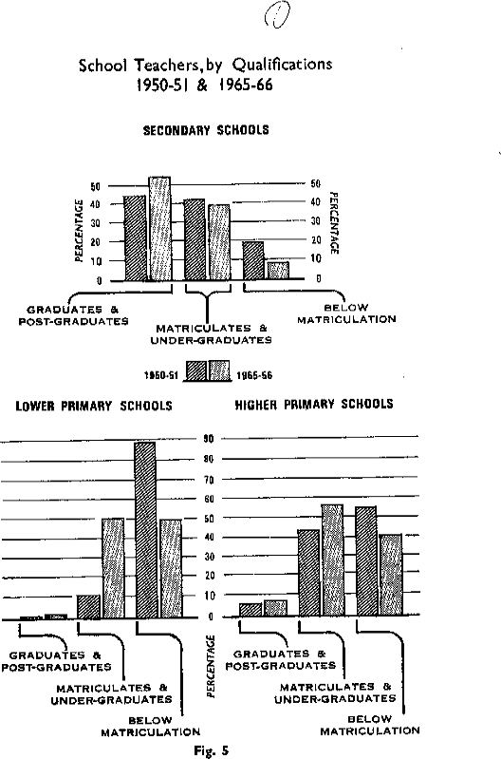

TABLE 4.2. NUMBER AND PERCENTAGE OF TRAINED TEACHERS IN THE STATES (1965-66)

Name of State Total number of teachers and percentage

 | Secondary stage | Higher primary stage | Lower primary stage
1. Andhra Pradesh | 34,215 | 15,625 | 86,501
 | (82.4) | (80.5) | (90.0)
2. Assam | 9,210 | 14,810 | 37,500
 | (18.6) | (22.4) | (55.0)
3. Bihar | 24,398 | 32,918 | 99,663
 | (50.2) | (72.5) | (82.7)
4. Gujarat | 22,290 | 83,640 | Included
 | (66.4) | (61.4) | under higher primary
5. Jammu & Kashmir | 4,613 a | 3,467 a | 4,874 a
(25.6) (54.2) |  |  | (54.0)
6. Kerala | 22,031 | 39,406 | 59,703
 | (89.0) | (82.7) | (93.0)
7. Madhya Pradesh | 197,006 | 27,961 b | 679,096
 | (69.0) | (72.0) | (80.0)
8. Madras c | 48,194 b  (86.3) | 59,440 b  (93.1) | 76,638 b  (96.7)
9. Maharashtra | 48,590 | 151,500 | Included
(71.4) (74.8) |  |  | under higher
 |  |  | primary
10. Mysore | 10,334 | 91,952 | Included
 | (59.5) | (59.9) | under higher primary
11. Nagaland | 309 | 745 | 1,764
 | (15.9) | (8.7) | (20.3)
12. Orissa | 8, 461 b  (52.0) | 10,322 b  (31.0) | 48,339 b  (60.0)

13. Punjab | 26,234 b  (96.0) | 14,911 b  (88.0) | 34,863 b  (89.0)
14. Rajasthan | 12,671 b | 18,352 b | 41,600
 | (60.0) | (71.0) | (75.0)
15. Uttar Pradesh | 33,311 | 46,819 | 162,472
 | (81.9) | (87.1) | (73.5)
16. West Bengal d | 40,238 | 12,041 | 98,306
 | (35.6) | (16.3) | (38.3)

Source. Furnished by Directors of Education.
N.B. Figures in parentheses indicate the percentages of trained teachers.

a. Figures relate to 1961-62. Taken from the memoranda of the State Government to the Education Commission.
B. Figures are estimated.
- Figures relate to 1964-65.
- Figures relate to 1963-64.

or receives such training within three years. It would, therefore, be necessary for each State to prepare a plan for the expansion of training facilities after taking into consideration all relevant factors including the need for in-service education.

In preparing these plans, the following points should be kept in view: (1) Expansion of Facilities. The objective should be to so expand training facilities that, by the end of the Fourth Plan, the output of trained teachers in any given year would be equal to the demand for additional teachers in the following year.

- Part-time Facilities. As large a part as possible of the total training facilities needed should be provided in full-time training institutions of large size. However, as the capital costs of this programme are very heavy, it may not be possible to provide all the facilities needed on a whole-time basis. The policy to be adopted, therefore, should be to ensure that the quality of full-time institutions is not diluted and that supplementary facilities are provided through such measures as the following:

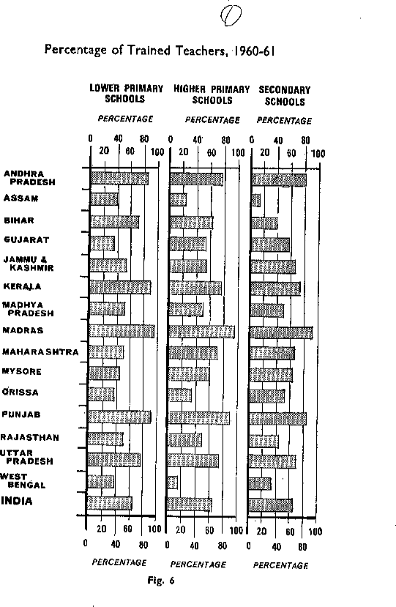

  - CORRESPONDENCE EDUCATION. In each State, at least one centre for correspondence education should be established, preferably in the State Institute of Education. It should provide pre-service courses and, in addition offer courses of in- service education for all teachers.

  - EVENING OR PART-TIME COURSES. In all big cities of 100,000 or more, the number of teachers would be large enough to justify the institution of part-time or evening courses. Those facilities would be of great value in clearing the backlog of untrained teachers.

- Clearance of Backlog. Another important objective of the plan should be to clear up the backlog of untrained teachers as early as possible, preferably within a period of five years. We collected data from 29 districts about the age-wise break-up of untrained teachers according to age-groups and the results are given in Table 4.3.

It will be seen that the bulk of the untrained teachers are below the age of 30 years. The proportion of teachers above the age of 40 years is comparatively very small. It would, therefore, be desirable to relate the policies with regard to the training of these teachers, partly to their age and partly to the total service they have put in. From this point of view, we make the following recommendations:

  - There is hardly any purpose in compelling teachers above the age of 40 years to undergo the full period of training. We recommend that, if they have had at least five years of service, they may be given only a short course and deemed trained.

  - Teachers below 40 years of age, who have put in at least 5 years

TABLE 4.3. UNTRAINED TEACHERS BY AGE-GROUP (1965)

Age Percentage of untrained teachers in the age-group

Lower primary | Higher primary | Secondary
schools | schools | schools

Men Women Men Women Men Women

Below20 | 8.9 | 11.9 | 11.0 | 9.0 | 2.9 | 2.5
21-25 | 40.7 | 31.7 | 30.1 | 30.3 | 40.3 | 51.0
26-30 | 23.2 | 23.8 | 26.9 | 27.6 | 29.8 | 30.6
31-35 | 11.6 | 13.7 | 13.7 | 15.3 | 12.7 | 8.8
36-40 | 6.5 | 7.9 | 8.9 | 8.6 | 7.8 | 4.0
41-45 | 3.7 | 5.0 | 4.0 | 4.5 | 2.6 | 1.6
46-50 | 2.4 | 3.1 | 2.5 | 2.7 | 1.6 | 0.9
51-55 | 1.9 | 2.2 | 1.9 | 1.2 | 1.2 | 0.2
56-60 | 0.9 | 0.7 | 0.9 | 0.6 | 0.9 | 0.5
Above60 | 0.2 | .. | 0.1 | 0.2 | 0.2 | ..
TOTAL PERCENTAGE
 | 100.0 | 100.0 | 100.0 | 100.0 | 100.0 | 100.0
Source. Data supplied by State Governments.

of service, need not be required to undergo the full training course. A shorter course, specially designed for the purpose, would be adequate.

  - Teachers below the age of 40 years, who have put in less than 5 years of service should, however, be required to undergo the full training course of one or two years. It would, of course, be open to these teachers to take this training either in full-time courses or through part-time and correspondence courses, in accordance with the arrangements made.

In our opinion, a flexible programme of this type would make it possible to clear the back-log of untrained teachers more quickly.

- Size of the Institutions. With a view to ensuring economy and efficiency, training institutions should be of a fairly large size. The minimum size of a training institution at the primary stage offering a two-year course should be 240 and that at the secondary stage should be 200. Existing institutions should be raised to this size, in a programme of about five years, by expansion and/or amalgamation. With regard to new institutions which are proposed to be established, the minimum size should not be less than 400. The classes for the training of primary teachers attached to secondary schools as well as teacher education departments attached to colleges of arts and science, should be abolished and replaced by large-size training institutions.

- Location. In planning the existing training facilities for teachers, it is necessary to pay attention to a number of factors. A certain proportion of the institutions, especially those at the primary stage, will have to be located in rural areas and the practice-teaching of the teachers suitably arranged in the schools in the neighbourhood. It would also help greatly to break the isolation of teacher-training if the responsibility for a teacher-training programme is accepted by a variety of institutions. For instance, we would very much like an IIT to start a teacher-training wing as a part of its programme. The same could be done by the agricultural universities. Programmes of this type will give a status and a broader basis for the training of teach- ers. Besides, it will also help to give education an orientation to agriculture and industry.

CONTINUING PROFESSIONAL EDUCATION OF TEACHERS

  - The Role of the School. In all professions there is a need to provide further training and special courses of study, on a continuing basis, after initial professional preparation. The need is most urgent in the teaching profession because of the rapid advance in all fields of knowledge and continuing evolution of pedagogical theory and practice. The programme will have to be developed through a number of agencies. The first is the school itself which must provide opportunities to the new teacher to learn from his experience and through consultation and discussion with experienced teachers in the school. The head and the senior teachers have a special role to play in providing guidance to the new teacher through planning his work and through organizing suitable activities

such as staff study circles and discussion groups. Education Departments, training colleges and teachers' organizations can also play a significant role in this programme.

  - Part-time and Whole-time In-service Education. Apart from what the schools and other agencies can do, there is need for the organization of a large scale, systematic and coordinated programme of in-service education, so that every teachers would be able to receive at least two or three months of in-service education in every five years of service. The curriculum of these programmes should be planned and organized systematically, materials being developed with great care and the staff in charge being properly oriented. Good textbooks and source books, audio-visual material and children's work should be exhibited. This can be done only if, over a period of 10-15 years, every training institution-pre-primary, primary and secondary- is staffed and equipped to take up extension work, institutes an advisory service for teachers, and organizes in-service training programmes such as refresher courses, seminars, workshops and summer institutes. Every training institution should work on a 12-month basis with proportionate provision for additional staff and facilities. In addition, institutions that will carry out in- service work on a whole-time and continuing basis should be established.

  - In-service Education of School Teachers. Very little is being done for the in- service education of primary teachers. This programme needs great emphasis. With regard to secondary teachers, one of the most recent developments is the organization of summer institutes and the role played therein by the universities. These will have far- reaching consequences on the whole field of teacher education. The programme needs very large expansion and has to become an integral part of the annual work of the universities and schools. In this context, the following suggestions are made:

- Arrangements are needed for systematic follow-up after a long-term seminar, course or summer institute. The organizers and resource personnel should keep in touch with teachers who participate in the programmes, and teachers should report the new activities that have been undertaken, the results achieved and the difficulties met with. A news bulletin may be published to facilitate exchange of ideas or experiences.

- There should be active collaboration and coordination among the agencies concerned with in-service education and those responsible for school education. The impact of summer institutes organized during the last three years would have been stronger if the collaboration of the Education Departments and the Boards of Secondary Education had been available and modifications had been devised in the curricula, syllabuses and the external examinations to reflect the new trends.

- Continuing in-service education of teachers needs the support of research in education. The results of research should flow down to the classroom teacher and stimulate him for experimentation in his work. Similarly, the problems of the classroom must climb up to research institutions for an effective and practicable solution. This two- way traffic could be considerably stimulated by the summer institutes and the State Institutes of Education.

  - Professional Preparation of Teachers in Higher Education. The preparation of teachers for higher education is a responsibility of the universities themselves and recommendations on this subject are discussed in the chapters dealing with higher education. We confine our discussion here to their professional training.

  - There is at present no provision for the professional initiation of a university teacher. A lecturer is generally expected to take on his full load of teaching work-and sometimes even more-from the first day of his appointment. He generally receives no initiation into his duties and no orientation to his profession. He is given no time for adaptation and no chance to watch the good senior teachers taking their classes. He has no prescribed opportunity to study the syllabus, plan lectures, consult the head of his department or other senior colleagues about them, or to study the techniques of seminars and tutorial classes. He even lacks at times the knowledge of the mechanics of his profession and does not know how to set question papers or to mark answer books. In this atmosphere of almost total neglect, the new teacher is too often content to copy mechanically the methods and procedures adopted by his own teachers and inflict them on his students. Thus, by and large, the dull pointless tradition of 'giving lectures' and dictating notes has passed on from generation to generation. The incalculable loss involved in this unimaginative approach can and should be avoided.

  - The tradition in India has been to regard training for college lecturers as unnecessary. Born teachers who can dispense with training certainly exist. Many are keen, devoted scholars, whose scholarship may win over the respect of the students- though this is not always a safe presumption-and may thus be able to discharge their function satisfactorily in spite of professional inadequacy. But the bulk of teachers unfortunately do not fall into these categories. For them some suitable form of training and orientation is essential, not only to overcome their initial 'teaching' troubles and to create a sense of confidence, but also to give them a reasonable understanding of educational objectives and purposes, the raison d'etre and place of their special subject in the curriculum, of new methods and techniques of teaching and learning, and a knowledge of psychology on which good teaching should be based. No question of amour propre should be involved. In most highly skilled professions-and education is certainly one-training is regarded as an essential qualification.

  - We do not think it necessary, however, to propose that full- fledged training colleges should be established for college lecturers, though we do not rule out this possibility. For the present we suggest that universities, individually or cooperatively, give their mind to this problem and work out practicable methods of meeting the present situation. Some measures have in fact been taken in recent years. The UGC, for example, has started a scheme of summer institutes in which teachers of different subjects are brought together under the guidance of competent professors and scholars to study the new dimensions of their disciplines. Their number is increasing and it is hoped that many more will be organized. But they are not a complete answer to the problem. In a few colleges, special lecture courses have occasionally been organized for this purpose and have proved useful. Some universities have instituted special postgraduate diplomas to meet these

needs. These, however have only a marginal effect on a problem for which more massive and imaginative measures are needed.

  - A few suggestions are made here in the hope that universities will draw up their own programmes for the orientation of their teachers, taking these suggestions into consideration:

- Newly appointed lecturers should be given some time and opportunity to acclimatize themselves to the institution, to learn the traditions and pattern of work, to get to know their colleagues and students. They should be expected to study the syllabus carefully, to prepare a detailed programme for the teaching work they propose to undertake, to draw up their schemes of lectures, consult the library and select books to be recommended to students. They should discuss these with the heads of their departments or other senior colleagues and invite their suggestions. The head of a department who is not interested in this work and is not prepared to give new teachers his help, guidance and time is unworthy of his position.

- They should be encouraged to attend the lectures of some senior teachers of their subject and study their methods of teaching and ways of handling their students. After the lecture, the senior teacher can discuss his methods and techniques with his junior colleagues who should be free to express their opinions and raise questions. If this is done, they would not mind if later the head of the department or some other senior colleague visits their classes. It is wrong to think that such visits are derogatory and should be avoided. If the college community is a fellowship of learning, such interchange of visits should be acceptable.

- Every university and, where possible, every college, should have regular orientation courses organized for a few weeks early in the session in which some new and some older teachers participate. The best teachers of the institution-as well as some distinguished teachers from outside should discuss with them the outstanding problems of teaching, research and discipline as well as the mechanics of the profession. During such courses new teachers will be able to make social and academic contacts and find their feet in their new environment. They will learn to feel at home in the college, accept some of its ideals and traditions and come into contact with well- known teachers of their own institution and from outside. Care should be taken to associate with these courses only such persons as enjoy a high reputation in the academic community for their scholarship and character and are likely to exercise a beneficial influence on new members.

- It may be possible, in the bigger universities or a group of universities, to place these activities on a permanent and continuing basis by establishing something like a staff college where teachers from all affiliated and constituent colleges as well as the university will be brought together for orientation, discussions, seminars, workshops, etc. Where this is not possible, a conference centre would be necessary to facilitate discussion of the issues which teachers have to face, e.g., objectives of education, methods of teaching, enrichment of subject-matter, etc. The staff college or conference centre should

also produce, in cooperation with other members of the faculty, occasional brochures, book-lists, guidance materials, etc., of use to all teachers.

MAINTENANCE OF STANDARDS IN TEACHER EDUCATION

  - Need for Organizations at the State and National Levels. Institutions that prepare teachers for the primary and secondary schools show a bewildering variety of courses, conditions of work, and quality of teachers turned out. It is unfortunate that there is no organization, at the State or national level, for ensuring standards in teacher education. The need for such organizations is increasingly realized and a number of suggestions have been put forward. It has been proposed that the National Association of Teacher Educators, whose main concern is with the improvement of teacher education at all levels, may be entrusted with this responsibility. While we recognize the useful role this Association can play in raising standards in teacher education, and have, therefore, proposed its representation on the Standing Committee of the UGC, whose role and functions are discussed later, we think that the Association, by itself, will not be able to fulfil this task. It has been suggested that special statutory organizations should be set up both at the national and State levels. We do not favour this idea because such bodies will tend to isolate teacher education from general academic life. In our opinion, the UGC on whom lies the responsibility for the maintenance of standards in higher education, should also be responsible for the maintenance of standards at the national level in teacher education and discharge it through its Standing Committee on Teacher Education discussed in paragraph 4.65. This will meet the principal objective of our proposals of bringing education within the mainstream of university academic life. At the State level, raising of standards should be the responsibility of the State Boards of Teacher Education discussed earlier, working in collaboration with the UGC.

  - The Role of the Centre. Since teacher education is vital for improving standards in all education, the Government of India should assume a special responsibility for improving teacher education and providing liberal funds for it, both in the Central and in the centrally sponsored sectors. The expansion of the Central sector can be done through the UGC and we recommend that substantial allocation of funds should be made for teacher education in the Fourth Five Year Plan and placed at the disposal of the UGC. Such allocations will have to be increased and continued in later Plans.

  - In order to discharge this responsibility adequately, the UGC should, in collaboration with the NCERT, set up a joint Standing Committee on Teacher Education. The Committee should consist Of- (1) Representatives of the UGC and the NCERT; (2) Representatives of universities; (3) Representatives of State Boards of Teacher Education by rotation; (4) School teachers including at least one primary teacher; (5)
Representatives of teachers' organizations; (6) Educationists; and

- A representative of the National Association of Teacher Educators. The Standing Committee on Teacher Education should be concerned with all aspects of teacher education, general and professional, at both the undergraduate and postgraduate levels. It should have the power

  - to develop and establish standards for training institutions and university departments;

  - to coordinate and improve standards of teacher education at all levels;

  - to advise universities and State Departments of Education regarding programmes, curricula, textbooks and qualifications of staff of training institutions at all levels;

  - to grant funds to teachers colleges, departments or schools of education in the universities;

  - to arrange for periodical inspection of training institutions and university departments of education; and

  - to develop and support financially, in cooperation with the universities or State Departments of Education, programmes for the in-service improvement of teacher educators and teachers, both in subject-matter and in professional qualification and skill.

  - In addition to these programmes, the Government of India will have to provide liberal funds in the Centrally sponsored sector to assist State Governments to develop teacher education programmes on the lines recommended. Some of the special programmes that need emphasis are the upgrading of training institutions for primary teachers to the university standard, improvement programmes of train- ing institutions at all levels, correspondence education, in-service education, and the establishment of training institutions of large size.

SUMMARY

- The professional preparation of teachers, being crucial for the qualitative improvement of education, should be treated as a key area in educational development and adequate financial provision should be made for it, both at the State and national levels. 4.01

- Removing the Isolation of Teacher Training. In order to make the professional preparation of teachers effective, teacher education must be brought into the mainstream of the academic life of the universities on the one hand and of school life and educational developments on the other. 4.03

- (1) To remove the existing isolation of teacher education from university life-

  - education, as distinguished from pedagogy, should be recognized as an independent academic discipline and introduced as an elective subject in courses for the first and second degrees; and

  - schools of education should be established in selected universities to develop programmes in teacher education and studies and research in education, in collaboration with other university disciplines. 4.04-05

- To remove the existing isolation of teacher education from schools-

- extension work should be regarded as an essential function of a teacher-training institution and an Extension Service Department should be established in each institution- pre-primary, primary and secondary-as an integral part of it;

- effective alumni associations should be established to bring old students and faculty together to discuss and plan programmes and curricula;

- practice-teaching for teachers under training should be organized in active collaboration with selected schools which should receive recognition from the Education Department as cooperating schools and special grants for equipment and supervision; and

- periodic exchange of the staff of the cooperating schools and of the teacher-training institutions should be arranged. 4.06-09 (3) An intensive effort should be made to remove the existing separation among the institutions preparing teachers for different stages of education or for special fields such as craft or art or physical education by-

- implementing a phased programme of upgrading all training institutions to the collegiate standard with the ultimate objective of bringing all teacher education under the universities;

- establishing comprehensive colleges of education in each State on a planned basis;

- establishing a State Board of Teacher Education in each State to be responsible for all functions related to teacher education at all levels and in all fields. 4.10-12

- Improving Professional Education. The essence of a programme of teacher education is 'quality' and in its absence, teacher education becomes, not only a financial waste but a source of overall deterioration in educational standards. A programme of highest importance therefore is to improve the quality of teacher education. This can be done through-

(1) organization of well-planned subject-orientation or content courses, in collaboration with university departments (or postgraduate colleges), leading to insight into basic concepts, objective' and implications of subjects to be taught; 4.14-17 (2) introducing integrated courses of general and professional education in universities; 4. 1 8-20

- vitalizing professional studies and basing them on Indian conditions through the development of educational research; 4.21-22

- using improved methods of teaching which leave greater scope for self-study and discussion and improved methods of evaluation which include continuous internal assessment of practical and sessional work as well as practice-teaching; 4.23-24

- improving practice-teaching and making it a comprehensive programme of internship;
4.25 (6) developing special courses and programmes; and 4.26 (7) revising the curricula and programmes at all levels of teacher education in the light of the fundamental. objectives of preparing. teachers for their varied responsibilities in an evolving system of' education. 4.27-32

- Duration of Training Course. The duration of the professional courses should be two years for primary teachers who have completed the secondary school course. It should be one year for the graduate students; but the number of working days in a year should be increased to 230. 4.15

- The State Boards of Teacher Education should conduct a survey of teacher education programmes and curricula and initiate the necessary revision. 4.34

- New professional courses must be developed to orientate head- masters and teacher educators to their special field of work. 4.26 8

The postgraduate courses in education should be flexible and be planned to promote an academic and scientific study of education and to prepare personnel for specific fields requiring special knowledge and initiation. The duration of the courses should be increased to three terms. Quality is crucial at this stage and only institutions having properly qualified staff and facilities should be allowed to conduct them. 4.35-39

- Improving the Quality of Training Institutions. Early steps should be taken to improve training institutions for teachers on the following lines:

- Secondary Teachers. (a) The staff of secondary training colleges should have a double Master's degree in an academic subject and in education. A fair proportion of them should hold doctorate degrees. They should aft have taken induction or orientation courses in teacher education.

- Qualified specialists in subjects like psychology, sociology, science or mathematics may be appointed on the staff even if they have not had professional training.

- Summer institutes should be organized for the in- service training of staff.

- No student should be allowed to specialize in the teaching of a subject unless he has studied it for his first degree or obtained an equivalent qualification prior to training.

- States and Union Territories should adopt a rule that teachers in secondary schools will ordinarily teach only those subjects which they had studied for a university de- gree. if they are required to teach subjects other than those they have studied, they should take a special course therein either by correspondence or in the summer institutes. Attempts should be made to recruit first and good second class students to teacher-training institutions and adequate scholarships should be provided for them. 4.41-44

- Primary Teachers. (a) The staff in institutions for training primary teachers should hold a Master's degree either in Education or in an academic subject as well as B.Ed. and should have undergone special induction courses in teacher education at the primary level.

- New appointments of primary teachers should be restricted to those who have completed at least ten years of general education; exceptions may be made for women teachers and teachers in tribal areas.

- Correspondence courses and liberal concessions for study leave should be made available to unqualified teachers in primary schools to improve their qualifications.

- Special courses should be organized for graduates entering primary teaching.

- The duration of the training course for primary teachers should be uniformly two years for those who have completed the secondary school course. Teachers with different educational qualifications should not be put into the same course. 4.45-50

- General. It is necessary to introduce the following reforms in training institutions for primary as well as secondary teachers:

  - AR tuition fees in training institutions should be abolished and liberal provision made for stipends and loans.

  - Every training institution should have an experimental or a demonstration school attached to it.

  - Adequate hostel facilities for trainees and residential accommodation for staff should be provided.

  - Libraries, laboratories, workshops, etc., are very inadequate at present in most institutions, especially at the primary level. These need to be improved. 4.51-53

- Other Teachers. Reforms on the above lines should be carried out in the training programmes for other categories of teachers. 4.40

- Expansion of Training Facilities. The training facilities should be expanded on a priority basis. The objective should be to ensure that every teacher in a primary or a secondary school is either already trained at the time of his appointment or receives such training within three year, of his appointment. From this point of view:

  - each State should prepare a plan for the expansion of training facilities in its area so that the output of trained teachers meets the demand for teachers as well as the needs for in-service education;

  - part-time facilities and correspondence courses should be provided on a large scale and care should be taken to see that the standards in full-time institutions are not diluted;

  - the backlog of untrained teachers should be cleared at an early date through measures of the type recommended in the Report;

  - the size of the institutions should be fairly large and they should be located on a planned basis. 4.54

- In-Service Education of School Teachers. (1) A large-scale and coordinated programme of in-service education for teachers should be organized by universities, training institutions and teachers organizations for teachers at all levels. The target should be that every teacher receives at least two or three months in-service education in every five years of his service.

(2) The programme of summer institutes for the in-service training of secondary school teachers should be extended, with systematic follow-up and active collaboration among the agencies concerned. 4.55-57

- Professional Preparation or Teachers in Higher Education. (1) Some orientation to professional education is necessary for junior lecturers in higher education and suitable arrangements should be made for the purpose.

- Newly appointed lecturers should be given some time to acclimatize themselves to the institution and should be encouraged to attend lectures of good teachers.

- Regular orientation courses for new staff should be organized in every university and, where possible, in every college.

- In the bigger universities, or groups of universities, these courses may be placed on a permanent basis by establishing a staff college. 4.58-62

- Standards in Teacher Education. (1) At the national level, the UGC should take the responsibility for the maintenance of standards in teacher education. The State Boards of Teacher Education should be responsible for the raising of standards at the State level.

- A substantial allocation of funds should be made available to the UGC in the Fourth Five Year Plan for improvement in teacher education in the universities.

- The UGC should set up a joint standing committee for teacher education in collaboration with the NCERT. It should consist of competent persons from the profession and should be responsible for the maintenance of standards in teacher education.

- The Government of India should make provision of funds in the Centrally sponsored sector to assist State Governments to develop teacher education which is now outside the universities. 4.63-66

CHAPTER V ENROLMENT AND MANPOWER

  - A National Enrolment Policy. One of the major programmes in national reconstruction is the development of our human resources, and in this there can be no limit to the education to be provided. But in any given society and at a given time, the decisions regarding the type, quantity and quality of educational facilities depend partly upon the resources available and partly upon the social and political philosophy of the people. Poor and traditional societies are unable to develop even a programme of universal primary education. But rich and industrialized societies provide universal secondary education and expanding and broad-based programmes of higher and adult education. Feudal and aristocratic societies emphasize education for a few. But democratic and socialistic societies emphasize mass education and equalization of educational opportunities. The principal problem to be faced in the development of human resources, therefore, is precisely this: How can available resources be best deployed to secure the most beneficial form of educational development? How much education, of what type or level of quality, should society strive to provide and for whom?

  - India has committed herself to the creation of a democratic and socialistic pattern of society. The fundamental principles that should guide the provision of facilities at the different stages and sectors of education, therefore, may be stated as follows:

- to provide effective general education of not less than seven years' duration to every child, on a free and compulsory basis, and to expand lower secondary education on as large a scale as possible;

- to provide higher secondary and university education to those who are willing and qualified to receive such education, consistent with the demands for trained manpower and the need to maintain essential standards; and to provide adequate financial assistance to those who are economically handicapped;

- to emphasize the development of professional, technical and vocational education and to prepare skilled personnel needed for the development of agriculture and industry;

- to identify talent and to help it grow to its full potential;

- to liquidate mass illiteracy and to provide an adequate programme of adult and continuing education; and

- to strive continuously to equalize educational opportunities, beginning with the elimination of at least some of the more glaring inequalities.

In this chapter, we shall briefly discuss some of the major implications of these policies.

ENROLMENT POLICIES AT DIFFERENT STAGES OF EDUCATION

  - Increasing the Educational Level of Citizens. In the next two decades the highest priority must be given to programmes aimed at raising the educational level of the average citizen. Such programmes are essential on grounds of social justice, for making democracy viable and for improving the productivity of the average worker in agriculture and industry. The most crucial of these programmes is to provide, as directed by Article 45 of the Constitution, free and compulsory education of good quality to all children up to the age of 14 years. In view of the immense human and physical resources needed, however, the implementation of this programme will have to be phased over a period of time. This can be done

- by providing five years of effective education to all children by 1975-76 and seven years of such education by 1985-86;

- by making part-time education for about one year compulsory for all children in the age-group, 11-14 who have not completed the lower primary stage and are not attending schools. The aim will be to make these children functionally literate and stop all further additions to the ranks of adult non-literates; and

- by efforts to liquidate adult illiteracy.

The second and the third programmes are transitional. But the first needs great emphasis as the only permanent solution of the problem. We discuss the details of these programmes elsewhere.³⁹

  - Provision of Secondary and Higher Education. Several complex problems relating to the amount, type and quality of education to be provided arise in respect of secondary and higher education. It is not easy to determine the size of total enrollments in the absence of clear and precise targets about overall expansion rates. Moreover, as education at these stages has to be diversified into a large number of courses to meet varied individual aptitudes as well as social requirements for trained manpower it becomes even more difficult to decide the precise extent of provisions for each course. Unfortunately, an understanding of these problems is still limited. Enrolment policy must, capacity of the society to provide the educational facilities needed at given levels of quality; and manpower needs for national development.

  - Public Demand for Secondary and Higher Education. During recent years, the demand for secondary and higher education has increased enormously. There are several reasons for this, such as:

- the traditional social status attached to a university degree;

³⁹Chapters VII and XVII.

- the growing hunger for education among the urban people and the middle classes who have realized that the best, and probably the only worthwhile legacy they can leave to their children, is to give them good education;

- the awakening among the rural people and the lower classes who are now seeking social advancement-just as the urban and middle classes did during the last hundred years- through education and government service;

- the disappearance of the old values' attached to primary education which makes secondary education the 'minimum' and higher education the 'optimum' qualification for any worth- while job;

-the absence of adequate employment opportunities for young persons so that many of them are forced to go in for secondary or university education simply because they have nothing else to do;

-the increasing provision which is being made by State Governments for free secondary education and for the liberal grant of free studentships, stipends and scholarships at the university stage; and

-a rapid multiplication of educational institutions at this level which has made them easily accessible to young persons in thousands of small and out-of-the-way places.

  - This situation could have been met in two ways, either by expanding facilities in secondary and higher education strictly on the basis of available real resources in terms of teachers and materials and adopting a policy of selective admissions to bridge the gap between the public demand for such education and the facilities actually provided, or by adopting a policy of open-door access and providing all the resources needed to create the required facilities and to maintain them at the optimum level of efficiency. But as it was neither possible to resist the demand nor to raise all the needed resources, a compromise approach was attempted: the access to all secondary education was provided on an open- door basis; and in higher education, both the selective and open-door policies were operated upon simultaneously in different sectors.

  - This policy has had several undesirable consequences. As overall resources were limited and were absorbed in programmes of expansion of general education, it became impossible to pay adequate attention to programmes of qualitative improvement or vocationalization. Most of this expansion has also been non-egalitarian since secondary schools and colleges enrolled students who had access to them and who could afford the expenditure involved, although their preparation and motivation were often inadequate. On the other hand, they failed to enroll a large proportion of talented students who were prevented from studying further by social or economic handicaps. The benefits of expansion thus went largely to the privileged rather than to the under-privileged classes. Moreover, there grew up an imbalance between the development of general and vocational education, the former far exceeding demand and the latter generally falling much below it. Consequently, the output of matriculates and of graduates in arts and

commerce was in excess of demand and created problems of educated unemployment while trained personnel for the development of agriculture, industry or research remained in short supply.

  - During the next two decades, the demand for secondary and higher education will increase still further as primary education becomes universal and the general economic conditions improve. Under these circumstances, a continuation of the earlier enrolment policies will merely accentuate these evils. It is, therefore, necessary to adopt some definite policy of 'selective admissions' so as to relate enrolments to facilities available and to maintain standards.

  - The Pool of Ability. Providing secondary and higher education to all the potentially able students generally sets up a very high target which even affluent societies find it difficult to achieve. It will be obviously beyond our reach, at least in the immediate future, in view of the limited resources available. This should, however, be the goal towards which we should continually move. In the transitional period, immediate effect should be given to one important implication of this policy, viz., to ensure that all gifted students (at least the top 515 per cent of all students), who complete primary or secondary education are enabled to study further in institutions of secondary (or higher) education. For this purpose, it will be necessary to provide a large number of scholarships on the lines to be discussed later.⁴⁰

  - Capacity to Provide Facilities. In planning enrolment facilities, it is essential to take into consideration the real resources available and the capacity of the society to create the educational facilities needed or in demand. There are internal constraints in every educational system which limit expansion of facilities, especially in secondary and higher education. These are the availability of competent teachers, of physical plant and of finance. Even in affluent societies, these built-in constraints make it almost impossible to provide all those facilities, quantitatively and qualitatively, which would be required on the basis of public demand or for the development of the total pool of ability. This is all the more so in a developing economy like our own. In trying to meet the pressures of the public demand, these constraints are often overcome by diluting standards. There are many instances where institutions have been started without the necessary teachers being available, without the needed equipment and without adequate financial allocations. This all too common practice must be resisted in the larger interests of the country. If a society

does not have the resources to meet the entire public demand for secondary and higher education, that is really unfortunate; but it would be tragic if this limitation was ignored and educational standards were thrown in jeopardy.

  - Manpower Needs. We would also like to stress the need to pay due attention to the relationship between enrolment and manpower requirements. If India is to achieve its targets of economic growth it must have an adequate supply of educated specialists for

⁴⁰See Chapter VI.

each category of job to be performed. Conversely, if there is an excess of trained people in any category, it implies an imprudent use of scarce resources and also creates difficult problems of unemployment of the educated. Even from the point of view of the individual, some matching of educational patterns and job opportunities is vital. Nothing is more frustrating than to be under-qualified or over- qualified for a job, or to be unemployed because there is no call for one's qualifications. We believe, therefore, that estimates of future manpower needs form a useful basis for regulating enrolment patterns above the primary level.

  - This broad recommendation of relating the provision of educational facilities in secondary and higher education to estimated manpower needs has to be understood in the light of some general reservations. Manpower forecasting is not a precise operation because of the large number of imponderables involved. It is, therefore, necessary to make a continuous effort to improve the collection of necessary data and the techniques of forecasting. This should be done regularly by the Central and State Governments. As manpower forecasts are ordinarily expressed in quantitative terms, the expansion of educational facilities tends to receive undue emphasis in translating them into enrolment terms. It is, therefore, essential to emphasize the quality of manpower produced because economic growth can be hindered rather' than accelerated if appropriate standards are not maintained. Moreover, manpower needs cannot be the only criterion for regulating the provision of facilities. Before final decisions are taken, its indications will have to be checked with the conclusions drawn from calculations based on the other criteria. However, even after making due allowance for these limitations, estimated manpower needs provide four broad indications in terms of magnitudes, e.g., the total enrolments needed in secondary and higher education; enrolments needed in different types of courses; shortages and surpluses in the manpower situation; and priorities involved.

  - A Strategy of Development. It will be seen from the foregoing discussion that the minimum level of expansion is provided. by the capacity to expand facilities in terms of real resources and that the public demand for secondary and higher education as well as the need to develop the available pool of talent to the fullest extent possible generally set high targets which are difficult to realize in the immediate future. The gap between these high and low targets can be bridged by considerations which emerge from manpower needs and equalization of educational opportunities. These will indicate the priorities to be adopted, the different courses of study to be developed, the extent to which facilities should be provided in the different courses and the manner in which enrolments in them could be made to include at least the best students in the community.

A FORECAST OF MANPOWER NEEDS

  - The ISI-LSE Estimates. We have recommended that educational facilities at the post-primary stage should be broadly related to manpower needs. Our task now is to forecast these needs and study their educational implications. In this, we have been fortunate in having two estimates prepared for us: one, a series of elaborate investigations carried out by the Institute of Applied Manpower Research; and the other, a part of a longer study undertaken by the Planning Unit of the Indian Statistical Institute, New

Delhi, and the Unit for Economic and Statistical Studies on Higher Education, London School of Economics, in collaboration with the Perspective Planning Division of the Planning Commission. In broad orders of magnitude, the results of the two estimates are similar; and the differences between them can generally be explained by the different assumptions used. For the main presentation of this chapter, we adopt the ISI-LSE estimates as they are more detailed, offer estimates up to 1986 and assume a higher target of economic growth. We believe that the risk involved in over-estimation is comparatively less than in under-estimation and that it is less harmful to have some surplus trained personnel on hand for some time rather than hold up the progress of agriculture or industry for lack of such personnel. At any rate, precise figures are less important than broad directions of policy. On this, both estimates largely agree.

  - Manpower (1961). We must first explain briefly the manner in which these estimates have been made. The starting point in the preparation of these estimates is provided by the country's stock of educated manpower in 1961 (derived from the 1961 Census and a special tabulation of the National Sample Survey, 16th round), expressed in terms of workers with matriculate, intermediate and degree qualifications. This is shown in Table 5.1.

  - Broadly there were 5.2 million workers with qualifications equivalent to matriculation and above, two-thirds of them in towns and the rest in rural areas. Over half of these were employed in 'other' services (public administration, education and so on). About one in five of them (1.1 million) were also graduates, and these were even more heavily concentrated in the service occupations. Only some 100,000 were in manufacturing industries.

  - Future Requirements of Educated Manpower. The question we must ask is how these numbers may be required to grow in the future. How many matriculate and graduate workers should there be in 1976 and 1986 ? Two broad methods have been used to answer these questions, one for services, in which many educated people are employed, and one for the other sectors of the economy.

  - To take the latter first, it has been assumed that, as net output in each sector and in each branch of manufacturing industries increases, so proportionately will be the employment of educated manpower. The targets for economic growth assumed in these estimates, for the economy as a whole and for each sector, are those proposed by the Perspective Planning Division of the Planning Commission. The overall growth targets are 6.6 per cent a year from 1961 to 1976

TABLE 5.1. MATRICULATES, INTERMEDIATES, GRADUATES AND TOTAL WORKERS, BY INDUSTRY: INDIA (1961)
(Thousands)

Industry group | Below Matric | Matri- culates | Inter- mediates | Gra- duates | Total Workers
1. Agriculture | 130,648 | 381 | 46 | 67 | 131,142
2. Mining, etc. | 5,143 | 68 | 5 | 6 | 5,222
3. Manufacturing | 19,377 | 436 | 89 | 104 | 20,006
4. Construction | 1,911 | 99 | 30 | 19 | 2,059
5. Trade and Commerce | 7,009 | 452 | 101 | 92 | 7,654
6. Transport and Commun-
ications | 2,528 | 318 | 80 | 93 | 3,019
7. Services (Other) | 16,895 | 1,509 | 405 | 765 | 19574
Public services | 3,711 | 722 | 245 | 296 | 4,974
Educational
Services | 1,584 | 467 | 103 | 289 | 2,443
Medical and health
services | 765 | 124 | 27 | 48 | 964
Religious and welfare
services | 1,082 | 38 | 6 | 26 | 1,152
Legal services . | 119 | 39 | 1 | 60 | 219
Business, trade,
labour association
Recreation, personal
and other services | 9,443 | 81 | 18 | 37 | 9,579
TOTAL | 183,511 | 3,262 | 756 | 1,147 | 188,676
 |  |  |  |  | (Percentage)
1. Agriculture | 99.6 | 0.3 |  | 0.1 | 100.0
2. Mining, etc. | 98.5 | 1.3 | 0.1 | 0.1 | 100.0
3. Manufacturing | 96.9 | 2.2 | 0.4 | 0.5 | 100.0
4. Construction | 92.8 | 4.8 | 1.5 | 0.9 | 100.0
5. Trade and Commerce | 91.6 | 5.9 | 1.3 | 1.2 | 100.0
6. Transport and
Communications | 83.7 | 10.5 | 2.7 | 3.1 | 100.0
7. Services (Other) . | 86.3 | 7.7 | 2.1 | 3.9 | 100.0
TOTAL | 97.3 | 1.7 | 0.4 | 0.6 | 100.0

Source. ISI/LSE Paper.
Note. The totals do not tally on account of rounding.

and 7.0 per cent for the whole period of 1961 to 1986. Within these overall targets, sectoral targets naturally vary-from 11.85 per cent (factory establishments including power supply) and 11.24 per cent (construction) to 3.86 per cent (agriculture) in the period 1961-76. Projecting the growth of output in each separately allows for shifts in patterns of employment and reveals demands for educated workers in fast-growing highly technical industries which would be lost in a simple overall growth rate.

  - Within services, each major service has been treated separately. In 1961, a quarter of employed matriculates and a similar proportion of employed graduates were in public administration and defence.

It is assumed that these will increase at four per cent a year. The need for teachers is derived from enrolment estimates and assumptions about pupil-teacher ratios and teachers' qualifications. The need for medical personnel distinguishes doctors, nurses and auxiliary personnel. The targets chosen imply one doctor per 3,000 population in 1975-76 and one per 2,000 in 1985-86, and similar numbers of fully trained nurses. The estimates for both educational and medical personnel take direct account of population growth and national income. Of the remaining services, legal and business services may grow as fast as the economy as a whole; recreational and personnel services perhaps less fast. For the combined remaining services, a growth of 3 per cent a year has been assumed up to 1976 and of 5 per cent thereafter.

  - The results of these various calculations show that matriculate workers should increase from 5.2 million in 1961 to 16.6 million in 1976 and 32.6 million in 1986.
Graduate workers should increase from 1.1 million in 1961 to 3.3 million in 1976 and 6.5 million in 1986. This and other relevant details will be seen from Table 5.2.

  - Workers, Stock and Output of Educated Manpower. So far, these projections have been in terms of members workers. But not all educated people work. Some remain students, some are housewives and some remain unemployed. Broadly speaking, it has been assumed that the proportion of educated men and women who are at work will remain the same as it was in 1961. On this basis, the stocks of workers (as well as the out-turn in each category) were worked out and are given in Table 5.3. It will be seen from it that the total number of those with matriculation and above grows from 8 million to 27 million in 1976 and 56 million in 1986 (or at the rate of 8.3 per cent a year up to 1976 and 7.5 per cent in the following decade). The total number of graduates shown grows from 1.5 million in 1961 to 4.5 million in 1976 and 9 million in 19896 (or at a steady growth rate of 7.5 per cent a year, compared with 6 per cent through out the 1950s).

  - in general, the output from the educational system needed to produce this pattern of stocks should grow at the same rate as the required stock. The exception is the output of matriculates up to 1976, which grows rather faster than the required stock as the actual output in 1961 was below the required if stock targets were to be met. Overall, the annual output of matriculates should grow from 0.6 million in 1961 to 4.8 million in 1986 and that of graduates from 0.1 million to nearly 0.8 million. The percentage of each gae-

group who matriculate, should rise from 7 per cent to 27 per cent and those who graduate from 1.5 per cent to nearly 5 per cent.
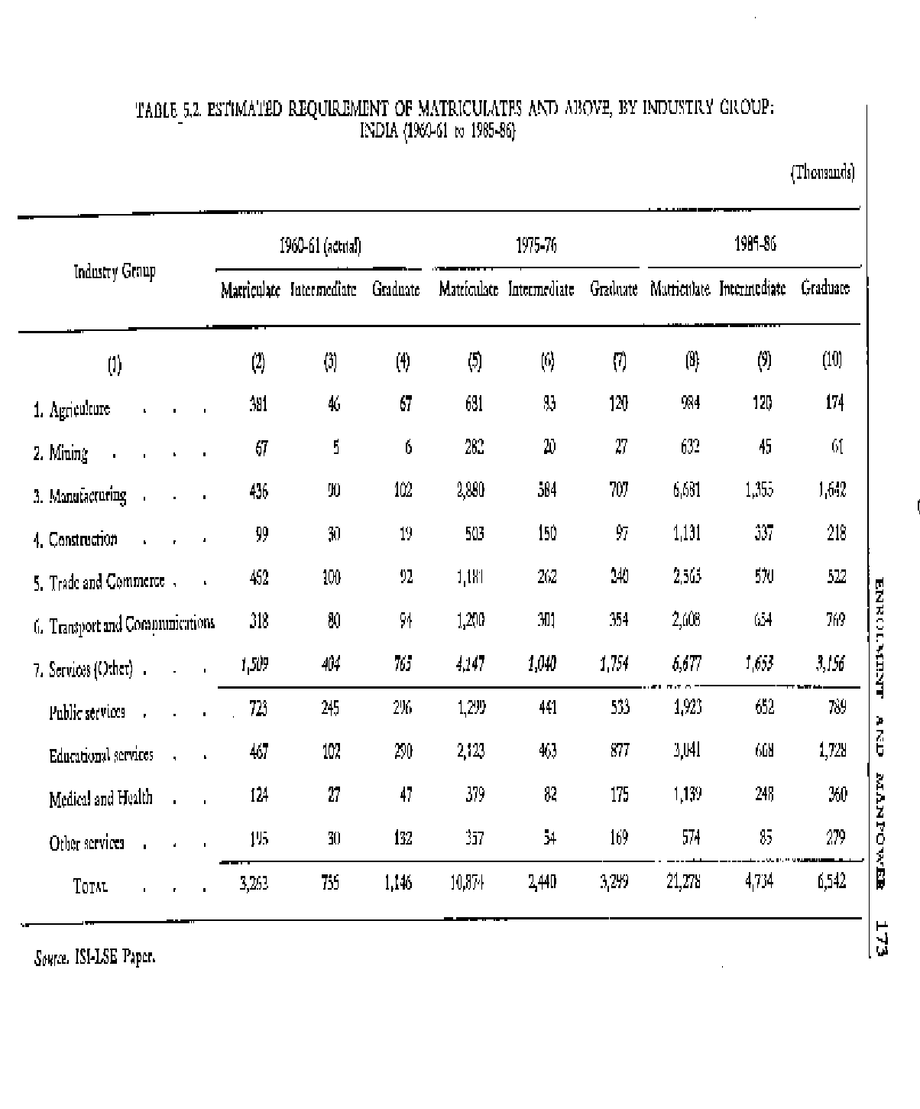

TABLE 5.3. ESTIMATES OF REQUIRED WORKERS, STOCK AND OUT-TURN OF MATRICULATES AND ABOVE: INDIA (1960-61 to 1985-86)

Thousands Annual Growth Rate 1961 1976 1986 1961-76 1976-86 1961-86

Matriculates and above

Workers | 5,164 | 16,612 | 32,554 | 8.1 | 7.0 | 7.7
Total stock | 8,227 | 27,339 | 56,223 | 8.3 | 7.5 | 8.0
Out-turn of matriculates | 623 | 2,324 | 4,779 | 9.2 | 7.5 | 8.5
 | (6.8) | (16.4) | (27.4)

Intermediates and above

Workers | 1,901 | 5,739 | 11,275 | 7.6 |  | 7.0 | 7.4
Total stock | 2,755 | 8,515 | 17,464 | 7.8 |  | 7.6 | 7.6
Out-turn of intermediates | 240 | 749 | 1,537 | 7.9 |  | 7.5 | 7.7
 | (2.8) | (5.6) | (9.1)
Graduates and above
Workers | 1,146 | 3,299 | 6,543 |  | 7.4 | 7.1 | 7.2
Total stock | 1,510 | 4,433 | 9,082 | 7.5 | 7.4 | 7.5
Out-turn of graduates | 123 | 377 | 772 | 7.7 | 7.5 | 7.6
 |  | (1.5) | (3.2) | (4.9)

Source. ISI/LSE Paper.
N.B. Figures in parentheses indicate percentages of the population in the corresponding age-groups.

  - On the other hand the proportion of those completing class VII who go on to be matriculates and graduates must fall. This is because of the very substantial expansion of

numbers in class VII as the Constitutional Directive on free and compulsory education is implemented. If the transition proportions (that is, those matriculating and graduating as a percentage of those in class VII) remain fixed even when all children complete class VII, the stocks of educated manpower would be well in excess of manpower needs. This would become especially serious from mid-1970s onwards: by 1986 there would be 4 million 'too many' matriculates and 1.5 million too many graduates.

  - In addition to these estimates for workers with broad educational levels, separate estimates have been made for engineers and agricultural graduates. These will be discussed elsewhere.⁴¹ When graduates in engineering and agriculture are taken with those in medicine and teaching and related to the total stock of graduates, they form an increasing proportion-33 per cent in 1961, 43 per cent in 1976 and 46 per cent in 1986. Comparable changes are required at lower levels.

⁴¹Chapters XII, XIV and XV.

  - Enrolments. The final stage in the calculation is to say what enrolments are implied by the out-turns required. This has been done on the basis of these observed relationships between enrolments and out-turns in 1960-61, allowance being made for our recommendations on the pattern of education, length of courses, wastages, etc. The net result is given in Table 5.4.

TABLE 5.4. ENROLMENTS PROPOSED (1960-61 to 1985-86)

 |  |  |  |  |  |  | (Thousands)
 | 1960-61 |  |  | 1975-76 |  | 1985-86
 | Enrol- |  | Passes | Enrol- | Passes | Enrol- | Passes
 | ments |  |  | ments |  | ments
Matriculation level
General : Classes
VIII/IX,IX/X, X/XI | 3,582 |  | 585 | 12,324 | 2,324 | 23,630 | 4,779
Vocational (school)^{1,2} | 119 |  | 48 | 361 | 135 | 738 | 278
TOTAL MATRICULATES | 3,701 |  | 633 | 12,685 | 2,459 | 24,368 | 5,057
Intermediate level
General : Years 1 and 11
degree course' | 597 | 208 |  | ... ... |  | ... ...
College (professional) | 80 | 35 |  | ... ... |  | ... ...
TOTAL COLLEGE | 677 | 243 |  | 2,176 | 749 | 4,460 1,537
School (vocational)

139
Engineering  Diploma | 46 | 10 | 297 | 67 | 573
Others  Teacher Training^{1,4} | 181 | 42 | 701 | 151 | 1,438
(all non-graduate) | 123 | 75 | 453 | 211 | 402

310

169
TOTAL SCHOOL¹ | 350 | 127 | 1,451 | 429 | 2,413 | 618
TOTAL INTERMEDIATE | 1,072 | 370 | 3,627 | 1,178 | 6,873 | 2,155
Undergraduate level
First degree :
Years I, II,
III and IV | 822 | 96 | ... ... |  | ... ...
Professional³ | 174 | 30 | ... ... |  | ... ...
TOTAL | 996 | 126 | 3,038 377 |  | 6,216 772
TOTAL (ENROLMENTS IN⁶
YEARS III, IV ONLY) 320 126 972 377 2,985 772

Source. ISI/LSE Paper. Notes.
- Not represented in the manpower data.

- Including some teacher training, 1960-61 only.

- First degree only (excluding degree in teaching and law).

- Excluding courses at matriculate level in 1960-61.

- Enrolment in Classes XI and/or XII and intermediate and equivalent classes.

- In 1985-86 the enrolment figure is based upon three-year course and thus represents enrolments in Years III, IV and V.

EDUCATIONAL IMPLICATIONS OF THE ESTIMATES

  - We broadly accept these forecasts, subject to periodical revision, as a basis for a national enrolment policy and invite attention to the main conclusion they indicate with regard to future educational development. These are:

    - to restrict the unplanned and uncontrolled expansion of general secondary and higher education, if massive educated unemployment is to be avoided;

    - to make special and intensive efforts to vocationalize secondary education and to develop professional education at the university stage; and

    - to devise suitable machinery, at both the national and State levels, which will relate the estimates of manpower needs effectively to the output of the educational system so that, by and large, there is some assurance that a suitably trained person would be available for every job to be done and every educated person would find a job appropriate for his education and professional training.

We shall now examine these conclusions briefly.

  - Admissions to Lower Secondary Education. In order to restrict unplanned and uncontrolled expansion of secondary and higher education, it is necessary to restrict the provision for places in accordance with manpower estimates and wherever the applicants for admission exceed the places, to make the admissions on a selective basis. At the lower secondary stage, however, which is to be regarded as completion of general education, emphasis should not be laid on ` selection' in the sense of admitting the 'fit' students and weeding out the 'unfit'. At this level, selection should be oriented more towards ` testing and guidance' than towards 'elimination'. Its main objective should be to enable a student to know his own level of achievement and his potentialities and to decide whether it would be in his interest to leave the school and enter the world of work, or to join a particular vocational course, or to continue in the stream of general education. In other words, ` selection' at this stage will be mostly 'self-selection' helped through a testing and guidance service. This service should be available to all schools in all areas, irrespective of the level of expansion of secondary education.⁴² Whether a system of more rigorous selections is needed or not in a particular area is a matter for local decision and will depend upon the needs for manpower in the area and the level of expansion already reached.

  - Admissions to Higher Secondary and University Education. Beyond the lower secondary stage, a system of selective admissions becomes inescapable in view of the limited resources available. This idea is gaining much wider support but is still opposed on certain socio-economic grounds. It is argued, for instance, that this policy would adversely affect access to higher education of the backward classes, the rural areas and under-privileged groups now entering higher education for the first time. These fears have some Justification. But the remedy is not to be sought in the continuance of the present policy of open-door access. The under-privileged sections have a very small and disproportionate share in existing facilities in spite of the unrestricted admissions. This inequality would be removed more quickly, not by continuing the present laissez- faire policy, but by adopting positive measures to promote equalization of opportunities, such as the grant of scholarships on the 'school cluster' basis recommended elsewhere.⁴³ When such measures are provided on an adequate scale and it is clearly demonstrated that they increase the proportional enrolment of the backward or under-privileged groups in institutions of higher education, opposition to selective admissions will quickly diminish and even disappear. As a transitional measure, however, these fears may be allayed, if necessary, by adopting a suitable system of reservation of seats.

⁴²The details about its organization are discussed in Chapter X. ⁴³Chapter VI.

  - It is often argued that secondary and higher education should be given to all young persons who have completed primary and secondary education and cannot find jobs and it is further contended that such asylum for them is a lesser evil than leaving them on the streets. This is an escapist attitude, commonly observed in developing and labour-surplus societies, to over-educate young persons by regarding education as a substitute rather than as a preparation for work. In industrialized and labour deficit societies, job opportunities are so plentiful that many young persons remain in school largely because of compulsory laws. As soon as the compulsory age-limit is reached, a large proportion (varying from 30 to 75 per cent) leave school and take up employment. This helps also in improving standards in educational institutions, because resources are plentiful in relation to the number of places to be provided in post- compulsory education. In developing and labour-surplus economies, on the other band, employment opportunities are so poor that 'opportunity costs' of education are very low and young people join secondary schools or colleges either because there is nothing else to do, or in the pious hope that a job may be more readily available from the raised platform of a higher education. But as resources are limited and the number of seats to be provided is larger, standards in secondary and higher education remain poor. The result, in some cases, is a negative rather than a positive contribution to individual and social life. We trust that decisive efforts will be made to check this tendency to use education as a substitute for employment.

  - Much of the opposition to a policy of selective admissions would disappear if good methods of selection were evolved. Existing methods of selection tend to be based on a rather rigid acceptance of examination marks. This approach finds popular support because of its apparent 'Justice', facility of administration, and because of a fear that any discretion given to individual institutions may lead to favouritism, nepotism, casteism or even corruption. But examination marks are an undependable measure of native talent or of potential growth. They are also socially unjust, being heavily weighted in favour of urban students and children from well-to-do homes and good schools. What is needed is a reliable method of selection which will take account of past performances, native talent and the principles of social justice. Educational research will have to be developed vigorously to discover such methods. Suggestions for reform of present methods are discussed later.⁴⁴

  - If enrolment in higher secondary and university education should be related to broadly determined national goals for trained manpower, two steps are needed. The first is to fix the number of places in university departments or colleges in advance, keeping in view the manpower needs and the facilities available; and the second is to make admissions to these places on a selective basis with due regard to the natural talents of the students, their achievements at earlier stages, and the principles of social justice. A policy of selective admissions is already being implemented, to a large extent, in courses in science, technology, medicine and agriculture and even in a fair number of institutions of general education which are anxious to maintain standards. The techniques of selection now in force will have to be improved on the lines indicated above. Moreover, it has now

⁴⁴Chapter XII.

become urgent to ensure that the principle of selective admissions becomes the national policy for all courses and institutions of higher education, including courses in humanities and commerce and in the affiliated colleges.

  - Development of Vocational Education. Estimates of manpower needs also serve as a guide for the expansion of vocational education. We shall discuss specific vocational training, in engineering and agriculture, elsewhere.⁴⁵ For the present we are concerned with the overall balance between general and vocational education at the secondary and higher levels.

  - At the lower secondary level, leading to matriculation, we must realize that the manpower data available give little guidance on the extent of vocationalization. Manpower needs are expressed in terms of matriculates only or in terms of pupils successfully completing courses of general education. Pupils in schools for technical or industrial education, arts and crafts training, or for music, dancing and other fine arts are not represented in the manpower data. How far these courses should expand and what new courses of a vocational or practical nature should be started are questions which can be answered only after further study. Our proposals on this subject will be discussed in the chapter on School Education.⁴⁶

  - At the higher secondary level, leading to intermediate or its equivalent, considerable guidance is given by the manpower forecasts. These suggest that by 1985-86 there should be 2,413,000 enrolments in vocational schools and perhaps 600,000 in vocational colleges out of total enrolments of 6,873,000. This is equivalent to 43 per cent of the total. Our proposals on this subject are discussed elsewhere.⁴⁷ We are of the view that vocational education at this level has to be emphasized. We have, therefore, assumed that enrolments in vocational courses at this level would be about 50 per cent of the total.

  - At the undergraduate level, forecasts of the need for specialists suggest some 833,000 enrolments in 1985-86, in engineering, agriculture and medicine. To this must be added the enrolments in degree courses in teaching and law. Our proposals on this subject are discussed elsewhere. ⁴⁸

  - As stated earlier, the total enrolments needed as well as the percentages of enrolments in different sectors which are derived from manpower data are not highly precise. The central principle on which they have been calculated, i.e., the Tinbergen formula, is itself open to question on several counts. The calculations are further complicated by the difficulties inherent in the available statistical data. But all things considered, we believe that they do offer a broad guide to the order of magnitude involved and for the formulation of a national enrolment policy. But, as stated earlier, these will have to be continuously revised in the light of the experience gained, improved techniques discovered and availability of more refined data.

⁴⁵Chapters XIV and XV.

⁴⁶ & ⁴⁷Chapter VII. ⁴⁸Chapters XII, XIV and XV.

  - Three other points deserve notice. The first refers to financial feasibility. Forecasts of manpower needs on these lines give only a broad quantitative indication of the needed workers according to broad levels of educational attainment. But the education and training of the number of workers indicated at given levels of efficiency may require expenditure of an order which the economy will not be able to afford. It is, therefore, necessary to examine the financial implications of the manpower needs continuously. The maintenance of proper standards should always be ensured. But where the total cost of the proposals goes beyond the finances available, priorities will have to be determined and enforced.

  - The second is the availability of real resources to train the manpower needed. In a poor country, money is difficult to be raised, no doubt. But it is easier to raise money than to find the necessary real resources, i.e., teachers, equipment and buildings. It is much easier to create a post than to find a suitable person to hold it. In spite of funds being available, for instance, the shortage of staff in engineering institutions is of the order of 30 per cent or more. Equipment, particularly of foreign manufacture, is in short supply; and grants for buildings remain often unutilized because steel and cement are not available. It is therefore necessary to examine the forecasts of manpower needs continuously and plan for only that level of expansion which would be feasible in terms of real resources available. While every effort should be made to increase the allocation of real resources to education, it will be dangerous to expand facilities, in the absence of real resources, by diluting standards. In a situation of this type, hard choices about priorities will have to be made.

  - The third issue relates to utilization and the problem is similar to that of utilization of facilities which we discussed in Chapter II. When we think of increasing trained manpower, we should also think of the manner in which the existing trained manpower is being utilized. There is reason to believe that a fair proportion of our trained manpower is being under-utilized; and in some cases, it even remains unutilized. A continuous effort to study the problem is needed. To the extent we increase the utilization of existing trained manpower, there will be an immediate gain without further investment. It will also alter the forecasts for the future, either by reducing the numbers needed or by increasing the level of achievements.

  - Enrolments and Manpower. Table 5.5 shows the enrolment and manpower positions in 1961 and 1986. It will be seen that the total enrolments in education will be about quadrupled between 1960-61 and 1985-86 and increase from 46 million to 170 million. The enrolment of boys will increase to about three times from 32 million to 94 million and that of girls to about five and a half times-from 14 million to 76 million.

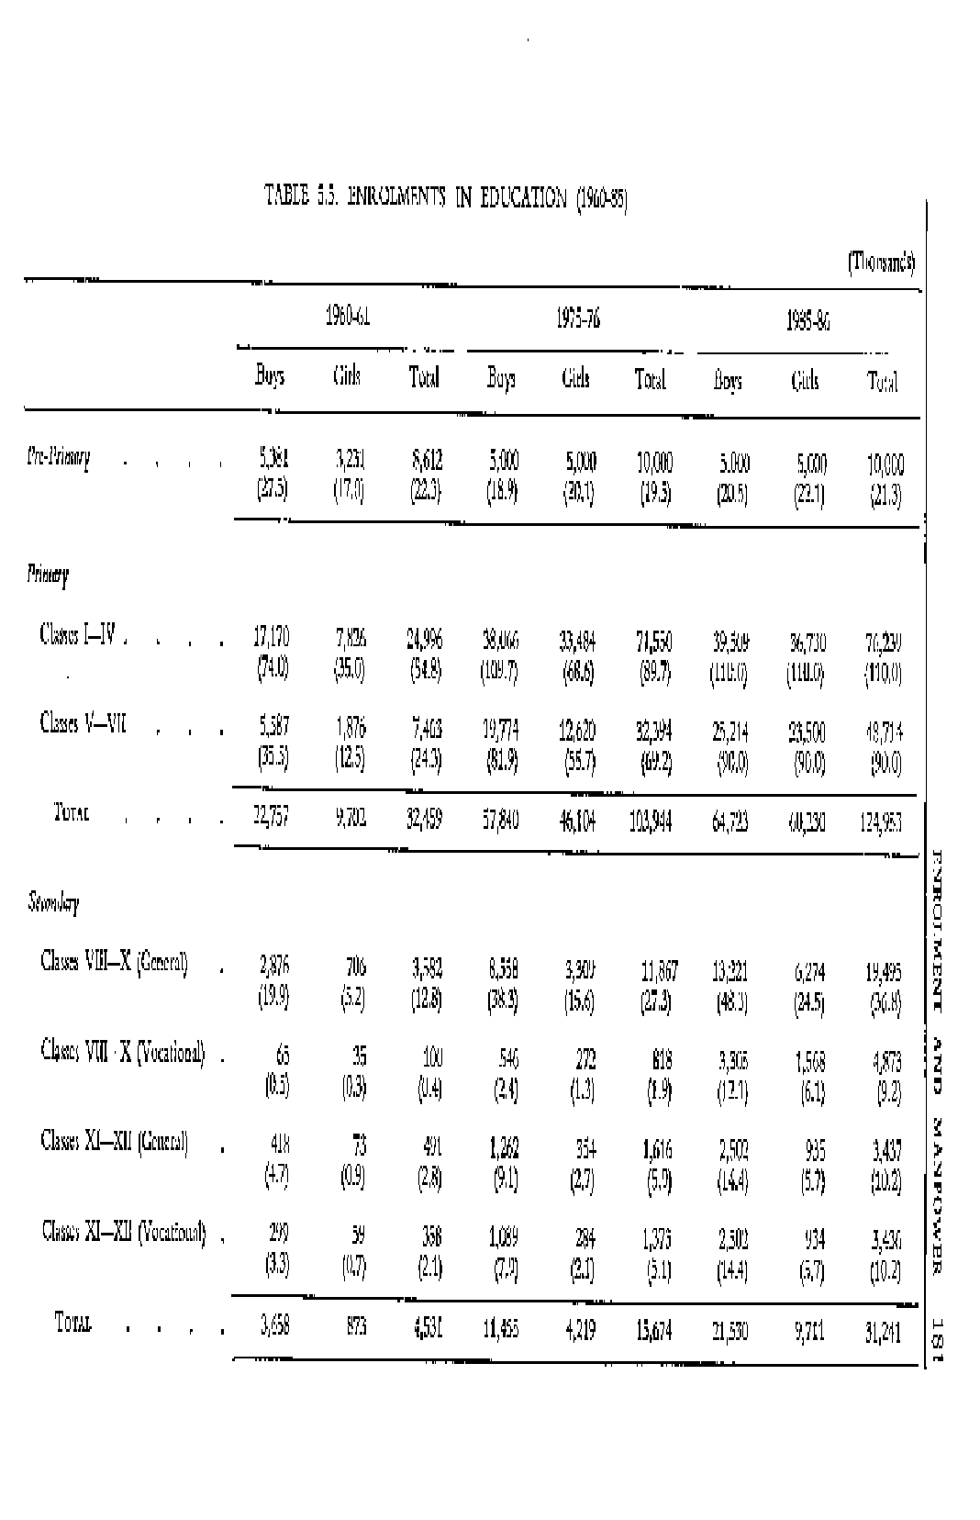

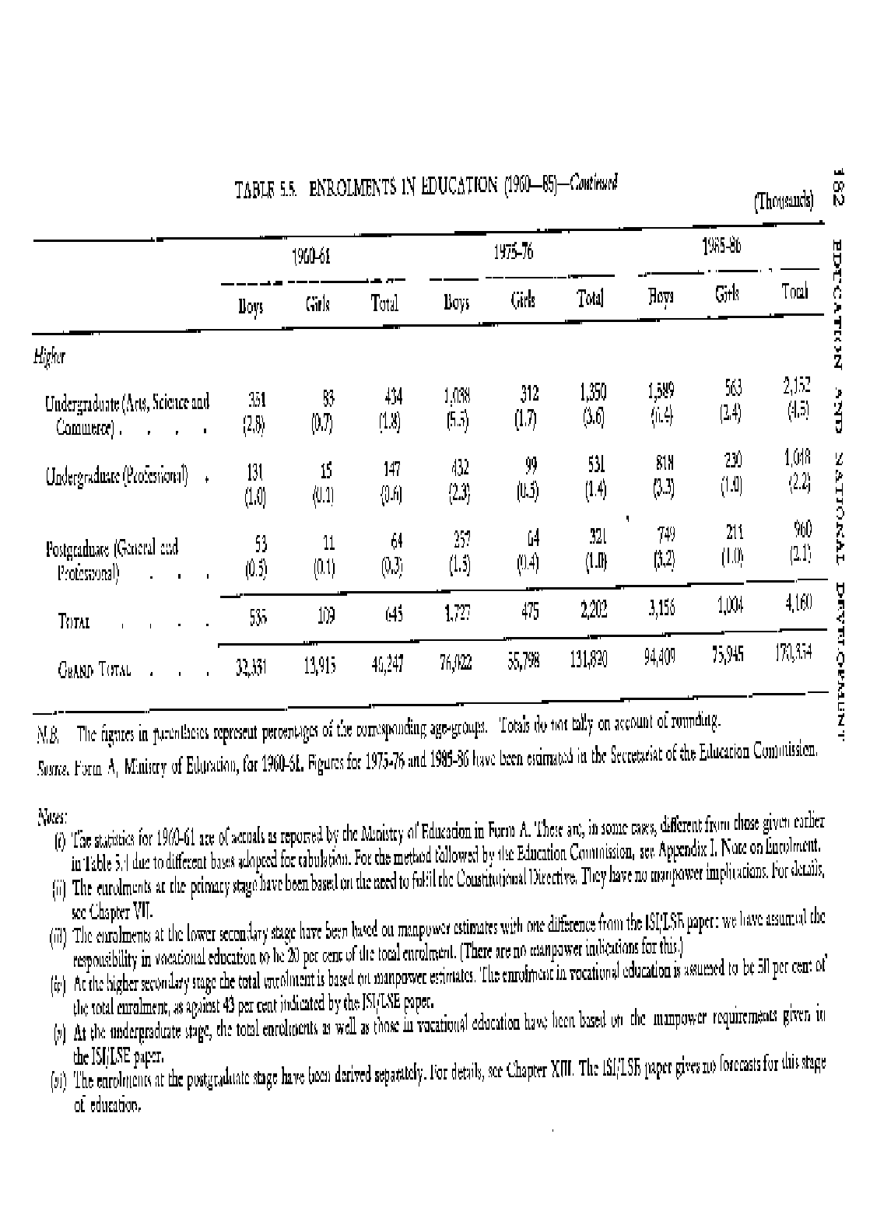

  - Educational Levels of the Working Force (1961-1986). The educational levels of the total working force during the same period (t961-1986) are given in Tables 5.6 A and B.

TABLE 5.6 (A). ESTIMATED TOTAL FUTURE EMPLOYMENT IN INDIA (1961- 1986)
(Thousands)

Industry All Workers of age 15 and above workers
1960-61 1960-61 1975-76 1985-86

(1) | (2) | (3) | (4) | (5)
1. Agriculture | 135,444 | 123,817 | 144,462 | 144, 462
2. Mining and manufacturing | 20,927 | 19,202 | 40,696 | 63, 861
3. Construction | 2,059 | 1,992 | 6,653 | 9,273
4. Trade and commerce | 7,654 | 7,500 | 12,135 | 18,764
5. Transport and communications | 3,019 | 2,995 | 6,882 | 11,525
6. Services (Other) 19,572 |  | 18,697 | 32,906 | 45,210
TOTAL 188,675 |  | 174,203 | 243,734 | 293,095

Source. ISI/LSE Paper, Table No. 13.

It will be seen from Tables 5.6 A and B, that, in spite of all the expansion of education we visualize, the proportion of educated and trained manpower would still be small even in 1986. We hope that illiteracy would be liquidated by then; or at any rate, there would be no non-literate workers. The proportion of matriculates in the total working force will increase from 1.7 per cent in 1960-61 to 4.5 per cent in 1975-76 and still further to 7.3 per cent by 1985-86. During the same period, the proportion of intermediates in the working force will rise from 0.4 per cent to 1.6 per cent and that of graduates from 0.6 per cent to 2.2 per cent. The total of all educated workers (matriculates and above) will rise from 2.7 per cent in 1960-61 to just over 11 per cent by 1985-86. This has also been graphically represented in the chart on page 187.

  - It may be pointed out that even this projected achievement is much below the level already reached in industrialized countries. For instance, the educational level of the populations of the USA and Japan is as shown in Table 5.7.

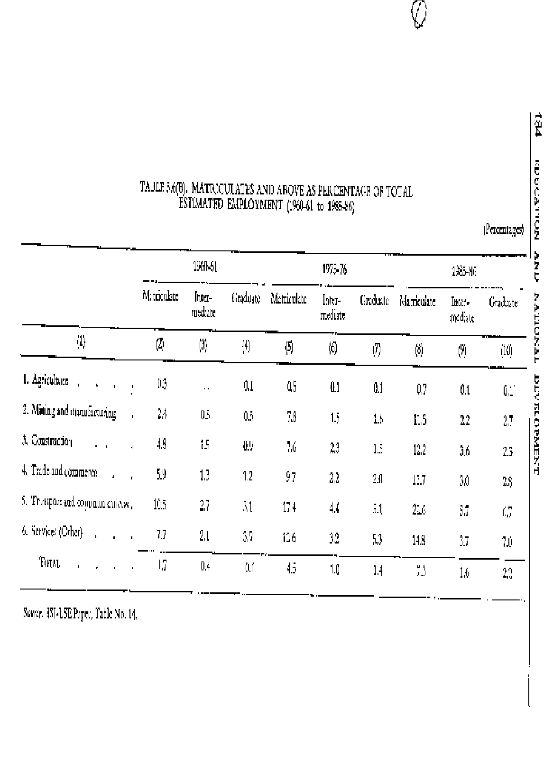

TABLE 5.7. EDUCATIONAL LEVEL OF WORKING POPULATION IN
JAPAN AND USA

Japan USA
Composition of Population (age 15 and over) Composition of civilian labour
Force(age 18-64) as on March 1959

Completed Percent Completed Per cent

Elementary school Elementary
(Class I-VI) 15.9 Less than 5 years 4.7

Junior high school
(Classes VII-IX) 44.8 5 to 8 years 24.2
Senior high school High School
(Classes X-XII) 24.7 1 to 3 years 20.3
4 years31.7
University or junior
college 5.2 College
1 to 3 years9.4
4 years or more 9.7
Attending Schools 7.3
Never Attended
Schools 2.2

Source. Population Census 1960. Source. Special Labour Force Report,
No. 53, Bureau of Labour Statistics, P. A- 6.

RELATING MANPOWER ESTIMATES TO ENROLMENTS

  - This brings us to our last point, namely, the creation of a machinery which will not only prepare estimates of manpower needs but also relate them effectively to the output of the educational system.

  - Proposals of Shri R. A. Gopalaswami. We are grateful to our colleague, Shri R. A. Gopalaswami, for preparing for our use, a number of detailed studies relating, to educational outputs, manpower needs and employment opportunities and for suggestions regarding the manner in which the estimates of manpower needs could be translated in terms of enrolment policies. We have carefully examined his proposals as well as other material placed before us. We are in full agreement with Shri Gopalaswami that there is

need to correlate the development of higher education broadly with manpower needs and we also agree with him in the statement of the following four objectives and implications of this policy.

First, the annual requirements of the country in respect of additions to the national stock of higher educated manpower should be assessed in advance with as much precision and firmness as may be found to be practicable. Arrangements should be made to secure that the assessed requirements are adequately met by the annual supply of higher educated manpower cohorts made available by all the higher educational institutions in the country.

Secondly, arrangements should be made to ensure that higher educated manpower cohorts will not remain unemployed or wastefully underemployed. Employment should be made available as nearly as may be possible in those capacities in which they are able to make the best use of the educational preparation given to them.

Thirdly, the courses of studies which are at present provided in higher educational institutions should be reviewed in the light of the changes which are occurring in the pattern of employment of higher educated manpower cohorts. The structure and content of these courses of studies, as well as admission requirements, should be reviewed and the entire system reformed so as to provide the best possible educational preparation for the different occupational groups of higher educated manpower.

Fourthly, there is need for developing a new type of 'promotional extension courses of studies for secondary educated persons who are already in employment and are found suitable for promotion, so as to raise their educational level to parity with that of higher educated manpower. Special arrangements necessary for this purpose should be devised and developed.

  - Shri Gopalaswami placed before us a detailed note outlining his proposals regarding the manner in which higher education should be reformed with a view to achieving these objectives. Our proposals for relating the output of universities and other institutions of higher education with manpower needs have been described in the sections that follow.

  - One specific proposal needs mention in this context. Some of our colleagues are of the view that pressure on higher education can be considerably reduced if the Central and State Governments were to recruit the personnel for all their services, not at the end of the first degree as is done at present, but at the end of the higher secondary stage. They also opine that this would increase the efficiency of the services themselves. As the idea has been elaborated in Shri Gopalaswami's Note, we do not think it necessary to state the case in its support or its organizational details at greater length. On a careful consideration of the proposal, however, we feel that it involves major questions of policy which go beyond our scope. We shall, therefore, merely content ourselves by drawing the attention of the authorities concerned to these proposals.

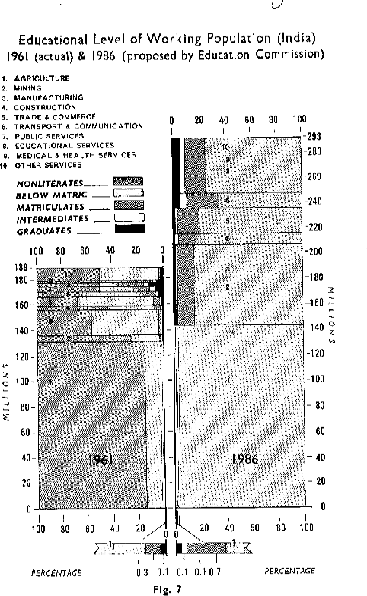

  - Machinery for Manpower Planning. We shall now briefly outline our proposals regarding the manner in which manpower estimates can be prepared, revised from time to time, and related to the enrolments in educational institutions. For this purpose, it will be necessary to devise suitable machinery at both the national and State levels.

- At the national level the Planning Commission has the responsibility for preparing estimates of manpower requirements in all sectors of national development and for revising them continuously. It may also consider the desirability of setting up, for this purpose, a Standing Committee for Manpower consisting of the representatives of the Ministries of Defence, Education, Food & Agriculture, Health, Home, Labour & Employment, Railways, and others concerned with the training of large and easily identifiable categories of manpower. The UGC on behalf of the universities-the largest producers of highly educated manpower-and the Institute of Applied Manpower Research should also be represented. This Committee should work in close collaboration with authorities for manpower planning at the State level. Its main responsibility should be to prepare and revise, from time to time, manpower forecasts for the overall output of the educational system as well as for different categories of specialists. These should be published for general information and for the guidance of those called upon to make decisions regarding the provision of educational facilities. The Committee should also advise Ministries of the Government of India and the State Governments on manpower problems and their implications for educational planning.

- At the State level, it may be desirable to set up State Committees for Manpower on the broad lines of the Standing Committee for Manpower at the Centre and having similar functions and responsibilities. It would be a duty of the State Committees to prepare State-level plans for manpower development. Similar plans at the district level should also be prepared as soon as practicable. The universities in the State should be closely associated with this Committee. When this machinery is in place, the best possible esti- mates of the requirements of manpower will be available at the nation- al and State levels, and, where necessary and possible (e.g., in respect of primary teachers), even at the district level.

  - Relating Manpower Estimates to Output of Educational Institutions. The next problem is to relate these estimates to the intake and output of the educational system or, to 'plan' the facilities to be provided in educational institutions in accordance with manpower requirements. This will have to be done both at the national and at the State levels.

- National Level. Planning at the national level should be done by the Centre in consultation with the States and should cover all sectors crucial for national development, where the mobility of trained personnel is or should be high, where it is very costly to set up institutions for training personnel or where the very high level staff required for such institutions is in short supply. These should include engineering, agricultural and medical education, and the preparation of teachers for higher education.

- State Level. The planning of the remaining sectors should be done at the State level by State Governments. The universities, which train all the higher level manpower and the district educational authorities who will be in charge of all education below the university level, should be closely associated with a programme to be developed on the following lines:

  - The planning facilities in secondary and higher education (excluding the sectors for which planning would be done at the Central level) should be done at the State level.

  - The provision of vocational education-both of school and college standard-will have to be expanded in all areas on a priority basis in keeping with the man- power needs. The same is also applicable to many areas of science education. (c) For enrolments in general education, however, which is underdeveloped in some areas and over-developed in others, a policy of equalization will have to be adopted. Decisions will have to be made by each State in view of its conditions; but as a general basis, the following may be suggested:

    - In all areas where the level of expansion reached is below the national average in 1966, steps should be taken to promote expansion.

    - In all areas where the level of expansion reached is about equal to the national average expected in 1986, a restrictive policy should be adopted unless there are special reasons to the contrary.

    - It will be for the Government of India to suggest the targets to be reached, from time to time, at the State level. State Governments may, in their turn, indicate suitable targets at the district levels.

    - The planning of higher education should be done on a State-basis. All universities in the State should be involved in this. Each university should be required to prepare a five year plan of the facilities to be provided in all its teaching departments and affiliated colleges and the output therefrom, and these should be approved after bringing them into accord with manpower needs. In granting affiliations or expanding their departments, the universities should be required to follow these plans.

    - It is also essential to have an authority at the district level which can plan all school education. This authority will have to plan in the light of general directives given from the Centre and the States. In order to assist it in its work, local studies of manpower needs, etc., will have to be carried out.

GENERAL

  - Education and Employment. In the present educational system there is no direct link between education and employment and no attempt is made even to establish an indirect link, by relating the output of the educational system closely with manpower needs or job opportunities. The recommendations made above will establish this link indirectly. But we might consider whether it would be possible to establish a direct link between education and employment. Under a good arrangement, every graduate should be given, along with his degree or diploma, an offer of appointment as well. This offer need not be binding and it may be left open to the Student, with the approval of the Government, to accept another offer. Moreover, the period of the offer may also be made brief-one to three years-so as to avoid any undue hardship. But a compulsion on the State to make such an offer would be the surest guarantee that the output of the educational system is closely linked-with employment opportunities or manpower needs. It will also improve the motivation of the students, give a purpose to their education, and make them feel that the country needs them and is waiting for them. In our opinion, this change could be an important factor in raising standards in higher education and in reducing the problems of discipline to the minimum. We realize, however, that it may not be possible to do so in the present situation, when the output in some sectors far exceeds the possibilities of employment. But we should strive to move towards this goal over a period of years; and we should make at least a beginning in a few selected sectors where numbers are manageable. The system of one-year internship, which is now prescribed for medical graduates, is a good beginning in this direction, though there is a certain resentment against it at present on the ground that the medical profession is singled out for this compulsion. If the system were to become more widespread and made applicable to one category of graduates after another till all categories were covered, this resentment would disappear and the efficiency of the system would also improve.

  - The Need (or a Wider Perspective. Significant problems of life cannot be solved in isolation. The planning of education is no exception to this general rule and, in our opinion, it may not be possible to find a satisfactory solution to it unless wider issues are solved. For instance if manpower planning is to be successful in the sense that there would be a trained man available for every job to be done and that an appropriate job would be available for every educated person, it is necessary to prepare an integrated plan of development-a plan which will consist of three parts: family planning, economic development and educational reconstruction. At present, the labour force cohort (i.e. the boys and girls who attain the age of 16 or over and enter the labour force in a given year) suffers from several serious defects or difficulties such as the following:

    - Its size is too large-about 2 per cent of the total population-owing to the large birth-rate.

    - Its educational attainments are also very meagre- about 60 per cent of the cohort is non- literate and about 40 per cent would have completed primary schooling and attained permanent literacy. Of the latter 40 per cent, about 25 per cent would have received more than five years of schooling and probably completed the primary school course; about 8 per cent would have completed the secondary school; and only about 1 or 2 per cent

might be graduates. The proportion of the educated persons in these cohorts is far too inadequate for the creation of a modern social order. What is worse, the little education that has been given is so predominantly academic that there are no trained persons to man the key posts in certain sectors of industrialization now being developed.

    - The rate of economic development, especially in rural areas, is so slow that there are not enough jobs for even half of this cohort.

  - If this situation is to be improved, it is necessary to prepare an integrated plan of development with these objects:

    - to reduce the birth-rate to about half in a planned programme of 10-15 years;

    - to bring about a very rapid economic development in such a manpower that there would be a job for every young man or woman who enters the labour force; and

    - to provide such education to the young boys and girls as will qualify them by having a specific job to do, to participate effectively in the national development programme.

Such plans are needed at the national, State and even district levels. Their preparation and implementation is the responsibility of the Government-Central, State and Local. It is only in the wider perspective of such plans that the problem of educational planning can be successfully solved.

SUMMARY

- A National Enrolment Policy. During the next twenty years, the national enrolment policy should have the following broad objectives:

    - to provide effective general education of not less than seven years' duration to every child, on a free and compulsory basis; and to expand lower secondary education on as large a scale as possible;

    - to provide higher secondary and university education to those who are willing and qualified to receive such education, consistent with the demands for trained manpower and the need to maintain essential standards; and to provide adequate financial assistance to those who are economically handicapped;

    - to emphasize the development of professional, technical and vocational education and to prepare skilled personnel needed for the development of agriculture and industry;

    - to identify talent and to help it grow to its full potential;

    - to liquidate mass illiteracy and to provide an adequate programme of adult and continuing education; and

    - to strive continuously to equalize educational opportunities, beginning with the elimination of at least some of the more glaring inequalities. 5.02

- Raising the Educational Level of the Average Citizen. High priority should be given to programmes of raising the educational level of the average citizen-

- by providing five years of effective primary education to all children by 1975-76 and seven years of such education by 1985-86;

- by making part-time education for one year compulsory for all children in the age- group 11-14 who have not completed the lower primary stage and are not at- tending schools. The aim will be to make these children functionally literate and stop all further additions to the ranks of adult non-literates; and

- by developing programmes to liquidate adult illiteracy. 5.03

- Enrolment Policies in Secondary and Higher Education. (1) The enrolment policies in post-primary education should be based on a combination of four criteria: public demand for secondary and higher education; full-development of the pool of natural ability; capacity of society to provide educational facilities at required levels of quality; and manpower requirements.

- The public demand for secondary and higher education has in- creased immensely in the first three Plans and will continue to in- crease in future. It sets up a high target which

is beyond the re- sources of the country in terms of men, money or materials. It is therefore necessary to adopt a policy of selective admissions to higher secondary and university education in order to bridge the gap between the public demand and available facilities.

- Providing secondary and higher education to all potentially able students also sets up a high target which even affluent societies find it difficult to achieve. It will be obviously beyond our reach, at least in the immediate future. While striving towards this goal, therefore, the immediate objective of the national enrolment policy should be to ensure that at least all the gifted students (5 to 15 per cent of all the students) who complete primary or secondary education are enabled to study further and that their financial handicaps are overcome through the institution of a liberal programme of scholar- ships.

- There are internal constraints in every educational system which limit expansion of facilities, especially in secondary and higher education, viz., the availability of competent teachers, physical plant and finance. These constraints have often been set aside in the past to meet the pressures of public demand and standards have been diluted. This temptation will have to be resisted in the larger interests of the country.

- Estimated requirements of manpower needs or available job opportunities form a good basis for planning the expansion of educational facilities. This broad recommendation has to be understood in the light of three reservations:

  - a continuous effort should be made to improve the collection of necessary data and the techniques of forecasting and the estimates of manpower needs should be continuously revised and kept up-to-date;

  - the quality of manpower produced should be equally emphasized; and

  - the estimates of manpower needs should not be regarded as the only criterion-it should be suitably combined with other criteria in taking final decisions about expansion of educational facilities. 5.04-12

- A Strategy of Development. The capacity of society to expand educational facilities in terms of real resources sets up minimum targets whereas the maximum targets are suggested by the public demand for secondary and higher education or the need to develop the available pool of native talent. The gap between these high and low targets can be bridged by considerations which emerge from the necessity to relate the output of the educational system to manpower needs and to equalize educational opportunities. These will indicate the priorities to be adopted, the different courses of study to be developed, the extent to which facilities should be provided in the different courses, and the manner in which enrolments in them could be made to include, after equality of access is provided for all, at least the best students in the community. 5.13

- Future Requirements of Educated Manpower : The ISI-LSE Estimates. We broadly accept the estimates of future requirements of educated manpower given in the ISI-LSE

Paper. This will, however, have to be continually revised in the light of the best data available and kept up-to-date. The table given on page 174 (Table 5.3) shows the estimates of the required workers, stock and out-turn of educated persons during the next twenty years.

- Educational Implications of the Estimates. The following are the main policy implications of these estimates:

- to restrict the unplanned and uncontrolled expansion of general secondary and higher education, if massive educated unemployment is to be avoided;

- to make special and intensive efforts to vocationalize secondary education and to develop professional education at the university stage; and

- to devise suitable machinery, both at the national and State levels, which will relate the estimates of manpower needs effectively to the output of the educational system so that, by and large, there is some assurance that a suitably trained person would be available for every job to be done and every educated person would find a job appropriate for his education and profession- al training. 5.26

- Enrolments. The enrolments implied in these targets of out- turn, workers and stock have been discussed in the appropriate context in the different sections of this Report. 5.40

- Machinery for Manpower Planning. The first two of these have been discussed in their appropriate context in later chapters. With regard to the third, the following recommendations are made:

  - At the national level, the Planning Commission, which is responsible for preparing estimates of manpower requirements in all sectors of national development should set up a Standing Committee for Manpower. Its main responsibility should be to prepare and revise, from time to time, manpower forecasts for the overall output of the educational system as well as for different categories of specialists.

  - At the State level, it may be desirable to set up State Committees on Manpower on the broad fines of the Standing Committee for Manpower at the Centre and having similar functions and responsibilities.

- Relating Manpower Estimates to output of Educational Institutions. The following measures will have to be taken to relate the output of the educational system to manpower needs:

  - National Level. Planning at the national level should be done by the Centre in consultation with the States and should cover all sectors crucial for national development, where the mobility of trained personnel is or should be high, where it is very costly to set up institutions for training personnel or where the very high level staff required for such

institutions is in short supply. These should include engineering, agricultural and medical education, and the preparation of teachers for higher education.

  - State Level. The planning of the remaining sectors should be done at the State level by State Governments. The planning of facilities in secondary and higher education (excluding the sectors for which planning would be done at the Central level) should be done at the State level.

  - The provision of vocational education-both of school and college standard-will have to be expanded in all areas on a priority basis in keeping with manpower needs.

  - For enrolments in general education, however, which is under-developed in some areas and over-developed in others, a policy of equalization will have to be adopted. Decisions will have to be made by each State in view of its conditions; but as a general basis, the following may be suggested:

    - in all areas where the level of expansion reached is below the national average in 1966, steps should to taken to promote expansion;

    - in all areas where the level of expansion reached is about equal to the national average expected in 1986, a restrictive policy should be adopted, unless there are special reasons to the contrary;

    - it will be for the Government of India to suggest the targets to be reached from time' to time, at the State level. State Governments may, in their turn, indicate suitable targets at the district level;

    - the planning of higher education should be done on a State-basis. All universities in the State should be involved in this. Each university should be required to prepare a five- year plan of the facilities to be provided in all its teaching departments and affiliated colleges and the output therefrom and these should be approved after bringing them into accord with manpower needs. In granting affiliations or expanding their departments, the universities should be required to follow these plans.

    - It is also essential to have an authority at the district level which can plan all school education. This authority will plan in the light of general directives given from the Centre and the State. In order to assist in its work, local studies of manpower needs, etc., will have to be carried out. 5.43-48

- Education and Employment. We should move in the direction of giving every graduate an offer of employment along with his degree or diploma. From this point of view, the system of one year internship now prescribed for medical graduates should be extended to other categories of graduates. 5.49

- A Wider Perspective. The basic problem of human resource development can be solved only against a wider perspective. From this point of view, it is necessary to

formulate and implement integrated plans which will have three objectives: (1) to reduce the birth-rate by about half; (2) to bring about an expansion of employment; and (3) to provide such education as will qualify young people for specific jobs. Such integrated plans are needed at the national, State and district levels. 5.50-51

CHAPTER VI

TOWARDS EQUALIZATION OF EDUCATIONAL OPPORTUNITY

  - One of the important social objectives of education is to equalize opportunity, enabling the backward or underprivileged classes and individuals to use education as a lever for the improvement of their condition. Every society that values social Justice and is anxious to improve the lot of the common man and cultivate all avail- able talent, must ensure progressive equality of opportunity to all sections of the population. This is the only guarantee for the building up of an egalitarian and human society in which the exploitation of the weak will be minimized.

  - Inequalities of educational opportunities anise in various ways. In places where no primary, secondary, or collegiate institutions exist, children do not have the same opportunity as those who have these facilities in the neighbourhood. This handicap should be overcome by the widest dispersal of educational institutions, consistent with economy and efficiency, by instituting, an adequate scholar- ship programme, by providing the needed hostel facilities or 'by making suitable transport arrangements. It is sometimes not fully appreciated that there are at present glaring imbalances of education- al development in different parts of the country: the educational developments in the States show wide differences, and even wider differences are found between the districts. To remove such inequalities, deliberate policies of equalization of educational opportunities and educational development in the different districts will have to be adopted.

  - Another cause of inequality of educational opportunity is the poverty of a large section of the population and the relative affluence of a small minority. Even in the neighbourhood of an educational institution, children from poor families do not have the same chance as those who come from richer ones. To overcome these handicaps, it is desirable to abolish fees progressively, to provide free books, stationery and even school meals and uniforms. In addition, it is necessary to develop a large programme of scholarships.

  - Again, differences in the standards of schools and colleges create an extremely intractable form of educational inequality. When admission to an institution such as a university or professional college, is made on the basis of marks obtained at the public examination at the end of the secondary stage, as often happens, the marks do not at all provide a common yardstick for a student from a rural area who attends an ill-equipped school in his village, and a student from an urban area who attends a good city school. To overcome this to some extent at least, it is necessary to evolve more reliable and egalitarian methods of selection, whether for admission to institutions or for award of scholarships.

  - Gross inequalities arise from differences in home environments. A child from a rural household or an urban slum having non- literate parents, does not have the same

opportunity which a child from an upper class home with highly educated parents has. These inequalities are obviously the most difficult to overcome and here progress essentially depends on the general improvement in the standard of living of the population. But something can be done by ensuring that special attention at school is paid to children from the under-privileged groups and by the provision of day-study centres or boarding houses.

  - Two other forms of educational 'inequalities, which are peculiar to the Indian situation, need attention. The first is the wide disparity between the education of boys and girls at all stages and in all sectors of education. The second is the equally wide, or sometimes wider disparity of educational development between the advanced classes and the backward ones-the Scheduled Castes and the Scheduled Tribes. On grounds of social justice as well as for the furtherance of democracy, it is essential to make special efforts to equalize educational opportunities between these groups.

  - Like all ideals in life, perfect equality of educational opportunity is probably unattainable. In such matters, however, the essence of the problem is not the attainment of the goal, but an impassioned faith and earnest striving. In a good system of education, there should be a continuous attempt to identify factors which tend to create significant forms of inequality and to adopt measures either to eliminate them altogether or at least to reduce them to the minimum.

We shall address ourselves, in the course of this chapter, to an examination of the implication of this policy for Indian education during the next twenty years.

TUITION FEES AND OTHER PRIVATE COSTS

  - Fees in Education. The attitude towards tuition fees has undergone several changes in our modern educational history. In 1854, the Wood's Education Despatch, which laid the foundation for the present system of education, 'insisted that some fee, however small, should be charged in all institutions on two grounds: people do not value anything which is given free; and the payment of a fee is an indication of the seriousness of purpose on the part of a student or his guardian. This view soon gave way to a concept of fees as a source of revenue for supporting schools; and in 1946-47, fees ac- counted for
25.6 per cent of the total educational expenditure. Since then dependence on fees as a source of revenue is diminishing and Government is assuming an increasing burden in the financing of education. This will be seen from the statistics given in Table 6.1.

TABLE 6.1. TOTAL REVENUE FROM FEES
(1950-51 to 1965-66)

 | 1950-51 | 1955-56 | 1960-61 | 1965-66  (Estimated)
 | Rs. | Rs. | Rs. | Rs.
1. Total receipts from fees (in 000's) | 233,272 | 379,033 | 590,258 | 918,077
2. Index of growth | 100 | 162 | 253 | 394
3. As percentage of total educational expenditure | 20.4 | 20,0 | 17.1 | 15.3
4. Contribution from Government Funds as percentage of total educational expenditure | 57.1 | 61.8 | 68.0 | 71.2
 | First  plan | Second  plan | Third  plan | All  plans
5. Average annual rate of
growth in fees 10.2 9.3 9.2 9.6
Source. Ministry of Education, Form A, except for 1965-66 which has been estimated in the Secretariat of the Commission.

  - The incidence of fees varies from stage to stage and from one type of educational institution to another. The percentage of students paying fees, the rates of fees, the type of institution charging fees and the total amount of fees collected-all show considerable variations. The detailed statistics relating to these matters for 1960-61the latest year for which data are available-are given in Table 6.2.

It will be seen that pre-primary education is mostly supported by fees.⁴⁹ Fees have almost disappeared at the lower primary stage; but they do play a more significant role at the higher primary stage. Their contribution becomes very important at the secondary stage where the fees collected form 45.8 per cent of all fees collected in the educational system, and where they contribute 39.2 per cent of the total expenditure on secondary schools. ⁵⁰ The position in vocational schools,

⁴⁹Except in the rural balwadis whose statistics are not included here and which are all tuition-free.

⁵⁰In 1960-61 the provision for free-studentships was rather meagre at this stage, although the position has considerably changed since.

TABLE 6.2. FEES IN EDUCATION (1960-61)

Stage-Object | Total amount collected through fees  (Rs. in  000's) | Percent- age of students paying fees | Average annual fee collected per student (Rs.) | Percent- age of fees  to total expendi- ture on the stage | Percent- age of fees collected at the stage to total of fees collected at all stages
1. Pre-Schools | 2,184 | 77.5 | 23.3 | 37.2 | 0.4
2. Lower Primary Schools | 17,169 | 3.9 | 16.4 | 2.3 | 2.9
3. Higher Primary Schools | 31,677 | 16.4 | 18.2 | 7.4 | 5.4
4. Secondary Schools | 270,394 | 64.8 | 55.6 | 39.2 | 45.8
5. Schools for Teacher Training | 1,856 | 20.0 | 84.2 | 5.3 | 0.3

6. Schools
for Vocational Education (excluding Teacher
Training) 13,604 | 72.0 | 65.0 | 17.2 | 2.3
7. Schools for Special  Education 1,378 | 10.0 | 8.1 | 4.3 | 0.2
8. University Teaching Depar-  tments 52,934 | 90.1 | .. | 37.4 | 9.0
9. Research  Institutions 375 | 86.3 | 147.1 | 1.4 | 0.1
10. Colleges for Arts & Sc-  ience 101,384 | 84.9 | 172.7 | 48.5 | 17.2
11. Colleges for Teacher  Training 2,761 | 34.7 | 156.9 | 12.8 | 0.5
12. Colleges for Professional Education  (excluding Teacher Training) 30,346 | 87.9 | 240.5 | 22.2 | 5.1
13. Colleges for Special  Education 1,447 | 52.4 | 109.0 | 15.9 | 0.2
ALL
INSTITUTIONS 527,510 18.7 .. |  |  | 20.7 | 89.4
14. Boards of  Education 23,342 .. .. |  |  | 96.7 | 3.9
15. Indirect  Expenditure 39,406 .. .. |  |  | 1.7 | 6.7
GRAND TOTAL 590,258 .. .. 17.1 |  |  |  | 100.0

Source. Ministry of Education, Form A.

universities, colleges of arts and science, and colleges of professional education is broadly similar; the proportion of free- studentships is comparatively small; the fee collected per student is comparatively high; and the revenue from fees contributes a sizable amount towards the expenditure of the institutions concerned.

  - It is undesirable to regard fees as a source of revenue. They are the most regressive form of taxation, fall more heavily on the poorer classes of society and act as an anti- egalitarian force. Suggestions have been made to make them progressive by relating them, on a graduated scale, to the income of the parent and the size of the family. But this would not be administratively feasible and, in a country where sixty per cent of the population has an income of less than Rs. 20 per head per month, their yield would be almost negligible. It would, on the whole, be much better to raise the required revenue in some other and more equitable form than to depend on fees. We recommend, therefore, that the country should gradually work towards a stage when all education would be tuition-free. The implementation of this programme, however, would have to be spread over a period of time and the abolition of tuition fees will have to proceed from stage to stage, beginning with primary. It may be mentioned that school education is completely free in most countries, and all education from elementary school to the research degree is free in the USSR.

  - Fees at the Primary Stage. The Constitution requires the provision of free and compulsory education for all children up to the age of 14 years. Even though the
`compulsory' part of this directive may take about 20 years to realize, the `free' part of it should be implemented without delay. We, therefore, recommend that all tuition fees at the primary stage should be abolished as early as possible and preferably before the end of the Fourth Five Year Plan. This implies that there would be no tuition fees in government, local authority and aided private schools, grants-in-aid to the last group being suitably adjusted. Fee-charging independent private schools which receive no aid may, however, continue to exist.⁵¹

  - Fees at the Secondary Stage. At the secondary stage, the problem is a little more difficult. Two arguments have been put forward in favour of the levy of fees at this stage. The first is that the expansion of secondary education being still largely restricted to the middle and upper classes of the society, the abolition of fees will be more in favour of the haves than of the have-nots, and the second is that the revenue from fees collected at this stage being substantial, the abolition of fees would be neither feasible nor desirable from the financial point of view. We cannot agree with either of these arguments. The levy of fees in secondary schools prevents several children from the poorer classes of society, and particularly girls, from receiving education and it is mostly among these groups that the expansion of secondary education will have to take place in the next two decades. The abolition of fees at the secondary stage is thus intended mainly for the benefit of such underprivileged groups who are now entering secondary education in large numbers. It is also necessary to point out that the total revenue from fees collected at the secondary

⁵¹For details see Chapter X.

stage has declined considerably in the Third Five Year Plan. Madras has made all education free till the end of the secondary stage. Uttar Pradesh and Orissa have made it free for girls. Mysore, which had already introduced a very large programme of free- studentships, has now decided to follow Madras from the current year. We understand that Andhra Pradesh is also proposing to adopt the same policy. Maharashtra and Gujarat now provide free-studentships to nearly 85 per cent of the total enrolment. In Punjab, Madhya Pradesh and Rajasthan, it is free for girls in all government schools at least and very largely free for boys also. In all parts of the country, it has always been free for the Scheduled Castes, the Scheduled Tribes and some other backward classes. If all these developments are duly allowed for, it appears that the provision of tuition-free secondary education is limited only in Assam, Bihar, Orissa (for boys), Uttar Pradesh (for boys) and West Bengal. The difficulty of making secondary education free of tuition or of finding alternative sources for the loss of revenue involved is thus no longer as formidable as it was five years ago.

  - There was a view in the Commission that the levy of tuition fees must continue to be the rule for lower secondary education, tempered by adequate and suitable provision for the grant of concessions and exemptions to all the needy students. On a careful consideration of the problem, however, we think that such a system does not have much to commend itself and involves several administrative difficulties. We, therefore, recommend that lower secondary education should be made tuition-free in all government, local authority and aided private institutions as early as possible and, preferably before the end of the Fifth Plan. Even where it is not possible to implement this recommendation in one step, a beginning should be made by making all vocational secondary education free; and as resources permit, the principle should be extended to girls and to children who come from the poorer families. Fees in higher secondary education should, however, be dealt with on the same lines as in university education, our proposals regarding which are given in paragraphs 6.14 and 6.15.

  - Fees in Higher Education. At present, fees play an important role in higher education. Table 6.1 will show that in 1960-61 fees contributed 37.4 per cent of the total expenditure on universities, 48.5 per cent of that on colleges of general education, 22.2 per cent of that in colleges of professional education (excluding teacher training), 15.9 per cent in colleges for special education and 12.8 per cent in colleges of teacher training. For higher education as a whole, the contribution of fees was as high as 37.3 per cent of the total expenditure. This is even larger than that in the educationally advanced and richer countries. In the United States, for instance, only about 25 per cent of the income of institutions of higher learning is derived from fees and in Britain, it is less than one- eighth.

  - We do not advocate the immediate general abolition of fees in higher education, although this should be the ultimate goal of educational policy. This programme has a lower priority than that of making all school education free and should be considered only after tuition fees have been abolished in secondary schools. At present, when higher education is mostly being availed of by the top five per cent of the population, a policy of levying fees combined with that of liberal provision of free-studentships to all the needy

and deserving students would prove to be better than that of general abolition of fees. We, therefore, recommend that, for the next ten years, the main effort with regard to fees in higher secondary and university education should be to expand the provision of tuition-free education to cover all the needy and deserving students. To begin with, the proportion of free-studentships should be increased to at least 30 per cent of the total enrolment.⁵² We also commend, for general acceptance, policies which have been adopted in some areas to provide tuition-free higher education to underprivileged groups, e.g., provision of free-studentships to Scheduled Castes, Scheduled Tribes, girls, or children of persons whose income is below a prescribed level. This will be adequate to meet the social demand from the underprivileged sections of society that are now in secondary schools and are quickly moving up to seek admission to institutions of higher education. The problem may be reviewed again after ten years.

  - Other Private Costs. The private costs of education required for textbooks, supplies, co-curricular activities, etc., have increased very substantially in recent years and amount not infrequently, to several times the tuition fees in fact, the greater financial burden that creates the non-egalitarian trends today is not so much tuition-fees as these other costs. The Commission carried out a small study to discover the approximate level of these indirect costs at the school stage. For this purpose, we selected a few schools with varying levels of such costs in each State and Union Territory and collected detailed information from them. The results are summarized in Table 6.3.

⁵²At present, the proportion of free-studentships to total enrolment in institutions of higher education is very small 14.6 per cent of students get tuition-free education in universities, 15.1 per cent in colleges of general education, 12.1 per cent in colleges of professional education, and 47.6 per cent in colleges of special education (1960-61 figures).

TABLE 6.3. PRIVATE COSTS OF EDUCATION (ANNUAL) 1965-66
Rupees

Total private costs of education
Class | Text- books | Stationery | Total | Lowest Text- books | Stationery | Highest Total
I . | 0.50 | 0.60 | 1.10 | 17.80 | 12.80 | 30.60
II . | 0.54 | 0.60 | 1.14 | 16.60 | 12.80 | 29.40
III . 0.69 |  | 2.11 | 2.80 | 28.51 | 8.33 | 36.84
IV . 2.10 3.26 |  |  | 5.36 | 38.85 | 14.50 | 53.35
V . 3.91 2.40 |  |  | 6.31 | 36.10 | 14.50 | 50.60
VI . 5.85 4.63 |  |  | 10.48 | 43.24 | 60.00 | 103.24
VII . 7.29 4.88 |  |  | 12.17 | 47.09 | 75.00 | 112.09
VIII . 9.30 6.95 |  |  | 16.25 | 169.68 | 21.40 | 191.08
IX . 11.15 7.51 |  |  | 18.66 | 192.55 | 70.00 | 262.55
X . 4.50 14.00 |  |  | 18.50 | 216.35 | 70.00 | 286.35
XI . 13.75 11.25 |  |  | 25.00 | 189.65 | 70.00 | 259.65
Source. Data supplied by schools.

  - It will be seen from the above that parents are required to incur very heavy expenditure for this purpose. Consequently, only a small proportion of children have all the books at the beginning of the school year; a much larger proportion have them, not at the beginning of the school year, but towards the middle or even the end. Not infrequently, a proportion of students have no books at all. This has a very adverse effect on standards. We, therefore, recommend that an earnest effort be made to reduce these private costs of education. They are often raised thoughtlessly or for snobbish rather than for educational reasons. Side by side a programme should immediately be developed for providing at least textbooks, if not stationery also, free of charge (or at concessional rates) to all students (or at least to all the needy and deserving students). This would be a crucial programme for the qualitative improvement of education. Obviously, the manner of its implementation will have to vary from one stage of education to another.

- Primary Stage. At the primary stage, a programme of providing free textbooks should be given very high priority and introduced immediately. It should also be extended to the higher primary stage as early as possible. Children freshly joining schools should be welcomed at a school function and presented with a set of books. Others should be presented with a complete set of books for the succeeding year as soon as the results of the annual examinations are declared and before the long vacation starts, so that they can make some use of the vacations for further study.

- Secondary and University Stages. A programme of book-banks should be developed in secondary schools and in institutions of higher education. In addition, the libraries of these institutions should contain a large number of sets of textbooks so that every student can have access to them in the library or the reading-room. The State Education Departments should have a fund at their disposal from which they could encourage the establishment of book-banks in secondary schools; and a similar fund should be placed at the disposal of the UGC which could organize them in the universities and affiliated colleges. The programme should be developed on so large a scale that every needy student in a secondary school or institution of higher education will be provided with a set of all the textbooks needed at the beginning of the school year or have easy access to them in the library.

- Grants for Purchase of Books. Grants for the purchase of books should be made to the more talented of the students. We recommend that the top 10 per cent of the students in educational institutions (subject to a means test, if necessary) should be given small grants annually for the purchase of books, which need not necessarily, be textbooks. The scheme should be begun in the universities and later extended to affiliated colleges and secondary schools.

SCHOLARSHIPS

  - Basis of Reorganization. The programme of scholarships has received considerable emphasis in recent years. The total expenditure on scholarships has increased from Rs.
34.5 million or 3 per cent of the total educational expenditure in 1950-51 to about Rs. 420 mil- lion or 7 per cent of the total educational expenditure in 1965-66. A careful study of the position, however, shows that an attempt will have to be made to reorient and expand the existing scholarship programmes on the following lines:

-The scholarship programme is a continuous process and has to be organized at all stages of education. At present there is a fairly well-organized programme in higher education and vocational courses, although even here, much expansion is needed. But as there is no adequate programme at the school stage, a good deal of talent is already eliminated by the time the threshold of university entrance is reached. The provision of scholarships in higher education does not, therefore, prove as helpful as it might otherwise have been.

- It has not been possible to evolve a good method of selecting awarders for scholarships. At present, most scholarships are awarded on the basis of marks obtained in some public examination; and as these tend to favour students from the well-to-do homes or good

urban schools, scholarships do not really help potentially talented students whose preparation has remained inadequate for no fault of theirs. A more equitable and egalitarian basis for the award of scholarships has, therefore, to be evolved.

- If the best results are to be obtained, a scholarship programme should be accompanied by a placement programme whose objective is to ensure that the scholarship holders are placed in good institutions and a further complementary programme of ensuring that an adequate number of institutions which maintain fairly high standards is available at all stages.

- A careful watch will have to be kept at all points of transfer from one stage or sub-stage of education to another to ensure that all the abler students (at least the top 5-15 per cent of the enrolment, depending upon the stage of education) do continue their studies further.

- An adequate machinery to administer the programme would have to be created and the operation of the programme fully decentralized to avoid the procedural delays and other difficulties that are experienced at present.

In the light of these broad principles we indicate below the manner in which scholarship programmes should be reorganized at the different stages of education.

  - Scholarships at the Primary Stage. Steps should be taken to ensure that, at the end of the lower primary stage (class IV or V), no `Promising' child is Prevented from continuing his studies further on account of non-availability of a school, or of socioeconomic difficulties; and to this end, scholarship of an adequate amount will have to be provided to every child that may need it. In addition, it will be desirable to evolve a placement programme and to try to place the brighter children to the extent possible in the good schools that may be available at this stage. We have assumed that the target should be to provide scholarships for 2.5 per cent of the enrolment at the higher primary stage by 1975-76 and to 5 per cent of the same enrolment by 1985-86.

  - Scholarships at the Secondary Stage. The main object of the scholarship programmes to be developed at the secondary stage would be to ensure that, under any circumstances, the top 15 per cent of the children in the age-group do get transferred to secondary schools and that their further education is not prevented by poverty. In this context, we would like to make the following concrete suggestions:

- The present system of awarding scholarships on a centralized basis such as a district or a block, tends to be unfair to students who have attended the weaker schools and who, in consequence, show an inferior level of preparation for no fault of theirs. While this system should be continued and even expanded, we recommend that as a supplement to it, about 10 per cent of students in class VII or VIII in each school should be assisted, to the extent necessary, to continue their studies further. Taking the system as a whole, the target should be to provide scholarships to 5 per cent of the enrolment by 1975-76 and to 10 per cent of the enrolment by 1985-86.

- The existing programme of scholarships would have to be considerably expanded to meet the demands of the situation. Wherever necessary, hostel facilities will also have to be provided.

- To begin with, one good secondary school (with adequate residential facilities) should be developed in each community development block and about 10 per cent of urban schools should also be similarly covered. Access to these schools should be mainly on the basis of talent; and an adequate placement programme should be developed at this stage- this does not exist at all at present-to help the gifted students and the scholarship-holders to get admission to these schools.

  - The responsibility for the development of this comprehensive programme should be squarely placed on the Education Departments which should work in collaboration with the universities. The secondary stage is the most crucial for discovery and development of talent, and unfortunately, it is precisely at this stage that the scholarship programme is now weak. Its development will, therefore, have to be accorded high priority.

  - We are aware of the great difficulties and lack of reliable criteria and techniques for identifying talent. We, therefore, recommend that steps should be taken immediately to devise suitable techniques for identifying talent at this stage. Each State should organize a testing service at the end of the primary stage (class VII or VIII) and also at the end of the lower secondary stage (class X) and make its assistance available to all the schools. The details of the organization of this service, under a new body called the State Evaluation Organization, has been discussed elsewhere.⁵³ If properly developed, this service could be of considerable help to students and institutions; they would obtain some useful information about their performance in relation to the district, State or even the national average level of attainment; and such information, apart from its utility to students and parents, would also be of great assistance to the Education Departments in the award of scholarships.

  - Two further points need mention. The first is that every educational institution should be assisted to develop a programme for identifying the brighter children attending it and for providing them with special enrichment programmes to suit their needs and to help in their growth. These programmes, the nature of which would very from stage to stage and from one type of institution to another, would have to be carefully designed and teachers would have to be trained in putting them across. Secondly, in all these programmes, `talent' should not be understood in the traditional sense only, but should cover a, wide range of mathematical, verbal, artistic and experimental skills. Scholarships and encouragement should be available, on a basis of equality, to all talent at all stages of education.

⁵³Chapter X.

  - Scholarships at the University Stage. The programme of scholarships in higher education is extremely important. The bulk of the existing programme is in this sector and a very large part of it is provided by the Government of India. In our opinion, a further development on the following lines is needed:

    - increase in the number of scholarships and other forms of student aid and in the amount of scholarships;

    - reduction of procedural and other delays;

    - improving the methods of selecting awardees;

    - institution of scholarships for study abroad; and

    - institution of a large programme of loan scholarships.

Our recommendations on these and other allied matters are given below.

  - Number of Scholarships. In our opinion, the ultimate target towards which we should move in the provision of scholarships at the university stage would be the following:

- Scholarships should be available to at least 15 per cent of the enrolment at the undergraduate stage by 1976 and to 25 per cent of such enrolment by 1986; and

- Scholarships should be available to at least 25 per cent of the enrolment at the postgraduate stage by 1976 and to 50 per cent of such enrolment by 1986.

These targets should be treated as national averages and it should be an objective policy to vary them from institution to institution or from faculty to faculty. For example, a much larger proportion of scholarships should be available in university departments and colleges. The proportion of scholarships available in affiliated colleges should generally be lower; but in good colleges, it may be higher than and even equal to, that in the universities. Similarly, the proportion of scholarships in courses in science could be greater than that in legal education. Even more liberal scholarships could be given to teachers under training.

  - Amount of Scholarships. At present, the amount of scholar- ships at a given level is the same for all students. For instance, the post-matriculation scholarship is of Rs. 50
p.m. in the first year and its amount remains the same for a student who stays with his parents and attends the college in Ms town or city as well as for another who has to leave his family and stay in a hostel to join a college or a university. Similarly, the amount of the Central scholarship is generally uniform for all parts of the country, irrespective of the fact that a place like Delhi is far costlier than a mofussil town. No studies are also conducted to find out the expenditure which a student has to incur in hostels or on items like purchase of books, equipment, etc. Hardly any serious attempt is made to keep costs

down. We have carefully examined the problem and make the following recommendations:

- Two kinds of scholarships would ordinarily be needed

  - for those who have to stay in hostels: these should cover all the direct and indirect costs of education (i.e., tuition fees, books, supplies, etc.) and living costs; and

  - for those who can stay at home: these should mainly cover direct and indirect costs.

- Studies should be continuously carried out to ascertain the direct and indirect costs, as well as the hostel charges, which students have to bear. This should be one of the studies which each university should undertake and periodically repeat. A continuous attempt should be made to keep the direct and indirect costs to the minimum. Everywhere, hostel costs are rising and very often, the increase is not justified. An attempt has to be made to keep the hostel costs down to the minimum. The number of `servants' in hostels should be reduced and gradually eliminated altogether. It is a part of education that students should learn to look after themselves and not be dependent on servants to serve meals, make beds, etc. Self- service should be the rule rather than the exception. This will make it possible to keep the value of scholarships down and to extend the benefit of financial assistance to a larger number of students.

  - National Scholarships. The national scholarships form another important category of scholarships awarded at the university stage. The entire expenditure on these scholarships which were instituted in the Third Five Year Plan and are awarded on the basis of merit, is met by the Government of India. In actual practice, the Government of India allocates a specified number of scholarships to each State Government and the award is made, under the rules framed by the Government of India, by the State Government concerned. This is a good scheme and should be continued and largely expanded. We make the following recommendations in this regard:

- Coverage. At present, the scheme covers less than one per cent of the students who appear at the various exam examinations to which the scholarships are allocated. The target to be reached should be to cover five per cent of such students by 1975-76 and ten per cent of such students by 1985-86.

- Decentralization. In the practice now in force, the Ministry of Education allocates the scholarships to the different States on the basis of population. The allocation is further sub- divided according to the different examinations held in the State and care is taken to see that at least one award is allocated to each examination irrespective of the number of students appearing therein. The names of the students eligible for these awards are communicated by the Director of Education of the State, in due course, to the Ministry of Education which then issues `entitlement' cards to the students concerned. On the production of these cards, the students do not find any difficulty about

payment of fees etc., before the scholarships are actually paid to them. This is a much simpler procedure than that which was in vogue some time ago; but even now there are delays and complaints about payments, and the procedure needs still further simplification.

One concrete suggestion in this regard is that the power to issue entitlement cards should be delegated to the authorities holding examinations to which the national scholarships have been assigned. As at present, the Ministry should allocate national scholarships to the different examinations in a State. The authorities holding these examinations should be instructed to announce the names of the winners of the national scholarships (subject to verification on the basis of the means test in due course) along with the examination results. They should also be supplied with the requisite number of entitlement cards duly signed by an officer of the Ministry of Education and these should become valid as soon as they are countersigned on behalf of the authority holding the examinations. It should also be made a rule that the entitlement card should be given to a student along with his examination result.

The institutions which the holders of national scholarships join should be under an obligation to pay them the amount of the scholarships direct, after verifying the means test. The payment should be made from mouth to month along with salaries of staff, and the institutions should claim reimbursement from the State Government in due course. This should not be difficult if the entitlement card has a perforated portion on the production of which the State Directors of Education are required to pay a year's scholarship in advance to the school authorities.

At present the Government of India makes the payment of the scholarship amount to the institutions concerned through the State Governments or the State Departments of Education. Since the vast majority of national scholarship-holders will be studying either in the universities or in their affiliated colleges, we think that it would be a much simpler and a more convenient procedure for the Government of India to make the payments direct to the universities (which will pass on the necessary funds to their affiliated colleges). This possibility should be explored. We believe that a procedure on the above lines would overcome several of the difficulties at present experienced by the students.

- A New Basis of Award. For the national scholarships to be given to university entrants, the most common practice adopted at present is to award them on the basis of marks obtained in the external public examination at the end of the secondary course; and for this purpose, the entire State is regarded as a unit. As was pointed out earlier, this method is unfair to the brighter students who happen to have attended weaker schools and whose preparation, therefore, leaves much to be desired. What is needed, therefore, is the adoption of a more egalitarian basis for the award of scholarships in such cases.

From this point of view, we suggest that it would be desirable to group schools in small clusters', on the basis of their enrolments and socio-economic backgrounds, and to select the top 'few' students in each duster for the award of scholarships, the actual number of students to be selected depending upon the funds available. The 'top' students in one

group may not come up to the top students in other groups. But they represent good potential talent and would make good if special arrangements were made in the universities or colleges to which they are admitted, to give them some special attention and help them to make up for the shortcomings in their attainments. The general policy should be to award fifty per cent of the scholarships on the basis of school dusters and the remaining fifty per cent, as at present, on the basis of the State as a unit.

We strongly recommend this new method of awarding scholarships, especially at a time when the provision of higher education will be made only on a selective basis. This egalitarian approach will secure social justice and net a much greater amount of talent than is done at present. With the expansion of secondary education to rural areas, the establishment of a large number of new secondary schools every year, and the entry of young persons from the unprivileged sections of the society into secondary and higher education , students will now begin to arrive at the threshold of higher education with widely varying levels of preparation which reflect, not much the variation in native capacity, as in their socioeconomic backgrounds and in the standards of the secondary schools which they attended. Unless due allowance is made for them, the stratification of Indian society will tend to increase rather than decrease.

  - University Scholarships. At present, the number of scholar- ships awarded by the universities is extremely small both at the undergraduate and at the postgraduate stages. This is not a happy position. We recommend that a scheme of university scholarships should be developed in the Fourth Plan itself and the funds required for it should be placed at the disposal of the UGC which should make them available to the universities (and which in their turn should make them available to colleges). The award of the scholarships should be made in accordance with the rules framed by the universities with the approval of the UGC; and the authority to select students for the award in accordance with the rules should be delegated to the heads of the institutions.

The target to be reached should be to cover about 10 per cent of the enrolment at the undergraduate stage and 20 per cent of such enrolment at the postgraduate stage by 1976.

These scholarships should be in the Central sector and the grants-in-aid on account of them should be borne by the Government of India, through the UGC, on a permanent basis.

  - There is a large Central scheme of post-matriculation scholarships for the Scheduled Castes and Scheduled Tribes. This will be discussed in a later section.

  - At the postgraduate stage, it is necessary to secure better coordination between the different agencies which award scholarships, e.g., the University Grants Commission, the Indian Council for Agricultural Research, the Atomic Energy Commission, etc. This multiplicity is welcome because it augments the resources available for scholarships. But it often leads to anomalies in the conditions for the award of scholarship (e.g., in matters like the amount of scholarships, qualifications needed, etc.). We think that the necessary coordination would be secured if a Standing Committee on Postgraduate and Research

Scholarships is set up at the national level in the Ministry of Education consisting of the representatives of the Ministries concerned and other organizations that award scholarships in the universities for postgraduate and research work and a representative of the Eater University Board. The Committee could meet about twice a year, review the programmes in operation and see that they are properly coordinated.

  - Scholarships in Vocational Education. At present there is much larger provision of scholarships in vocational schools and professional colleges than in schools and colleges of general education. But further improvements are needed on two lines: (a) a more egalitarian policy in admissions; and (b) a still further increase in the number of scholarships as well as in their amount.

  - Admissions. The Commission carried out a study of the socioeconomic backgrounds of the students who generally go to vocational schools and their implications for policies relating to admissions and scholarships. At present, most of these institutions make their own admissions and award scholarships according to rules framed for the purpose. The pressure for admissions to institution like the engineering and medical colleges has, however, led to the creation of centralized agencies for selection and placement of students. The Indian Institutes of Technology, which draw their students practically from all parts of the country, hold a common competitive examination for admission on a national basis. But as examination marks figure largely as a basis of selection, in most cases, the students admitted to the more important of these institutions generally tend to come from urban areas from good schools or from well-to- do homes. This will be seen from Table 6.4.

The following broad conclusions can be drawn from Table 6.4:

- Institutes of Technology. In the highest of these institutions-the Indian Institutes of Technology-87.2 percent of the students come from urban areas and most of them also from well-to-do families (58.7 per cent from those earning more than Rs. 500 per month).

- Regional Engineering Colleges and Engineering Colleges. In the regional engineering colleges, the under-privileged groups get a little more representation than in the Institutes of Technology. For instance, in comparison with the IITs, the proportion of rural students in regional colleges rises from 12.8 per cent to 41.2 per cent, that of agriculturists from 4.3 per cent to 23.9 per cent and that of persons with an income of less than Rs. 150 per month from 6.9 per cent to 32.9 per cent. The same trends are continued even further in the engineering colleges.

- Medical Colleges. Here also, the overall position is the same as that in engineering institutions; but in so far as admissions of the under-privileged groups are concerned, the medical colleges may be said to stand between the regional engineering colleges on the one hand and the engineering colleges on the other.

- Agricultural Colleges. Here the rural students are in a majority (59.0 per cent). Similarly, the agriculturists form 58.3 per cent and the children from the poorer families (with an income of less than Rs. 150 per month) are 58.7 per cent.

- Polytechnics. Here the rural areas, the agriculturists and the poorer families get much better representation than in other types of engineering institutions. It is to be particularly noted that children of parents whose income is in the lowest group ( Rs. 150 per month ) form as large a proportion as 55.8 per cent.

- Industrial Training Institutions. These are definitely the institutions of the poor man and of the rural community. The rural areas account for 58.8 per cent of their enrolment and the families in the lowest income bracket 83.0 per cent.

On the whole, the rural areas which form 80 per cent of the total population, get only 41.4 per cent of the seats in these institutions. Families with an income of less than Rs. 150 per month, who again form about 80 per cent of the total population, get 50.5 per cent of the total seats available.

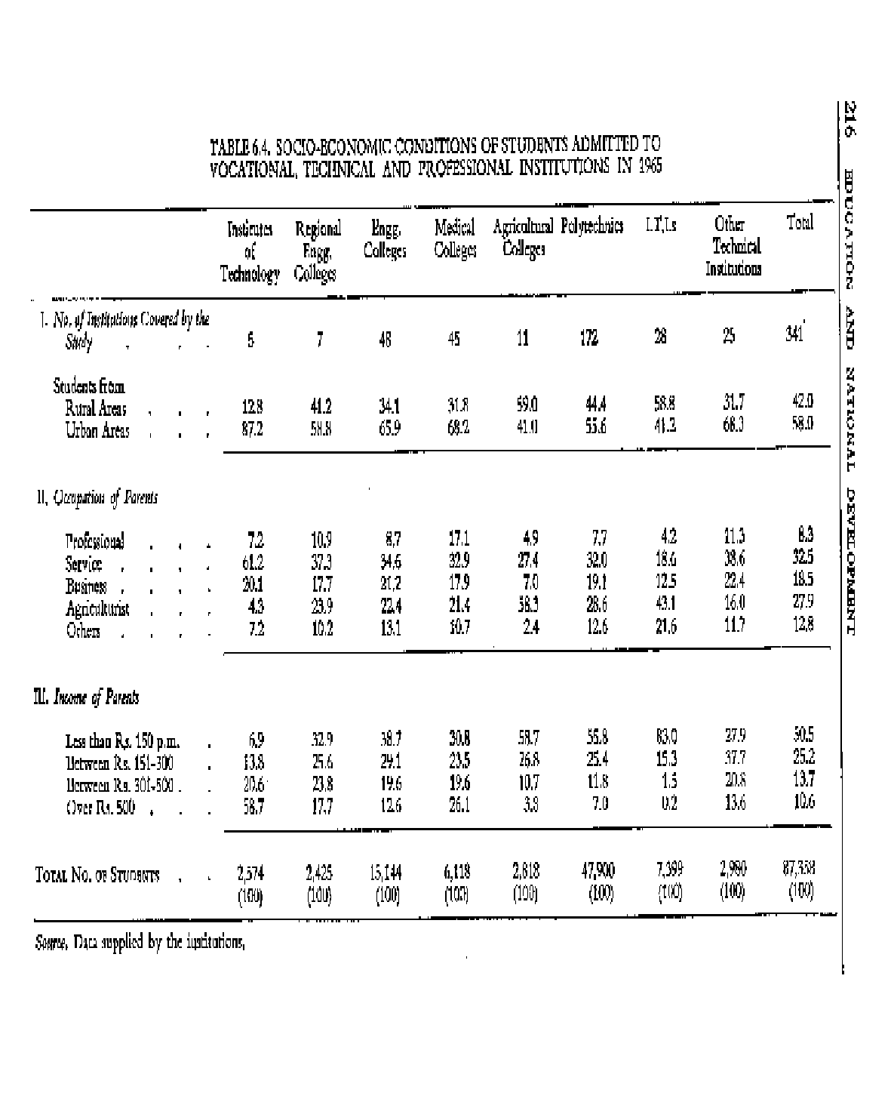

6.33. With regard to the scholarships programme in vocational education, therefore, we make the following recommendations:

- It is necessary to make more intensive efforts in future to introduce an egalitarian element in admissions to institutions of vocational education and particularly to institutions like the institutes of technology and colleges of engineering and medicine.

- The admission examinations to the institutes of technology are held in English. This gives an undue weightage to students from English medium schools to which the rich send their children. We recommend that these admission examinations should be held in English and also in the regional languages and the best students from each linguistic group should be selected, if necessary, on the basis of a quota related to population. Some of the students so selected may not be quite up to the standard in English. But this deficiency should be overcome by giving an intensive training in English to the selected students in their first year at the institutes.

- The proportion of scholarships in institutions of vocational education should be much larger than in those of general education. At the school stage, about 30 per cent of the students should be covered by scholarships of one type or another; and at the collegiate stage, this proportion should be raised to 50 Per cent.

  - Scholarships for Study Abroad. A national programme for award of scholarships to enable some of our best talented persons to go abroad for further education or training in research is also needed. Young persons so trained would be of very great use for the development of agriculture, industry, universities and research centres. We, therefore, recommend that a national programme of about 500 awards a year should be set up for this purpose.

  - Loan Scholarships. An important issue raised in the evidence before us relates to the general use of loan scholarships. One view was that all scholarships in higher education should be given in the form of loans only. Three arguments were put forward in support of the proposal:

    - it would set up a revolving fund in 5-10 years that would greatly reduce the burden on the State revenue;

    - it would prevent wasteful expenditure as students would draw only the minimum amount required for their maintenance; and

    - it would help to build up character and create a sense of responsibility and self-respect in the rising generation.

The counter-argument was that a programme of loan scholarships involves innumerable administrative problems about recoveries and causes hardship to young persons who would have to begin life with a heavy load of debt. To meet this, an elaborate proposal for the establishment of a National Scholarships Foundation to be-set up by the

Government of India under an Act of Parliament was advocated. This proposal visualizes that the Corporation would start functioning with a fairly big capital fund, say of Rs. 500 million or more. The interest to be charged on scholarships would be kept to the minimum, to cover only bad debts and administrative expenditure. The necessary loans would be advanced to young persons on their personal security only. Recovery would begin one year after the person begins to earn; and there would be no recovery if the earnings fall below a prescribed level. The installments to be paid would be related to the total earnings of the Person in a graduated manner. There would also be a suitable provision for bonuses or discounts for prompt payments; and to facilitate recovery, every employer would be under an obligation to deduct the loan-repayment installments from the salary at source, on the analogy of the Income-Tax Act.

  - While we are attracted by several features of a scheme of this type, we are not in favour of restricting all scholarships inn higher education to loans only; For the next ten years, the proposal of loan scholarships does not have any advantage over that of outright scholarships-the needed funds would have to be raised through taxation in either case. We also think that an exclusive programme of loan scholarships is non-egalitarian since it creates a disadvantage only for the economically handicapped students. It will also not be workable-unless a fair element of subsidy is provided-for students of humanities whose chances of employment and level of earning leave much to be desired. We would, therefore, prefer a proposal in which a programme of outright scholarships is combined with one of loan scholarships.

  - As we visualize it, the programme of loan scholarships in higher education should be organized on the following lines:

- The programme would be a supplement to that of outright scholarships which should be provided on the scale we have suggested.

- It would be essentially meant for students in the sciences and the professional courses where the chances of employment and levels of earnings are comparatively better and are more likely to make the scheme successful. There should be no upper limit to the number of such loan scholarships in this sector and an attempt should be made to provide financial assistance to every needy student. To a limited extent and in deserving cases, the programme should be extended to cover arts students also.

- If a person who holds a loan scholarship joins the teaching profession, one-tenth of the loan should be written off for each year of service. This will encourage good students to join this profession.

- For convenient administration of the loan scholarships programme, a National Loan Scholarships Board may be set up as outlined above.

  - The programme of scholarships and placement at the university stage will have to be accompanied by a complementary programme of developing quality institutions. This need will be met by the development of major universities, centers of advanced study,

and of at least one good college in each district. The details of these programmes are discussed elsewhere.⁵⁴

  - Some General Problems relating to Student Aid. We shall now briefly discuss a few other related issues. These relate to all stages of education.

- Transport. The provision of transport facilities can help to reduce the cost on hostels and scholarships. We have seen schools in rural areas which provide bicycles to the students who have to come from a distance. An arrangement of this type should be encouraged, as it makes the secondary school accessible to students in outlying villages. Wherever possible, the same arrangement could also be extended to other categories of institutions.

- Day-Study centres and Lodging Houses. For students who do not have adequate facilities for study at home, it is necessary to provide a large number of day-study centres at the secondary and university stages. It would also be desirable to provide lodging houses, i.e., places where they can stay throughout the day, and even at night, but go home for food. Some institutions have tried to provide this facility by adopting an unorthodox approach i.e., by using classrooms for residential and study purposes before and after school hours and at night. Experiments of this type should be encouraged.

- Earn and Learn. Facilities for Students to earn and pay a part of their expenses should be developed on as large a scale as possible as a supplement to the programme of scholarships.

- Scholarships for Girls. In scholarships and other forms of student aid, preferential consideration should be given to the needs of girls.

⁵⁴Chapters XI-XIII.

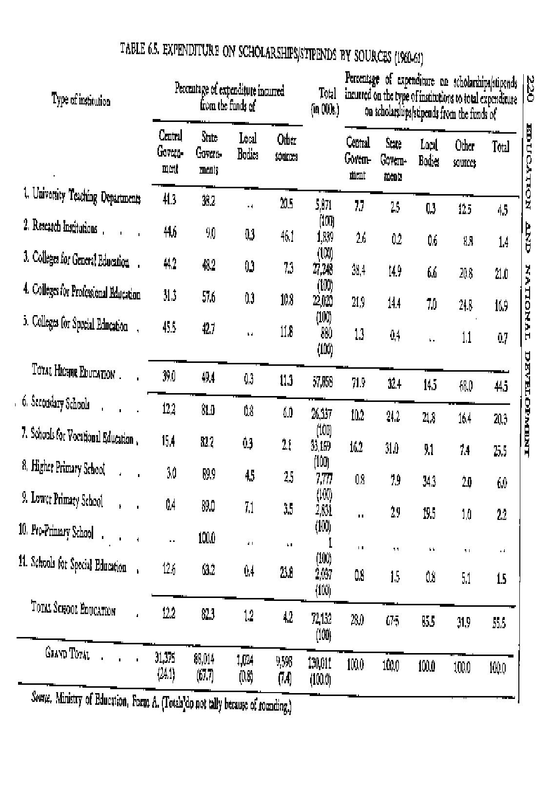

  - Financial Responsibility about Scholarships. The data given in Table 6.5 for 1960-61 (the latest year for which they are available) show how the expenditure on scholarships at different stages and indifferent sectors of education were financed. The position in 1965-66 is expected to be similar.

It will be seen that about 92 per cent of the expenditure on scholarships comes from Central and State Government funds. The Central funds account for nearly one-fourth of the total expenditure. More than seventy per cent of the Central expenditure on scholarships is incurred on higher education only. 6.41 Our recommendations in this regard are as follows:

- The responsibility for developing an adequate scholarship programme at the school stage should rest with the State Governments. In higher education, it should be regarded as a responsibility of the Government of India to make adequate provision for scholarships in all institutions of higher education-general and vocational-and also for scholarships for study abroad. We also trust that State Governments and other voluntary organizations which now provide some scholarships in higher education would continue to do so and even expand their effort.

- To develop a good programme of scholarships at the school stage, the funds needed for it should be provided in the centrally sponsored sector in the Fourth Plan and the same basis may be continued in the Fifth Plan. The State Governments would then be able to carry it on their own.

HANDICAPPED CHILDREN

  - We now turn to the education of handicapped children. Their education has to be organized not merely on humanitarian grounds, but also on grounds of utility. Proper education generally enables a handicapped child to overcome largely his (or her) handicap, and makes him a useful citizen. Social justice also demands it; it has to be remembered that the Constitutional Directive on compulsory education includes handicapped children as well. Very little has been done in this field so far; and on account of several difficulties, any great improvement in the situation does not seem to be practicable in the near future. All the same, it is important that a serious beginning is made immediately. Our proposals attempt to indicate a feasible programme of action which may well lay the foundation for a more massive attack on the problem to be made in later years. There is much in the field that we could learn from the educationally advanced countries which in recent years have developed new methods and techniques, based on advances in science and medicine.

  - Scope and Size of the Programme. The primary task of education for a handicapped child is to prepare him for adjustment to a socio-cultural environment designed to meet the needs of the normal. It is essential, therefore, that the education of handicapped children should be an inseparable part of the general educational system. The differences lie in the methods employed to teach the child and the means the child uses to acquire information. These differences in methodology do not influence the

content or the goals of education. This form of education is, therefore, conveniently referred to as `special education'.

  - Determination of the size of the handicapped population has eluded educators, planners and social workers not only in this country but also in many of the economically advanced countries. For instance, even the United States does not have a reliable estimate of the number of handicapped children. From the available evidence, it appears, however, that the total population in the following categories is about 2.5 million in our country.

- The Blind. A recent survey undertaken under the auspices of the Ministry of Health has, however, suggested that the number of blind persons might be of the order of four million. This is also the estimate of the Royal Commonwealth Society for the Blind, London. The number of children of school age is estimated at 400,000.

- The Deaf. No national survey of the incidence of deafness has been undertaken. Estimates based on a few sample surveys would seem to indicate that the number of deaf persons in the country maybe anywhere between 1 million and 1.5 Million. The number of children of school-going age is believed to be about 300,000.

- The Orthopaedically Handicapped. No national survey of this category of handicapped persons has yet been undertaken. Again, based on a few sample surveys, it would appear that the number of orthopaedically handicapped children in the country is about the same as that of the blind.

- The Mentally Retarded. Mental retardation is a complex concept influenced to a large extent by cultural factors and its determination involves the administration of sophisticated psychological tests. It is, therefore, difficult to estimate the number of such children in the country. Here again, estimates based on somewhat inadequate sample surveys seem to suggest that the country may have between 1.4 million and 1.8 million mentally retarded children.

Briefly, the position is summed is up below :
TABLE 6.6. ESTIMATED NUMBER OF HANDICAPPED CHILDREN

Category | Estimated number of children
The Blind | 400,000
The Deaf | 300,000
The Orthopaedically Handicapped | 400,000
The Mentally Retarded | 1,400,000
TOTAL | 2,500,000

  - Existing Educational Facilities. The present position of educational facilities for these children is as follows:

- The Blind. At present, there are about 115 schools and other establishments for the blind with an enrolment of 5,000 or a little over 1 per cent of the total number of blind children in the country. Most of these institutions impart primary education coupled with training in a few simple handicrafts. Music forms an integral part of the curriculum. The great majority of the existing institutions are run by voluntary agencies but are assisted by State Governments. The Central Government has set up a comprehensive National Centre for the Blind at Dehra Dun. This Centre includes a Central Braille Press which publishes textbooks and other reading material in Braille. The Centre also has a workshop for the manufacture of Braille appliances, which produces the basic equipment needed for the education of the blind. There are three centres for the training of teachers of the blind sponsored by the Government of India and they can train between 30 and 40 teachers annually. In addition, the Governments of Madras and Andhra Pradesh conduct courses for training teachers when needed.

- The Deaf The number of schools for deaf children is about 70. Most of these schools provide primary education coupled with some pre-vocational training in engineering and non-engineering occupations. The majority are privately managed but are aided by the State Governments. The total enrolment is about 4,000 or a little over one per cent of the total population of such children. About half a dozen centres for the training of teachers of the deaf are functioning at present and can train 50 to 60 teachers per annum.

- The Orthopaedically Handicapped. The major problem of this category of children is locomotor in character and they often attend ordinary schools. At present, there are about 25 institutions for such children with a total enrolment not exceeding about 1,000. Since most orthopaedically handicapped children do not present special educational problems, it is not considered necessary to have specially trained teachers for this category of children.

- The Mentally Retarded. On account of its complexity, this aspect of special education has received very little attention. There are only about 27 schools for mentally retarded children with a total enrolment not exceeding 2,000. One of these schools is run by the Government of India. Two centres for the training of teachers of mentally retarded children are functioning at present and they can train about 20 teachers annually.

At present, there are practically no facilities for the education of other categories of handicapped children. Some of the emotionally disturbed children are cared for in children's homes and other institutions set up under the various Children's Acts. As a rule, however, such homes are not intended primarily for the educational treatment of emotionally disturbed children.

It is evident from the brief review given in the preceding paragraphs that the existing facilities are extremely inadequate. In certain cases, the foundation has been laid while in others we have to begin at the beginning. The importance of a carefully thought-out plan

for the development of educational services for the handicapped cannot, therefore, be over-emphasized.

  - A Plan for Action. The progress in providing educational facilities to handicapped children will be limited by two main considerations; teachers and financial resources. A reasonable target will. therefore, be to provide, by 1986, education for about 15 per cent of the blind, deaf and orthopaedically handicapped children and to about 5 per cent of the mentally retarded ones-this will mean the provision of educational facilities for about 10 per cent of the total number of handicapped children. As a part of the programme, it should be possible to have at least one good institution for the education of handicapped children in each district.

  - This goal can be reached through the adoption of two programmes-the special and the integrated. In the special programmes which alone have been developed so far in our country, the handicapped children are isolated from the normal ones and placed in special institutions. In the educationally advanced countries, however, a great deal of stress is now being laid on the integration of handicapped children into the regular school programmes. This has several advantages of which two are important; reduction of costs and promoting mutual understanding between handicapped and the non-handicapped children. This has also its disadvantages. For instance, many handicapped children find it psychologically disturbing to be placed in an ordinary school. On an overall view of the problem, however, we feel that experimentation with the integrated programmes is urgently required and every attempt should be made to bring in as many children into integrated programmes as possible.

  - In addition, it will be desirable to develop services on a pilot basis for some additional categories of children who have peculiar educational needs, viz., the partially- sighted, the speech- handicapped, the aphasic, the brain-injured and the emotionally disturbed. As pointed out earlier, hardly any attempts have been made in this field-so far. It is impossible to state at this stage what the number of such children will be. Even the facilities for training teachers are very inadequate. The Ministry of Health is already in the process of setting up an institute for the training of speech- therapists at Bangalore. These speech-therapists could deal with speech-handicapped and aphasic children. There are hardly any facilities for the training of teachers for the partially-sighted or the emotionally disturbed and brain-injured children. We, therefore, suggest that an attempt should be made in the next two Plans, to set up a few centres as a pilot project to assist these categories of children. The whole problem may be reviewed again after 10 years.

  - To develop these programmes adequately, attention will have to be paid to the following matters:

- The preparation of teachers will need emphasis and attention. Assuming a pupil- teacher ratio of 10:1, about 16,500 teachers will be needed for the blind, deaf and mentally retarded children only. This will necessitate a considerable increase in the capacity of the existing training institutions and the establishment of new ones.

- It is necessary to coordinate the efforts of different agencies working in the field such as the Ministry of Education, the Central Social Welfare Board, voluntary organizations interested in the problem and the Ministry of Health. Similar coordination will also be needed at the State levels.

- It is also necessary to develop adequate research in the problem. We recommend that the Ministry of Education should develop a programme for this and allocate the necessary funds. The NCERT should have a cell for the study of handicapped children. The principal function of this cell would be to keep in touch with the research that is being done in the country and outside and to prepare materials for the use of teachers. 15

REGIONAL IMBALANCES

  - Imbalances of Educational Development in the States. The development of educational facilities in the different parts of the country has been very uneven and one of the important objectives of educational policy should be to strive to reduce the existing im- balances to the minimum. With a view to highlighting the problem, we made a special study of some of the regional imbalances as they exist between the different States and districts for the year 1960-61, the latest year for which the data are available. Table 6.7 shows some of the variations in the level of educational development in the States.

It will be seen that the State income per head is lowest in Bihar (Rs. 220.7) and the highest in Maharashtra (Rs. 468.5). The percentage of State income devoted to education is lowest in Orissa (1.5) and highest in Kerala (3.6). Illiteracy, both among men and women, is lowest in Kerala (450 and 611 respectively per 1,000 of population), and highest in Jammu and Kashmir (830 and 957 respectively). At the lower primary stage, the enrolment of boys and girls is highest in Kerala (115.4 per cent and 100 per cent respectively of the corresponding age-group) and lowest in Rajasthan (64.0 per cent and 16.3 per cent respectively).At the higher primary stage, Kerala again stands first (67.7 and 49.1 per cent respectively for boys and girls).while Orissa comes last (16.1 percent for boys and 2.0 per cent for girls). At the secondary stage, Assam is first for the enrolment of boys (25.5 per cent) and Kerala first for the enrolment of girls (12.6 per cent).But in both respects, Orissa stands last (7.5 per cent for boys and 0.7 per cent for girls).In higher education, West Bengal stands first with an enrolment of 40 per 10,000 of population and Orissa comes last, with an enrolment of 8 only.(See also chart on page 228.)

6.51. Imbalances in Educational Development in the Districts. The differences at the district level are much greater than those at the State level. Some of the most striking conclusions that emerged from our study in this regard are given below:

- Lower Primary Stage (Classes I-V). At the lower primary stage, the target to be reached is an enrolment of 142 per thousand (at 110 per cent of the total population in the age group 6-10). As against this, there is a wide spectrum of achievement. At the State

level, in case of total enrolment it ranges from 55 in Rajasthan to 140 in Kerala while in the case of girls it ranges from 23 in Rajasthan to 130 in Kerala. The mean enrolment of all children for all States was 74 with a standard deviation of 24.6. The mean for girls was 46.7 with a standard deviation of 23.8.
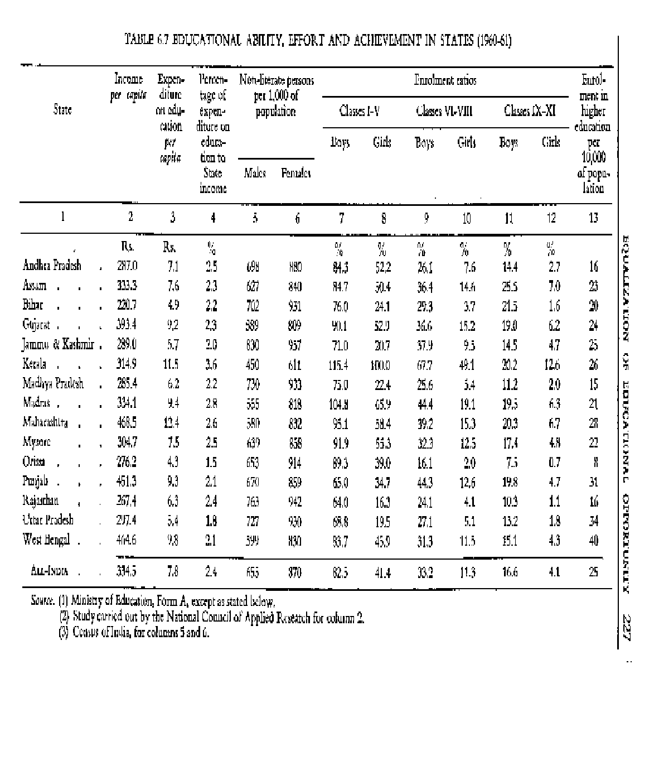

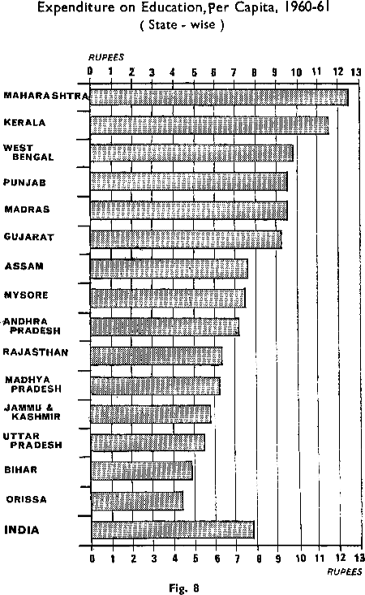

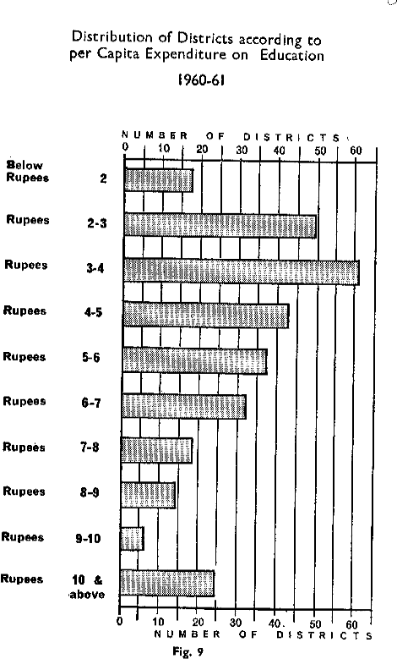

The variations between districts are even larger-from 21 in Barmer (Rajasthan) to 158 in Quilon (Kerala) for total enrolment and from 5 in Barmer to 151 in Quilon for girls. The districts with lowest and highest enrolments per 1,000 of population are given below (see also charts on pages 232 and 233):

TABLE 6.8. DISTRICTS WITH LOWEST AND HIGHEST TOTAL ENROLMENT AT LOWER PRIMARY STAGE

Districts with Lowest Total Enrolment Districts with Highest Total Enrolment
District | Enrolment | District | Enrolment
 | (per 1,000) |  | (per 1,000)
1. Barmer (Rajasthan) | 21 | 1. Quilon (Kerala) | 158
2. Coorg (Mysore) | 32 | 2. Alleppey (Kerala) | 156
3. Jaisalmer (Rajasthan) | 33 | 3. Trivandrum (Kerala) | 148
4. Jalore (Rajasthan) | 33 | 4. Ernakulam (Kerala) | 147
5. Gulbarga (Mysore) | 35 | 5. Kanya Kumari(Madras) | 147

TABLE 6.9. DISTRICTS WITH LOWEST AND HIGHEST ENROLMENT OF GIRLS AT LOWER PRIMARY STAGE

Districts with Lowest Enrolment of Girls Districts with Highest Enrolment of Girls District Enrolment District Enrolment
(per 1,000) (per 1,000)
- Barmer (Rajasthan) 5 1. Quilon (Kerala) 151
- Sidhi (Madhya Pradesh) 7 2. Alleppey (Kerala) 147
- Jaisalmer (Rajasthan) 8 3. Kottayam (Kerala) 141
- Jalore (Rajasthan) 8 4. Kanya Kurmri (Madras) 139
- Tehri Garhwal
(Uttar Pradesh) 8 5. Mizo (Assam) 138
Target. An enrolment of 142 per thousand in total and 143 for girls.

- Higher Primary Stage (Classes VI-VIII). At the higher primary stage, the picture is similar, although the task that remains to be done is far greater. At the State level, the highest total enrolment was 41 per thousand in Kerala and lowest-5 per thousand in Orissa. In respect of girls, the highest enrolment was 35 per thousand, again in Kerala, while it was lowest-1 per thousand in Orissa, 2 per thousand in Bihar and 3 per thousand in Madhya Pradesh, Rajasthan and Uttar Pradesh. The mean and standard deviations for all States were 13.7 and 8.3 in the case of all children and 6.7 and 7.3 in the case of girls. The variations between the districts, which are wider, are given below (see also charts on pages 234 and 235).

TABLE 6.10. DISTRICTS WITH LOWEST AND HIGHEST TOTAL ENROLMENT AT HIGHER PRIMARY STAGE

Districts with Lowest Total District | Enrolment Enrolment | Districts with Highest Total District | Enrolment Enrolment
 | (per 1,000) |  | (per 1,000)
1. Kalahandi (Orissa) | 2 | 1. Alleppey (Kerala) | 59
2. Koraput (Orissa) | 2 | 2. Quilon (Kerala) | 53
3. Barmer (Rajasthan) | 3 | 3. Kottayam (Kerala) | 48
4. Bastar (Madhya Pradesh)3 4. Trivandrum (Kerala) 46
5. Bolangir (Orissa). | 3 | 5. Trichur (Kerala) | 44

TABLE 6.11. DISTRICTS WITH LOWEST AND HIGHEST ENROLMENT OF GIRLS AT HIGHER PRIMARY STAGE

Districts with Lowest Enrolment of Girls Districts with Highest Enrolment of Girls District Enrolment District Enrolment
(per 1,000) (per 1,000)
- Sidhi (Madhya Pradesh) 0.1 1. Alleppey (Kerala) 53
- Kalahandi (Orissa) 0.2 2. Quilon (Kerala) 46
- Jalore (Rajasthan) 0.3 3. Kottayam (Kerala) 45
- Barmer (Rajasthan) 0.3 4. Trivandrum (Kerala) 41
- Jaisalmer (Rajasthan) 0.5 5. Trichur (Kerala) 37
Target: An enrolment of 75 per thousand, both for total and for girls (110 p.c. of the age-group 11-13).

- Secondary Education Stage (Classes IX-XI). Kerala again stands first with an enrolment of 11 per thousand of population for total enrolment and 8 per thousand of population for girls, while Orissa stands last with an enrolment of 2 per thousand for all children and a negligible enrolment for girls. The mean enrolment for all States was 6.29 for total (with a standard deviation of 3.5) and that for girls was 2.21 (with a standard deviation of 2.8). At the district level, the differences are even greater as the following figures will show (see also chart on page 237):
TABLE 6.12. DISTRICTS WITH LOWEST AND HIGHEST TOTAL ENROLMENT AT SECONDARY STAGE
Districts with Lowest Total Enrolment Districts with Highest Total Enrolment
District | Enrolment (per 1,000) | District Enrolment  (per 1,000)
1. Kalahandi (Orissa) | 1 | 1. Greater Bombay  (Maharashtra) 23
2. Baudhi Khondmal (Orissa) | 1 | 2. Debra Dun (U.P.) 21
3. Sidhi  (Madhya Pradesh) | 1 | 3. Kanya Kumari (Madras) 20
4. Bastar (Madhya Pradesh) | 1 | 4. Alleppey (Kerala) 18
5. Ladakh  (Jammu & Kashmir) | 1 | 5. Ambala (Punjab) 18

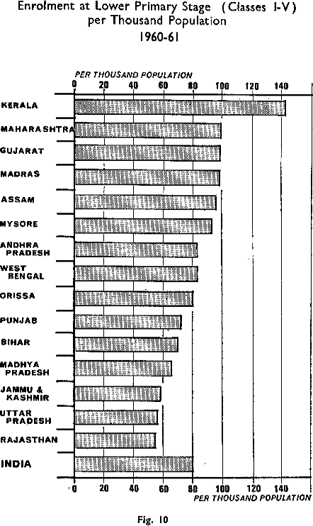

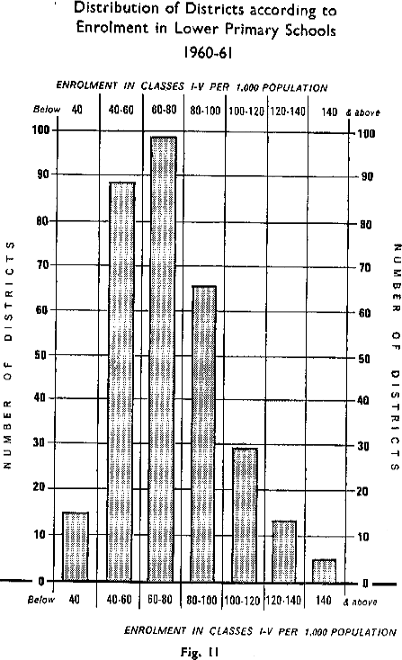

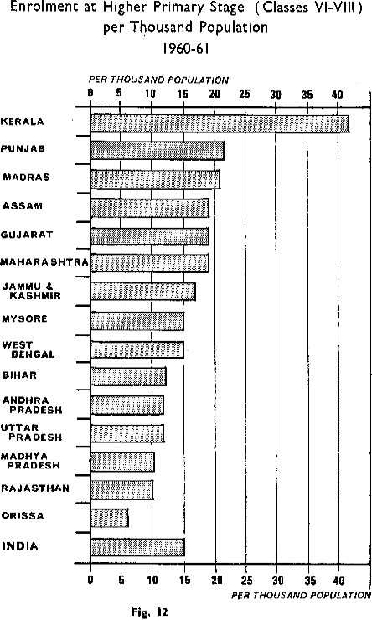

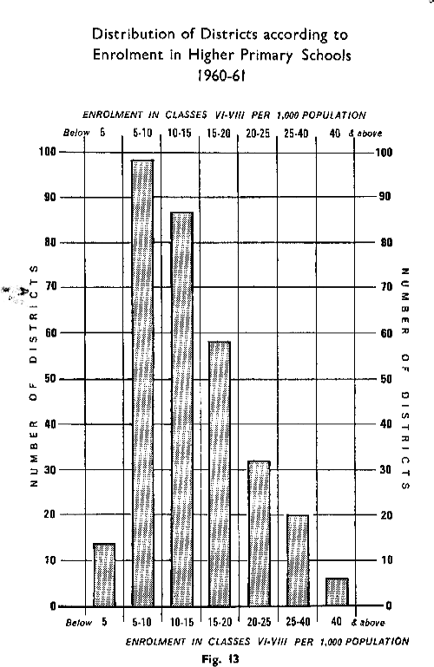

TABLE 6.13. DISTRICTS WITH LOWEST AND HIGHEST ENROLMENT OF
GIRLS AT SECONDARY STAGE

Districts with Lowest Enrolment of Girls Districts with Highest Enrolment of Girls District Enrolment District Enrolment
(per 1,000) (per 1,000)

- Ladakh (J & K) 0.01 1. Greater Bombay
(Maharashtra) 20
- Sidhi (Madhya Pradesh) 0.02 2. Kanya Kumari (Madras) 15
- Jalore (Rajasthan) 0.03 3. Dehra Dun (U.P.) 14
- Kalahandi (Orissa) 0.06 4. Madras Corporation 13
- Barmer (Rajasthan) 0.07 5. Calcutta Corporation 12

Target for 1986: 27 per 1,000 population.

(4) Educational Expenditure (Direct) per Head of Population. With regard to total direct expenditure per capita, Kerala spends highest (Rs. 11.2) and Orissa lowest (Rs. 2.8). There are 17 districts which spend less than Rs. 2.00 and 25 districts which spend more than Rs. 10 per head of population. The five districts with the highest and the lowest expenditure per head of population on education are given in Table 6.14.

TABLE 6.14. DISTRICTS WITH LOWEST AND HIGHEST EDUCATIONAL
EXPENDITURE

Districts with lowest educational expenditure Districts with highest educational
expenditure (excluding city districts)
District Expendi- District Expendi- ture ture
per head per head

Rs. Rs.
- Kalahandi (Orissa) 1.1 1. Poona (Maharashtra) 16.2
- Mohindergarh (Punjab) 1.2 2. Trivandrum (Kerala) 15.6
- Koraput (Orissa) 1.3 3. Nagpur 15.3
- Bolangir (Orissa) 1.5 4. Sehore (Madhya Pradesh) 14.3
- Fatehpur (U.P.) 1.5 5. Trichur (Kerala) 14.2

The chart on page 229 shows the distribution of districts according to per capita expenditure on education.

  - Recommendations. The programmes for the reduction of regional imbalances in educational development will have to be pursued side by side with the wider programmes for removing imbalances in the socio-economic development. The problem is complex

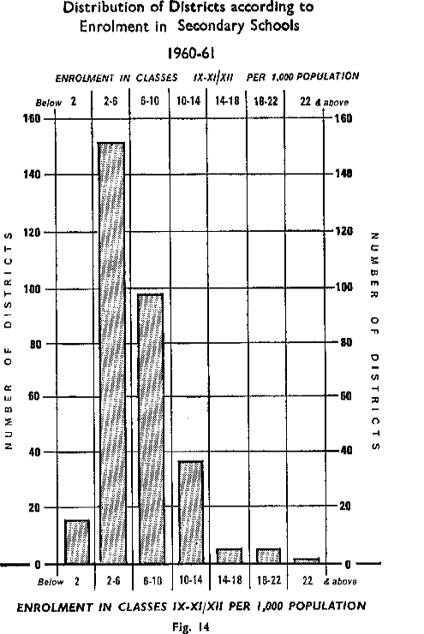

and difficult; and its solution will have to be spread over a number of years. Our principal object in this Report is to draw attention to this problem and to highlight its significance. In our opinion, the solution of the problem can be considerably facilitated if an emphasis is laid on removal of imbalances in educational development. From this point of view, we suggest that action should be taken on the following lines:

- A total elimination of these differences in educational development is neither possible nor desirable. In the larger interests of the country each region should be free to strive its best and to develop at its own pace. This will necessarily lead to some inequalities of development. But what is needed is a balancing factor, a deliberate and sustained effort to assist the less advanced areas to come up to at least certain minimum levels so that the gap between them and the advanced areas would be reduced to the minimum. This is the policy of `equalization' under which each area is assisted, subject to the condition that it makes a given effort to come up to certain minimum levels prescribed. Our grants-in-aid in education will have to be broadly based on this principle of equalization.

- The district should be adopted as the basic unit for educational planning and development. Our detailed proposals in this regard will be discussed elsewhere.⁵⁵

- At the State level, there should be a deliberate policy of equalization of educational development in the different districts and the necessary administrative and financial measures to this end should be taken.

- At the national level, it should be regarded as the responsibility of the Government of India to secure equalization of educational development in the different States. The necessary programmes for this, including special assistance to the less advanced States, should be developed.

EDUCATION OF GIRLS

  - The significance of the education of girls cannot be over- emphasized. For full development of our human resources, the improvement of homes, and for moulding the character of children during the most impressionable years of infancy, the education of women is of even greater importance than that of men. As stated earlier, the education of women can assist greatly in reducing the fertility rate.

In the modern world, the role of the woman goes much beyond the home and the bringing up of children. She is now adopting a career of her own and sharing equally with man the responsibility for the development of society in all its aspects. This is the direction in which we shall have to move. In the struggle for freedom, Indian women fought side by side with men. This equal partnership will have to continue in the fight against hunger, poverty, ignorance and ill- health.

⁵⁵Chapter XVIII.

  - Development of the Education of Girls (1950-51 to 1965-66). There has been a phenomenal development in the education of women-one of the most distinctive characteristics of life in modern India-in the last 150 years At the beginning of the nineteenth century, there was hardly any provision for the formal education of girls. Even at the opening of the present century, not much progress had been made. In 1901, the percentage of literacy amongst women was only 0.8. The number of girls enrolled for every 100 boys was only 12 at the primary stage and 4 at the secondary. The total enrolment in higher education was only 264 (which included 76 girls reading in medical colleges and 11 in colleges of education). Much faster progress was made in the next 50 years, both in raising their social status and in developing their education; and the progress in the last fifteen years has been almost phenomenal. This will be seen from the statistics given in Table 6.15.

TABLE 6.15 EDUCATION OF GIRLS (1950-1965)

1950-51 | 1955-56 | 1960-61 | 1965-66  (Estimated)
1. Enrolment of Girls in Classes I-V
(1) Total enrolment (in 000's) 5,385 | 7,639 | 11,401 | 18,145
(2) No. of girls for every 100  boys enrolled 39 | 44 | 48 | 55
(3) Percentage of girls in  schools for boys 74.8 | 79.2 | 82.1 | 85.0
2. Enrolment of Girls in Classes VI-VIII  (1) Total enrolment (in 000's) 534 | 867 | 1,630 | 2,839
(2) No. of girls for every 100  boys enrolled 21 | 25 | 32 | 35
(3) Percentage of girls in schools  for boys 26.7 | 51.8 | 68.9 | 78.0
3. Enrolment of Girls in Classes IX-XI  (1) Total enrolment (in 000's) 163 | 320 | 541 | 1,069
(2) No. of girls for every 100  boys enrolled 15 | 21 | 23 | 26
(3) Percentage of girls in schools  for boys 21.0 | 29.7 | 36.4 | 40.0

4. Enrolment of Girls at the University
Stage (General Education)
(1) Total enrolment (in 000's) | 40 | 84 | 150 | 271
(2) No. of girls for every 100 boys  enrolled | 14 | 17 | 23 | 24
(3) Percentage of girls in boys' institutions | 56.0 | 53.1 | 50.2 | 48.2
5. Enrolment of Girls in Vocat- ional Courses (School standard)  (1) Total enrolment (in 000's) | 41 | 66 | 86 | 120
(2) No. of girls for every 100 boys enrolled | 28 | 31 | 25 | 23
6. Enrolment of Girls in Professio- nal Courses (Collegiate Standard)  (1) Total enrolment (in 000's) | 5 | 9 | 26 | 50
(2) No. of girls for every 100  boys enrolled | 5 | 7 | 11 | 14

Source. Ministry of Education, Form A, except for the year 1965-66 estimates for which were made in the Secretariat of the Education Commission.

Some interesting points emerge from this data. The rate of expansion of education of girls is much faster than that among the boys so that the gap between them is gradually and steadily narrowing. At the lower primary stage, the number of girls enrolled per 100 boys has increased from 12 in 1901 to 39 in 1950 and to 55 in 1965. At the secondary stage,
the corresponding figures are 4 in 1901, 15 in 1950 and 26 in 1965. In higher education, their enrolment has increased from a mere 264 in 1901 to 40,000 in 1950 and to 240,000 in 1965. Education in mixed schools is being accepted more at the lower primary stage where 85 per cent of the girls enrolled are in mixed schools and at the higher primary stage where the proportion is 78 per cent. But there is still a considerable resistance to it at the secondary stage where only 40 per cent of the girls enrolled are in mixed schools. These resistances, however, soften down to some extent at the university stage.

  - Recommendations. The problem of women's education has in recent years been examined by a number of committees: the National Committee on the Education of Women under the chairmanship of Smt. Durgabai Deshmukh; the Committee on Differentiation of Curricula between Boys and Girls under the chairmanship of Smt. Hansa Mehta; and the Committee under the chairmanship of Shri M. Bhaktavatsalam which studied the problem in the six States where the education of girls is less developed. We fully endorse the recommendations of these Committees.

  - In our opinion, the strategy for the development of the education of girls and women will have to take two forms. The first is to emphasize the `special' programmes recommended by the National Committee on Women's Education; and the second is to give attention to the education of girls at all stages and in all sectors as an integral part of the general programmes for the expansion and improvement of education. With regard to the first, we recommend that, as suggested by the National Committee, action should be taken on the following lines:

- The education of women should be regarded as a major programme in education for some years to come and a bold and determined effort should be made to face the difficulties involved and to close the existing gap between the education of men and women in as short a time as possible;

- Special schemes should be prepared for this purpose and the funds required for them should be provided on a priority basis; and

- Both at the Centre and in the States, there should be a special machinery to look after the education of girls and women. It should bring together officials and non-officials in the planning and implementation of programmes for women's education.

These special programmes, by their very nature, are temporary and will have to be pursued only till the gap between the education of boys and girls is almost bridged. But they should not be made an excuse for neglecting the second aspect of the strategy, viz., giving adequate attention to the education of girls at all stages and in all sectors. In fact, if this had been done right from the beginning, the need for special programmes would hardly have arisen. in our opinion, a stage has now been reached when intensive effort should be made to develop this aspect of the strategy so that the need for special programmes will disappear in the course of a few years.

  - The role of women outside the home has become an important feature of the social and economic life of the country and in the years to come, this will assume large proportions affecting a majority of women. it will, therefore, be necessary to pay adequate attention to the problems of training and employment of women.

- An important problem is to enable women to carry out their dual role of home-making and following a suitable career. The Census of 1961 shows that there are at present more than a million young women, below the age of 24 and with a minimum qualification of matriculation, who are working only as housewives-and this number will increase still further in the days ahead. To enable these women to participate in programmes of national reconstruction, opportunities for part-time employment will have to be greatly increased. In addition, they will have to be drawn, wherever possible, into all types of nation-building activities on an honorary basis as well.

- Side by side, opportunities for full-time employment will also have to be expanded. As the age of marriage continues to rise, full-time employment will have to be provided for almost all young unmarried women. it may also be expected that, as in other

countries, once their children reach a school-going age, women will have a great deal of time on their hands and will desire to spend it usefully by taking up full-time employment. This need also will have to be satisfactorily met. Teaching, nursing and social service are well-recognized areas where women can have a useful role to play. Opportunities for women will have to be largely expanded in these fields and several new avenues, covering almost all the different walks of life, will have to opened out.

  - Our recommendations regarding different aspects of women's education have been given, in the appropriate context in this Report, along with those for the education of boys.

EDUCATION OR SCHEDULED TRIBES

  - The Problem. It is necessary to pay special attention to the education of children from the backward classes which include the Scheduled Castes, the Scheduled Tribes, denotified communities and a few nomadic and semi-nomadic groups.

- In so far as the Scheduled Castes are concerned, the problem has become a little easier because of the diminution in the rigour of untouchability. For its early solution, however, we recommend that the existing programmes for the education of the Scheduled Castes should continue and be expanded.

- With regard to the last category, it may be stated that there are several nomadic and semi-nomadic groups in the country whose educational needs have been hitherto neglected almost completely. It will not be easy to provide educational facilities for such groups. To the extent possible, such groups have to be assisted in developing more settled ways of living. This calls for a degree of fundamental reorganization in their economy and their way of life and, therefore, for close study of their problems with a view to evolving solutions which will meet their needs and secure their cooperation. While such a process of change would only be carried out over several years, efforts have to be made to provide marketing, credit, health and educational facilities in a mobile form wherever there are sizable nomadic groups. Similar facilities are required for communities which migrate from their homes for several months in the year.

- The problem of denotified communities is small in magnitude, but extremely difficult. Patient work over years is needed. Provision of hostels where the children from these communities can live and grow up in a proper atmosphere is probably the best solution in the long run. In this section, we shall deal mainly with the education of the Scheduled Tribes which, in our opinion, deserve special emphasis.

  - Tribal people⁵⁶ generally live in forest areas which are difficult of access and where conditions of life can be very trying. Some of them live in small concentrations in the midst of a non-tribal population; but the larger proportion of tribal people live in areas which are predominantly inhabited by the tribals themselves. Examples of these are groups of districts in Madhya Pradesh, Bihar, Orissa, the hill districts of Assam and other areas in the North-Eastern region.

  - The problem is comparatively simple in the former case where the tribals live in
`small pockets' or they are mixed up as it were with the rest of the population and constitute a smaller part. In such cases, special attention will have to be paid to the needs of the tribals to ensure that they receive a fair share of the benefits of educational development. But the situation becomes uniquely challenging in the predominantly tribal areas because here is presented an ideal opportunity for an integrated development to which we referred earlier.⁵⁷ In all these areas, three tasks stand out above all others. These are, firstly, development of communications; secondly, transformation of the present system of shifting cultivation into a developing agricultural economy, including care of forests, improved systems of shifting cultivation, settled cultivation and pasture; and thirdly, development of a system of education related to the scheme of economic and social development and responsive to the cultural and economic needs of the people.

  - The problems of education among the tribals have received a good deal of attention in recent years. They were examined in detail by the Commission on Scheduled Areas and Scheduled Tribes under the chairmanship of Shri U. N. Dhebar. They were also discussed in two seminars organized by the Planning Commission in New Delhi and by the NCERT at Udaipur. We broadly agree with their re-commendations.

  - Present Position. The latest available statistics for the education of the Scheduled Tribes are for 1960-61 and have been summarized in Table 6.16. The principal object of the table to compare the education of the Scheduled Tribes with that of the general population of the State. For instance, if the proportion of the Scheduled Tribes population in Madhya Pradesh is 20.6 per cent, and if their educational progress were the same as that of the general population, we should expect that the percentage of enrolment would also be the same. But this is never the case. In some cases (e.g. , primary education in Assam), the enrolment of tribal children is greater than that of the general populations,⁵⁸ showing thereby that the tribals are a little more educationally advanced than the average citizen. On the other hand, the percentage of their enrolment is very much lower in most areas and shows the extent of their educational backwardness.
56We are not very happy with the word `tribal'. It has certain overtones which are resented, and rightly so, by the tribal people. We recommend that the Government of India should adopt a suitable alternative phrase to describe these brethren of ours In the meanwhile, we have reluctantly retained the use of the word.

⁵⁷Chapter V.
58This does not mean that all tribes are equally advanced. Even in Assam, there are extremely backward tribes like Mikirs and educationally advanced tribes like the Mizos.

It will be seen from Table 6.16 that the education of tribals is relatively better developed at the lower primary stage only in some States, e.g., Assam, Gujarat or Maharashtra. Even at this stage, the position is far from happy in States like Madhya Pradesh or Rajasthan. There is a sudden drop in enrolments after the lower primary stage in all parts of the country- This shows that the wastage among the tribals is much greater than in the population as a whole. The principal weakness in tribal education is really in the age- group 11- 17 or higher primary and lower secondary education where the programme of scholarships and other assistance is not adequately development and in our where talent is either eliminated or remains underdeveloped and, in our opinion , it is this area to which greater attention will have to be paid in the future. There is a slight improvement of enrolments in higher education because of the Central programme of scholarships. Vocational education is obviously more popular with the tribal students everywhere. The tribals have a natural aptitude for such practical programmes and these deserve every encouragement.

  - Primary Education. Intensive efforts will have to be made

TABLE 6.16 EDUCATION AMONG THE SCHEDULED TRIBES (1961)

Percentage of Percentage of enrolment of Scheduled Tribes to total enrolment Scheduled
Tribes Lower Higher Secondary Higher Vocational Grand State population primary primary education and total
to total professional
population education
of the State

Andhra Pradesh 3.7 2.3 0.7 0.6 0.4 1.8 1.9

Assam 17.4 24.0 16.2 9.3 9.8 32.9 20.9

Bihar 9.1 8.7 7.4 3.7 2.4 7.1 7.6

Gujarat 13.3 12.4 7.5 1.9 0.2 12.0 8.1

Jammu & Kashmir.. .. .. .. .. .. .. Kerala 1.2 0.5 0.4 0.2 .. 0.1 ..
Madhya Pradesh | 20.6 | 12.3 | 6.5 | 2.2 | 2.2 | 5.0 | 9.0
Madras | 0.7 | 0.5 | 0.1 | 0.2 | 0.8 | 0.3 | 0.4
Maharashtra | 6.1 | 6.6 | 0.1 | 1.0 | 0.6 | 2.6 | 3.4
Mysore | 0.1 | 0.7 | 0.2 | 0.2 | 0.1 | 0.4 | 0.6

Orissa .. .. .. .. .. .. ..

Punjab | 0.1 | 0.1 | 0.1 | 0.1 | 0.2 | 0.3 | 0.1
Rajasthan | 11.5 | 2.3 | 0.9 | 0.6 | 0.5 | 4.5 | 1.9
Uttar Pradesh | .. | .. | .. | .. | .. | .. | ..
West Bengal | 5.9 | 3.5 | 3.2 | 1.4 | 0.3 | 8.5 | 3.4

Source. Ministry of Education, Form A. Data for Orissa were not available. Population of Scheduled Tribes in Jammu and Kashmir and Uttar Pradesh was negligible.

among the tribal people to provide five years' effective education for all children by 1975-76. This will need an intensive programme of parental education. Special encouragement should be given to the education of girls and this will not be difficult because women have a good status in tribal life. The teachers should be invariably conversant with the tribal languages. The medium of education in the first two years of the school should be the tribal language and books should be specially prepared in these languages (using the script of the regional language) for use at this stage. During this period, the children should be given oral instruction in the regional language and their familiarity and command over it should be improved. By the third year, the regional language should be the medium of education. There will be no difficulty in this because the children will already have learnt the script and become familiar with the language.⁵⁹

  - It is necessary to improve the provision of educational facilities which are often very meagre. In very sparsely populated areas, Ashram Schools will have to be established in large numbers. To attract children to schools and to hold them, the working and programmes of the schools should be made to harmonize with the environment. Vacations and holidays should coincide with agricultural and forest operations and social festivities. The school hours should be fixed to suit the work the children are required to do for their families. These measures are needed for the rural population as a whole. But they are of special significance for tribal education. Moreover, the introduction of work experience and an emphasis on art education would attract the tribal children as would the teaching of folk songs, stories and riddles which are so popular with the tribal. Tribal games and archery as well as tribal music and dances should be introduced as extra- curricular activities.

  - Secondary Education. Far greater attention will have to be paid, as stated earlier, to the development of higher primary and secondary education among the tribals. For this a programme of hostels is very essential. Brighter children should be picked up at the lower primary stage and admitted to hostels. Careful arrangements should also be made for

⁵⁹Where the Roman script is already being used for tribal languages, the practice may be continued.

giving personal guidance and some extra tuition to these children so that they will be able to perform better in comparison with the non-tribal students. The additional expenditure on such extra tuition will be small; but it will greatly enhance the effectiveness of the large expenditure on hostels which we incur at present. The scheme of Ashram Schools is very good from this point of view. It should be developed as largely as possible.

  - Tribal children find difficulties in getting admission to good higher primary or secondary schools. The Education Departments would have to make special efforts to secure such admission and, if necessary, offer some inducements to the schools for this purpose. Where admission to such schools requires a better preparation on the part of the students, special measures should be taken to provide this coaching to tribal students and to bring them up to the required standard. As stated earlier, tribals are fond of vocational courses. Special efforts should, therefore, be made to place them in good vocational schools, the junior technical schools, the industrial training institutes, polytechnics, etc. Special vocational schools should also be organized for the grown-up children who leave school at the end of the lower primary stage.

  - Higher Education. It is necessary to streamline the administration of the scholarships programme instituted by the Government of India. In this context, we make the following recommendations:

- The administration of scholarships and other aids needs to be decentralized a great deal. Heads of institutions should be authorized to grant scholarships, along with admission, on their own authority. For this purpose, the necessary amount should be placed at their disposal well in advance of the academic year. This could be done on the basis of the previous year's expenditure with a margin for increase.

- The scope of the programme should be expanded to include, not only the provision of funds but also the provision of such additional coaching facilities as may be required, watching of progress, planning ahead of careers and ensuring placement in appropriate institutions, or in other words to provide for a personal follow-up. The staff necessary for this purpose should be made available.

- The scope of scholarships should cover all courses available to secondary school leavers; and special preference should be given to vocational and technical courses, including those at industrial training institutes.

  - General. The basic issue in the development of tribal life and education is the provision of leadership of the right type. For the next few years at any rate, this leadership will have to come from the non-tribal people-officials and non-officials-but the ultimate solution of the problem requires the development of a proper leadership among the tribals themselves. Our attempt in this field should, therefore, be directed to both these objectives.

  - There are not many non-tribal persons who want to live and work among the tribals. But a few individuals and institutions are devoted to this cause. They should be

encouraged and provided with necessary funds so that they could recruit and train batches of young persons who would be willing to adopt the service of the tribals as their mission in life. Among the officials, the main difficulty is that of continuous transfers. No officer remains long enough in the tribal areas to understand their problems and to be able to identify himself with the tribal interests. Many of them are not even aware of the tribal language. In several tribal areas, we found a lack of rapport between the officials and the tribal people which probably was a major reason for the inadequate implementation of developmental schemes. To overcome this difficulty, it is necessary to have sub-cadres amongst officers in all departments. The persons in these sub-cadres will be selected for their competence and aptitude for work among the tribals. Once an officer is recruited to this cadre, his work should be watched for an year or two in the first instance and if it is found satisfactory, he should be retained in it for a period of 10 to 15 years at least and posted to work with the tribals. There should be special allowances or privileges to go with the cadre which should be attractive enough for the better type of officers to compete for admission to it. Such special cadres are very necessary for teachers. We have discussed this problem elsewhere.⁶⁰

6.71. To develop leadership among the tribal people themselves, some unorthodox approaches are necessary. It is but natural that young tribals who have received secondary or higher education should go out of their areas in search of employment. The work among the tribal areas would, therefore, have to be done, for some years to come, by tribals who have received comparatively less formal education but whose identification with their people would be deeper and greater. It is necessary to pick up such young persons, give them training through specially organized courses and use them as our workers for tribal uplift. In doing so, several of the formal rules of recruitment will have to be set aside. But probably this is the only way in which some tangible progress can be made in the immediate future.

  - Different tribal people are at varying stages of economic and cultural development. There is much difference in the skills they have attained and in the technology they employ. Therefore, in predominantly tribal areas, each group and the area in which it lives, should be studied closely, and appropriate patterns of development worked out in close cooperation with the people. It is in terms of such a design of development that educational programmes, institutions and priorities should be proposed. A uniform approach as between different tribal areas, applied in a mechanical manner, will not secure the purpose in view.

  - To be able to do justice to the tasks and problems of tribal education, it is important that the Ministry of Education at the Centre and the Departments of Education in those States which have sizable tribal populations, should be equipped with special sections or units whose task it would be to study the needs of the tribal people and assist in

⁶⁰Chapter III.

developing educational systems best calculated to promote their welfare and development. These sections or units should work in close collaboration with other Ministries or Departments involved in the programme. Aspects of tribal education which might call for special attention will vary from area to area, and no pains should be spared in understanding the problems which arise in different contexts.

  - There is a very great dearth of statistical information regarding the spread of education among the tribal people. It is necessary to collect this data, and we welcome the introduction of the new forms designed for this purpose by the Ministry of Education. In addition, it is necessary to carry out special investigations regarding important aspects of the spread of education amongst the tribals and their effect. A: continuous programme of research and evaluation has to be developed for this purpose. Although the tribal research institutes have a special role to play in this, it would be desirable to involve the universities also. We recommend that the UGC should set aside a fund for such research to be conducted through selected universities and special institutions.

  - The education of the backward classes in general and of the tribal people in particular is a major programme of equalization and of social and national integration. No expenditure is too great for the purpose.

SUMMARY

- Fees in Education. The country should work towards a stage when all education would be tuition-free. From this point of view:

  - tuition fees at the primary stage should be abolished in all government, local authority and aided private schools as early as possible and preferably before the end of the Fourth Plan;

  - lower secondary education should be made tuition-free in all government, local authority or aided private institutions as early as possible and preferably before the end of the Fifth Plan. if necessary, a phased programme may be drawn up for the purpose;

  - for the next ten years, the main effort with regard to fees in higher secondary and university education should be to extend provision of tuition-free education to all needy and deserving students. As a first step, the proportion of free-studentships should be increased to 30 per cent of the enrolment. 6.08-15

- Other Private Costs. Other private costs in education have increased greatly in recent years and not necessarily for educational reasons. Efforts are needed to reduce them to the minimum.

- Free textbooks and writing materials should be provided at the primary stage. Children freshly joining schools should be welcomed at a school function and presented with a set of books. Others should be presented with a complete set of books for the next year as soon as the results of the annual examinations are declared and before the long vacation starts so that they can use the vacations for further study.

- A programme of book-banks should be developed in secondary schools and institutions of higher education. The State Education Departments should have a fund at their disposal from which they can encourage the establishment of book-banks in secondary schools and a similar fund should be placed at the disposal of the UGC for organizing them in the universities and affiliated colleges.

- The libraries of secondary schools and institutions of higher education should contain an adequate number of sets of textbooks so that the students can have easy access to them.

- Grants for the purchase of books, which need not necessarily be textbooks, should be made to talented students-the top 10 per cent- in educational institutions. The scheme should begin in the universities and later on be extended to affiliated colleges and secondary schools.

- Scholarships. The programme of scholarships has received considerable emphasis in recent years, but it needs reorganization on the following lines:

(1) The scholarships programme is a continuous process and has to be organized at all stages of education. At present, the programme is weak and needs to be strengthened at the school stage. (2) It is necessary to evolve a more equitable and egalitarian basis for the award of scholarships. (3) A scholarships programme will yield better results it is accompanied by a programme to maintain an adequate number of quality institutions at every stage and in every sector and an attempt is made to place the talented students in these institutions.

- A careful watch should be kept at all points of transfer from one stage or sub-stage of education to another to ensure that all the abler students continue their studies further.

- An adequate machinery should be created for administering this combined programme of scholarships, placement and maintenance of quality institutions. 6.18

- The following programme of scholarships is proposed at the different stages of education:

  - Primary Stage. Steps should be taken to ensure that, at the end of the lower primary stage, no promising child is prevented from continuing-his studies further and to this end, a scholarship of an adequate amount will have to be provided to every child that may need it. It has been assumed that the target should be to provide scholarships for 2.5 per cent of the enrolment at the higher primary stage by 1975-76 and to 5 per cent of the same enrolment

  - Secondary stage. Steps should be taken to ensure that the top 15 per cent of the children in the age-group do get scholarships from higher primary to the secondary stage. To this end, the necessary financial assistance should be provided to about 10 per cent of the top students in class VII or VIII in each higher primary school. At least one good secondary school, with adequate residential facilities, should be developed in each community development block and admission to such institutions should be regulated on the basis of merit. 6.20-23

  - In every school, there should be a programme for the identification of talented students who should be provided with special enrichment programmes to suit their needs and to help in their growth.

  - University Stage. At the university stage the target for the provision for scholarships should be as follows:

    - Scholarships should be available to at least 15 per cent of the enrolment at the undergraduate stage by 1976 and to 25 per cent of such enrolment by 1986; and (b) scholarships should be available to at least 25 per cent of the enrolment at the postgraduate stage by 1976 and to 50 per cent of such enrolment by 1986. (5) There

should be two kinds of scholarships: (a) for those who have to stay in hostels; these should cover all the direct and indirect costs of education, such as tuition fees, books, supplies, etc.; and (b) for those who can stay at home and attend schools or colleges; these should mainly cover direct and indirect costs. At the lower stages, the scholarships of the second type would be most needed. As one goes up the educational ladder, the proportion of scholarships of the first type would have to be increased.

- Steps should be taken to study the indirect costs of education and living costs and to reduce them to the minimum. In particular, it is necessary to cut down hostel expenses by reducing the number of servants, etc.

- The amount of scholarships should be regulated in such a manner as to cover all costs. 6.24-26

- National Scholarships. (1) The scheme of national scholarships should be expanded. The target to be reached should be to cover the top 5 per cent of the students who pass out of the examinations by 1975-76 and 10 per cent of such students by 1985-86. The administration of the scheme should be still further simplified and decentralized. In particular, the power to issue entitlement cards should be delegated to the authorities holding the examinations at which these scholarships have been instituted.

(2) With a view to introducing a greater egalitarian element in the award of these scholarships, it is suggested that 50 per cent of these scholarships should be awarded, as at present, on the State basis. The remaining 50 per cent should be awarded on the
`school- cluster' basis in which a group of schools with similar socioeconomic background of students are grouped into a cluster and the top students from each cluster are awarded the scholarships. 6.27

- University Scholarships. To supplement the above, a scheme of university scholarships should be instituted and implemented through the UGC. The target to be reached should be to cover 10 per cent of the enrolment at the undergraduate stage and 20 per cent of the enrolment at the postgraduate stage by 1976.

- A Standing Committee on Postgraduate and Research Scholarships should be set up at the national level in the Ministry of Education. It should consist of the representatives of the Ministries which award scholarships at the postgraduate stage and its main function would be to coordinate the different scholarship programmes. 6.28-30

- Scholarships in Vocational Education. With regard to scholarships in vocational education, the following reforms are necessary:

  - It is necessary to make a more intensive effort to introduce an egalitarian element in admissions.

  - The admission examinations to IITs should be held in English and also in regional languages and the best students from each linguistic group should be selected, if

necessary, on the basis of quota related to population. If some of these students are not quit up to the standard in English, this deficiency should be overcome by giving an intensive training in English to the selected students in their first year at the institute.

  - At the school stage, about 30 per cent of the students should be given scholarships; and this proportion should be increased to 50 per cent at the collegiate stage. 6.31-33

- Scholarships for Study Abroad. There should be a national programme for the award of scholarships to the best talented students for study abroad. About 500 scholarships should be awarded each year. 6.34

- Loan Scholarships. It is necessary to institute a programme of loan scholarships to supplement the outright grant of scholarships described above. it should be organized on the following lines:

  - The programme would be a supplement to that of outright scholarships which should be provided on the scale we have suggested.

  - It would be essentially meant for students in the sciences and the professional courses where the chances of employment and levels of earning are comparatively better and are more likely to make the scheme successful. There should be no upper limit to the number of such loan scholarships in this sector and an attempt should be made to provide financial assistance to every needy student. To a limited extent and in deserving cases, the programme should be extended to cover arts students also.

  - If a person who holds a loan scholarship joins the teaching profession, one-tenth of the loan should be written off for each year of service. This will encourage good students to join this profession.

  - For convenient administration of the loan scholarships programme, a National Loan Scholarships Board may be set up as re- commended in the Report.

- Other Forms of Student Aid. Some other forms of student aid need development.

- Transport facilities should be provided imaginatively to reduce the cost on hostels and scholarships, e.g., we have seen schools in rural areas which provide bicycles to students who come from a distance.

- Day-Study Centres and lodging houses (i.e., places where the students can stay throughout the day and even at night but can go home for food) should be provided on a liberal scale.

- Facilities for students to earn and pay a part of their educational expenses should be developed. 6.35-37

- General. (1) In all programmes of scholarships, preferential consideration should be given to the needs of girls.

(2) The Government of India should assume the bulk of the responsibility for providing scholarships in higher education. At the school stage, this responsibility should vest in the State Governments. To develop a good programme of scholarships at the school stage, however, the funds needed for it should be provided in the centrally sponsored sector in the next two Plans. The State Governments may be able to develop the programme on their own thereafter. 6.39-41

- Handicapped Children. The progress in providing educational facilities to handicapped children will be limited by two main considerations: lack of teachers and financial resources. A reasonable target will, however, be to provide, by 1986, education for about 15 per cent of the blind, deaf and orthopaedically handicapped children and to about 5 per cent of the mentally retarded ones. This will mean the provision of educational facilities for about 10 per cent of the total number of handicapped children. As a part of this programme, it should be possible to have at least one good institution for the education of the handicapped children in each district.

- In the educationally advanced countries, a great deal of stress is now being laid on the integration of the handicapped children into regular school programmes. We feel that experimentation with integrated programmes is urgently required in our country and that every attempt should be made to bring in as many children into the integrated programmes as possible.

- In addition, it will be desirable to develop services on a pilot basis for some other categories of children who have peculiar educational needs, viz., the partially-sighted, the speech-handicapped, the aphasic, the brain-injured and the mentally disturbed.

- To develop the above programmes for the education of the handicapped children on proper lines, it Will be necessary to emphasize the training of teachers, the coordination of the efforts of the different agencies working in the field and to promote adequate research into the problem. 6.42-49

- Regional Imbalances. There are wide differences in the educational development in the different States. These become wider still at the district level. A reduction of these differences to the minimum is desirable and the programme for this will have to be pursued side by side with the wider programmes for reducing the imbalances in the socio- economic development of the different States and districts in the country. The solution of this complex problem will, however, be facilitated if action is, taken on the following lines:

  - A total elimination of these differences in educational development is neither possible nor desirable. What is needed, however, is a balancing factor, a deliberate and sustained effort to assist the less advanced areas to come up to at least certain minimum levels so that the gap between them and the advanced areas will be reduced.

  - The district should be adopted as the basic unit for educational planning and development.

  - At the State level, there should be a deliberate policy of equalization of educational development in the different districts and the necessary administrative and financial measures to this end should be taken.

  - At the national level, it should be regarded as the responsibility of the Government of India to secure equalization of educational development in the different States. The necessary programmes for this, including special assistance to the less advanced States, should be developed. 6.50-52

- Education of Women. We fully endorse the recommendations of the three committees which have examined the problem of women's education in recent years: (a) the National Committee on the Education of Women under the chairmanship of Shrimati Durgabai Deshmukh; (b) the Committee on Differentiation of Curricula between Boys and Girls under the chairmanship of Shrimati Hansa Mehta; and (c) the Committee under the chairmanship of Shri M. Bhaktavatsalam which studied the problem in the six States where the education of girls is less developed.

- We invite special attention to the following recommendations of the National Committee on Women's Education:

  - The education of women should be regarded as a major programme in education for some years to come and a bold and determined effort should be made to face the difficulties involved and to close the existing gap between the education of men and women in as short a time as possible;

  - Special schemes should be prepared for this purpose and the funds required for them should be provided on a priority basis; and

  - Both at the Centre and in the States, there should be a special machinery to look after the education of girls and women. It should bring together officials and non-officials in the planning and implementation of programmes for women's education.

- In addition, it will also be necessary to give adequate attention to the education of girls at all stages and in all sectors.

- The role of women outside the home has become an important feature of the social and economic life of the country and, in the years to come, this will become still more significant. From this point of view, greater attention will have to be paid to the problems of training and employment of women. Opportunities for part-time employment which would enable women to look after their homes and to have a career outside will have to be largely expanded. As the age of marriage continues to rise, full-time employment will have to be provided for almost all young and married women. As the programme of family planning develops, older women whose children have grown up, will also need

employment opportunities. Teaching, nursing and social service are well-recognized areas where women can have a useful role to play. In addition, several new avenues will have to be opened out to them. 6.53-58

- Education of the Backward Classes. (1) The existing programme for the education of the Scheduled Castes should continue and be expanded.

- Greater efforts are needed to provide educational facilities for the nomadic and semi- nomadic groups.

- Hostels should be provided for the children of the denotified communities.

- Education of the Tribal People. The education of the tribal people deserves great emphasis and attention. We broadly agree with the recommendations made in this respect by the Commission on Scheduled Areas and Scheduled Tribes under the chairmanship of Shri U. N. Dhebar and in the seminars on the education and employment of the tribal people organized by the Planning Commission and the NCERT. We invite special attention to the following programmes in this context:

  - At the primary stage, the provision of facilities will have to be improved and Ashram schools will have to be established in sparsely populated areas. The teachers should be invariably conversant with tribal languages. The medium of education for the first two years of the schools should be the tribal language; and during this period, the children should be given oral instruction in the regional language. By the third year, the regional language should become the medium of education. The programmes of the schools should be attuned to tribal life and atmosphere.

  - At the secondary stage, provision of schools, hostel facilities and scholarships has to be greatly-expanded.

  - In higher education, the administration of the scholarships programme will have to be decentralized for the programme to be efficient.

  - Provision for special tuition will have to be made both at the secondary and university stages.

  - It is essential to develop cadres of persons who will devote themselves to the service of the tribal people. In the early stages, these cadres will consist mostly of non-tribals but an effort has to be made to develop such cadres among the tribals themselves. From this point of view,

    - non-official organizations working in the tribal areas should be encouraged;

    - special sub-cadres should be formed among the official ranks with the object of selecting persons for work in the tribal areas. The emoluments for these sub-cadres should be good enough to attract the best persons available;

    - promising young persons from the tribals should be selected and specially trained to work in tribal areas. The usual prescriptions regarding recruitment or minimum qualifications will often have to be set aside in this programme. 6.59-75

APPENDIX I

AN EXPLANATORY NOTE ON ENROLMENT STATISTICS INCLUDED IN THE REPORT

(Prepared by Shri D. L. Sharma under the guidance of the Member- Secretary)

AI.01. The object of this Note is to explain the basis of compilation for the enrolment statistics included in this Report.

AI.02. The organization of the educational system, as visualised by the Education Commission, has been explained in detail in Chapter II. The manner in which the existing structure in the different States at the school stage is equated with this proposed structure, is shown below:

TABLE AI.1

EQUIVALENCE OF CLASSES I-X AT THE SCHOOL STAGE (1965-66)

X | X | XI | X
IX | IX | X | IX
VIII | VIII | IX | VIII
VII | VII | VIII | VII
VI | VI | VII | VI
V | V | VI | V
IV | IV | V | IV
III | III | IV | III
II | II | III | II
I | I | II | I
Pre- Primary Education | B  A | I

As proposed | Group A | Group B | Group C
by the | Assam | Andhra Pradesh | Jammu & Kashmir
Education | Nagaland | Bihar | Kerala
Commission | NEFA | Gujarat | Madhya Pradesh
 |  | Madras | Mysore
 |  | Maharashtra | Punjab
 |  | Orissa | Rajasthan
 |  | Dadra & Nagar | Uttar Pradesh
 |  | Haveli | West Bengal
 |  | Goa, Daman and | A & N Islands
 |  | Diu | Delhi
 |  | Pondicherry | Himachal Pradesh
 |  |  | L.M.A. Islands
 |  |  | Manipur
 |  |  | Tripura
A

Explanatory Note. (i) The chart given above shows the position in 1965-66. It has varied from time to time. In tabulating enrolment, the position as it was in the year concerned, has been adopted.

(ii) There is no public examination at the end of Class X in Madhya Pradesh, Delhi and A & N Islands. But the higher secondary examination in these areas, which is held at the end of Class XI, leads to the three-year degree course. We have, therefore, equated Class X in these areas with the class leading to the high school examination in other States.

AI.03. In the school stage ending with the high school, the total duration of schooling is 12 years in one group of States and Union Territories, 11 years in another group, and 10 years in the third group.

AI.04. The central point in this proposal is to treat the public examination at the end of the high school stage (which is Class X in some States and Class XI in others) as equivalent and to go downwards, equating each successive class in school education and also upwards, equating each successive year in higher education.

In the enrolment statistics given in the Report, the equation of school classes is as follows:

 | TABLE AI.2
Class in the Commission's Report |  | Equated with
Pre-Primary Stage |  | Infant A and B in Group A, Class I in Group B and Pre-Primary (not  shown in the chart) in 1 State.
Class
I |  | Class I in Groups A & C and Class II in Group B.
II |  | Class II in Groups A & C  and Class III in Group B,and so on.
X |  | Class X in Groups A & C, and Class XI in  Group B.

AI.05. The equivalence in higher education courses (arts and science) has been shown in the chart given below.
TABLE AI.3
EQUIVALENCE IN HIGHER EDUCATION
(1965-66)

(a) | (b) | (c) | (d) | (e) | (f) | (g)
 | III | III | A | III | III | III
First | II | II | II | II | II | II
Degree | I | I | I | I | I | I
Higher | XII | II | XII | A | A | A
Secondary | XI | I | XI | XI | XI/XII/ PUC | PUC

(a) (b) | (c) | (d) | (e) | (f) | (g)
As proposed by the Education Commission | Kerala (The first two years belong to | U.P. | Madhya Pradesh A & N Islands | Andhra Pradesh Assam Bihar | Gujarat Madras Nagaland Orissa
junior Colleges) |  | Delhi |  | Jammu & Goa, Kashmir Daman, Mahar- and Diu ashtra Pondicherry Mysore  Punjab Rajasthan West Bengal Himachal Pradesh Manipur NEFA  Tripura
Explanatory Note
- Columns marked 'A' show the year to be added by 1986.

- The chart given above shows the position in 1965- 66. It has varied from time to time. In tabulating enrolment, the position as it was in the year concerned has been adopted.

- PUC=Pre-University Course.

AI.06. Pre-Primary Education. In our statistics, pre-primary education includes enrolments in the following three categories:

  - Pre-Primary classes proper

  - Infant A Class

  - Infant B Class and Class I (where it corresponds to the Infant B Class).

AI.07. In each year of tabulation the corresponding enrolments in an the States and Union Territories which had the categories mentioned above have been aggregated together and given in Table AI.4

AI.08. General School Education. (Classes I-X). Enrolment in Classes I-X as aggregated by us, includes Classes II-XI in those States where the school stage is spread

over 11 years and Classes I-X in all the other States. The retabulated enrolments are

given in Table AI.5.

AI.09. Basis of Estimating Enrolments at the School Stage in 1965-66. The total enrolments at the school stage for 1965-66 were assumed to be the same as given by the Planning Commission. In breaking down these enrolments class by class, however, it was assumed that owing to the reduction of wastage and the increasing desire to stay longer at school the proportion of the enrolment in higher classes to the total enrolment at the school stage will be a little better in 1965-66 than in 1960-61. Table AI.6 shows the actual proportion of the enrolments in each class to the total enrolment at the school stage for the years 1950-51, 1955-56 and 1960-61 (on the new pattern of aggregation adopted by us). It also gives the assumptions made by us regarding this proportion for 1965-66.

AI.10. General School Education (Classes XI and XII). In tabulating enrolments in general school education in Classes XI and XII, the enrolments in the following categories were included:

    - Class XI of the higher secondary schools in all the States which have adopted the higher secondary pattern.

    - The pre-university class.

    - Intermediate classes (1st and 2nd year) in U.P. except the second year in the Universities of Aligarh and Banaras which have adopted the three-year degree course.

    - The first year of the Intermediate class in all the other States which have now adopted the three-year degree course (the second year, where it existed, has been shown in the undergraduate stage).

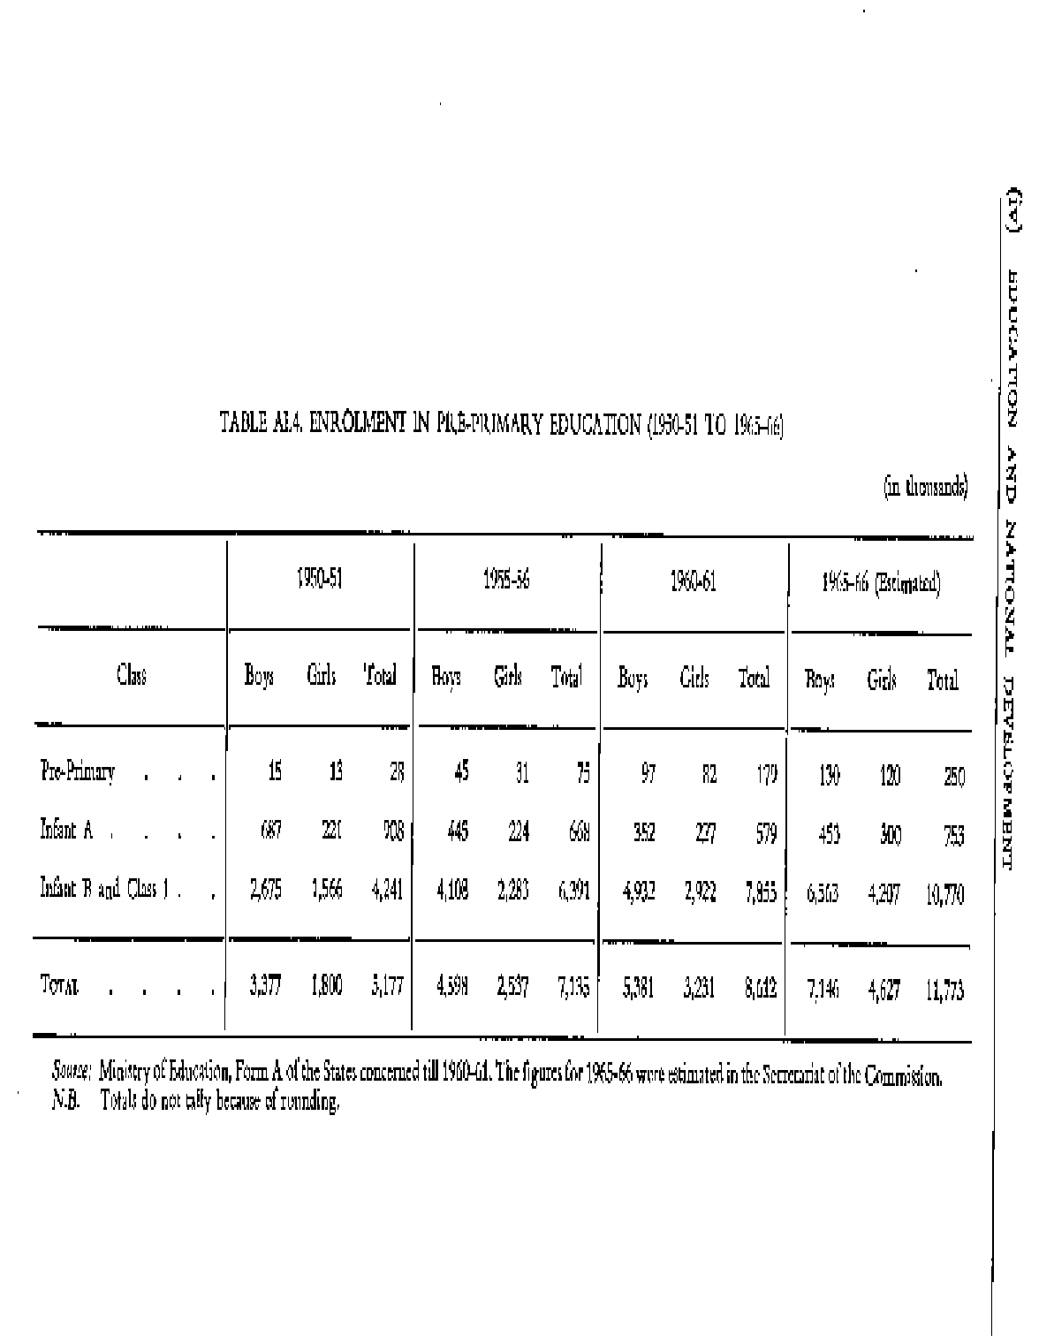

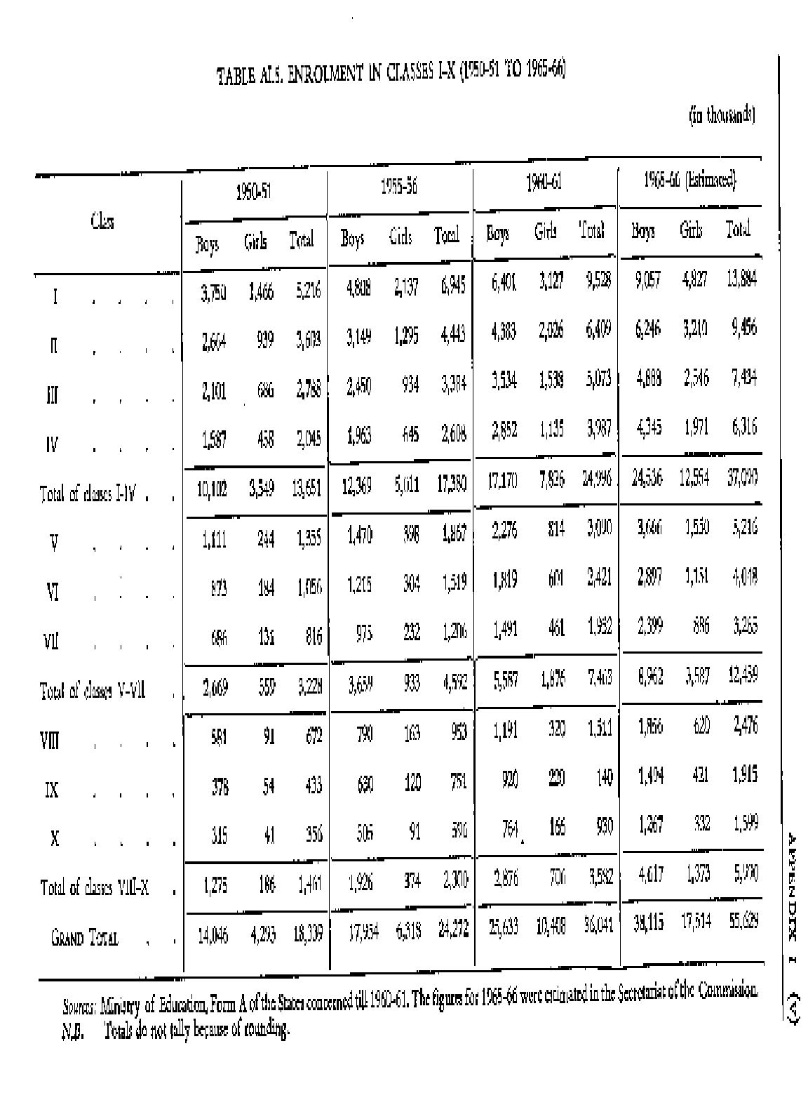

TABLE AI.6

PROPORTION OF ENROLMENT IN EACH CLASS AT THE SCHOOL STAGE TO TOTAL ENROLMENT

 | 1965-66 |  | 1950-51 |  | 1955-56 |  | 1960-61  (estimated)
Class | Boys Girls |  | Boys Girls |  | Boys Girls |  | Boys Girls
 | % | % | % | % | % | % | % | %
Pre-Primary | 0.1 | 0.2 | 0.2 | 0.4 | 0.3 | 0.6 | 0.3 | 0.6
A | 3.9 | 3.6 | 2.0 | 2.5 | 1.1 | 1.7 | 1.0 | 1.3
B | 15.4 | 25.7 | 18.2 | 25.8 | 15.9 21.4 |  | 14.5 19.0
I | 21.5 | 24.1 | 21.3 | 24.1 | 20.6 22.9 |  | 20.0 21.8
II | 15.3 | 15.4 | 14.0 | 14.6 | 14.1 14.9 |  | 13.8 14.5
III | 12.1 | 11.3 | 10.9 | 10.5 | 11.4 11.3 |  | 10.8 11.5
IV | 9.1 | 7.5 | 8.7 | 7.3 | 9.2 | 8.3 | 9.6 | 8.9
V | 6.4 | 4.0 | 6.5 | 4.5 | 7.3 | 6.0 | 8.1 | 7.0
VI | 5.0 | 3.0 | 5.4 | 3.4 | 5.9 | 4.4 | 6.4 | 5.2
VII | 3.9 | 2.1 | 4.3 | 2.6 | 4.8 | 3.4 | 5.3 | 4.0
VIII | 3.3 | 1.5 | 3.5 | 1.8 | 3.8 | 2.3 | 4.1 | 2.8
IX | 2.2 | 0.9 | 2.8 | 1.4 | 3.0 | 1.6 | 3.3 | 1.9
X | 1.8 | 0.7 | 2.2 | 1.0 | 2.5 | 1.2 | 2.8 | 1.5
TOTAL | 100.0 100.0 |  | 100.0 100.0 |  | 100.0 100.0 |  | 100.0 100.0

Source. Ministry of Education, Form A of the States till 1960- 61. The figures for 1965- 66 were estimated in the Secretariat of the Commission.

In short, we have shown the first year of the Intermediate class as a part of Classes XI and XII in all cases. Where the three-year degree course has been adopted, the second year has been shown in the undergraduate stage. Where the three-year degree course has

not been adopted, both the years have been shown under classes XI and XII, the only exception to this being the city of Bombay for which no separate figures are available.

The Intermediate (Commerce) classes have been regarded as part of general education and the corresponding enrolment has been shown under Classes XI and XII.

The retabulated enrolments on these assumptions have been given in Table AI.7

AI.11. General Education (Undergraduate Stage). In our retabulation, the enrolments in general education at the undergraduate stage include the following:

- Enrolments in the second year of the Intermediate classes in all States which have now adopted the three- year degree course.

- Enrolments in the First Degree Courses for Arts and Science.

- Enrolments in the First Degree Courses for Commerce.

AI.12. General Education (Postgraduate and Research). There are no difficulties about the enrolments in general education at the postgraduate stage and research. These have been taken from the publications of the Ministry of Education and are given in Table AI.8 along with the enrolments at undergraduate stage.

Al. 13. Vocational Schools. The enrolment in vocational schools is of a mixed character. In some courses such as polytechnics, admission is given only to those who have completed the secondary school. In other courses such as teacher-training or in industrial training institutes, admission is given to those who have completed the secondary school as well as to those who have completed the primary school only. In some other courses such as arts and crafts (e.g. tailoring) the admission is mostly of those who have not completed the secondary school, although there are a few students who have done so. It is, therefore, necessary to make certain assumptions regarding the enrolment of students who have completed the secondary school and of those who have completed the primary school only. We make the following assumptions:

- Teacher Training. 20 per cent of the enrolment was regarded as not having completed the secondary school.

- Arts and Crafts. All the enrolment was regarded as not having completed the secondary school.

In all other vocational courses, such as engineering and technology, medicine and veterinary science, agriculture and forestry, commerce, physical education, library science, co-operation, marine training, etc., the enrolment was regarded as being of the higher secondary stage or equivalent to Classes XI to XII. We realize that there is a small proportion of students in agriculture and medical schools who have not completed the

secondary school. But we have assumed that this will be off-set by the enrolment of students who have completed the secondary school and joined courses of arts and crafts.

AI.14. The enrolments in vocational courses retabulated on these bases are given in Table AI.9

AI.15. Professional Education at the University Stage. In professional education at the university stage, we divided the enrolments into three parts:

- Enrolments corresponding to the higher secondary stage or Classes XI and XII;

- Enrolments for the first degree or the undergraduate stage; and

- Enrolments for the second degree or the postgraduate stage.

Enrolments corresponding to those at the higher secondary stage (Classes XI and XII)

In the statistics of enrolments in training colleges, the enrolments of graduates preparing for the B.T. or B.Ed. degree are mixed up with those of matriculates undergoing a one or two year course. The enrolments in the B.T. or B.Ed. class are also separately available in the publication, Education in Universities issued by the Ministry of Education. Deducting these, after making adjustments for certain relevant factors, we estimated the enrolments of students in the training colleges who have completed the secondary school stage only. These have been shown as belonging to the higher secondary stage.

Similarly the enrolments for Intermediate Science (Agriculture) have been estimated and shown as vocational education at the school stage corresponding to Classes XI and XII.

In the same way we have estimated the enrolments in Intermediate (Commerce) and as pointed out earlier these have been shown under general education at the higher secondary stage.

All the remaining enrolments in the professional courses in higher education were divided into two categories: enrolments at the first degree stage (or undergraduate) and enrolments at the second and research degrees (or postgraduate).

AI.16. The retabulated enrolments on the above assumptions have been shown in Table Al. 10.

AI.17. Total Enrolments. The total enrolments in the educational system as a whole, re- tabulated on the lines indicated above, are given in Table Al. 11. In this context the following points may be noted:

- Enrolments in vocational education corresponding to the lower secondary stage (Classes VIII-X) have been taken from the school portion in Table Al. 9.

- Enrolments in vocational education corresponding to the higher secondary stage (Classes XI-XII) have been taken from Tables Al. 9 and AI. 10.

- No attempt has been made to retabulate the enrolments in special schools and colleges. These have been reproduced from the publications of the Ministry of Education.

AI.18. Enrolment Statistics published by the Ministry of Education. The enrolment statistics published by the Ministry of Education adopt a different system of equivalence at the school stage. They start by equating the lowest classes with one another, i.e. Infant 'A' in Assam, Class I in a State like Maharashtra with 11-year school system and also Class I in a State like Uttar Pradesh with a 10-year school system are all equated together. The equivalence proceeds upwards class by class. In this method, the main weakness is that classes which are quite unlike to each other are added together. For example, Class X of Uttar Pradesh which is matriculation class is added to Class X of Bihar which is pre- matriculation class or Class XI of Delhi which is the higher secondary class is added to Class XI of Maharashtra which is the matriculation class.

The enrolments according to this system have been given in Table Al. 12 for purposes of comparison. It will be seen that the totals of enrolments in Tables Al. 11 and Al. 12 tally. But the enrolments at substages do not tally for reasons already explained.

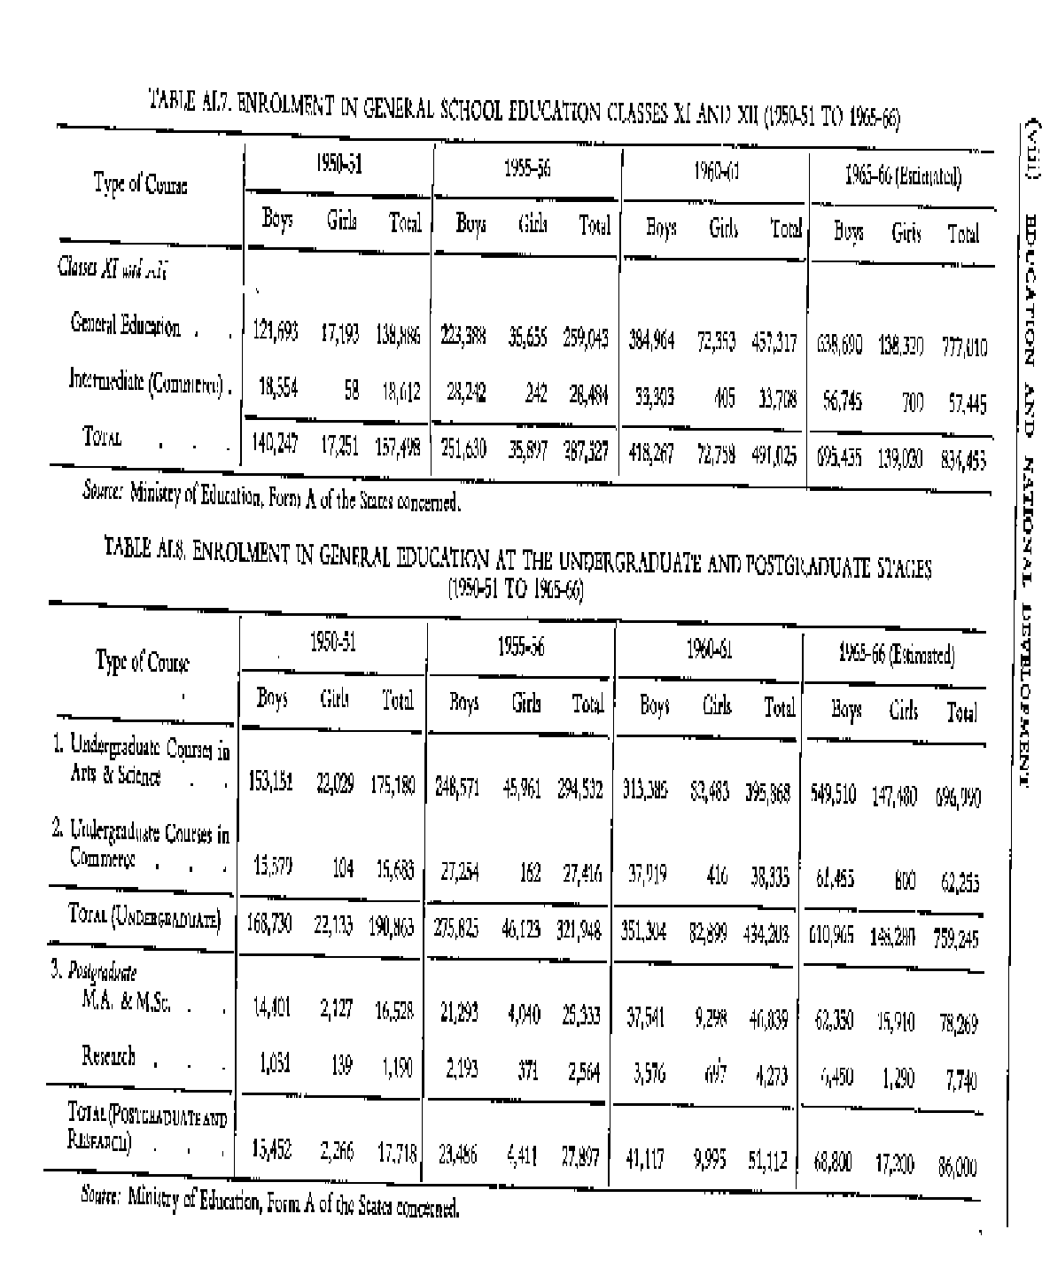

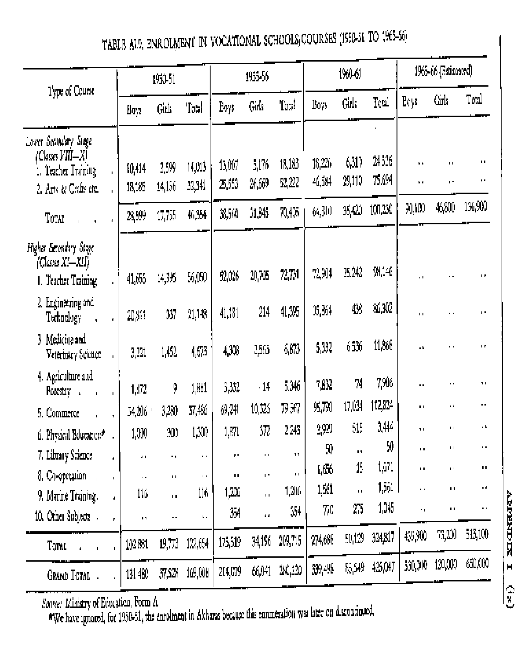

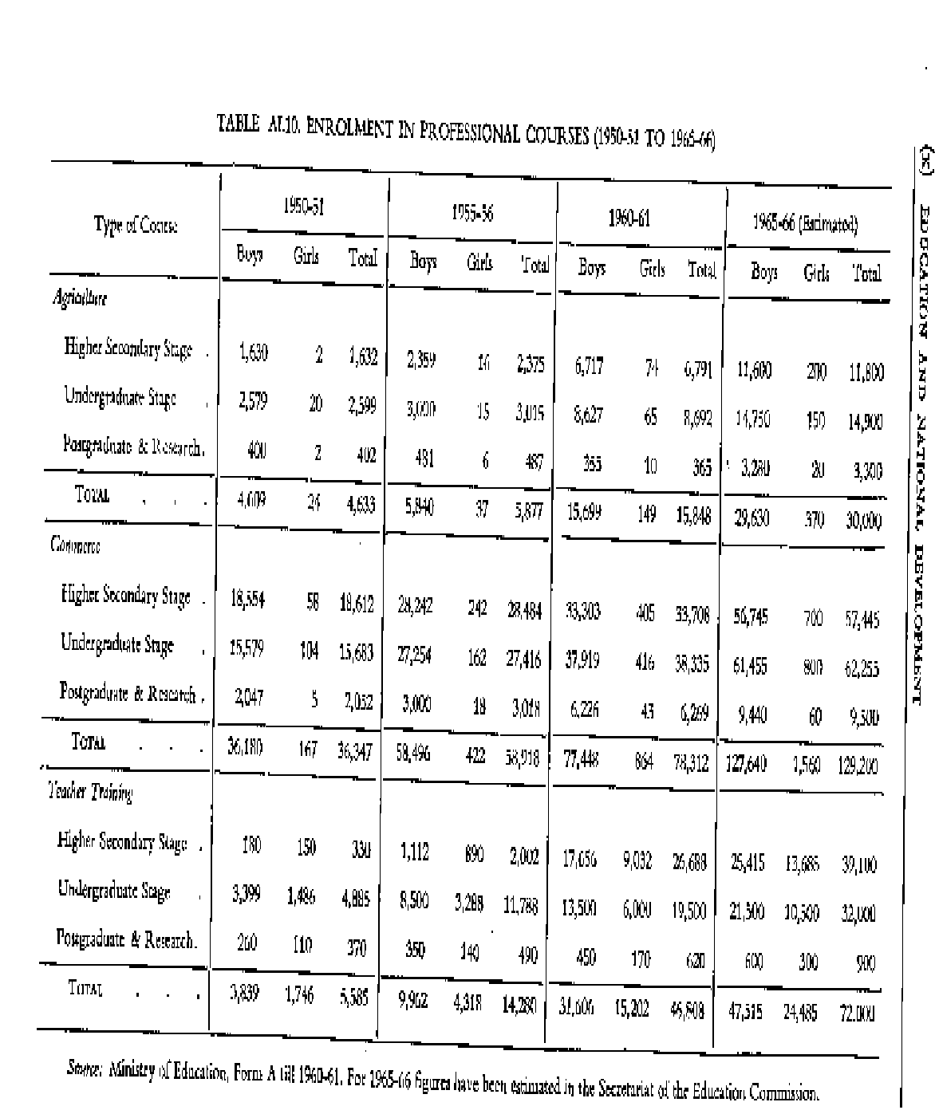

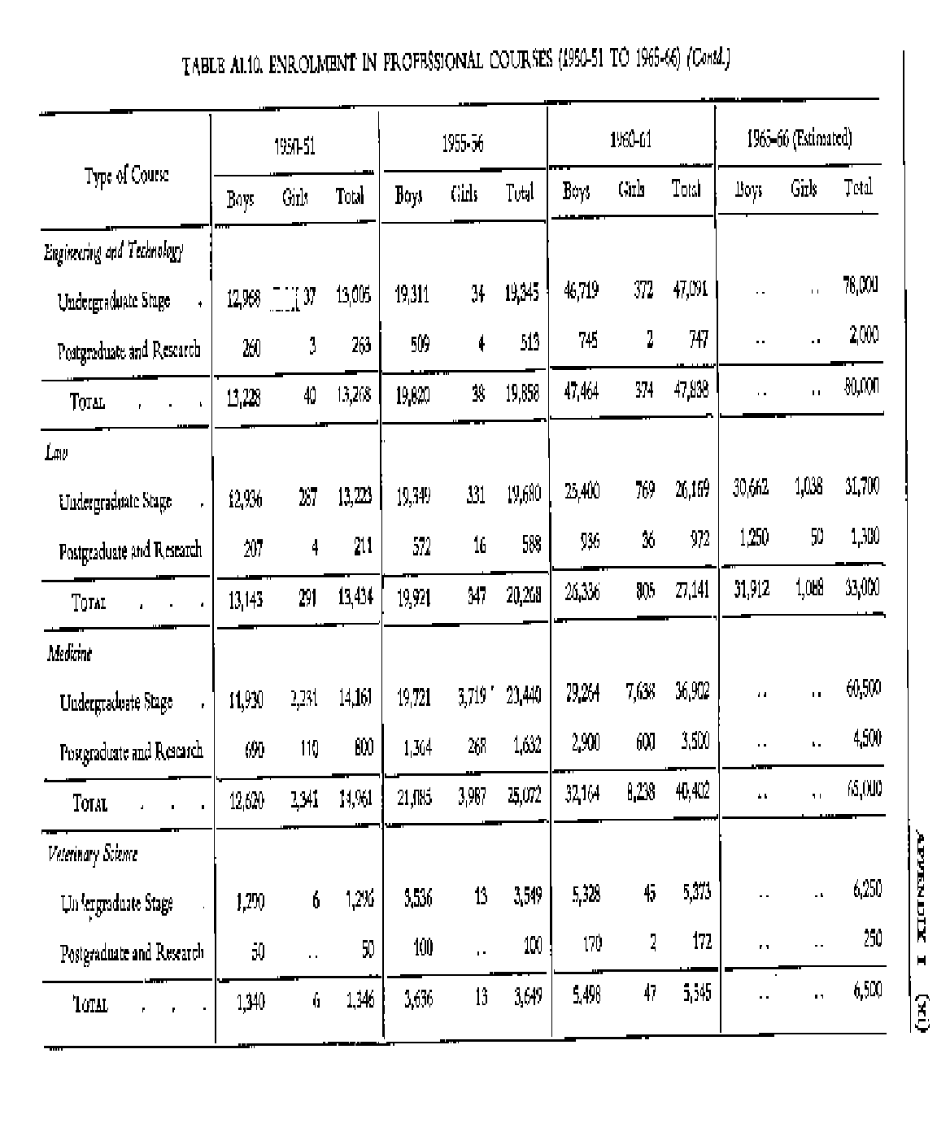

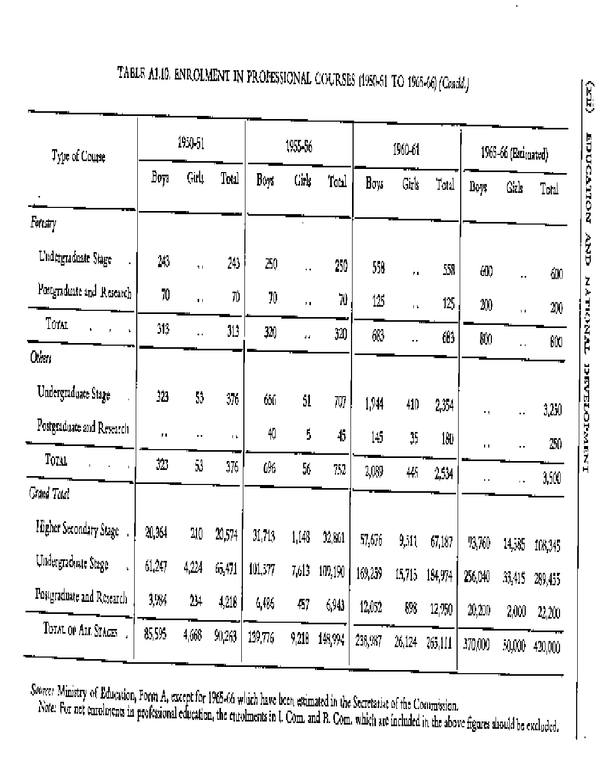

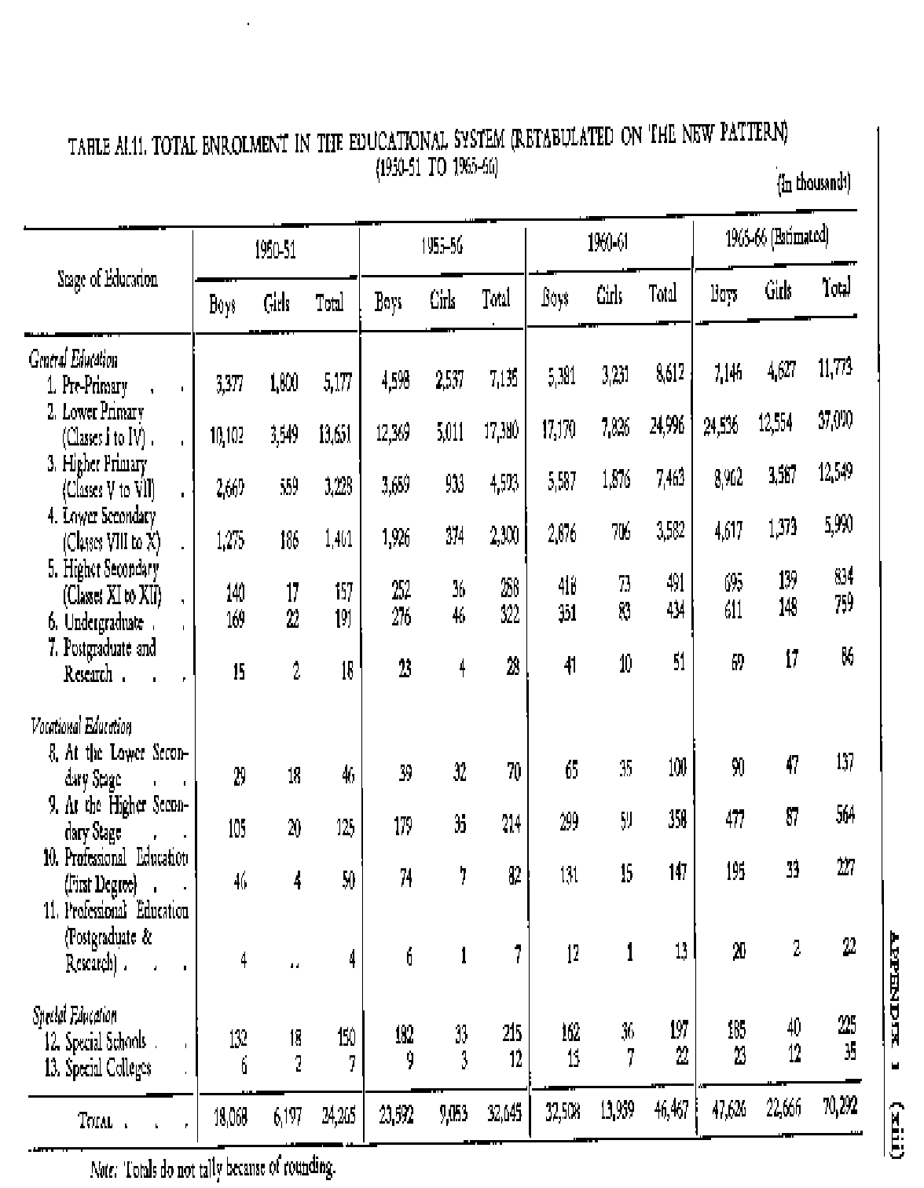

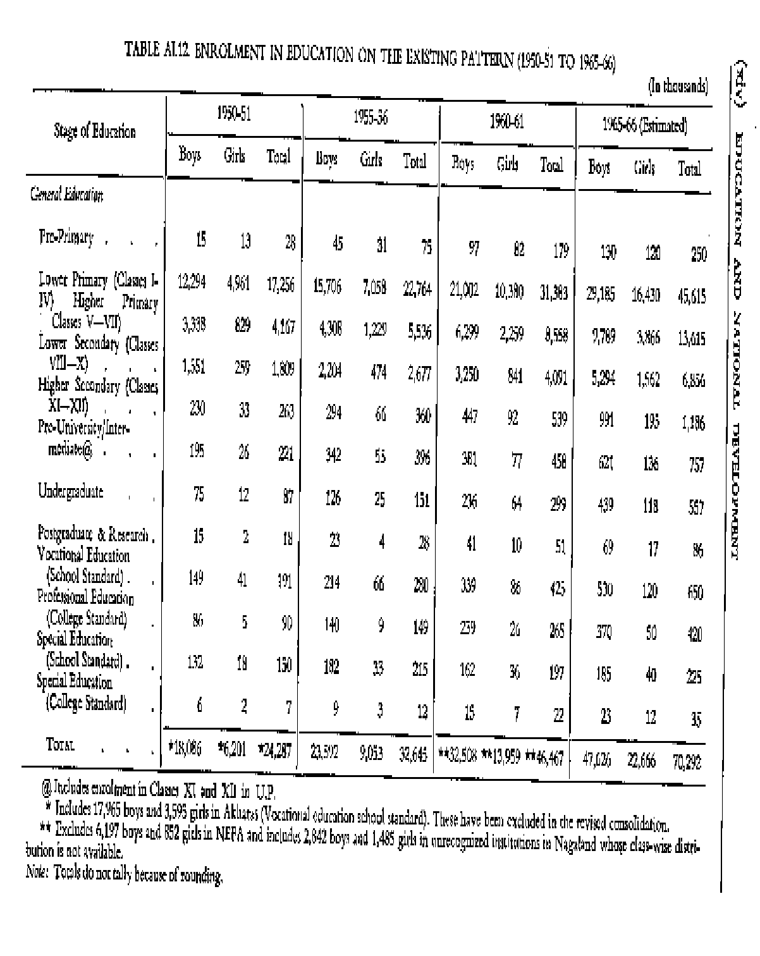

APPENDIX II

RESOLUTION OF THE GOVERNMENT OF INDIA SETTING UP THE EDUCATION COMMISSION

AII.01. The Government of India, ever since the attainment of independence, have given considerable attention to the development of a national system of education rooted in the basic values and the cherished traditions of the Indian nation and suited to the needs and aspirations of a modern society. While some advances have been made in these directions, the educational system has not generally evolved in accordance with the needs of the times, and a wide and distressing gulf continues to persist between thought and action in several sectors of this crucial field of national activity. In view of the important role of education in the economic and social development of the country, in the building of a truly democratic society, in the promotion of national integration and unity, and above all, for the transformation of the individual in the endless pursuit of excellence and perfection, it is now considered imperative to survey and examine the entire field of education in order to realize within the shortest possible period a well-balanced, integrated and adequate system of national education capable of making a powerful contribution to all spheres of national life.

AII.02. The attainment of independence ushered in a new era of national development founded upon: the adoption of a secular democracy, not only as a form of government but also as a way of life; the determination to eliminate the poverty of the people and to ensure a reasonable standard of living for all, through modernization of agriculture and rapid development of industry; the adoption of modern science and technology and their harmonizing with traditional spiritual values; the acceptance of a socialistic pattern of society which will secure equitable distribution of wealth and equality of opportunity for all in education, employment and cultural advancement. Greater emphasis came to be placed on educational development because of the realization that education, especially in science and technology, is the most powerful instrument of social transformation and economic progress and that the attempt to create a new social order based on freedom, equality and justice can only succeed if the traditional educational system was revolutionized, both in content and extent.

AII.03. Quantitatively, education at all levels has shown a phenomenal development in the post-Independence period. In spite of this expansion, however, there is widespread dissatisfaction about several aspects of educational development. For instance, it has not yet been possible to provide free and universal education for all children up to 14 years of age. The problem of mass illiteracy continues to be immense. It has not been possible to raise standards adequately at the secondary and university stages. The diversification of curricula in secondary and higher education has not kept pace with the times so that the problem of educated unemployment has been intensified on the one hand while, on the other, there is an equally acute shortage of trained manpower in several sectors. The remuneration and service conditions of teachers leave a great deal to be desired; and several important academic problems are still matters of intense controversies: In short,

qualitative improvements in education have not kept pace with quantitative expansion, and national policies and programmes concerning the quality of education, even when these were well-conceived and generally agreed to, could not be implemented satisfactorily.

AII.04. The Government of India are convinced that education is the key to national prosperity and welfare and that no investment is likely to yield greater returns than investment in human resources of which the most important component is education. Government have also decided to mobilize all the resources of science and technology which can only be done on the foundation of good and progressive education and, to that end, to increase considerably their total investment in the development of education and scientific research. The nation must be prepared to pay for quality in education, and from the value attached to education by all sectors of the people it is clear that they will do so willingly.

AII.05. It is desirable to survey the entire field of educational development as the various parts of the educational system strongly interact with and influence one another. It is not possible to have progressive and strong universities without efficient secondary schools and the quality of these schools is determined by the functioning of elementary schools. What is needed, therefore, is a synoptic survey and an imaginative look at education considered as a whole and not fragmented into parts and stages. In the past, several commissions and committees have examined limited sectors and specific aspects of education. It is now proposed to have a comprehensive review of the entire educational system.

AII.06. While the planning of education for India must necessarily emanate from Indian experience and conditions, Government of India are of the opinion that it would be advantageous to draw upon the experience and thinking of educationists and scientists from other parts of the world in the common enterprise of seeking for the right type of education which is the quest of all mankind, specially at this time when the world is becoming closely knit together in so many ways. It has, therefore, been decided to associate with the Commission, either as members or as consultants, some eminent scientists and educationists from other countries. The United Nations Educational, Scientific and Cultural Organization has provided three members for the Commission, viz., Mr. Jean Thomas, Inspector General of Education, France, and formerly Assistant Director General of UNESCO, Prof. Shumovsky, Director, Methodological Division, Ministry of Higher and Special Secondary Education, RSFSR, Moscow, and Professor of Physics, Moscow University, and Prof. Sadatoshi Ihara, Professor of the First Faculty of Science and Technology, Waseda University, Tokyo, who have since joined the Commission. It is expected that the collaboration of some eminent scientists and educationists, as consultants, with the work of the Commission, will also be forthcoming. Negotiations are in progress with some more specialists and additions of names of

*N. F.41 3(3)64-E.I. Ministry of Education, Government of India, New Delhi, the 14th of July 1964 as finally modified.

foreign consultants will be notified from time to time. In addition, the Commission has been authorized to invite from time to time such other consultants in India in relation to any aspect of its enquiry as it may consider necessary.

AII.07. For the purposes outlined in the foregoing paragraphs, Government of India have decided to set up an Education Commission consisting of the following members:

Chairman

- Prof. D. S. Kothari, Chairman, University Grants Commission, New Delhi.

Members

- Shri A. R. Dawood, former Director, Extension Programmes for Secondary Education, New Delhi.

- Mr. H. L. Elvin, Director, Institute of Education, University of London, London.

- Shri R. A. Gopalaswami, Director, Institute of Applied Manpower Research, New Delhi.

- Dr. V. S. Jha, former Director of the Commonwealth Education Liaison Unit in London.

- Shri P. N. Kirpal, Educational Adviser to the Government of India, New Delhi.

- Prof. M. V. Mathur, Professor of Economics and Public Administration, University of Rajasthan, Jaipur.

- Dr. B. P. Pal, Director, Indian Agricultural Research Institute, New Delhi.

- Kumari S. Panandikar, Head of the Department of Education, Karnatak University, Dharwar.

- Prof. Roger Revelle, Dean of Research, University of California, USA

- Dr. K. G. Saiyidain, former Educational Adviser to the Government of India, New Delhi.

- Dr. T. Sen, Rector, Jadavpur University, Calcutta.

- Mr. Jean Thomas, Inspector General of Education, France, and formerly Assistant Director-General of UNESCO.

- Prof. S. A. Shumovsky, Director, Methodological Division, Ministry of Higher and Special Secondary Education, RSFSR, Moscow, and Professor of Physics, Moscow University.

- Prof. Sadatoshi Ihara, Professor of the First Faculty of Science and Technology, Waseda University, Tokyo.

Member-Secretary

- Shri J. P. Naik, Head of the Department of Educational Planning, Administration and Finance, Gokhale Institute of Politics and Economics, Poona.

Associate Secretary

- Mr. J. F. McDougall, Assistant Director, Department of School and Higher Education, UNESCO, Paris.

AII.08. The Commission will advise Government on the national pattern of education and on the general principles and policies for the development of education at all stages and in all its aspects. It need not, however, examine the problems of medical or legal education, but such aspects of these problems as are necessary for its comprehensive enquiry may be looked into.

AII.09. The Commission will submit its final report as early as possible and not later than the 31st March, 1966. Where immediate implementation of certain programmes is necessary the Commission may also submit, from time to time, interim reports dealing with limited sectors on problems of education. Government are anxious that the implementation of agreed recommendations about specific matters of importance shall on no account be held up until the completion of the Commission's work. On the other hand its expert advice and guidance should be continuously available to those charged with the responsibility for implementing educational programmes and policies.

Ordered that a copy of the Resolution be communicated to all State Governments and Administrations of Union Territories and to all Ministries of the Government of India.

Ordered also that the Resolution be published in the Gazette of India for information.

PREM KIRPAL

Secretary to the Government of India

B

APPENDIX III

CONSULTANTS TO THE EDUCATION COMMISSION

- Dr. James E. Allen, Jr., Commissioner, State Education Department, and President, University of the State of New York, New York, USA.

- Dr. C.E. Beeby, Visiting Professor, Centre for Studies in Education and Development, Graduate School of Education, Harvard University, Cambridge, Massachusetts, USA.

- Prof. P.M.S. Blackett, President of the Royal Society, UK, and Professor of Physics, Imperial College of Science and Technology, University of London, London.

- Recteur J.J. Capelle, Professor, University of Nancy, and former Director-General of Education in France, Paris.

- Sir Christopher Cox, Educational Adviser, Ministry of Overseas Development, UK, and Fellow, New College, Oxford.

- Dr. Philip H. Coombs, Director, UNESCO International Institute for Educational Planning, Paris.

- Prof. Andre Daniere, Centre for Studies in Education and Development, Graduate School of Education, Harvard University, Cambridge, Massachusetts, USA.

- Prof. S. Dedijer, Institute of Sociology, University of Lund, Sweden.

- Dr. Nicholas DeWitt, Director, International Survey of Educational Development and Planning, Indiana University, Bloomington, Indiana, USA.

- Dr. John Guy Fowlkes, School of Education, University of Wisconsin, Madison, USA.

- Sir Willis Jackson, Head of the Department and Professor of Electrical Engineering, Imperial College of Science & Technology, University of London, London.

- Dr. J. Paul Leonard, Professor of Education, Columbia University Teachers' College, and Chief of Party, Columbia University Team in India, New Delhi.

- Dr. Gordon N. Mackenzie, Professor of Education, Teachers' College, Columbia University, New York, USA.

- Professor C. A. Moser, Director, Unit for Economic and Statistical Studies on Higher Education, London School of Economics and Political Science, London.

- Prof. S. Okita, Executive Director, Japan Economic Research Centre, Tokyo, and Special Adviser to the Minister of Economic Planning Agency, Government of Japan.

- Professor A.R. Prest, Professor of Economics and Public Finance, University of Manchester, Manchester, England.

- Lord Robbins, Professor Emeritus, London School of Economics, and Chairman of Financial Times, London. Recently Chairman of the Committee on Higher Education, UK.

- Professor Edward A. Shils, Professor of Sociology and Social Thought in the Committee on Social Thought, University of Chicago, USA, and Fellow of King's College, Cambridge, UK.

- Dr. Frederick Seitz, President, National Academy of Sciences, Washington, USA.

- Professor W.C. Smith, Professor of World Religions and Director, Centre for the Study of World Religions, Harvard University, Cambridge, Massachusetts, USA.

APPENDIX IV

TASK FORCES AND WORKING GROUPS

AIV.01 Task Force on Adult Education

- Dr. V. S. Jha, Member, Education Commission, New Delhi. Convener

- Shri Abdul Qadir, Director-General of Employment & Training, Ministry of Labour & Employment, New Delhi.

- Shri G. K. Chandiramani, Additional Secretary, Ministry of Education, New Delhi.

- Shri A. R. Deshpande, Adviser (Social Education), Ministry of Education, New Delhi.

- Shrimati Durgabai Deshmukh, Vice-Chancellor's Residence, Delhi University, Delhi.

- Mrs. Welthy Fisher, Literacy House, Kanpur Road, Lucknow.

- Shri K. L. Joshi, Secretary, University Grants Commission, New Delhi.

- Shri D. R. Kalia, Director, Delhi Public Library, Delhi.

- Dr. T. A. Koshy, Director, National Fundamental Education Centre, 38-A, Friends Colony (East), Mathura Road, New Delhi.

- Mr. J. F. McDougall, Associate Secretary, Education Commission, New Delhi.

- Dr. M. S. Mehra, Vice-Chancellor, Rajasthan University, Jaipur.

- Mrs. A. R. Moore, Regional Adviser on Health Education, World Health Organization, WHO House, Ring Road, New Delhi.

- Shri J. P. Naik, Member-Secretary, Education Commission. New Delhi.

- Dr. M. S. Randhawa, Special Secretary, Ministry of Food & Agriculture (Department of Agriculture), New Delhi.

- Dr. K. G. Saiyidain, Member, Education Commission, New Delhi.

- Dr. Hans Simons, Ford Foundation, 32, Feroze Shah Road, New Delhi.

- Shri Sohan Singh, Asia Foundation, 29, Rajpur Road, Delhi.

- Dr. S. M. S. Chari, Deputy Educational Adviser, Education Commission, New Delhi. Secretary

Sub-Group on Literacy Education

EMBERS

- Mrs. Durgabai Deshmukh, Vice-Chancellor's Residence, University of Delhi, Delhi. Convener

- Shri A. R. Deshpande, Adviser (Social Education), Ministry of Education, New Delhi.

- Dr. T. A. Koshy, Director, National Fundamental Education Centre, New Delhi.

- Shri Mustaq Ahmed, Director, Literacy House, Lucknow.

- Shri H. P. Saxena, Assistant Director, National Fundamental Education Centre, New Delhi.

Sub-Group on Role of Universities and Institutions of Higher Learning in Adult Education

MEMBERS

- Shri Sohan Singh, Asia Foundation, New Delhi. Convener

- Shri Bashiruddin, 33-A, Kasturba Gandhi Marg, Allahabad.

- Dr. Nagendra, Chairman, University Extension Lectures Board, University of Delhi, Delhi.

- Dr. K. G. Saiyidain, Member, Education Commission, New Delhi.

- Dr. Hans Simons, Ford Foundation, New Delhi.

- Shri Uma Shankar, Director, Adult Education Department, Rajasthan University, Jaipur.

Sub-Group on Education of Workers

MEMBERS

- Dr. T. A. Koshy, Director, National Fundamental Education Centre, Friends Colony, New Delhi. Convener

- Shri Abdul Qadir, Director-General, Employment and Training, Ministry of Labour and Employment, New Delhi.

- Shri N. Bhadriah, President, Mysore State Adult Education Council, Mysore.

- Shri L. S. Chandrakant, joint Educational Adviser, Ministry of Education, New Delhi.

- Shri Chenstal Rao, Secretary, Federation of Indian Chambers of Commerce and Industry, New Delhi.

- Shri S. C. Datta, Secretary, Indian Adult Education Association, Indraprastha Estate, New Delhi.

- Shri M. C. Nanavatty, Director (Social Education), Ministry of Food and Agriculture, New Delhi.

- Shri Annasaheb Sahasrabuddhe, Chairman, Rural Industries Planning, Planning Commission, New Delhi.

- Dr. R. K. Singh, Director, Rural Institute, Bichpuri (Agra), U.P.

Sub-Group on Role of Cultural Institutions in Adult Education

MEMBERS

- Shri D. R. Kalia, Director, Delhi Public Library, Delhi. Convener

- Shrimati Kamladevi Chattopadhyay, Chairman, All- India Handicrafts Board, Wellingdon Crescent, New Delhi.

- Shri J. C. Mathur, joint Secretary, Ministry of Food and Agriculture, New Delhi.

- Dr. Grace Morley, Director, National Museum, New Delhi.

- Dr. Mulk Raj Anand, Panjab University, Chandigarh.

- Dr. M. S. Randhawa, Special Secretary, Ministry of Food and Agriculture, New Delhi.

AIV.02. Task Force on Agriculture Education

- Dr. B. P. Pal, Director-General and Vice- President, I.C.A.R. and Additional Secretary, Ministry of Food and Agriculture, New Delhi. Convener

- Dr. Amir Ali, Director, Rural Institute, Jamia Millia, Jamia Nagar, New Delhi.

- Dr. Anant Rao, Dean, U.P. Agricultural University, Pant Nagar.

- Dr. Chintamani Singh, Dean, Veterinary College, Punjab Agricultural University, Hissar.

- Dr. R. W. Cummings, Field Director, Rockefeller Foundation Programme in India, 17, Kautilya Marg, Chanakyapuri, New Delhi-21.

- Prof. V. M. Dandekar, Centre for Advanced Study in Agricultural Economics, Gokhale Institute of Politics and Economics, Poona.

- Dr. K. C. Kanungo, Head of the Division of Agricultural Economics, Indian Agricultural Research Institute, New Delhi.

- Dr. A. B. Joshi, Dean and Deputy Director (Education), Indian Agricultural Research Institute, New Delhi.

- Managing Director, Banana and Fruit Development Corporation, 7, 1st Main Road,
C.I.T. Colony, Madras.

- Mr. J. F. McDougall, Associate Secretary, Education Commission, New Delhi.

- Dr. S. N. Mehrotra Deputy Secretary, Education Department, Government of Uttar Pradesh, Lucknow.

- Dr. S. K. Mukherji, Deputy Agricultural Commissioner, Indian Council of Agricultural Research, Krishi Bhavan, New Delhi.

- Shri J. P. Naik, Member-Secretary, Education Commission, New Delhi.

- Dr. K. C. Naik, Vice-Chancellor, University of Agricultural Science, 9-XI Main, 16th Cross, Malleswaram, Bangalore-3.

- Dr. N. K. Panikar, Director, Indian Programme, Indian Ocean Expedition, C.S.I.R., New Delhi.

- Shri C. S. Ranganathan, Fertilizer Association of India, New Delhi.

- Dr. S. C. Verma, Field Adviser (Agriculture), N.C.E.R.T., New Delhi.

- Shri S. Ramanujam, Assistant Educational Adviser, Education Commission, New Delhi. Secretary

AIV.03. Task Force on Educational Administration

- Shri Prem Kirpal, Secretary, Ministry of Education and Member, Education Commission, New Delhi. Secretary

- Shri A. C. Deve Gowda, Director, Directorate of Extension Programmes for Secondary Education (N.C.E.R.T.). 7, Lancer Road, Timarpur, Delhi-6.

- Dr. V. Jagannadham, Professor of Social Administration, Indian Institute of Public Administration, Indraprastha Estate, New Delhi.

- Prof. M. V. Mathur, Member, Education Commission, New Delhi.

- Dr. S. Misra, Director of Public Instruction, Orissa (now Vice-Chancellor, Utkal University), Cuttack

- Dr. S. N. Mukherjee, Head of the Department of Educational Administration, (N.C.E.R.T.), B-2/6A, Model Town, Delh-9.

- Shri J. P. Naik, Member-Secretary, Education Commission, New Delhi.

- Shri H. M. Patel, Chairman, Charotar Vidya Mandal, Vallabh Vidyanagar, via Anand (Gujarat).

- Dr. D. M. Sen, Education Secretary, West Bengal, (now Vice-Chancellor, Burdwan University), Calcutta.

- Shri J. D. Sharma, Director of Public Instruction, Punjab, Chandigarh.

- Shri V. D. Sharma, Education Secretary, Rajasthan, Jaipur.

- Dr. Rudra Dutt Singh, Head of the Research Project on Panchayati Raj Institutions, Indian Institute of Public Administration, Indraprastha Estate, New Delhi.

- Miss S. Rajan, Assistant Educational Adviser, Education Commission, New Delhi. Secretary

AIV.04. Task Force on Educational Finance

- Prof. M. V. Mathur, Member, Education Commission, New Delhi. Convener

- Shri D. A. Dabholkar, Principal, Chintamanrao College of Commerce, Sangli (Maharashtra).

- Dr. B. Dutta, Education Secretary, Government of West Bengal, Calcutta.

- Shri R. A. Gopalaswami, Member, Education Commission, New Delhi.

- Shri K. L. Joshi, Secretary, University Grants Commission, New Delhi.

- Dr. D. T. Lakdawala, Head of the Department of Economics, University of Bombay, Bombay-1.

- Dr. Gautam Mathur, Head of the Department of Economics, Osmania University, Hyderabad.

- Dr. Atmanand Misra, Director of Public Instruction, Madhya Pradesh, Bhopal.

- Dr. Sadashiv Misra, Director of Public Instruction, (now Vice-Chancellor, Utkal University), Cuttack, Orissa.

- Shri J. P. Naik, Member-Secretary, Education Commission, New Delhi.

- Dr. K. A. Naqvi, Delhi School of Economics, University of Delhi, Delhi.

- Dr. Pritam Singh, Director, National Council of Applied Economic Research, New Delhi.

- Shri Gurbax Singh, Assistant Educational Adviser, Education Commission, New Delhi. Secretary

AIV.05. Task Force on Higher Education

- Dr. K. G. Saiyidain, Member, Education Commission, New Delhi Convener

- Shri j. W. Airan, Principal, Wilson College, Bombay-7.

- Shri P. K. Bose, Principal, Bangabasi College, Calcutta.

- Shri Chandrahasan, Head of the Department of Hindi, University of Kerala, Ernakulam.

- Dr. V. S. Jha, Member, Education Commission, New Delhi.

- Dr. A. C. Joshi, Adviser, Planning Commission, New Delhi.

- Shri K. L. Joshi, Secretary, University Grants Commission, Bahadur Shah Zafar Marg, New Delhi-1.

- Shri C. L. Kapur, Retired Director of Education and Education Secretary, Punjab, IE/5, Patel Road, Patel Nagar, New Delhi-12.

- Dr. D. S. Kothari, Chairman, Education Commission and University Grants Commission, Bahadur Shah Zafar Marg, New Delhi-1.

- Prof. M. V. Mathur, Member, Education Commission, New Delhi.

- Shri P. G. Mavlankar, Principal, L. D. Arts College, Navrangpura, Ahmedabad.

- Mr. J. F. McDougall, Associate Secretary, Education Commission, New Delhi.

- Shri J. P. Naik, Member-Secretary, Education Commission, New Delhi.

- Dr. P. J. Philip, joint Secretary, University Grants Commission, Bahadur Shah Zafar Marg, New Delhi-1.

- Shri A. B. Shah, Executive Secretary, Indian Committee for Cultural Freedom, Army and Navy Building, 148, Mahatma Gandhi Road, Bombay-1.

- Dr. Hans Simons, Consultant in General Education, Ford Foundation, 32, Feroze Shah Road, New Delhi-1.

- Dr. Amrik Singh, Secretary, Inter-University Board of India and Ceylon, 1, Rouse Avenue, New Delhi.

- Dr. R. K. Singh, Director, Balwant Vidyapeeth Rural Higher Institute, Bichpuri, Agra (U.P.).

- Dr. H. J. Taylor, Principal, Union Christian College, Barapani, Shillong (Assam).

- Miss. S. Rehman. Assistant Educational Adviser, Education Commission, New Delhi. Secretary

SPECIAL INVITEES

- Dr. C. Gilpatric, Visiting Professor of Philosophy, University of Delhi (The Rockefeller Foundation), Delhi-7.

- Dr. M. S. Mehta, Vice-Chancellor, Rajasthan University, Jaipur.

- Prof. M. Mehrotra, 43, Lal Quarters, Govinda Nagar, Kanpur-6.

Sub-Group on Equalization of Educational Opportunities at University Level

- Dr. R. K. Singh, Director, Balwant Vidyapeeth Rural Higher Institute, P.O. Bichpuri (Agra). Convener

- Shri K. L. Joshi, Secretary, University Grants Commission, Bahadur Shah Zafar Marg, New Delhi-1.

- Shri P. G. Mavlankar, Principal, L. D. Arts College, Navrangpura, Ahmedabad-9.

- Shri J. P. Naik, Member-Secretary, Education Commission, New Delhi.

- Shri A. P. Shah, Executive Secretary, Indian Committee for Cultural Freedom, Army and Navy Building, 148, Mahatma Gandhi Road, Bombay-1.

Sub-Group on Rural Higher Education

- Shri G. Ramachandran, Director, Gandhigram, Gandhigram P.O., Madurai District (Madras). Convener

- Dr. H. Amir Ali, Director, Jamia Rural Institute, Jamia Millia Islamia, P.O. Jamia Nagar, New Delhi-25.

- Shri K. L. Bordia, Director, Vidya Bhavan Rural Institute, Udaipur (Rajasthan).

- Dr. V. S. Jha, Member, Education Commission, New Delhi.

- Shri J. P. Naik, Member-Secretary, Education Commission, New Delhi.

Sub-Group on Salaries of Teachers

- Shri K. L. Joshi, Secretary, University Grants Commission, Bahadur Shah Zafar Marg, New Delhi-1. Convener

- Dr. C. Gilpatric, Visiting Professor of Philosophy, University of Delhi, (The Rockefeller Foundation), Delhi-7.

- Shri C. L. Kapur, Retired Director of Education and Education Secretary, Punjab, IE/5, Patel Road, Patel Nagar, New Delhi-12.

- Prof. S. A. Shumovsky, Member, Education Commission.

Sub-Group on University Standards

- Dr. P. J. Philip, joint Secretary University Grants Commission, Bahadur Shah Zafar Marg, New Delhi-1.

- Shri J. W. Airan, Principal, Wilson College, Bombay-7.

- Shri A. R. Dawood, Member, Education Commission, New Delhi.

- Dr. V. S. Jha, Member, Education Commission, New Delhi.

- Shri M. N. Kapur, Principal, Modern School, New Delhi.

- Shri C. L. Kapur, Retired Director of Education and Education Secretary, Punjab, IE/5, Patel Road, Patel Nagar, New Delhi-12.

- Shri A. B. Shah, Executive Secretary, Indian Committee for Cultural Freedom, Army and Navy Building, 148, Mahatma Gandhi Road, Bombay-1.

Sub-Group on Evaluation at University Level

- Dr. K. G. Saiyidain, Member, Education Commission, New Delhi. Convener

- Dr. R. H. Dave, Deputy Director (Examination Unit), Directorate of Extension Programmes for Secondary Education (N.C. E.R.T.), 7, Lancer Road, Timarpur, Delhi-9.

- Dr. V. S. Jha, Member, Education Commission, New Delhi.

- Dr. A. C. Joshi, Adviser, Planning Commission, Yojana Bhavan, Parliament Street, New Delhi-1.

- Shri J. P. Naik, Member-Secretary, Education Commission, New Delhi.

- Shri Shantinarayan, Principal, Hans Raj College, Delhi.

- Shri Ishwarbhai Patel, Vice-Chancellor, Sardar Vallabhbhai Vidyapeeth, Vallabh Vidya Nagar (via Anand).

- Dr. Hans Simons, Consultant in General Education, The Ford Foundation, 32 Feroz Shah Road, New Delhi-1.

- Dr. H. J. Taylor, Principal, Union Christian College, Barapani, Shillong.

Sub-Group on the Functions of a University

- Dr. C. Gilpatric, Visiting Professor of Philosophy, University of Delhi, (The Rocke- feller Foundation), Delhi-7. Convener

- Dr. V. S. Jha, Member, Education Commission, New Delhi.

- Mr. J. F. McDougall, Associate Secretary, Education Commission, New Delhi.

- Dr. R. K. Singh, Director, Balwant Vidyapeeth Rural Higher Institute, P.O. Bichpuri (Agra).

Sub-Group on Policy of Admissions and Sub-standard Institutions

- Dr. V. S. Jha, Member, Education Commission, New Delhi. Convener

- Dr. C. Gilpatric, Visiting Professor of Philosophy, University of Delhi (The Rockefeller Foundation), Delhi-7.

- Shri C. L. Kapur, Retired Director of Education and Education Secretary, Punjab, IE/5, Patel Road, Patel Nagar, New Delhi-12.

- Shri J. P. Naik, Member-Secretary, Education Commission, New Delhi.

- Dr. R. K. Singh, Director, Balwant Vidyapeeth Rural Higher Institute, P.O. Bichpuri (Agra).

AIV.06. Task Force on Manpower

- Shri R. A. Gopalaswami, Member, Education Commission, New Delhi. Convener

- Shri Abdul Qadir, Director-General, Employment and Training, New Delhi.

- Shri K. L. Joshi, Secretary, University Grants Commission, Bahadur Shah Zafar Marg, New Delhi-1.

- Prof. M. V. Mathur, Member, Education Commission, New Delhi.

- Shri J. P. Naik, Member-Secretary, Education Commission, New Delhi.

- Shri R. Prasad, Director, Manpower, Ministry of Home Affairs, (now Development Commissioner, Bihar), New Delhi.

- Dr. T. Sen, Member, Education Commission, New Delhi.

- Dr. S. P. Aggarwal, Head of Division, Area Manpower, Institute of Applied Manpower Research, Indraprastha Estate, New Delhi.

AIV.07. Task Force on Techniques and Methods in Education

- Dr. V. S. Jha, Member, Education Commission, New Delhi. Convener

- Shri G. K. Athalye-later Shri S. L. Ahluwallia, Director, National Institute of Audio- Visual Education (N.C.E.R.T.), Indraprastha Estate, New Delhi.

- Shri M. L. Bharadwaj, Director, Advertising and Visual Publicity, Ministry of Information and Broadcasting, 'B' Block, Curzon Road, New Delhi.

- Shri A. R. Dawood, Member, Education Commission, New Delhi.

- Dr. (Miss) S. Dutt, Reader in Education, Central Institute of Education, N.C.E.R.T., 33, Chhatra Marg, Delhi-6.

- Shri C. L. Kapur, IE/5 Patel Road, Patel Nagar, New Delhi-12.

- Dr. S. S. Kulkarni, Psychometrician, Department of Psychological Foundations, N.C.E.R.T., 2/3, Model Town, Delhi-9.

- Shri J. C. Mathur, joint Secretary, Ministry of food and Agriculture (Department of Agriculture), Krishi Bhavan, New Delhi.

- Mr. J. F. McDougall, Associate Secretary, Education Commission, New Delhi.

- Dr. S. K. Mitra, Head of the Department of Psychological Foundations, N.C.E.R.T., 2/3, Model Town, Delhi-9.

- Shri J. P. Naik, Member-Secretary, Education Commission, New Delhi.

- Dr. Paul Neurath, Ford Foundation Consultant, Educational Television, 222, Jor Bagh, New Delhi.

- Miss S. Panandikar, Member, Education Commission, New Delhi.

- Dr. Albert J. Perrelli, Expert, Central Institute of Education, N.C.E.R.T., 33, Chhatra Marg, Delhi-6.

- Miss S. Rehman, Assistant Educational Adviser, Education Commission, New Delhi.

- Mr. J. M. Ure-later Mr. D. A. Smith, Chief Education Officer, British Council, 21, Jor Bagh, New Delhi.

- Dr. S. M. S. Chari, Deputy Educational Adviser, Education Commission, New Delhi. Secretary

AIV.08. Task Force on Professional, Vocational and Technical Education

1 . Dr. T. Sen, Member, Education Commission, New Delhi. Convener

- Prof. S. K. Bose, Director, Indian Institute of Technology, Powai, Bombay.

- Shri G. K. Chandiramani, Additional Secretary, Ministry of Education, New Delhi.

- Shri L. S. Chandrakant, joint Educational Adviser, Ministry of Education, New Delhi.

- Dr. D. R. Dhingra, 3/40, Vishnupuri, Nawabganj, Kanpur.

- Shri R. N. Dogra, Director, Indian Institute of Technology, Hauz Khas, New Delhi.

- Prof. V. G. Garde, Principal, Malaviya Regional Engineering College, Jaipur (Rajasthan).

- Shri R. A. Gopalaswami, Member, Education Commission, New Delhi.

- Shri K. L. Joshi, Secretary, University Grants Commission, New Delhi.

- Dr. P. K. Kelkar, Director, Indian Institute of Technology, Kanpur.

- Mr. J. F. McDougall, Associate Secretary, Education Commission, New Delhi.

- Col. S. G. Pendse, Director of Training, Directorate General of Employment and Training, New Delhi.

- Shri S. C. Sen, Principal, Delhi College of Engineering, Delhi.

- Shri R. K. Srivastav, Deputy Secretary, Directorate of Manpower, Ministry of Home Affairs, New Delhi.

- Dr. H. C. Visvesvaraya, Deputy Director, Indian Standard Institute, New Delhi.

- Shri S. Venkatesh, Deputy Educational Adviser, Education Commission, New Delhi. Secretary

AIV.09. Task Force on Science Education

- Dr. D. S. Kothari, Chairman, Education Commission, New Delhi. Convener

- Prof. S. Deb, Head of the Department of Geology, Jadavpur University, Jadavpur.

- Prof. B. D. Jain, Professor of Chemistry, Delhi University, Delhi.

- Miss P. Florence Nightingale, Lecturer, Science Education Unit, Hyderabad.

- Prof. R. C. Paul, Head of the Department of Chemistry, Panjab University, Chandigarh.

- Dr. R. N. Rai, Head of the Department of Science Education, N.C.E.R.T., H-2/3, Model Town, Delhi-9.

- Prof. T. S. Sadasivan, Director, Centre of Advanced Study in Botany, Madras University, Madras.

- Dr. D. Shankernarayan, Development Officer, University Grants Commission, Bahadur Shah Zafar Marg, New Delhi.

- Prof. Shantinarayan, Principal, Hansraj College, Delhi.

- Dr. A. R. Verma, Director, National Physical Laboratory, New Delhi.

- Dr. R. D. Deshpande, Development Officer, University Grants Commission, Bahadur Shah Zafar Marg, New Delhi. Secretary

- Shri I. C. Menon, Education Officer, University Grants Commission, Bahadur Shah Zafar Marg, New Delhi. Secretary

AIV. 10. Task Force on School Education

- Shri A. R. Dawood, Member, Education Commission, New Delhi. Convener

- Shri K. L. Gupta, Principal, M.B. Intermediate College, Brindaban.

- Dr. G. S. Khair, Principal, Poona Anath Vidyarthi Griha, Sadashiv Peth, Poona-2.

- Shri K. Kuruvila Jacob, Principal, The Hyderabad Public School, Begumpet, Hyderabad-16.

- Dr. D. R. Mankad, Secretary, Gangajala Vidyapith, Aliabad, Jamnagar (Gujarat).

- Shri P. N. Mathar, Banasthali Vidyapeeth, Banasthali (Jaipur).

- Dr. (Mrs.) R. Muralidharan, Reader, Department of Psychological Foundations, N.C.E.R.T., H-2/6, Model Town, Delhi-9.

- Shri J. P. Naik, Member-Secretary, Education Commission, New Delhi.

- Miss S. Panandikar, Member, Education Commission, New Delhi.

- Shri H. Radhakrishna, Secretary, Akhil Bharat Sarva Seva Sangh, Rajghat, Varanasi- 1.

- Dr. S. N. Saraf, Director, Education Division, Planning Commission, New Delhi.

- Shrimati S. Doraiswami, Assistant Educational Adviser, Education Commission, New Delhi. Secretary

Sub-Group on Secondary Education

- Shri A. R. Dawood, Member, Education Commission, New Delhi. Convener

- Shri S. S. Desnavi, Principal, M. H. Saboo Siddik Polytechnic, 8 Shepherd Road, Bombay-8.

- Shri A. C. Deve Gowda, Director, DEPSE, 7, Lancer Road, Timarpur, Delhi-6.

- Shri A. D Souza, Inspector of Anglo-Indian Schools, West Bengal, New Secretariat Building, 6th Floor, 1, Hasting Street, Calcutta-1.

- Shri K. L. Gupta, Principal, M. B. Inter College, Brindaban.

- Dr. G. S. Khair, Principal, Poona Anath Vidyarthi Griha, Sadashiv Peth, Poona-2.

- Shri K. Kuruvila Jacob, Principal, The Hyderabad Public School, Begumpet, Hyderabad.

- Shri P. N. Mathur, Banasthali Vidyapeeth, Banasthali (Jaipur).

- Shri S. G. Nadgir, Headmaster, K.E. Boards High School, Malmaddi, Dharwar.

- Shri S. Natarajan, S.I.T.U. Council of Educational Research, Robertsonpet, Raja Annamalaipuram, Madras-28.

- Shri S. P. Nigam, Principal, Government Model Multipurpose School, Jabalpur.

- Miss S. Panandikar, Member, Education Commission, New Delhi.

- Shri Vajubhai Patel, Shri Chandulal Nanavati, Kanya Vinaya Mandir, Vallabhbhai Patel Road, Vile Parle (West), Bombay-56.

- Shri Nandakishore Rath, Headmaster, Ravenshaw Collegiate Higher Secondary School, Cuttack-2.

- Shri Satya Priya Roy, All India Secondary Teachers' Federation, 15, Bankim Chandra Chatterjee Street, Calcutta-12.

- Dr. S. N. Saraf, Director, Education Division, Planning Commission, New Delhi.

- Shri H. N. Sarma, Headmaster, Pattacharkuchi Vidyapith, P.O. Pattacharkuchi, District Kamrup, Assam.

- Miss S. Sethi, Principal, Government Higher Secondary School, Sector 4, House No. 40, Chandigarh.

- Shri C. C. Shah, Principal, Sarvajanik College of Education, Desai Pole, Surat.

- Shri Kailash Singh, Principal, D.A.V. Higher Secondary School, Mithapur, Patna.

- Shri P. M. Cherian Tharakan, Headmaster, St. John's Model High School, Trivandrum.

- Shrimati S. Doraiswami, Assistant Educational Adviser, Education Commission, New Delhi. Secretary

Sub-Group on Evaluation at the School Stage

- Shri A. R. Dawood, Member, Education Commission, New Delhi. Convener

- Dr. R. H. Dave, Deputy Director, DEPSE, 7, Lancer Road, Delhi-6.

- Shri V. B. Desai, Deputy Director of Education in- charge Examinations, Government of Mysore, Mysore.

- Dr. C. D. Deshpande, Director of Education, Maharashtra, Poona.

- Shri L. L. Joshi, Chairman, Board of Secondary Education, Rajasthan, Jaipur.

- Shri J. P. Naik, Member-Secretary, Education Commission, New Delhi.

- Dr. H. J. Taylor, Principal, Union Christian College, Barapani, Shillong (Assam).

AIV.11. Task Force on Student Welfare

- Shri A. R. Dawood, Member, Education Commission, New Delhi. Convener

- Dr. V. S. Jha, Member, Education Commission, New Delhi.

- Dr. D. R. Mankad, Gangajala Vidyapith, Aliabad, Gujarat State.

- Dr. M. S. Mehta, Vice-Chancellor, Rajasthan University, Jaipur.

- Dr. (Mrs.) Perin H. Mehta, Director, Bureau of Educational and Vocational Guidance, N.C.E.R.T., New Delhi.

- Shri J. P. Naik, Member-Secretary, Education Commission, New Delhi.

- Dr. Prem. Pasricha, United States Educational Foundation in India, 12, Hailey Road, New Delhi.

- Dr. V. Ramakrishna, Director, Central Bureau of Health Education, New Delhi.

- Dr. A. S. Raturi, Dean of Students, Banaras Hindu University, Varanasi-5.

- Dr. D. S. Reddy, Vice-Chancellor, Osmania University, Hyderabad.

- Shri S. L. Saruparia, Research Fellow, Department of Economics, Rajasthan University, Jaipur.

- Dr. Vikram Singh, Deputy Educational Adviser, Ministry of Education, New Delhi.

- Shrimati S. Doraiswami, Assistant Educational Adviser, Education Commission, New Delhi. Secretary

SPECIAL INVITEES

- Dr. H. H. Howes, c/o United States Educational Foundation in India, 12, Hailey Road, New Delhi.

- Shri Nauhria Ram, Deputy Educational Adviser, Ministry of Education, New Delhi.

- Dr. Olive 1. Reddick, United States Educational Foundation in India, 12, Hailey Road, New Delhi.

Sub-Group on Hostels

- Dr. D. R. Mankad, Gangajala Vidyapith, Aliabad, Distt. Jamnagar (Gujarat).

- Dr. A. S. Raturi, Dean of Students, Banaras Hindu University, Varanasi.

- Shri S. L. Saruparia, Research Fellow, Department of Economics, Rajasthan University, Jaipur.

Sub-Group on Guidance and Counseling

- Dr. (Mrs.) Perin H. Mehta, Director, Central Bureau of Educational and Vocational Guidance, N.C.E.R.T., New Delhi.

- Dr. Prem Pasricha, United States Educational Foundation in India, 12, Hailey Road, New Delhi.

- Dr. Olive 1. Reddick, United States Educational Foundation in India, 12, Hailey Road, New Delhi.

- Shrimati S. Doraiswami, Assistant Educational Adviser, Education Commission, New Delhi.

Sub-Group on Health Services

- Shri A. R. Dawood, Member, Education Commission, New Delhi.

- Dr. A. M. Gade, Regional Adviser in Maternal and Child Health, World Health Organization, Indraprastha Estate, New Delhi.

- Miss F. Kornegay, Health Educator, World Health Organization, Indraprastha Estate, New Delhi.

- Dr. V. Ramakrishna, Director, Central Health Education Bureau, New Delhi.

- Dr. D. K. Roy, Medical Officer-in-Charge, World University Service Health Centre, University of Delhi, Delhi.

- Dr. (Miss) Sebastian, Adviser in Maternity and Child Welfare, Directorate-General of Health Services, New Delhi.

- Miss K. Sood, Deputy Assistant Director-General of Health Services, New Delhi.

- Shrimati S. Doraiswami, Assistant Educational Adviser, Education Commission, New Delhi.

AIV.12.Task Force on Teacher Education and Teacher Status

- Miss S. Panandikar, Member, Education Commission, New Delhi.Convener

- Dr. S. P. Aggarwal, Institute of Applied Manpower Research, Indraprastha Estate, New Delhi.

- Dr. Reginald Bell, Expert, Teachers' College, Columbia University Team c/o American Embassy, Faridkot House, New Delhi.

- Shri A. C. Deve Gowda, Director, Directorate of Extension Programmes for Secondary Education, 7, Lancer Road, Timarpur, Delhi-6.

- Dr. G. N. Kaul, Field Adviser, National Institute of Basic Education, D. 14/16, Model Town, Delhi-9.

- Shri J. P. Naik. Member-Secretary, Education Commission, New Delhi.

- Shri S. Natarajan, Director of Projects, The South Indian Teachers' Union Council of Educational Research, Robertsonpet, Raja Annamalaipuram, Madras-28.

- Dr. K. G. Saiyidain, Member, Education Commission, New Delhi.

- Dr. Salamatullah, Principal, Teachers College, Jamia Millia Islamia, Jamianagar, Delhi-25.

- Dr. M. D. Paul, Deputy Educational Adviser, Education Commission, New Delhi. Secretary

Sub-Group on Teacher Education

- Miss S. Panandikar, Member, Education Commission, New Delhi. Convener

- Dr. Reginald Bell, Expert, Teachers College, Columbia University Team, c/o American Embassy, Faridkot House, New Delhi.

- Mrs. Nalini Das, Principal, Institute of Education for Women, 20-B, judges' Court Road, Hastings House, Alipore, Calcutta.

- Shri A. C. Deve Gowda, Director, Directorate of Extension Programmes for Secondary Education, N.C.E.R.T., 7, Lancer Road, Timarpur, Delhi-6.

- Shri Dwarika Singh, Director, State Institute of Education, Bihar, Patna.

- Shri V. S. Mathur, Principal, State College of Education, Patiala.

- Mrs. I. Miri, Principal, Postgraduate Training College, Assam State, Jorhat.

- Dr. A. Mujib, Head of the Department of Education, Aligarh University, Aligarh.

- Dr. S. N. Mukerji, Head of the Department of Educational Administration, N.C.E.R.T., B-6/A, Model Town, Delhi-9.

- Dr.(Mrs.) Chitra Naik, Director, State Institute of Education, Maharashtra, Poona-2.

- Shri P. K. Roy, Principal, Central Institute of Education (N.C.E.R.T.), 33, Chhatra Marg, Delhi.

- Dr. K. G. Saiyidain, Member, Education Commission, New Delhi.

- Dr. Salamatullah, Principal, Teachers' College, Jamia Millia Islamia, Jamianagar, Delhi-25.

- Dr. R. K. Singh, Director, Rural Higher Institute, P.O. Bichpuri, Agra.

- Miss M. Vergese, Principal, College of Women, Trivandrum.

Sub-Group on Evaluation in Teacher Education

- Dr. Salamatullab, Principal, Teachers' College, Jamia Millia Islamia, Jamianagar, Delhi-25. Convener

- Shri B. V. Bapat, Principal, Tilak College of Education, Poona.

- Dr. R. H. Dave, Deputy Director, Directorate of Extension Programmes for Secondary Education, N.C.E.R.T., 7, Lancer Road, Timarpur, Delhi-6.

- Dr. K. G. Desai, Principal, A.G. Teachers' College, Ahmedabad.

- Prof. H. M. Dutta, Professor of Education and Director of Research School, B. R. Training College, Agra.

- Shri J. P. Naik, Member-Secretary, Education Commission, New Delhi.

- Miss S. Panandikar, Member, Education Commission, New Delhi.

- Shri P. D. Sharma, Vice-Principal, Regional College of Education, Ajmer.

- Dr. V. B. Taneja, Principal, Training College, Kurukshetra.

Sub-Group on Comprehensive Scheme of Teacher Training

- Shri A. C. Deve Gowda, Director, Directorate of Extension Programmes for secondary Education, 7, Lancer Road, Timarpur, Delhi-6. Convener.

- Dr. Reginald Bell, Expert, Teachers College, Columbia University Team, c/o American Embassy, Faridkot House, New Delhi.

- Dr. G. S. Chaurasia, Principal, Regional College of Education, Mysore (now O.S.D., Regional College of Education Unit, N.C.E.R.T.).

- Dr. R. C. Das, Principal, Regional College of Education, Bhubaneswar.

- Shri A. R. Dawood, Member, Education Commission, New Delhi.

- Shri B. Mariraj, Director, State Institute of Education, Dharwar (Mysore).

- Miss S. Panandikar, Member, Education Commission, New Delhi.

- Shri G. C. Satpathy, joint Director of Public Instruction, Orissa, Cuttack.

Sub-Group on Recruitment, Pay-Scales and Conditions of Service of Teachers

- Miss S. Panandikar, Member, Education Commission, New Delhi. Convener

- Shri P. Adinarayan, Deputy Director (Secondary Education), Andhra Pradesh, Hyderabad-22.

- Shri B. R. Desai, Principal, Gokalbai High School, Vile Parle, Bombay-57.

- Shri A. C. Deve Gowda, Director, Directorate of Extension Programmes for Secondary Education, N.C.E.R.T., 7, Lancer Road, Timarpur, Delhi-6.

- Dr. V. S. Jha, Member, Education Commission, New Delhi.

- Shri J. P. Naik, Member-Secretary, Education Commission, New Delhi.

- Shri S. Natarajan, Director of-Projects, The South Indian Teachers Union Council of Educational Research, Robertsonpet, Raja Annamalaipuram, Madras-28.

- Shri A. V. Sriranga Raju, Deputy Director of Public Instruction (Examinations), Victory Hall, Bangalore.

Sub-Group on Statistical Calculations, Finance and Unit Costs

- Shri j. P. Naik, Member-Secretary, Education Commission, New Delhi. Convener

- Dr. S. P. Aggarwal, Head of Division, Area Manpower, Institute of Applied Manpower Research, Indraprastha Estate, Ring Road, New Delhi-1.

- Shri A. R. Dawood, Member, Education Commission, New Delhi.

- Dr. G. N. Kaul, Field Adviser, National Institute of Basic Education, D. 14/6, Model Town, Delhi-9.

- Prof. M. V. Mathur, Member, Education Commission, New Delhi.

AIV.13. Working Group on Educational Buildings

- Shri A. R. Dawood, Member, Education Commission, New Delhi.

- Shri R. K. Chhabra, Deputy Secretary, University Grants Commission, New Delhi.

- Shri Dinesh Mohan, Director, Central Building Research Institute, Roorkee.

- Shri B. V. Doshi, Architect, Designs Organization, Ahmedabad.

- Mr. J. F. McDougall, Associate Secretary, Education Commission, New Delhi.

- Shri M. M. Mistri, Assistant Director, National Buildings Organization, New Delhi.

- Shri J. P. Naik, Member-Secretary, Education Commission, New Delhi.

- Shri M. H. Pandya, Architect, Central Building Research Institute, Roorkee.

- Shri C. B. Patel, Chairman, National Buildings Organization, New Delhi.

- Shri S. Rahaman, Architect, Central Public Works Department, New Delhi.

- Shri J. L. Sehgal, Deputy Director, National Buildings Organization, New Delhi.

- Shri T. S. Vedagiri, Chief Industrial Engineer and Chief Designs and Planning Engineer, Bhilai Steel Plant, Bhilai.

- Dr. H. C. Visvesaraya, Deputy Director, Indian Standard Institute, New Delhi.

- Lieut.-General H. Williams, Consultant (Construction), Planning Commission, New Delhi.

- Shri S. Venkatesh, Deputy Educational Adviser, Education Commission, New Delhi. Secretary

AIV.14. Working Group on Education of the Backward Classes

- Shri L. M. Shrikant (Resident Vice-President, Bharatiya Adimjati Sewak Sangh), Thakkar Bapa Sadan, New Delhi. Convener

- Shri Sashimeren Aier, Additional Development Commissioner, Nagaland, Kohima.

- Shri N. V. Bapat, Secretary, Varnavasi Seva Mandal, Mandla (M.P.).

- Acharya S. R. Bhise, Secretary, Adivasi Seva Mandal, Bordi, Dt. Thana, via Gholwad (Maharashtra).

- Shri P. D. Kulkarani, joint Director, Social Planning and Welfare, Planning Commission, New Delhi.

- Shri J. Lakra, President, G. L. Mission Church, Ranchi (Bihar).

- Shri D. J. Naik, M.P., President, Bhil Sewa Mandal, Dohad, Dt. Panchmahals (Gujarat).

- Shri J. P. Naik, Member-Secretary, Education Commission, New Delhi.

- Shrimati V. Rajlakshmi, Secretary, Kasturba Gandhi National Memorial Trust, Kasturba Gram, Distt. Indore (M.P.).

- Shri T. Sanganna, Minister for Rural & Tribal Welfare, Orissa, Bhubaneswar.

- Shri S. C. Sen Gupta, joint Secretary, Department of Social Security, New Delhi.

- Shri Manikya Lal Verma, M.P., 156, North Avenue, New Delhi.

- Shri Vimal Chandra, Deputy Commissioner for Scheduled Castes and Scheduled Tribes, Ministry of Home Affairs. New Delhi.

- Shri N. M. Wadiwa, M.P., Secretary, Bharatiya Adimjati Sewak Sangh, Chhindwara (M.P.).

- Shri Gurbax Singh Assistant Educational Adviser, Education Commission, New Delhi. Secretary

AIV.15. Working Group on Educational Statistics

- Shri j. P. Naik, Member-Secretary, Education Commission, New Delhi. Convener

- Dr. S. P. Aggarwal, Head of Division, Area Manpower, Institute of Applied Manpower Research, New Delhi.

- Shri R. K. Chhabra, Deputy Secretary, University Grants Commission, New Delhi.

- Dr. G. P. Khare, Statistician, Asian Institute of Planning and Administration, Indraprastha Estate, New Delhi.

- Shri D. Natarajan, Deputy Registrar-General, Office of the Registrar-General, New Delhi.

- Dr. H. Webster, Columbia University Teachers' College Team working with N.C.E.R.T., New Delhi.

- Shri Gurbax Singh, Assistant Educational Adviser, Education Commission, New Delhi. Secretary

AIV.16. Working Group on Pre-Primary Education

- Miss S. Panandikar, Member, Education Commission, New Delhi. Convener

- Smt. Bilquis Ghufran, Inspecting Officer, Central Social Welfare Board, Parliament Street, Jeevan Deep Building, New Delhi.

- Kumari L. Jesudian, Principal, Balar Kalvi Nilayam, 2, Ritherdon Road, Vepery, Madras.

- Mrs. Shalini Moghe, Principal, Montessori Training Institute, Bal Adhyapan Mandir, Pagnis Bag, Indore.

- Shri Shesh Namle, Shishu Vihar, 118, Hindu Colony, Dadar, Bombay.

- Shri M. C. Nanavatty, Director (Social Education), Department of Community Development, Ministry of Food, Agriculture, Community Development and Co- operation, New Delhi.

- Kumari A. Pakrashi, Principal, Chittaranjan Teachers Training Centre, 6, Nafar Kundu Road, Calcutta- 26.

- Smt. Grace Tucker, Deputy Minister of Education, Mysore, Vidhan Saudha, Bangalore.

- Kumari P. K. Varalakshmi, Technical Officer, Indian Council for Child Welfare, 4, Rouse Avenue, New Delhi-1.

- Smt. Amrita Varma, Dean, Home Science Faculty of Education, M. S. University of Baroda, Baroda.

- Dr. (Smt.) R. Muralidharan, Head, Department of Child Study Unit (N.C.E.R.T.), H- 2/6, Model Town, Delhi- 9. Secretary

AIV.17. Working Group on School Community Relations

- Shri L. R. Desai, Vice-Chancellor, Gujarat University, Ahmedabad. Convener

- Prof. Hulbe, Rural Life Development and Research Project, Ahmednagar College, Ahmednagar.

- Dr. V. S. Jha, Member, Education Commission, New Delhi.

- Shri H. B. Majumder, Director, National Institute of Basic Education, New Delhi.

- Shri P. N. Mathur, Banasthali Vidyapeeth, Banasthali, Jaipur.

- Shri J. P. Naik, Member-Secretary, Education Commission, New Delhi.

- Shri M. C. Nanavatty, Director (Social Education), Department of Community Development, Ministry of Food, Agriculture, Community Development and Co- operation, New Delhi.

- Shri H. Radhakrishna, Sarva Seva Sangh, Rajghat, Varanasi.

- Dr. K. G. Saiyidain, Member, Education Commission, New Delhi.

- Dr. R. K. Singh, Director, Rural Higher Institute, Bichpuri, Agra.

- Shri M. P. Balakrishnan, Research Officer, Education Commission, New Delhi. Secretary

AIV.18. Working Group on School Curriculum

- Miss S. Panandikar, Member, Education Commission, New Delhi. Convener

- Shri J. P. Naik, Member-Secretary, Education Commission, New Delhi.

- Shri A. R. Dawood, Member, Education Commission, New Delhi.

- Shri L. S. Chandrakant, joint Director, National Council of Educational Research and Training, New Delhi.

- Dr. A. J. Perrelli, Specialist in Social Studies and Curriculum, Columbia University Teachers College Team in India, N.C.E.R.T., New Delhi.

- Prof. B. Ghosh, Director, Department of Curriculum, Methods and Textbooks, N.C.E.R.T., New Delhi. Secretary

AIV.19. Working Group on Women's Education

- Dr. D. S. Kothari, Chairman, Education Commission, New Delhi. Convener

- Smt. Durgabai Deshmukh, Vice-Chancellor's Residence, University of Delhi, Delhi.

- Smt. Rajammal Devadas, Principal, Home Science College, Coimbatore.

- Shri P. N. Mathur, Banasthali Vidyapeeth, Banasthali, Jaipur.

- Shri J. P. Naik, Member-Secretary, Education Commission, New Delhi.

- Miss S. Panandikar, Member, Education Commission, New Delhi.

- Dr. K. G. Saiyidain, Member, Education Commission, New Delhi.

- Smt. Raksha Saran, Chairman, National Council for Women's Education, 6, Bhagwan Das Road, New Delhi.

- Dr. Premlila V. Thackersey, Vice-Chancellor, S.N.D.T. Women's University, Bombay.

- Miss S. Rajan, Assistant Educational Adviser, Education Commission, New Delhi. Secretary

