Kohlberg's Theory of Moral Development



Based on Piaget’s Theory of Cognitive Development, American psychologist Lawrence Kohlberg (1927-1987) developed his own theory of moral development in children. According to Kohlberg’s Theory of Moral Development, there are 6 stages of moral development, known as Kohlberg’s stages of moral development. Kohlberg classified their moral reasoning into three levels, each of which contains two distinct substages:
- Pre-conventional Level
- Obedience
- Self-interest

- Conventional Level
- Conformity
- Law and order

- Post-conventional Level
- Social contract orientation
- Universal human ethics

Level 1 - Pre-conventional morality
At the pre-conventional level (most nine-year-olds and younger, some over nine), we don’t have a personal code of morality. Instead, our moral code is shaped by the standards of adults and the consequences of following or breaking their rules.
Authority is outside the individual and reasoning is based on the physical consequences of actions.
- Stage 1. Obedience and Punishment Orientation. The child/individual is good in order to avoid being punished. If a person is punished, they must have done wrong.


- Stage 2. Individualism and Exchange. At this stage, children recognize that there is not just one right view that is handed down by the authorities. Different individuals have different viewpoints.

Level 2 - Conventional morality
At the conventional level (most adolescents and adults), we begin to internalize the moral standards of valued adult role models.
Authority is internalized but not questioned, and reasoning is based on the norms of the group to which the person belongs.
- Stage 3. Good Interpersonal Relationships. The child/individual is good in order to be seen as being a good person by others. Therefore, answers relate to the approval of others.
- Stage 4. Maintaining the Social Order. The child/individual becomes aware of the wider rules of society, so judgments concern obeying the rules in order to uphold the law and to avoid guilt.



Level 3 - Post-conventional morality
Individual judgment is based on self-chosen principles, and moral reasoning is based on individual rights and justice. According to Kohlberg this level of moral reasoning is as far as most people get.
- Stage 5. Social Contract and Individual Rights. The child/individual becomes aware that while rules/laws might exist for the good of the greatest number, there are times when they will work against the interest of particular individuals.
The issues are not always clear-cut. For example, in Heinz’s dilemma, the
protection of life is more important than breaking the law against stealing.
- Stage 6. Universal Principles. People at this stage have developed their own set of moral guidelines which may or may not fit the law. The principles apply to everyone.
E.g., human rights, justice, and equality. The person will be prepared to act to defend these principles even if it means going against the rest of society in the process and having to pay the consequences of disapproval and or imprisonment. Kohlberg doubted few people reached this stage.

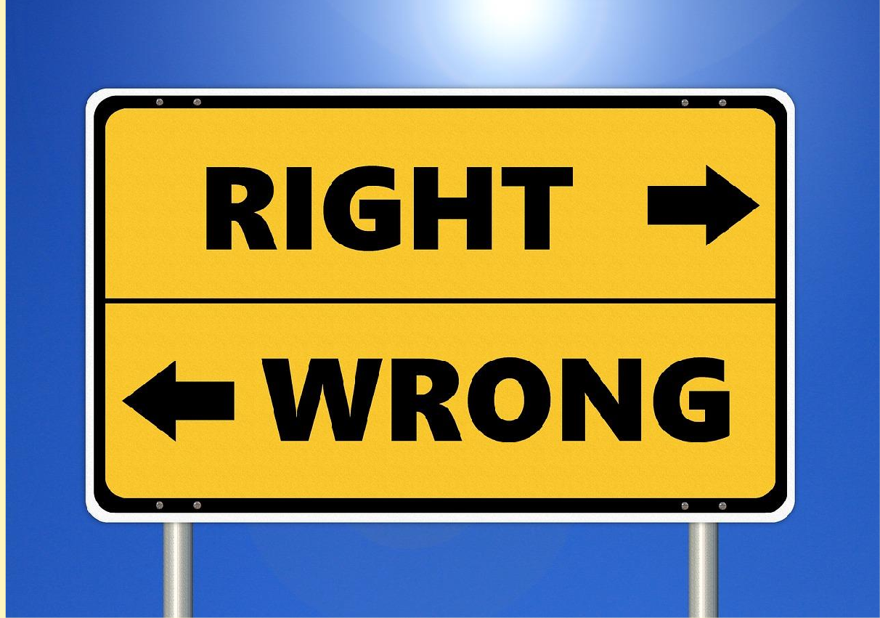
REEFERENCE :

  - Kohlberg, L. (1958). The Development of Modes of Thinking and Choices in Years 10 to 16. Ph. D. Dissertation, University of Chicago.
  - Kohlberg, L. (1984). The Psychology of Moral Development: The Nature and Validity of Moral Stages (Essays on Moral Development, Volume 2). Harper & Row
  - https://www.simplypsychology.org/kohlberg.html
  - https://www.psychologynoteshq.com/kohlbergstheory/

