Report of ‘The Committee to Advise on Renovation and Rejuvenation of Higher Education’

Table of Contents
FOREWORD 2
- The Idea of A University 8
- Challenges of the Higher Education Sector 11
  - Distances and Disconnects
    - Invisible walls
    - Divide between research bodies and universities
    - Isolation of IITs and IIMs
    - Erosion of democratic space

  - Architecture of learning 16
    - Learning across disciplines
    - Teacher education
    - Rehabilitating professional education in the university
    - Undermining undergraduate education
    - Performance criteria
  - Structures, Expansion and Access 28
    - State universities and affiliated colleges
    - Growth of private-commercial providers
    - Mushrooming of ‘deemed’ universities
    - Issues of affordability
    - Foreign universities
    - Resource management and financing

  - Governance and Autonomy 43
    - Poor governance of universities
    - Interference in university functioning: Loss of autonomy
    - Subversion from within

  - Multiplicity of Regulatory Systems 48

- Recovering the idea of the University: A Roadmap 52
  - A New Regulatory Framework
  - Objectives of ‘The National Commission for Higher Education and Researc’h
  - Restructuring Universities
  - Agenda for Action
Appendix
A : Role of The National Commission for Higher Education and Research 63
B : Draft for according Constitutional status to the
proposed National Commission for Higher Education and Research 67
C : Documents related to evolution of the work of the Committee. 71

1

Report of ‘The Committee to Advise on Renovation and Rejuvenation of Higher Education’

FOREWORD

It is a pleasure to present the report of the “Committee to Advise on the Renovation and Rejuvenation of Higher Education”. This has been a deep immersion for my colleagues and me. We hope that we have come out with something that would make a difference. To give you some background of our work, it would be best if I start by quoting from the letter I wrote to the then Minister of Human Resource Development, Shri Arjun Singh, while forwarding our Draft Report on 1st of March, 2009:
“I am submitting the Draft Interim Report of the Committee you had set up through a Notification on 28th of February 2008. You had given us a year. The committee was originally supposed to review UGC/AICTE and various other Councils connected with higher education. The expressed, and the overall implied, hope was that we might be able to suggest ways of moving our higher education to a more active and creative form. I felt that engaging with listing the limitations and faults of these two organizations would not be very productive, besides being very limiting. We did not want to expend our energies in suggesting minor and major modifications in their structures; instead we decided to explore some basic aberrations in our system that are generally ignored. Therefore, a few months down the line I came to you to suggest that our task might be made broader; that we should be asked to advise on “Renovation and Rejuvenation of Higher Education”. I was both pleased and overwhelmed that you conceded to my request. As you would notice, the salient points of our report also meet the essence of the earlier, more limited, task given to us.
We were struck by the fact that over the years we have followed policies of fragmenting our educational enterprise into cubicles. We have overlooked that new knowledge and new insights have often originated at the boundaries of disciplines. We have tended to imprison disciplinary studies in
2

Report of ‘The Committee to Advise on Renovation and Rejuvenation of Higher Education’

opaque walls. This has restricted flights of imagination and limited our creativity. This character of our education has restrained and restricted our young right from the school age and continues that way into college and university stages. Most instrumentalities of our education harm the potential of human mind for constructing and creating new knowledge. We have emphasized delivery of information and rewarded capability of storing information. This does not help in creating a knowledge society. This is particularly vile at the university level because one of the requirements of a good university should be to engage in knowledge creation – not just for the learner but also for society as a whole.
It became clear to us, therefore, that the overall regulating structure for all higher education should be just one. This would imply that the UGC and AICTE should be subsumed within a single Higher Education Commission. There is no need for separate Councils for various areas and the responsibilities of various existing Councils should be changed to define the floor-exit qualifications of personnel who exit from the respective institutions. Knowledge and curricular details would be determined by appropriate universities under guidelines of appropriate structures set up by various wings of Higher Education Commission. Some details about the structure of the Higher Education Commission (HEC), various bodies attached to it and other aspects are discussed in the report. (It might be noted that the justification and role of the suggested HEC are different from those proposed by the Knowledge Commission). We hope the Commission proposed by us would also act as a facilitator and catalyst for joint programs between different Universities and other institutions.
Let me point to some of the recommendations that have arisen from this way of thinking. Our report comes at a time when there is a refreshing seriousness about doing some thing ambitious and unprecedented in our higher education. A large number of Central universities are being set up. Also several Institutes of Technology, Management and other areas. During a
3

Report of ‘The Committee to Advise on Renovation and Rejuvenation of Higher Education’

lot of discussion in this regard we have also talked of World-Class Universities. We would like to point out that there are no great universities in the world that do not simultaneously conduct world class programs in science, astronomy, management, languages, comparative literature, philosophy, psychology, information technology, law, political science, economics, agriculture and many other emerging disciplines. Indeed the emerging disciplines do their emerging because of infection or triggering by other fields in the same university. That is the reason that such universities are so great and our academics keep going to them. Our argument is that they would not be great if they could not accommodate people from many other disciplines. Put together, all the disciplines, breed value into each other. If forced to stay in isolation from each other they would not have the character demanded for greatness. It is our strong recommendation that the new Universities, including those we call Indian Institutes of Technology – or Management should have the character of such world-class universities. Furthermore, the existing Institutes of Technology whose competence as excellent undergraduate institutions we do recognize (also their brand name) should be challenged to play a bigger role – for example similar to that of great universities like the Massachusetts Institute of Technology (MIT) or Caltech. In addition, like these great universities of the world they should engage with a much wider universe of knowledge, both at undergraduate and post graduate levels.
We are also convinced that Indian higher education as a whole cannot go far without our paying equal attention to the State universities. They are also Indian universities and a large fraction our students will continue to come from them. Many of them are as good as our Central institutions and should be given a chance to fly. We should think seriously about the manner in which the motivation and resources are enhanced all over the country.
I would like to mention our deep concern in respect of two matters.

4

Report of ‘The Committee to Advise on Renovation and Rejuvenation of Higher Education’

Mushrooming engineering and management colleges, with some notable exceptions, have largely become, mere business entities dispensing very poor quality education. We have made some recommendations in this regard.
Deemed Universities have also mushroomed. Most of them do not belong to the same class as those recognized as such twenty years ago. This provision was reserved for a few truly outstanding education and research institutions, with a consideration that they would bring depth and variety into the education system. We are seriously concerned about the character and value of the recent explosive growth and have made specific recommendations in this regard.
Finally, we would share with you the prevalent feeling in the universities that there is too much inspection, interference and delay in their dealings with State and Central Governments. I am sure universities and colleges should themselves share some blame in this regard, but we need to move away from this blame game. We have to devise somewhat different, more efficient, funding management system. We have made some recommendations in this regard. We would recommend that universities should become self- regulating partners in managing the overall education system. Continuous monitoring and inspection cause delays and lead to corruption. Some suggestions in this regard have also been made.”
You would notice that we are placing supreme importance on the character of universities. They must create new knowledge. Besides making people capable of creating wealth they have a deep role in the overall thinking of society and the world as a whole. This job cannot be performed in secluded corners of information and knowledge. It would be silly to deny the practical role of experts in areas of science, technology, economics, finance and management. But narrow expertise alone does not make educated human beings for tomorrow. Indeed, speaking more seriously, one could almost say that most serious problems of the world today arise from the fact that we are dominated by striations of expertise with deep chasms in between.
5

Report of ‘The Committee to Advise on Renovation and Rejuvenation of Higher Education’

A year and some months after we started I feel that I have been engaged in a movement in which there has been lot of thinking and an enormous amount of sharing. We did have several meetings in proper meeting rooms, but we also had open interaction with close to a thousand Vice-Chancellors, Principals of Colleges and teachers. In addition, in most places we visited there was interaction with large groups, school and college students. For me meetings with children are always energizing because they are not yet fully imprisoned in disciplines. After all this I have been left with a deep feeling of optimism. Hidden in small places, in obscure schools, colleges and universities, there are potential geniuses to be discovered. Many of them could be the great knowledge creators of tomorrow. We have to discover and implement ways that would not put useless hurdles in their path. That is our challenge. I do not propose to go over every thing that has been said in our report. But a few essential might be worth repeating:
We have suggested that the present regulating bodies should all be subsumed within a National Commission for Higher Education and Research (NCHER).
To reduce most possibilities of interference this Commission should be established through a Constitutional amendment and have a Constitutional status.
A suggested provision to be inserted appropriately in the Constitution through an amendment is annexed with the Report.
NCHER has not been visualised as a Czar. The autonomy of universities is to be respected and we should not enforce dead uniformity. They do not have to be carbon copies of each other.
Quite a few suggestions have been made to improve the method of appointment of Vice-Chancellors and internal working of universities.

6

Report of ‘The Committee to Advise on Renovation and Rejuvenation of Higher Education’

To highlight our suggestions for the management system within a University it has been suggested that our best run institutions, in ascending order might be some of the Central Universities, IITs and IIMs. They might show the way to others.
Stand-alone single discipline institutions should try to broaden themselves to provide a more wholesome education to their students and thus qualify for the title of a degree giving university.
We have addressed the question of public private partnership appropriately, welcoming a proper movement in this direction.
And a lot of other matters, such as the question of affiliated colleges, have been discussed at length. We have been conscious of the fact that our committee should not try to do the job of the proposed NCHER.
But I do reserve the right to add that in order to enrich our higher education we might invite from abroad a substantial number of potentially great academics and scientists to work with our students and teachers, instead of importing mediocre foreign universities to set up shop here.
I also want to express my deep appreciation of the fact that Shri Arjun Singh sensed the value of what we were trying to do, when I went to him with a request to change the name and charge of our Committee after two months of deep collective thinking.
I would also like to disclose that before I agreed to get involved with this work, I had a conversation with the Prime Minister and got the impression that some out of the box thinking might not be frowned upon. Indeed, it was expected. Perhaps we have done a bit of that.
A few words with Shri Kapil Sibal, after he agreed to steer the MHRD also assured me that some real resonance might be around the corner!

7

Report of ‘The Committee to Advise on Renovation and Rejuvenation of Higher Education’

I think this is more than enough for a Foreword. I want to personally thank every one who has contributed to this unique effort and given so much of their time and talent. It has been a rare privilege to be given the chance of spending so much time with my distinguished colleagues. I assure you all that, whatever the fate of your Report, your work will have a meaning for our future.

Yash Pal

8

Report of ‘The Committee to Advise on Renovation and Rejuvenation of Higher Education’

THE IDEA OF A UNIVERSITY

A university is a place where new ideas germinate, strike roots and grow tall and sturdy. It is a unique space, which covers the entire universe of knowledge. It is a place where creative minds converge, interact with each other and construct visions of new realities. Established notions of truth are challenged in the pursuit of knowledge.
To be able to do all this, universities have to be autonomous spaces. They are diverse in their design and organization, reflecting the unique historical and socio-cultural settings in which they have grown. This diversity reflects the organic links that they have with their surroundings, which are not only physical but cultural as well. Through research and teaching, they create, evaluate and bring about advances in knowledge and culture. The principle of moral and intellectual autonomy from political authority and economic power is ingrained in the very idea of the university. This autonomy ensures freedom in research and training and it is expected that the governments and the society would respect this fundamental principle. Teaching and research have to be inseparable, because the task of the university is not only to impart knowledge to young people but also to give them opportunities to create their own knowledge. Active and constant engagement with the young minds and hearts of the society also implies that the universities are to serve the society as a whole, and in order to achieve this, considerable investment in continuing education is essential.
The slow but increasing democratization of higher education in India has meant that the university is no longer the preserve of the children of the elite, or of the educated/professional middle-class. As more youngsters from a different segment of society enter the universities, they look at higher education as a means to transcend the class barriers. Consequently, university education is no longer viewed as a good in itself, but also as the stepping-stone into a higher orbit of the job market, where the student
9

Report of ‘The Committee to Advise on Renovation and Rejuvenation of Higher Education’

expects a concrete monetary return, and consequently in this perception, the university of today is expected to be in tune with the emerging needs of the society. Even so, graduates should be sufficiently exposed to interdisciplinary experiences, which can sustain them when the demands of a particular job market changes.
The university has also been regarded as the trustee of the humanist traditions of the world and it constantly endeavors to fulfill its mission by attaining universal knowledge, which can be done only by transcending geographical, cultural and political boundaries. By doing so, it affirms the need for all cultures to know each other and keeps alive the possibilities of dialogue among them. It is also important to remember that the university aims to develop a scholarly and scientific outlook. This outlook involves the ability to set aside special interests for the sake of impartial analysis. Standing for more than specific factual knowledge, a scientific outlook calls for an analytical and questioning attitude and the continuous exercise of reason. All this requires us to go beyond specialized knowledge and competence. This universal approach to knowledge demands that boundaries of disciplines be porous and scholars be constantly on guard against the tendency towards ‘cubicalization’ of knowledge.
Apart from resisting fragmentation of knowledge, the idea of a university should at the same time aspire to encompass the world of work in all its forms. Work constitutes the human sphere where knowledge and skills are born, and where new knowledge takes shape in response to social and personal needs. Indeed, the experience and culture of work represents that core space where the humanities and the sciences meet.
The founders of the Indian Republic, with these essential features of a university at the back of their minds, realized even during the freedom struggle that the future of Indian democracy depended largely on the ability of the society to create new knowledge. The enrichment and development of cultural, scientific and technical resources was to be done in centres of
10

Report of ‘The Committee to Advise on Renovation and Rejuvenation of Higher Education’

culture, knowledge and research, as represented by true universities. These expectations were to be fulfilled in a social context characterized by a sharp division between the rural and the urban, the elite and the masses, and between men and women. Since a university is based on the fundamental principle of transcendence and meeting of minds from diverse backgrounds, higher education was increasingly perceived as a means to overcome caste and class hierarchy, patriarchy and other cultural prejudices and also a source of new knowledge and skills, a space for creativity and innovations. Higher education, therefore, was and continues to be considered a national responsibility and the state has to make necessary provisions to realize its potentials.

11

Report of ‘The Committee to Advise on Renovation and Rejuvenation of Higher Education’

CHALLENGES OF THE HIGHER EDUCATION SECTOR

Loss of primacy of the universities in the scheme of the higher education sector in India, erosion of their autonomy, undermining of undergraduate education, the growing distance between knowledge areas and the isolation of universities from the real world outside and crass commercialization are some of the problems that characterise the growth of the Indian higher education system. It is important that we develop an understanding of these issues before suggesting strategies to renovate and rejuvenate higher education in India.
  - DISTANCES AND DISCONNECTS

    - Invisible walls
It is often pointed out that our undergraduate and graduate programmes are too ‘theoretical’, the implication being that they are devoid of ‘practical’ experiences. Without going into familiar epistemological issues, we can say that a theory is as good as the power it has to explain the world. A theory is put to practice when a student attempts to use it to make sense of what she notices in the world. Conversely, by noticing something in the world and seeking an explanation for it, a student feels the need to have a theory.
The chasm that exists between theory and practice combined with the fragmentation of the idea of knowledge leads to the confusion that our system of higher education is suffering from. To overcome this, it would be necessary that the universities adopt a curricular approach which treats knowledge in a holistic manner and creates exciting opportunities for different kinds of interfaces between the disciplines, which is unthinkable today in most of the universities and institutions of higher learning. It is
12

Report of ‘The Committee to Advise on Renovation and Rejuvenation of Higher Education’

important that universities relate to the world outside and the walls of disciplines are porous enough to let other voices be heard. It would also be necessary that the university education is seen in its totality and subject areas not be designed in isolation.
The Indian system of higher education has also kept itself aloof from the local knowledge base of the worker, the artisan and the peasant. It has kept itself at a distance from the real world outside. Within the system, there are distances between disciplines. Within a single campus, disciplines often grow in complete ignorance even of each other’s presence.
This lack of dialogue becomes more profound when we talk of areas like engineering, medicine and teacher training. Here, we have ended up with statutory bodies, which exist purely for the task of regulation. While universities award engineering and medical degrees, it is ironic that they do not have the powers to determine whether an institution that claims to train engineers or doctors has the wherewithal to do so. Nor do they have sufficient say in designing the academic programmes, in professional disciplines, as these are largely influenced by statutory bodies like the Medical Council of India and the AICTE.
Ostensibly, the university’s loss of academic influence in this respect looks like a case of distribution of responsibilities. Yet, at its heart lie the erosion of university’s concept of knowledge, and perpetuation of a divisive view of knowledge and skill.
    - Divide between Research Bodies and Universities
Universities were historically conceived as spaces where teaching and research go together. They are closely linked. Research and teaching are simply different aspects of academic work. To teach
13

Report of ‘The Committee to Advise on Renovation and Rejuvenation of Higher Education’

effectively at the university level, one needs to actively engage in research. This was not questioned when only a small section of the elite had access to the universities and when university research was comparatively inexpensive. It seemed proper (and feasible) for undergraduates to be taught by people who were actively engaged in research and scholarship. Now, when universities have become mass institutions and costs of research, especially in the context of science and engineering, have become very high, things have changed.
Over the years, there has been an increasing tendency to treat teaching and research as separate activities, although for very different reasons, with some wishing to preserve research as élite activity. This distinction is being reinforced by separate policies, programmes and structures.
This disjoint between teaching and research has led to a situation in which, on the one hand, most of the universities have been reduced to the status of centres that teach and examine masses and, on the other hand, more and more elite research bodies are being created where researchers have absolutely no occasion to engage with young minds.
It should be necessary for all research bodies to connect with universities in their vicinity and create teaching opportunities for their researchers and for all universities to be teaching and research universities
    - Isolation of IITs and IIMs
The IITs and IIMs are considered to be bright spots in the otherwise dismal scenario of higher education in India. There is little dispute over their claim to quality and excellence. They
14

Report of ‘The Committee to Advise on Renovation and Rejuvenation of Higher Education’

have also fiercely and successfully defended their autonomy over the years.
IITs and IIMs were created in the first phases of nation building, and kept out of the traditional university structure to give them free play to be able to help the nation have a pool of excellent engineering and managerial talent. To a fair extent, these institutions have succeeded.
Looking at the enormous potential they have, it has been felt that they must strive to be models of all-round excellence, like the famous Massachusetts Institute of Technology or CALTECH in the US. This requires rethinking to prevent isolation of the study of engineering and management from other knowledge areas. This realization is reflected in the initiatives of some of the IITs that aim to introduce humanities and other disciplines and expand their scope. These initiatives strengthen our argument that they need to broaden their curriculum framework and assume the functions of full-fledged universities without losing their unique character. We can then look forward to the day when IITs and IIMs would be producing scholars in literature, linguistics and politics along with engineering and management wizards who would have substantial motivation for engagement with the local community, and the opportunity to use and enhance learning by solving real-life problems in their immediate environment. While working towards this goal we need to understand that different IITs and IIMs would have different strategies to expand and diversify, and we must refrain from issuing a uniform diktat to all of them to move in a prescribed direction.

15

Report of ‘The Committee to Advise on Renovation and Rejuvenation of Higher Education’

    - Erosion of democratic space
The role of higher education in creating an institutional space for dialogue and liberal inquiry is well recognized, but it is seldom appreciated in the context of establishing norms of democratic behaviour and exchange. In India, where social hierarchy and divisions are sharp, institutions of learning serve as sites where powerful social forces vie for dominance. The institutional capacity to maintain peace and a democratic process plays a critical role in shaping the ethos of this site. Peace in this context can be described as a pre-condition for rationally organized dialogue between contending forces, ideologies and viewpoints. If institutions of higher education fail to ensure peace on their own premises in this sense of the term, they cannot avoid failing in a far greater sense when they claim public money on a gigantic scale and lose public faith.
For a considerable length of time following Independence, institutions of higher learning succeeded in providing a space where dialogue between rival social forces and ideologies could take place in a peaceful atmosphere. However, over the last few decades certain distinct signs of the erosion of this space have surfaced quite often in different parts of the country. The situation has worsened over the last few years. Not only organized youth but the official machinery of the university has been deliberately used to obstruct or subvert the possibility of peaceful debate and inquiry resulting in a long-term institutional damage to their capacity to serve as sites of peace. This is a matter of great anxiety, not just because it marks the erosion of institutional sanctity, but also because it distorts the idea of a university and its role in the creation of knowledge by free and open inquiry through research and dialogue.
16

Report of ‘The Committee to Advise on Renovation and Rejuvenation of Higher Education’

The issue of geo-cultural diversities is another critical area where our universities have increasingly failed to act as spaces where students would learn to respect diversity as a value. In a world where boundaries are blurring, it is important that we learn to acknowledge and appreciate differences and not try to homogenize everything.
  - ARCHITECTURE OF LEARNING

Currently, many students passing out from institutions of higher education do so without obtaining the kind of skills they really need to work in a real-world environment. Among the drawbacks many students face are lack of ability to analyze or solve problems, relate problems to different contexts, communicate clearly and have an integrated understanding of different branches of knowledge.
These problems can be addressed if the processes by which curriculum is designed and then syllabi are determined undergo improvement.
    - Curriculum issues and syllabus-making
There is a need to ask as to what is the purpose of a university, especially at the undergraduate level, and then use the answers to develop a curriculum.
At present, the design of curriculum and syllabi is reflective of the entrenched examination system under which the student is asked to face a question paper at the end of the year, or in some universities, at the end of the semester. This archaic examination system, ostensibly used as a means of certifying the ability of students, unfortunately does not really test the kind of skills they require to be successful in either the pursuit of pure theoretical knowledge or in practical real world situations.

17

Report of ‘The Committee to Advise on Renovation and Rejuvenation of Higher Education’

The examination system, even in the case of the relatively better equipped and less rigid institutions, has remained quite manifestly traditional and incapable of distinguishing between different talents of students in a reliable manner. Similar to what happens at the school level, university-level evaluation practices also simply broaden the scope of memory-based questioning, with the occasional rote-based ‘application’ question masquerading as real-world problem solving. In doing so, they entrench the student’s lack of ability to examine and understand the real world, as a result of which their engagement with people or issues remains scarce once they enter the world of work, with implications for their abilities as workers and citizens.
As a result of this lopsided emphasis on evaluation of students through examinations, what is considered knowledge in the prevailing setup is at best a body of facts. This occasionally leads to students gaining ‘knowledge’ with varying, though usually low, degrees of success.
The mode of transmission is also generally quite poor in terms of its pedagogic quality. The methods of teaching and evaluation used are not conducive to improving the ability of students for abstract thinking.
If the syllabi were to be designed with a view to inducting the student into a community of participant citizens, a new kind of institutional culture and ethos can be created in our general and professional colleges. For this to happen, all syllabi should require the teachers and students to apply what they have learnt in their courses, on studying a local situation, issue or problem. There should be sufficient room for the use of local data and resources to make the knowledge covered in the syllabus come alive as experience.
18

Report of ‘The Committee to Advise on Renovation and Rejuvenation of Higher Education’

This is required simply because engaging with the world surrounding us – both local and international- is an important aspect of learning, both as a means as well as an end. Knowledge- both theoretical and applied- when pursued with reference to the milieu is qualitatively different from knowledge, which is pursued in isolation from the surroundings. The difference becomes apparent both in the depth to which the acquisition of knowledge shapes the learner’s mind and personality, as well as in the nature and productivity of the relationship between the learner and the teacher.
Exposing students to the world of work plays two related and essential roles. First, by helping them to understand the reality of different kinds of work, and those who perform this work, ranging from manual labour to intellectual tasks, it sensitizes them to the conditions of a universe of persons outside of their own. Second, it allows them to apply what they have learnt in the classroom to real-world situations, and in doing so not only makes them better prepared for their own entry into the world of employment or academic research, but also strengthens their understanding of the underlying concepts they are supposed to have learned.
Curricular reform in this regard would include compulsory exposure and engagement with different kinds of work, in the form of summer jobs or internships, according to the circumstances and surroundings of the particular university, and should include both manual and other kinds of work/occupations, with a certain minimum set of occupational exposure compulsory for all students, irrespective of discipline. Evaluating students on these fronts would necessarily have to analyse how well they have understood, and are as a result
19

Report of ‘The Committee to Advise on Renovation and Rejuvenation of Higher Education’

capable of applying themselves to work and be problem-solving in these situations.
Examples of this process of syllabus designing will need to be worked out in different disciplines, since an engineering or science course will clearly engage with local matters differently from history or political science. For this strategy of syllabus redesigning to succeed, evaluation and examination practices will also have to change, and certainly, there will have to be a change in pedagogic practices used by teachers.
    - Learning across disciplines
At present, much of our higher education is uni-disciplinary or within a narrow spread. Specialization in a given discipline is only valuable in so far as it allows the learner to link that discipline with the real world and contextualize his/her own conceptions of life and its various phenomena.
Wherever education does involve inclusion of disciplines other than the major one that the student is studying, it is in the form of ‘subsidiary’ subjects. By their very nomenclature these subjects are seldom regarded as serious, either for the assessment they carry, or, least of all, for their content. Likewise, the teaching and syllabi of these subjects, over a period of time, also become poor in quality and motivation. Hence, currently despite going through the motions there is no real learning across disciplines happening.
Contextually understanding a particular subject or discipline, and applying its concepts to worldly questions is an acknowledged aim of education, particularly at the higher levels such as undergraduate education. Integrating a given subject to which the student devotes a majority of her/his time with other
20

Report of ‘The Committee to Advise on Renovation and Rejuvenation of Higher Education’

relevant subjects is therefore essential to improve the current undergraduate education structure.
One way of improving the quality of teaching of these additional disciplines and stimulating students’ interest is to allow students for whom a subject is additional to study along with those for whom the same subject is primary. For instance, a mathematics student should study and undergo evaluation in philosophy as an optional subject along with students for whom philosophy constitutes the primary subject.
In sum, there is a need to expose students, especially at the undergraduate level, to various disciplines like humanities, social sciences, aesthetics etc., in an integrated manner. This should be irrespective of the discipline they would like to specialize in subsequently.
    - Teacher education
The preparation of teachers for all levels of school education
should be the responsibility of institutions of higher education. For historical reasons, the involvement of universities in school-level teacher education has been confined to secondary and senior secondary-level school - teachers' pre-service training under the B.Ed. degree programme. The State governments manage the
One exception to this general picture is the Bachelor of Elementary Education (B.El.Ed.) course of the University of Delhi. The success of this course in establishing a benchmark of quality indicates how necessary it is to recognize teacher education – for all stages of school education – as a sector of higher education. The rationale for such a move is self-evident.
Irrespective of the level at which a teacher serves, he or she deals with knowledge. Higher education is where knowledge is produced and
therefore it makes sense to regard teacher
education.
preparation of teachers for the primary and pre-primary levels. Although these levels have been

 | 21 |  | education as a whole as a sector of higher

Report of ‘The Committee to Advise on Renovation and Rejuvenation of Higher Education’

recognized as being fundamental to the development of children and the nation, the absence of university-level interest has resulted in poor academic quality.
It is also necessary to enhance the quality of teacher education within higher education. At present, Academic Staff Colleges are serving to provide refresher courses required by faculty to acquire eligibility for promotion. While this role is important, the manner in which it is being fulfilled is far from satisfactory. It is necessary to develop full-fledged orientation programmes for newly recruited teachers in colleges and universities. Such courses should orient teachers towards the proposed curriculum framework as well as to impart communication and assessment skills.
    - Rehabilitating professional education in the university
Substantial damage has been done to universities and institutions of professional education by their separation from each other. The pursuit of engineering and medicine, in particular, in colleges or institutes, which exist like islands, has come at an incalculable social and cultural cost. Seventeen-year- olds who move from a higher secondary school straight into an engineering or medical college, and who thereby have no means to gain exposure to any in-depth knowledge of society, its economy, politics and culture, while possibly becoming excellent engineers and doctors in a very restricted sense also have as much potential to become an impediment to holistic social development.
In the context of medicine, this matter has received some attention in a few exceptional institutions, but as institutions of professional education, medical colleges in general have evolved
22

Report of ‘The Committee to Advise on Renovation and Rejuvenation of Higher Education’

in isolation from the rest of the university, with the latter acting merely as a degree-granting or certification authority.
Conversely, there is also a trend for creation of stand-alone universities in certain fields, such as agriculture, medicine and law. While there has been a need for providing depth in specialization in specific knowledge areas, this process has been trivialized and has now deteriorated to such an extent that universities are being created for narrow areas like information technology, pharmacy, catering, yoga, music and fashion technology.
In order to provide the graduates of these specialized institutions with a holistic curriculum including other relevant branches of knowledge , it would be necessary that their curriculum framework is so designed that they could work in partnership with other institutions in their vicinity. Instead of making any prescription in this regard the committee proposes that these institutions should evolve creative ways of engaging with diverse range of knowledge areas.
In order to build strong epistemic bridges between different fields of professional education and the different disciplines of science, social sciences, and humanities, it is necessary that professional institutions are returned to universities in a complete administrative and academic sense by the abolition of intermediary bodies set up to issue licenses to professional colleges alone, and to inspect them. Such a measure will open the possibility of new kinds of course-designing for professional learning in all fields from management and architecture to medicine and engineering, along the lines indicated in other sections of this report.
23

Report of ‘The Committee to Advise on Renovation and Rejuvenation of Higher Education’

The vocational education sector is at present outside the purview of universities and colleges. The knowledge and skills covered by this sector have no linkages with institutions of higher education and research. Students who go for vocational and technical education after completing higher secondary education are deprived of any possibility of pursuing higher education after completing their vocational or technical training. Alienation of this sector can be overcome by bringing it under the purview of universities and by providing necessary accreditation to the courses available in polytechnics, industrial training institutions, and so on. In the context of the rural economy and livelihoods, certain institutions and programmes have attempted
to provide opportunities for further education after the higher secondary stage. They also need to be brought under the purview of the university system. Such incorporation will create the
There is a trend of granting university status to major organizations such as CSIR, ISRO etc. The basis for this trend is to provide opportunities to various laboratories under such organizations to utilize their facilities and expertise to provide degree level programmers in their fields of specialization. This approach needs to be reconsidered. Laboratories can offer degree level programs of a holistic nature in association with other institutions and can be recognized as universities. However, the organizations or departments themselves should not be treated as universities.
possibility of addressing long-
neglected issues of social justice and inequity arising out of the hierarchical social order and entrenched rural-urban disparities.
The reason why vocational education has remained under- developed and continues to be perceived as a last option is because it is largely the poor, who
either cannot afford academic education or who pass out of poorly-equipped and uninspiring schools with low marks. This
24

Report of ‘The Committee to Advise on Renovation and Rejuvenation of Higher Education’

kind of stigmatization of vocational education, as a last resort and essentially for the poorer sections of society, needs to be overcome for speedy development of the skills necessary in the present phase of India's economic development. The setting up of a skill-development council at the Central level is a positive step in this direction. Further growth will greatly depend on the guidance and leadership that universities will be able to provide for institutions of vocational and technical education, once they are brought into the domain an all-encompassing system of higher education.
Additionally the barriers to entry into universities for students going through vocational training should be lowered to enable them to upgrade their knowledge base at any stage of their careers.
    - Undermining undergraduate education
The years following school education form the most important stage of induction into adult life, including academic life and employment. In our country, the undergraduate years have mostly remained in the precinct of affiliated colleges, i.e., not as part of mainstream university life. Indeed, quite a few universities do not have undergraduate classes at all. In many universities, the faculty serving undergraduate colleges is given some opportunity to participate in postgraduate teaching at the university, but there is no such provision for the university faculty to serve in colleges. This arrangement illustrates the perceived hierarchy of the UG and PG stages of higher education. In treating UG education as a ‘lower’ level of learning, the Indian university system has perpetuated a source of its own intellectual malnourishment. It is the younger student studying in UG classes who is in the best position to raise basic questions
25

Report of ‘The Committee to Advise on Renovation and Rejuvenation of Higher Education’

on a host of issues while participating in the entrenched discourses of various disciplines. By not exposing itself to UG- level teaching, university faculty, especially the senior faculty, deprives itself of a rejuvenating pedagogic experience. In all the great universities of the world we know of, great teachers, even Nobel Laureates, prefer to teach undergraduate students.
It should be mandatory for all universities to have a rich undergraduate programme and undergraduate students must get opportunities to interact with the best faculty. While appointing teachers to the universities their affiliation to a particular college should also be specified to emphasize the need for their exposure to undergraduate students.
    - Performance Criteria
Setting up of certain performance criteria is a common device for infusing accountability in an organization. Such a device is particularly useful for institutions, which are expected to work in an autonomous manner. Even as we endorse the principle of full autonomy for a university, we recognize the need to evolve certain performance criteria on the basis of which universities can assess themselves and can be assessed by others in a transparent manner.
The current environment favors those criteria which can generate enumerative data, such as the number of research papers published by the faculty in journals, the number of patents acquired, and so on. Criteria of this kind are convenient to use, but often end up becoming mechanical and lose their significance in the context of larger aims of education when the faculty’s work gets delinked from national or social concerns and priorities. Taking a cautionary view towards such a possibility, we propose three parameters for evolving performance criteria.
26

Report of ‘The Committee to Advise on Renovation and Rejuvenation of Higher Education’

These are: one, socio-cultural aims of higher education; two, academic excellence; and three, institutional self-reform.
The Constitution of India offers a framework for aims of education. The socio-cultural aims enshrined in the Constitution assign a transformative role to education. Therefore, in the first parameter we suggest the application of criteria, which derive their value from the categories in terms of which the inequality and social injustice prevailing in Indian society are commonly understood and expressed. Gender is the first and foremost category of this kind. The higher education system offers pervasive instances of gender asymmetry. Perhaps no instances are as glaring as the ones we see in our best institutions of technology and management, but the situation is quite grim in several other domains, especially if we extend the scope of our enquiry to cover the composition of the faculty at the highest levels and administrative positions like that of the Vice- Chancellor. Caste and economic class are two other categories on the basis of which a university’s performance can be assessed by asking what steps it has taken to reduce gender, caste and class asymmetries, the modality of such steps, and their outcomes. In the composition of the faculty, the representation of regions other than the one in which a university is located can serve as a valuable means of assessing a university’s resolve to avoid the parochial tendencies we commonly notice. By definition, a university is a place where India’s diversity must find adequate and visible expression.
Academic excellence forms a separate parameter, which must overlap with the first parameter. Excellence in academic work is partly a reflection of the rigor with which faculty and students pursue their studies in the respective areas of their choice, but
27

Report of ‘The Committee to Advise on Renovation and Rejuvenation of Higher Education’

excellence must also be perceived in a social perspective. As we have discussed elsewhere in this report, our universities and institutes tend to isolate themselves from the social world that surrounds them. Quite often, they look like islands or oases, protected by a boundary wall and gates. In several cities, the contrast between the life and landscape one sees inside the gates and outside is sadly stark. It shows the absence of social responsibility in the concept of excellence. It also shows that the concept of knowledge that such a university does not require engagement or experiential construction of knowledge by learners and teachers. It is necessary that all kinds of documents generated by the university, including its syllabi, the papers and books published by its faculty, the assignments submitted by its students and other products such as audio and video material, be treated as its knowledge products which need to be sampled for independent assessment on the basis of intrinsic merits as well as relevance for the study of problems which are manifest in the university’s immediate social and natural milieu.
The third parameter we propose is that of institutional self- reform. An institution’s awareness of its own problems, its will and capacity to study these problems and to draw roadmaps for resolving them are indicators of its overall institutional quality. Capacity for such an intrinsically inspired reform is also a sign of true autonomy. Therefore, we feel that an important set of criteria can be identified within a university’s own targets for organizational improvement and its record of moving towards them within specified time frames. Priority areas for such self- motivated institutional reforms can be decided and articulated by the university itself.
28

Report of ‘The Committee to Advise on Renovation and Rejuvenation of Higher Education’

It is important that universities set up processes of self- evaluation, which are transparent and credible. Internationally, academic institutions and universities set up teams consisting of academics of eminence, recognized internationally for their expertise and integrity to get themselves assessed. Even in India we have such models available. For example, National law Schools have a process of evaluation similar to this. IIMs have a different process. Universities must submit themselves to credible processes of evaluation which would only help them establish their credentials in the academic world and society at large in a transparent manner.
  - STRUCTURES, EXPANSION AND ACCESS

During the past two decades, even though there has been a rapid expansion of the higher education system, it has been mainly through private investments, since successive governments started reducing their investments in higher education. A large number of colleges and university-level institutions, including institutions deemed to be universities commonly known as ‘deemed universities’, and private universities established through State legislation, have come into existence in recent years. There is a growing demand for further expansion of private institutions.
The implications of the increasing trend towards privatization of higher education need to be understood in terms of the system’s enrolment capacity, programme focus, regional balance, and ownership pattern, modes of delivery, and degree of regulation, quality and credibility as well as social concerns of inclusiveness.
    - State universities and affiliated colleges
State universities are still the backbone of higher education in India. Majority of our students get enrolled there and yet, it is
29

Report of ‘The Committee to Advise on Renovation and Rejuvenation of Higher Education’

the State universities, which are meant to be the responsibility of State Governments to maintain and develop, which have been treated very shabbily in the matters of allocation of funds or creation of more facilities to help them in enriching their existing academic programmers.
Even though State Universities are primarily the responsibility of States, because state legislatures create them, development of all young people, be they in state-run institutions or central institutions, is a national responsibility and there cannot be any discrimination between the two. Ideally all benefits, which are thought to be essential for a central university, should be made available to the state universities. To achieve this state governments would need to significantly enhance their support to the universities while the Centre should make matching incentivizing allocations available in a sense of a joint national enterprise.
The current structure of the Indian university system has a large number of affiliated colleges associated with either a Central or State university, where bulk of the enrollment takes place. This structure has burdened many universities with the management of academic content, examination, and quality of these colleges. In addition, while better colleges feel stifled by the university bureaucracy – delays, controls, and inadequate support – the better universities are affected by the limited thinking of the college leadership and their negative role in university processes. It is obvious that the better institutions are suffering and creativity is a casualty.
It has been a plea of many academic planners that the colleges need to be treated as the foundation of higher education similar to the way primary schools are for school education.Qualitative
30

Report of ‘The Committee to Advise on Renovation and Rejuvenation of Higher Education’

development of these colleges should be our priority. While the initiative by the Central government to create more Central facilities in the field of higher education should be welcomed, one must not forget that money needs to be made available for the qualitative development of colleges. Or, that even when new universities are created, they should begin with undergraduate

education and build on

There have been many suggestions in the past to eliminate the affiliation system in India, which has been the bane of our higher education system. Some of the suggestions include conversion of affiliated colleges to autonomous colleges, creating a cluster of colleges with autonomous academic responsibilities, upgrading some of them to university level and separating examining universities. There are more than 20,000 colleges in India. It can be confidently said that nearly 1,500 of them are very good colleges with a rich history, strong infrastructure and a large body of students. They can easily be upgraded to the level of universities. Then there are a large number of colleges, which can be clubbed in clusters and these clusters can be recognized as universities.

There is also a suggestion of creating universities, which would be only examining bodies to which these colleges can be affiliated. Colleges can also be encouraged to merge with each other to make optimal use of the resources. While doing so it would be important that Colleges are given more autonomy in academic, administrative and financial matters.

However, it is necessary for the apex body in the field of higher education to address this vexed problem in a comprehensive manner as one of its first tasks and suggest a

31 time frame for elimination of the present form of affiliating system.
this base their post- graduate programmes, thus becoming not only role models for the colleges in their States but also a resource for them.
The need is, therefore to renew and revitalize the college system and also to “lighten the load” of these universities and freeing the better and large colleges to become independent of the university processes. It has been argued that underperformance of the State universities has a direct relation to their size. Many of the State universities have, over the years, had more and more colleges affiliated to them, which has made it very

Report of ‘The Committee to Advise on Renovation and Rejuvenation of Higher Education’

difficult for them to perform the role of maintaining academic quality.
There is a view that the optimum size of a university has not only a quantitative but also a qualitative dimension. The optimality of a university has to take account of a critical level of students, teachers, disciplines, programmers of study and the needs of society and its emergence as a nurturer and creator of knowledge, which may vary across universities.
    - Growth of private-commercial providers
The absence of any significant expansion in different sectors of higher education by the State has created a space for the growth of private providers.
However, there has been no policy or guidelines to measure the competence of private investors in starting and managing a technical institution other than the requirement that it should be registered as a non-profit or charitable trust or society.
This lacuna has been exploited by many investors, who have no understanding or experience of the responsibilities associated with institutions of higher education. The trusts or societies that have been formed largely consist of immediate family members – some of whom had little or no educational background - with some exceptions.
All investments on the institution and all appointments and service conditions and, to a considerable extent, most decisions on admission of students in the management quota have been under the control of such family trusts or societies. The principal or the other academic staff members have been mostly excluded

32

Report of ‘The Committee to Advise on Renovation and Rejuvenation of Higher Education’

from these processes and asked to mind only the requirements of the university in terms of syllabus and examinations.
Specific studies need to be done regarding the sources of funds utilized by such family trusts or societies as there are allegations that such funds are either unaccounted wealth from business and political enterprises (occasionally with some bank loans for purposes of legitimacy) or from the capitation fees charged from the students in addition to a plethora of unexplained fees charged whimsically by these managements.

higher education altogether.
It must be mentioned that during the past two decades there have also been many respectable institutions established by private individuals or corporations either with some funding from the government or with no public funding. However, investors and philanthropists wishing to set up institutions of higher education with noble motives have been deterred by the unpredictable and often whimsical rules and regulations imposed on them by regulatory bodies in this sector.

The solution to the unscrupulous methods of some private investors should not mean doing away with their participation in the field of
In many private educational institutions, the appointment of teachers is made at the lowest possible cost. They are treated with scant dignity, thereby turning away competent persons from opting for the teaching profession. A limited number of senior positions are filled at attractive salaries, especially from other reputed institutions, mainly for prestige. Otherwise, there are many terrible instances of faculty being asked to work in more than one institution belonging to the management; their salary being paid only for nine months; actual payments being much less than the amount signed for; impounding of their certificates and passports; compelling them to award pass marks in the internal examination to the “favorites” and fail marks for students who protest illegal collections and so on.

33

Report of ‘The Committee to Advise on Renovation and Rejuvenation of Higher Education’

In order to reach the goals of doubling the higher education capacity from the present level, it will be necessary to encourage participation of the private sector. At the same time it must be emphasized that governments cannot afford to abandon the responsibility for further augmentation of the existing capacity entirely to the private sector.
In fact we must recognize the need for different layers of institutions in the field of higher education, including state-run, private and those established through public-private partnerships. What is required in order to make all of them work efficiently and serve overall national goals is the framing of rational and consistent ground rules overseen by a transparent regulatory mechanism.
Purely private initiatives require a credible corrective mechanism to do away with the ills associated with it currently. It would be necessary for instance that the present practice of family members who sometimes don’t have the experience or the competence relating to education occupying the controlling position of the governing systems of the private educational institutions be prevented. Similarly, the practice of conferring academic designations such as Chancellor, Vice Chancellor, and Pro Vice Chancellor on members of the family has to stop.
There is a need to have a clear understanding of the difference in the roles of a promoter or philanthropist as a trustee as opposed to being an executive of the institution he or she establishes. Executives must have appropriate abilities and qualifications required for the job.
All private institutions, which seek the status of a university, will have to submit to a national accreditation system.
34

Report of ‘The Committee to Advise on Renovation and Rejuvenation of Higher Education’

It is also important that private initiatives in the field of higher education are not driven by the sole motive of profit. They should not confine themselves only to ‘commercially viable’ sectors of education, such as management, accountancy and medicine etc. but should also encompass areas of social and natural sciences by establishing comprehensive universities.
Alternately, such institutions should be allowed to confer only diplomas and certificates and not university degrees. These certificates or diplomas, however, may be recognized by universities for further upgradation to degree levels through programmes of a more holistic nature.
All this would mean modification in the legal framework under which such entities operate to include very tight regulations on auditing their accounts, on transparency, on paying a minimum stipulated salary to qualified and competent teachers, and an insistence on a certain percentage of seats being provided full scholarships/freeships on the basis of merit. The modalities of this and of any mandatory reservations can be worked out.
    - Mushrooming of deemed universities
The sudden spurt in the number of newly established educational institutes as deemed universities is another area of concern. Some of the private institutions took the deemed-to-be university route to get degree-granting powers. Between 2000 and 2005, 26 private-sponsored institutions got the deemed university status. Since 2005, the number of private deemed universities has increased to 108. By a notification of the UGC, it is no longer necessary for them to use the adjective “deemed” and they all call themselves simply universities. In Tamil Nadu alone, the number of private deemed universities has increased from 18 in 2007 to 35 in 2008 and many are in the queue.
35

Report of ‘The Committee to Advise on Renovation and Rejuvenation of Higher Education’

Though, the deemed universities do not have affiliating powers, many of them have a number of campuses spread throughout the country.
The provision for the status of deemed universities was made with a noble intent. It was felt that the institutions, which had unique and distinct character of their own could enjoy the privileges of a university without losing their distinct character and autonomy.
According to the University Grants Commission, in its guidelines for considering any proposal for declaring an institution a deemed university under Section 3 of the UGC Act, "the institution should generally be engaged in teaching programmers and research in chosen fields of specialization which are innovative and of very high academic standard at the master's and research levels. It should also have a greater interface with society through extramural extension and field-action related programmers."
In the first 10 years after the enactment of the UGC Act, eight institutions were notified as deemed universities. In the 1970s, the UGC decided that notification under Section 3 should be made only rarely in special cases and three institutions were conferred the deemed university status. There was a slight shift in the policy in the 1980s and 18 more institutions were added under Section 3.
Between 1956 and 1990, in 35 years, only 29 institutions were granted the deemed university status. In the last 15 years, 63 institutions were declared deemed universities and particularly in the last 5 years, 36 institutions, excluding RECs, have been notified as deemed universities. It may be argued that the
36

Report of ‘The Committee to Advise on Renovation and Rejuvenation of Higher Education’

increase in the number of deemed universities is commensurate with the increase in the number of institutions of higher learning in the country. What has raised the concern of the academic world is the fact that the majority of these institutes are not established with any educational purpose, and they end up only deluding the students.

In view of considerable misuse of the provision for Deemed University status, the granting of such status should be put on hold till unambiguous and rational guidelines are evolved. Institutions wishing to get deemed university status should demonstrate special capabilities as was originally intended and should be rigorously evaluated to see if they fulfill the holistic and universal concept of university outlined in this report. The institutions, which have somehow managed to secure such status should be given a period of three years to develop as a
The behaviour of some private universities has become a matter of serious concern to a large body of students and parents. There have been several instances of campus violence and related litigations. A detailed probe into the basic reasons for the concerns revealed that many of them were professional colleges that got approval from the regulatory bodies for university status. Immediately thereafter, they started admitting five to six times their intake capacity, without a corresponding increase in faculty strength or academic infrastructure. The classes and laboratories were conducted at strange hours like a factory production operation. The students who paid huge capitation fees felt cheated. The students from the underprivileged sections could not get admission in many of them due to heavy capitation fees.
The existing guidelines and the Memoranda of Association (MOA) with the UGC were ambiguous and inappropriate to the new situation. Compounding the stigma is the offer made by some of them, after obtaining university status, to give “guaranteed” degrees at any level, including Ph.D., for a price. This has dealt a serious blow to the credibility of the Indian university degree.

37

Report of ‘The Committee to Advise on Renovation and Rejuvenation of Higher Education’

university and fulfill the prescribed accreditation norms failing which the status given to them would be withdrawn.

Every University, Public or Private, could strive to attain the status and eminence that is expected of a university , derived from the adherence to the basic concepts of university discussed in this regard in terms of curriculum, feasibility of its regulation and transparency of the governance system. Every university, large or small, should have the scope to rise up to the prestige achieved through its performance and recognition. While the State could do everything to enable the university to demonstrate higher levels of performance, it is also incumbent on the universities themselves to organize their programmers and activities in a manner that would continue to attract the support of the State as well as the Private enterprise. The ability to attract partnership from private sector, either in the execution of its programmers or in more enduring relationship will be conditioned by the demonstration by the university as to how well it is organized and by the level of its performance which would be judged by the criteria as suggested in this report and to be worked out by the apex body in the field of higher education.
    - Issues of affordability
Many private institutions charge exorbitant fees (beyond the prescribed norms) in the form of many kinds of levy (not accounted for by vouchers and receipts) and are unable to provide even minimum competent faculty strength. The non- affordability of the programmers of such institutions to a vast majority of eligible students is a matter of public concern.
38

Report of ‘The Committee to Advise on Renovation and Rejuvenation of Higher Education’

The regulatory agencies have been unable to come to grips with the problems of capitation fee and unauthorized annual fees mainly due to deficiencies in enforcement instruments, and partly due to high-level reluctance to sort out this problem.
Since the norms for fixation of fees are vague, the quantum of fees charged has no rational basis. The illegal capitation fees range from: Rs. 1-10 lakh for the engineering courses; Rs. 20-40 lakh for MBBS courses; Rs. 5-12 lakh for dental courses; and about Rs. 30,000-50,000 for courses in arts and science colleges, depending on the demand.
Studies and research show that most of the private investment in higher education is in the field of engineering, management and medicine whereas the majority of enrollment is taking place in traditional disciplines. The private providers are, therefore, not putting their money in areas which attract the bulk of the students, especially first generation university goers. This remains the responsibility of the state. It is the middle class, which has for long benefited from the state education system and is now breaking away from it.
The primary focus should, therefore be on making education affordable, either through scholarships or loans. An assured loan to every student (and a scholarship based on merit for the needy) in accredited institutions should be the aim (and our recommendation). Institutional funding can then be for capital costs and research, and based on the worthiness of the institution. Once a student qualifies to enter an institution of her choice, she should not be deprived of education for want of money. It is the duty of the institution and the state to provide for her education through means as suggested above.
39

Report of ‘The Committee to Advise on Renovation and Rejuvenation of Higher Education’

Steps need to be initiated to ensure availability of loans and scholarships.
    - Foreign Universities
One has to keep in mind the fact that universities grow in organic connection with their social, cultural and geographical surroundings and even the best of them cannot be transplanted somewhere else and expected to do as well. A university is known not only for its courses, it is the physicality of it, which gives it a unique character. As has been rightly said, education is a touch-sport. Before taking any decision on allowing foreign universities to operate in India we have to be very clear about the purpose it is going is achieve. Don’t we want the best learning experiences to be shared by our students? If so, can this not be done by opening our doors to foreign scholars and making our rules more flexible? Interaction with the best minds of the world would only enhance the quality of our universities. But giving an open license to all and sundry carrying a foreign ownership tag to function like universities in India, most of them not even known in their own countries, would only help them earn profit for their parent institutions located outside or accrue profit to the shareholders. If the best of foreign universities, say amongst the top 200 in the world, want to come here and work, they should be welcomed. Any decision in this regard has to be taken with utmost care keeping in mind the features, which are essential for an institution to be called a University. Such institutions should give an Indian Degree and be subject to all rules and regulations that would apply to any Indian University.

40

Report of ‘The Committee to Advise on Renovation and Rejuvenation of Higher Education’

    - Resource management and financing
      - Financing
It may be recognized that the cost of providing quality education is increasing. Universities require constant infusion of resources to maintain and upgrade their facilities, resources and technologies. State funding for the same has been dwindling over the years and is irregular. Universities are expected to raise their own resources. This has resulted in poor infrastructure – physical and intellectual – as well as introduction of very low quality self-financing programmes that have no relationship with the university curriculum.
While the State cannot walk away from its responsibility of financing higher education, imaginative ways will have to be devised to find complementary sources of funds so that our universities can move beyond their current levels of engagement with students and excellence in providing education. Changes in regulatory systems are required to encourage philanthropy from society.
Universities have not engaged on a continuous basis with their stakeholders, particularly the alumni, to give them a sense of participation and consequently, giving has suffered. Wherever institutions have reached out to alumni and the society, they have only benefitted. For instance, the alumni of the Institute of Technology at BHU have recently built a guesthouse of the university. Alumni at IITs and IIMs have also created resources for their alma mater. Universities and other academic institutions should be able to hire professional fund raisers and professional investors to attract funding from non-government sources.
41

Report of ‘The Committee to Advise on Renovation and Rejuvenation of Higher Education’

Funding to universities is inadequate, irregular and inflexible. For every post, whether academic or non-academic, the university has to face inordinate delays before approval, if any, are given by funding agencies. As a consequence, universities are unable to plan their development on any long-term basis. Academics cannot see a trajectory of their progress due to constraint on the number of professor/readers/lecturers that the funding agency imposes on universities. Academics, globally, compete with themselves rather than not get promoted for want of a position at an appropriate level. Release of funds annually is leading to delay in implementation of plans and is an intrusion in the autonomy of the institution. Block grants against a plan should become the norm with universities being competent expend according to their priorities.
While it is true that a large number of students in our universities need to be funded by their institution and the State, there does exist a large student body that can also afford to pay for their education. There is no reason why both these two categories of students be placed on the same level when it comes to financing their education. No student should be turned away from an institution for want of funds for education. Absence of differential fee has led to subsidization of a segment of student body that can afford to pay for its education. Guaranteed student loans at low interest rates for those who can take loans and free education for those who cannot afford it at all will be necessary to educate India.
National tests like GRE should be organized round the year and students from all over the India aspiring to enter universities should be allowed to take these tests as many times as they like. Their best test score can then be sent to the universities of their
42

Report of ‘The Committee to Advise on Renovation and Rejuvenation of Higher Education’

choice which can admit them if they satisfy other criteria set up be the universities. This requires a rethinking on the need to continue with State Boards of Secondary Education and the Central Board of Secondary Education (CBSE) which are instruments for normalizing school level competencies – a purpose equally accomplished by the national tests mentioned here – and seriously think of reviving our faith in each school and its teachers to credibly evaluate its own students.
India is in a unique position to serve as a destination for affordable higher education for a vast number of students from countries in the southern hemisphere. At present, our system manages to attract only a small fraction of this potential clientele. If systemic impediments are removed and academically imaginative and flexible programmes are made available, the participation of foreign students in our higher education can significantly increase. Apart from the benefit it will provide to them, it will enrich the ethos of our universities as well.
      - Human Resource Management
Irrespective of the checks and balances one may place on a regulatory system, we will have to ultimately depend on the quality of people in our universities to ensure its health over time. The best and the brightest in India are no longer aspiring to become teachers. The university ambience and the controls imposed on it do not permit the youth to be able to contribute unencumbered to her research or gain from the intrinsic joy of teaching. Urgent measures are needed to bring such people who enjoy teaching and research back to the university. Resources in terms of laboratories, libraries, research assistance etc. as well as competitive remuneration would be needed to attract as well as retain good people to our universities.
43

Report of ‘The Committee to Advise on Renovation and Rejuvenation of Higher Education’

Higher education has lost a generation of academics due to the inability of universities to find place for their scholarship. The constraints from the funding agency had led universities to stop recruitment of faculty even on approved positions. Positions of retiring academics are lost. Retired academics are re-hired to teach and are paid meagerly for each session. This is indeed a national shame and not a strategy of developing higher education in the world’s most promising country.
Quality of teaching is the best indicator and a key determinant of the overall quality of institutional life. Any reform of higher education, therefore, must give the highest priority to attracting good teachers and giving them a positive and motivating environment. It is important that the universities attract talent from diverse backgrounds and take care not to encourage inbreeding. Assessment of teachers is another area which has been in discussion for quite some time. It is necessary to remember that while research and publications can serve as important criteria for assessing the scholarly dimension of a teacher's personality, students are in a unique position to provide an experiential assessment of the quality of teaching. Parameters of student feedback can be drawn up so as to avoid distorting factors, such as the tendency to earn cheap popularity by using conventional means like dictating examination-oriented notes. Student feedback at the end of each semester should become a routine, and teachers whose feedback record remains poor in successive years should be required to face formal procedures which might allow a university or college to shed them.

44

Report of ‘The Committee to Advise on Renovation and Rejuvenation of Higher Education’

  - GOVERNANCE AND AUTONOMY

Autonomy is arguably the lifeline of any institution that deals with education, creation of knowledge and learning of all kinds. Of equal importance however is the need for governance structures which ensure the preservation of such autonomy under all circumstances.
    - Poor governance of universities
Universities remain one of the most under-managed organizations in our society. The governance structures are archaic and have not changed with changing environment to meet the expectations of its various stakeholders. While most other organizations in society have adapted themselves in terms of organizational design, mechanisms for conducting their business and motivating people, use of technology to bring effectiveness in operations etc., universities have not changed much.
Hard rules that were framed for a past era still dominate rather than soft-processes and collegial consensus making. All of these have led to centralization of decision-making and low involvement of faculty and students in most policy decisions affecting academics. These may have been the direct outcomes of low autonomy as well as low management skills amongst administrators at these institutions.
There is an urgent need to improve governance by developing expertise in “educational management” and avoid burdening good academics with administrative chores. One way to go about this is to encourage universities to start programmes in management of educational institutions. A separation between academic administration and overall management (including fund-raising) may be desirable. In this context it will be
45

Report of ‘The Committee to Advise on Renovation and Rejuvenation of Higher Education’

necessary for many state governments to abandon the trend of appointing of civil servants as university administrators.
In general the Governance structure of centrally funded institutions, such as the Central Universities, IITs, NITs, IIITs, IISERs etc., are relatively more autonomous than the state funded institutions. Even among state institutions, National Law Universities enjoy high levels of autonomy as compared to other state universities. The governance structure and autonomy of the IIMs are one step ahead of the IITs, which – in turn - were beyond the traditional universities. This progression needs to be continued.
Any change in the governance structures of a university should be aimed at achieving more autonomy for it. In academic matters, the teacher should have complete autonomy to frame her/his course and the way she/he would like to assess her/his students. This autonomy should also be available to the students who should be allowed to take courses of their choice in a relaxed manner from different universities and then be awarded a degree on the basis of the credits they have earned.
    - Interference in university functioning: Loss of autonomy
Interference, from various political or commercial vested interests, in the functioning and priorities of the universities comes in many different forms and intensities. It touches all aspects of higher education and involves improper admission of students, pressures in selection of teachers, manipulation in appointment of senior functionaries like vice-chancellors, registrars and deans, purchase of equipment and allotment of construction contracts and so on.

46

Report of ‘The Committee to Advise on Renovation and Rejuvenation of Higher Education’

A society with high propensity for corrupt practices in the higher education system should reflect on the long-term damages this entails. It should be possible to reduce this effect either through persuasion or exposure by a vigilant society, failing which a significant number of disappointed and frustrated youth may take to ways that may lead to violence and social disorder. An attempt was made by the UGC not long ago, to demand academic and administrative audit of higher educational institutions, to be eligible for its support. This was meant to be essentially an introspection process with a viable internal quality assurance cell to overcome undesirable practices and enforce quality norms. This has now become defunct.
Making a cursory review of the quality of Indian institutions by whatever yardstick one may choose, it is gratifying to note that a substantial number of higher educational institutions demonstrate a credible record of quality and ethics. Most of these are Centrally funded institutions like Central universities, institutions of national importance such as IITs, several higher technology and management institutions and some state-funded institutions. One common feature they share among them is their structure of governance, consisting of eminent persons, excluding practicing politicians and including only a limited representation from the Government. Autonomy in the true sense is available to these institutions with the guidance and support of such governing bodies.
Similarly, the appointments of heads of such institutions, like vice-chancellors, directors etc., are made by Search Committees with candidates of impeccable credentials, keeping the best interest of the institution in view. It is a matter of deep concern that in recent years, choosing persons for such high-level
47

Report of ‘The Committee to Advise on Renovation and Rejuvenation of Higher Education’

appointments is becoming scandalous in several states involving political and financial considerations at the cost of qualifications and competence.
At this point of time when the university system in India is subjected to harsh criticism, it would be worthwhile to examine the underlying processes that influence the functioning of our universities. The Kothari Commission recognized the imperatives of university autonomy and cautioned that, “only an autonomous institution, free from regimentation of ideas and pressure of party or power politics, can pursue truth fearlessly and build up in its teachers and students, habits of independent thinking and a spirit of enquiry unfettered by the limitations and prejudices of the near and the immediate which is so essential for the development of a free society”.
The report of the Knowledge Commission also recognizes this phenomenon. It states that, “the autonomy of universities is eroded by interventions from government and intrusions from political processes.” It further adds that, “experience suggests that implicit politicization has made governance of universities exceedingly difficult and much more susceptible to entirely non- academic interventions from outside. This problem needs to be recognized and addressed in a systematic manner within universities but also outside, particularly in governments, legislatures and political parties”.
The university system in India is unfairly condemned by comparing it with world-class institutions without pondering over the disabling resource crunches and vexing political interferences. It has been proved that wherever the higher educational institutions have a governance system which functions with a high degree of autonomy, their performance
48

Report of ‘The Committee to Advise on Renovation and Rejuvenation of Higher Education’

have earned national and international respect not withstanding financial constraints. The absence of any sense of academic and administrative autonomy, introduces a high degree of educational and social distortion.
    - Subversion from within
One needs to realize that blaming private initiative, political interference and other forces for the loss of autonomy of universities is not sufficient. An objective observer of the university system in India would accept that there was no rigorous resistance from within the academic community to the role played by socio-political and market forces to manipulate and subvert the normative structures of the university system. The subversion ranges from matters of policy implementation to appointments and the day-to-day functioning of the institutions.
There is a need for deep introspection by the academia on the origins and the extent of the crisis that the higher education system is going through and on its own role in exacerbating this crisis. This introspection would reveal that there has been a willing abdication on part of the academic community, of the autonomy which was available to it. Education was made subservient to ideological compulsions which led to its loss of respect.
The independence of scholarship from power has often been put to test and regrettably the academic community has, on most crucial occasions, failed. It has resulted in a situation where it has become easy for some of those in power and in the bureaucracy to curtail the autonomy as the academic community has proved itself to be unworthy of practicing it.

49

Report of ‘The Committee to Advise on Renovation and Rejuvenation of Higher Education’

  - MULTIPLICITY OF REGULATORY SYSTEMS

The responsibility for the establishment and monitoring of the performance of this large variety of institutions has been exercised by many different statutory regulatory bodies as well as governments and universities, often leading to multiplicity of authorities and duplication of inspection and control. In this process, the need for stimulating innovations of curricula, experimenting with the approaches to teaching and learning, and establishing meaningful links with the society have rarely been emphasized.
Only a few organizations such as the UGC took major initiatives in fostering educational innovations such as setting up of inter-university centres to facilitate national synergy in research efforts among universities and to optimize the investments in sophisticated research infrastructure. The creation of country-wide educational communication facility through multiple platforms and creating large-scale contents; the setting up of national network of libraries including e-journals for convenient access to higher educational institutions across the country; special incentives to advanced centres of research; and additional resources to institutions with potential for excellence were some of the other initiatives of the UGC in the recent past. However, the initiatives occurred randomly with no sustainable goals for further multiplication.
Given the national aspirations for greater and equitable access to knowledge it is essential that the regulatory system propel the growth in the right direction. A well-designed regulatory system will also help to promote a high degree of professionalism in managing higher education institutions.
A highly over-regulated system consists of interference by multiple agencies which tend to stifle innovation and creativity, increase
50

Report of ‘The Committee to Advise on Renovation and Rejuvenation of Higher Education’

inefficiency and breed corruption and malpractices. An under-regulated system encourages exploitation, contributions to disorder and erosion of social justice. Therefore, it is important to design a balanced and all encompassing regulatory mechanism that is overarching , transparent and ensures accountability which would evoke confidence in the academic institutions and academic body at large.
It needs to be realized at this stage that the creation of bodies like the AICTE, ICAR, MCI and so on has certainly helped in focusing attention on specialized areas. It has, at the same time, fragmented the higher educational sector in the country from a policy perspective.

51

Report of ‘The Committee to Advise on Renovation and Rejuvenation of Higher Education’

The higher education institutions in India are regulated by many statutory agencies such as the All India Council of Technical Education (AICTE), Bar Council of India (BCI), Council of Architecture (COA), Indian Nursing Council (INC), Medical Council of India (MCI), National Council on Teacher Education (NCTE), Pharmacy Council of India (PCI),Distance Education Council(DEC), University Grants Commission (UGC) and so on. In addition, there are regulations of the institutions by Central and State universities as well as by the Directorates of College and Technical Education in each State, leading to undesirable cubicalization of knowledge, unwarranted fragmentation of disciplines and separation of knowledge from application and skills.

The regulatory provisions of the various Acts are substantially different from each other since they were created at different periods by different legislations. The overall responsibilities for the entire higher education system assigned to the UGC are not validated in the provisions of other Acts. There is very little co-ordination among the statutory bodies in respect of degree durations, approval mechanisms, accreditation processes, etc. It sometimes leads to very embarrassing situations in which we find two regulatory agencies at loggerheads and fighting legal cases against each other. There are various stages of regulation such as approval, recognition, affiliation and accreditation.

This has, on many occasions, created situations where different agencies have taken different views on issues of regulation and promotion of higher education. While the need to pay focused attention on some important aspects of education remains valid, it is imperative that a holistic view of education is not lost. In terms of regulation what it requires is a De Novo regulatory body under which the various functions of existing regulatory agencies would be subsumed. The powers vested currently in these multiple agencies for regulating creation of academic institutions and their content would be also taken over by the proposed apex regulatory body. The idea of a single
52

Report of ‘The Committee to Advise on Renovation and Rejuvenation of Higher Education’

regulatory body for higher education has been in discussion for more than two decades. There have been suggestions to create a co- ordination council of various existing regulatory bodies, which could ensure harmony in their views. A mechanism, which seeks to defragment policy areas, would need to act like one mind. Co-ordination among agencies which have different views of knowledge and education and which tend to treat knowledge within narrow confines is extremely difficult, if not impossible. It would, therefore be necessary to have a single apex body in the field of higher education which treats all knowledge areas in an integrated manner and works towards convergences which overarching regulatory powers. Only such a body would ensure that there is a live and close interaction among co- thinkers and co-workers and there is no dilution of any idea, which it has to suffer if made to traverse a bureaucratic maze.

53

Report of ‘The Committee to Advise on Renovation and Rejuvenation of Higher Education’

- RECOVERING THE IDEA OF A UNIVERSITY: A ROADMAP

There is no doubt that the Indian higher education system, given the enormity of the challenges it is facing, needs a drastic overhaul. Apart from various short-term issues there is a serious threat to the very idea of the university and its values of knowledge generation in our society today. This report is therefore making definitive recommendations pertaining to the overall structure of the system of higher education in the country. However, what exactly needs to be done in detail is beyond the scope of this Report and we are separately suggesting that a Task Force is given the responsibility for it. Implementation of our prescription has to be worked out by institutions of higher education themselves, in keeping with the principles of autonomy and self-regulation that this report seeks to preserve and promote.
  - A NEW REGULATORY FRAMEWORK

A holistic view of knowledge would demand a regulatory system, which treats the entire range of educational institutions in a holistic manner. All of higher education has to be treated as an integrated whole. Professional education cannot be detached from general education. It would be, therefore, imperative that all higher education, including engineering, medicine, agriculture , law and distance education, is brought within the purview of a single, all-encompassing higher education authority.
The National Policy of Education (1986) and the Plan of Action, 1992 envisaged the establishment of a national apex body for bringing about greater co-ordination and integration in the planning and development of higher education system which would include research.
54

Report of ‘The Committee to Advise on Renovation and Rejuvenation of Higher Education’

The UGC has performed its overarching function of steering the higher education in this country. However, over time, new Councils have been set up to promote and regulate specialized areas of education. Presently, there are 13 such professional Councils created under various Acts of Parliament. We see the present functions of these Councils as two-fold; first, the bench-marking of standards for professional practice and second, the pedagogy and academic inputs required for professional studies. It needs to be acknowledged that not all academic engagement in a professional programme of study leads to practice of the profession. A medical graduate may not necessarily practice medicine but choose to engage in research in allied areas or teach including interacting with other disciplinary areas. Increasingly, there is convergence of disciplines which were stand alone in the past.
It is, therefore, proposed that the academic functions of all these professional bodies, be subsumed under an apex body for Higher Education, to be called The National Commission for Higher Education and Research (NCHER). Rather than acting as bodies engaged in giving licenses to professional institutions, these bodies should be looking after the fitness of the people who wish to practice in their respective fields. They should be divested of their academic functions. They may conduct regular qualifying tests for professionals in their respective fields – a Bar Council exam for practicing advocates for example. The professional councils may prescribe syllabi for such exams and leave it to the universities to design their curriculum including such syllabi. All academic decisions should necessarily be left to academics in universities. Similarly, any ‘vocational’ or technical education, which is post-secondary, should be the concern of the universities.
This is not just a change in the nomenclature of UGC or any other existing regulatory body. The structure and composition of the
55

Report of ‘The Committee to Advise on Renovation and Rejuvenation of Higher Education’

proposed NCHER, which would also subsume UGC, AICTE, NCTE and DEC apart from the academic aspects of the professional Councils, is meant to insulate it from political and other external interferences from the government of the day. By making it report directly to the Indian Parliament, it is ensured that the NCHER would be made fully accountable. The proposed NCHER should move away from the current tendencies of the existing regulatory bodies to control and impose bureaucratic interferences in the functioning of universities and colleges.
The creation of this entirely new structure of NCHER is being proposed with full realization of the commendable role played by the UGC for a long time. It was created at a time when there were hardly more than 25 universities and practically no private university. Times have changed dramatically and the challenges in the field of higher Education demand an entirely new approach towards the issue of regulation. It would do no good if we go for incremental changes in the present regulatory structures. A new structure created to respond to the new emerging realities has always a better chance to last more than the older frames with incremental changes. This is with full realization that a time may come when the structure, which is now being proposed, would be deemed as insufficient and then new ways of managing higher education would be found out by future generations.
The National Commission for Higher Education and Research (NCHER) would perform its regulatory function without interfering with academic freedom and institutional autonomy. It would not take recourse to inspection-based approval method. From the current inspection-approval method, it would move to a verification and authentication system. As a matter of fact, we envisage universities and institutions to put out self-declarations mandatorily in the public domain for scrutiny. Universities are to be seen as self-regulatory bodies
56

Report of ‘The Committee to Advise on Renovation and Rejuvenation of Higher Education’

and the Commission is to be seen as a catalytic agency which is more interested in creating more and more space for the individuality of each university and protecting their autonomy.
Keeping in mind the federal nature of our country and the role of the States in the field of higher education, it would be necessary to create Higher Education Councils in the states which would be in constant dialogue with the national NCHER with an aim to create a comparable national system of higher education which respects regional diversities and also allows different kinds of institutions, created by the state or the centre to grow on equal footing. There are already some states with well functioning Higher Education Councils, like West Bengal, Kerala and Andhra Pradesh. Other states can be encouraged, through appropriate incentives, to establish such bodies. These HECs would also insulate State Universities and institutions from outside interference.
  - Objectives of the Commission for Higher Education and Research (NCHER) . The Commission shall:
- Be responsible for comprehensive, holistic evolution of HE sector;

- Strategize and Steer the expansion of higher education;

- Ensure autonomy of the universities and shield them from interference by external agencies;
- Acts as a catalyst and also as a conduit to encourage joint/cross- disciplinary programs between and amongst Universities and Institutes;
- Spearhead continuous reforms and renovation in the area of higher education;

57

Report of ‘The Committee to Advise on Renovation and Rejuvenation of Higher Education’

- Establish robust global connectivity and make it globally competitive while creating our own world class standards;
- Promote greater engagement and enhancing resources to State universities with an aim to bridge the divide between the State and Central universities;
- Ensure good governance, transparency and quality in higher education;
- Connect with industry and other economic sectors to promote innovations;
- Devise mechanisms for social audit processes and public feedback on its performance and its achievements; and
- Devise mechanisms for social audit processes and public feedback on its performance and achievements.
  - RESTRUCTURING UNIVERSITIES

The foundational principle on which Indian universities need to be restructured is that complete autonomy of institutions of higher learning is essential for free pursuit of knowledge. While in practice, autonomy of any institution is closely linked to structural factors such as its sources of finance, the legal framework it operates under and rules and regulations it is subjected to, it is also critically dependent on the overall culture prevailing within them.
So in order to achieve autonomy, Indian institutions of higher learning need to:
- Be freed from control of both government and ‘for-profit’ private agencies in matters of not just academics but also finance and administration;
58

Report of ‘The Committee to Advise on Renovation and Rejuvenation of Higher Education’

- Collectively frame for themselves a transparent set of rules to guide their regular functioning and submit themselves to an internationally recognized process of evaluation;
- Foster a culture of independent assertion of ideas, guarding of institutional prerogatives from external interference, transparency and accountability for decisions taken.
The process by which institutions of higher learning obtain autonomy is also critical to their ability to first understand its value and sustain it in the long run. It is recommended that a series of consultations, dialogue and debate be undertaken by the NCHER with wide participation from all relevant sections of society to arrive at a broad consensus on the details of the structural changes needed to ensure autonomy.
The University will facilitate undergraduate education program in a manner that all students will have opportunities to access several disciplines in all knowledge areas. In addition the universities will also have vibrant research areas, not oriented towards any particular department, but built around thematic concerns. This will enable researchers from several disciplines to work together. It would also be worthwhile to create ‘ virtual departments’ to represent emerging areas of knowledge which can have members from more than one university. In order to facilitate this primary goal it is necessary to have a governance system that is visionary and transparent and leadership at all levels, including VCs.
Universities have become strongly centralized at the levels of the Vice Chancellors and Registrars with little or no participation of individual faculty. Institutions that are faculty governed (when it comes to academic leadership) are found to be more nimble and reactive to changes in the environment. This rigidity is largely derived from the controls currently exercised by the governments. Delays in appointment
59

Report of ‘The Committee to Advise on Renovation and Rejuvenation of Higher Education’

of VCs, approval of faculty positions, approval of funds for new programmes, disbursement of funds etc., and even in fixation of pensions at times, are not uncommon. In addition, the academic institutions that are controlled either by the Central or State governments are found to suffer from certain rigidity in developing innovative academic as well as compensation-related practices.
Persons associated with administering and managing academic institutions are most often not trained or equipped with knowledge of best or next practices in academia globally. Universities have not been able to attract talented administrators for a variety of reasons.
The increasing involvement of Higher Education Institutions and Universities in long drawn out litigation in judicial courts is also a matter of deep concern. Such litigation often involves various stake- holder groups and at times even institutions vying with each other legally. Precious time that ought to be devoted to teaching, learning and research is spent wastefully in courts of law, which is avoidable. We feel that there should be a fast-track statutory mechanism in place for the adjudication of disputes between teachers, employees and management of institutions and universities in respect of matters concerning service conditions, as well as in matters of disputes relating to fee, admissions etc. We recommend that a suitable law be enacted to establish a National Education Tribunal along with State Education Tribunals or appropriate number of Benches of the Apex Tribunal in place for such adjudication. This would be in line with the observations of the Supreme Court of India in the TMA Pai matter, where such Tribunals were recommended.
The leadership of universities is often in the hands of government administrators as well as executive councils or similar agencies that are far removed from the institutions and do not have a good understanding of the issues of concern, needs of development and growth of
60

Report of ‘The Committee to Advise on Renovation and Rejuvenation of Higher Education’

institutions. In addition, these councils are too large in numbers to make nuanced decisions. Many a time, the boards or equivalent bodies are filled with ex-officio members who change so often that their presence on these bodies becomes disruptive due to lack of continuity. The VCs most often have low degrees of freedom in terms of administrative stretch, and faculty often has even lower degrees of freedom vis a vis the university authorities.
Universities need the autonomy to operate in a healthy competitive setting. The leadership of the university must be driven by the objectives of the institution and draw on government only for macro policies. They need to set their own policies and thereby experiment with strategies on university governance. They need to be accountable to the various stakeholders – the society, government, students, recruiters, alumni etc. A University needs a governance system, which is engaged with the university and comprising people who understand the ethos of the institution. The role of VCs is to attract the best of students, faculty and staff to the institution by making their institution very attractive to these talents.
The governance structure of a university should be revamped so as to make them more democratic and efficient in their functioning. The academic decisions need to be freed from excessive bureaucratic controls both within as well as outside the university. At the same time a university needs to engage with society. Creating consultative bodies on the lines of Parliamentary Consultative Committees can also ensure participation of people’s representatives at different levels. This mechanism would be statutory in nature and it would be mandatory for the university to share all information with such committees.
The role of a VC is to provide academic leadership to the university, develop and execute the vision of the university including its growth and to ensure that the university is academically and financially
61

Report of ‘The Committee to Advise on Renovation and Rejuvenation of Higher Education’

healthy. This requires skills that reach beyond academic talent. The VC must enunciate a sound financial model for the university and undertake the fiduciary responsibility of the university. He/she also ensures that the regulatory requirements are met. He/she works with the Pro-VC and the Deans to manage the activities of the institution.
The universities should also be able to employ professional fund- raisers who have the skills to identify the unique selling points of the university and persuade potential donors and investors to invest in the university. One obstacle today is the lack of any trust about the proper utilization of the donation or beneficial use of money.

62

Report of ‘The Committee to Advise on Renovation and Rejuvenation of Higher Education’

  - AGENDA FOR ACTION

- Creation of an all-encompassing National Commission for Higher Education and Research (NCHER), a Constitutional body to replace the existing regulatory bodies including the UGC, AICTE, NCTE and DEC (See Appendix A) and to follow up the Constitutional amendment with an appropriate law for the Commission’s functioning;

- Universities to be made responsible regarding the academic content of all courses and programmes of study including professional courses. Professional bodies like the AICTE, NCTE, MCI, BCI, COA, INC, PCI etc. to be divested of their academic functions, which
A Few premises on institutional autonomy of universities

Any agency whose intention is to protect students from sub-par education is better off by providing information on the programmers and universities to the student rather than walk the slippery path of establishing minimum standards of quality (for education is about academic over-reach rather than reaching the minimum). The objective is also to ensure that universities follow national policies on equity and ensure that no student is turned away for want of financial resources.

The above, however, may not ensure that certain national or social objectives will get achieved. Here, the above suggestion has to be supported with targeted subsidies to induce certain desired behavior. This will be a wiser way of persuading universities to behave in a certain manner without coercion or intrusion in the autonomy of the institutions.

The rest of the areas of failure in policy design & implementation (especially, when it comes to public

interest) is hoped to be plugged through good judgment of policy-makers and university administrators.

Decentralize decision-making to universities vis-à-vis the Central or State agencies.

Decisions regarding an institution must be taken by its board of governors or other similar bodies as opposed to agencies in national or State capitals. The latter do not understand well the nuanced requirements of individual institutions.

Learning and innovation requires unencumbered thinking and building a sense of infinite possibilities in the minds of young students and faculty.
63

Report of ‘The Committee to Advise on Renovation and Rejuvenation of Higher Education’

would be restored to the universities;

- Curricular reform to be the topmost priority of the newly created NCHER which would create a curricular framework based on the principles of mobility within a full range of curricular areas and integration of skills with academic depth;
- It should be mandatory for all universities to have a rich undergraduate programme and undergraduate students must get opportunities to interact with the best faculty. While appointing teachers to the universities their affiliation to a particular college should also be specified to emphasize the need for their exposure to undergraduate students;
- Undergraduate programs to be restructured to enable students to have opportunities to access all curricular areas with fair degree of mobility. It is highly recommended that normally, no single discipline or specialized university should be created;
- The vocational education sector is at present outside the purview of universities and colleges. Alienation of this sector can be overcome by bringing it under the purview of universities and by providing necessary accreditation to the courses available in polytechnics, industrial training institutions, and so on. Additionally the barriers to entry into universities for students going through vocational training should be lowered to enable them to upgrade their knowledge base at any stage of their careers;
- The NCHER should also galvanize research in the university system through the creation of a National Research Foundation;

64

Report of ‘The Committee to Advise on Renovation and Rejuvenation of Higher Education’

- New governing structures to be evolved to enable the universities to preserve their autonomy in a transparent and accountable manner;
- Practice of according status of deemed university be stopped forthwith till the NCHER takes a considered view on it. It would be mandatory for all existing deemed universities to submit to the new accreditation norms to be framed on the lines proposed in this report within a period of three years failing which the status of university should be withdrawn. However, unique educational initiatives which have over a period of time enriched higher education by their innovations to be given recognition and supported appropriately;
- Modern higher education system requires extension facilities, sophisticated equipment and highly specialized knowledge and competent teachers. It would not be possible for every university to possess the best of these infrastructures. Hence, one of the primary tasks of the NCHER to create several inter-university centres (IUCs) in diverse fields to create the best of these possibilities and attract the participation of several institutions of higher learning to avail them. The model already successfully demonstrated by the IUCs of the UGC like the Inter University Centre for Astronomy and Astrophysics, Inter University Accelerator Centre and others, would be a valuable guidance in their structures, governance, operation and support.
- Institutions of excellence like the IITs and IIMs to be encouraged to diversify and expand their scope to work as full-fledged universities, while keeping intact their unique features, which shall act as pace-setting and model governance systems for all universities;
65

Report of ‘The Committee to Advise on Renovation and Rejuvenation of Higher Education’

- One of the first tasks of the NCHER should be to identify the best 1,500 colleges across India to upgrade them as universities, and create clusters of other potentially good colleges to evolve as universities.
- Universities to establish live relationship with the real world outside and develop capacities to respond to the challenges faced by rural and urban economies and culture;
- All levels of teacher education to be brought under the purview of higher education;
- A national testing scheme for admission to the universities on the pattern of the GRE to be evolved which would be open to all the aspirants of University education, to be held more than once a year . Students would be permitted to send their best test score to the university of their choice.
- Quantum of Central financial support to State-funded universities be enhanced substantially on an incentive pattern, keeping in view the needs for their growth;
- Expansion of the higher education system to be evaluated and assessed continuously to excel and to respond to the needs of different regions in India in order to ensure not only equity and access but also quality and opportunity of growth along the academic vertical. The NCHER too should be subject to external review once in five years.
- Establish a National Education Tribunal with powers to adjudicate on disputes among stake-holders within institutions and between institutions so as to reduce litigation in courts involving universities and higher education institutions; and

66

Report of ‘The Committee to Advise on Renovation and Rejuvenation of Higher Education’

- Set up a Task Force to follow up on the implementation of this Agenda for Action within a definite time-frame.
Some of these recommendations may be implemented immediately while others may take some evolutionary steps and procedures. Even so, it is hoped that the ideas behind them would be kept alive by keeping them under active and wide-ranging discussions. In fact, there should be an educational movement to continuously articulate and debate these issues so that changes are made in keeping with the emerging trends nationally and globally on the most effective forms of higher education.
These recommendations are not for all times to come. There should be sufficient social and political awareness to continuously monitor and adopt new innovations based on the ever evolving demands of the society and economy.

-o-

67

Report of ‘The Committee to Advise on Renovation and Rejuvenation of Higher Education’

APPENDIX

A : ROLE OF THE NATIONAL COMMISSION FOR HIGHER EDUCATION AND RESEARCH (NCHER)
- While acting as the apex regulatory body in the field of higher education in India it creates an enabling environment for universities to become self-regulatory bodies;
- Becomes the premier advisory body to the Central and State Governments on policy issues regarding higher education in India;
- Prepares and presents a Report on the State of Higher Education in India annually to Parliament;
- Serves as a think tank on higher education policy in the country: provides a vision of higher education to be reflected in a curriculum framework, benchmarks universities, compares with institutions globally, develops requirements of disciplines, proposes new education policies both for Central and the State institutions, and evaluates the costs and price of education;
- The Commission would create appropriate norms, processes and structures for ensuring quality and accrediting universities;
- Establishes transparent norms and process for entry and exit of institutions – the need is to make the process easy for good and serious proposals for setting up new institutions;
- Develops sources & mechanisms of funding for universities and other institutions, including for research;
- Initiates measures to ensure that governance in universities is done in a transparent and accountable manner;
- Provides the mechanism for a national database on higher education;
- Helps in creating an environment in academic institutions that is conducive to bring young people to take up academia as a career;
- Creates soft processes for interaction between students and teachers;
- Lightens the load of Universities, by developing a scheme to gradually free the universities of the colleges affiliated to them.
68

Report of ‘The Committee to Advise on Renovation and Rejuvenation of Higher Education’

STRUCTURE OF THE NATIONAL COMMISSION FOR HIGHER EDUCATION AND RESEARCH (NCHER)
The National Commission for Higher Education and Research (NCHER) has to be a body, which would inspire confidence in the academic community of India and serve as the voice of the academic community related to higher education and gains the serious attention of policy-makers. Its structure and composition and the process of its formation has to be such that it acquires an autonomous character of its own.
The NCHER would be an autonomous body created by making a suitable amendment to the Constitution, accountable only to the Indian parliament and drawing its budgetary resources from the Ministry of Finance. It would have a seven-member board with a full-time Chairperson. Of the seven members, one would be an eminent professional from the world of industry and one with the background of a long and consistent social engagement. All other five members would be academic people of eminence, representing broad areas of knowledge.
The structure of the National Commission for Higher Education and Research would not be top heavy and its role would be free of excessive centralization of regulation of universities and colleges. The status of the Chairperson of the commission should be analogous to that of the Chief Election Commissioner and that of the members should be comparable to the Election Commissioners.
The Process of identifying the Chairperson and members should be vested with a search committee comprising the Prime Minister, the Leader of the Opposition in Parliament and the Chief Justice of India in consultation with a Collegium consisting of eminent academics, learned academies and prestigious institutions relating to the fields of knowledge in diverse fields.
The Chairperson of the NCHER should be invited to appear before both the Houses of the Parliament or its Committees and appraise the members about
69

Report of ‘The Committee to Advise on Renovation and Rejuvenation of Higher Education’

the state of Higher Education in India and the directions for its growth and development. While the NCHER is expected to devise its own processes and structure for functioning, it is suggested that the Commission may initially consist of five divisions. These are suggested to be as follow:
Future Directions: Developing global benchmarks on student performance; university performance; salaries, potential programmers; new research directions; and articulation of needs of the government in terms of manpower etc.
Accreditation Management: Creating norms for accreditation and certifying multiple accreditation agencies which would be independent of the government .Institutions and universities may like to get accreditation from one or more than one agencies depending on their reputation. They would be also providing annual feedback to universities, and organizing workshops etc.
Funding & Development: Developing funding needs of universities, developing mechanisms for funding institutions, helping universities with development of corpus and good endowment management, managing the guaranteed student loan/scholarship programme, and funding the requirements of universities etc.
New Institutions & Incubation :including training workshops for first-time VCs as well as on themes like accounting, investing the corpus, communication within & outside the university, negotiations & managing vendors, good office practices, human resource management etc.
Information & Governance: This division will focus on managing the data needs of the commission, display of information on universities, develop performance parameters on the governance of universities, support other divisions with information as well as provide students with information on each university. This division will also inform the Accreditation and Funding
70

Report of ‘The Committee to Advise on Renovation and Rejuvenation of Higher Education’

& Development divisions of the performance or lack thereof, for each university, each year.
An eminent academic with a tenure of five years would head each division. Each board member would be an overseer of one or two of the divisions. Each division will have an advisory board. The advisory board will comprise eminent persons from India or abroad.
The Chairperson and the five heads of the above-mentioned divisions would form the executive body of the commission, which would oversee all its functions.
The Commission will be independent of all ministries of the Government of India. It will have the autonomy to hire talent at various levels within and outside the government. It will also have the autonomy to define the compensation of its employees.
It is also crucial that NCHER develops a talented group of professionals who understand the proposed philosophy and see the difference between the existing and proposed processes.
It is important to keep in mind that the transition from the present regulatory system to the proposed one would not be easy. A smooth transition would require availing the expertise already available with the present apex bodies. Transition to the new organizational frame should enhance the people working in the present structures. Maximum care needs to be taken to ensure that the creation of the new apex body does not affect these people adversely. However, this need not be a constraint while deciding the structure of the new body. All this needs very careful analysis of the potential requirements. It is proposed that the job to provide operational frame should be assigned as a project on a consultancy basis to a competent professional organization. A task force would need to be constituted by the Government to work out the details of the process of implementation of the recommendations once they are accepted.
71

Report of ‘The Committee to Advise on Renovation and Rejuvenation of Higher Education’

B. Draft for according constitutional status to the proposed Commission for Higher Education and Research.
- There shall be a Commission for all matters relating to or incidental to the regulation of standards in all branches of Higher Education, including technical, medical and professional education in any field of knowledge, to be known as the National Commission for Higher Education and Research.
- Subject to the provisions of any law made in this behalf by Parliament, the Commission shall consist of a Chairperson and six other Members to be appointed by the President, by warrant under his hand and seal; and the conditions of service and tenure of office of the Chairperson and other Members so appointed shall be as may be provided in such law.
- The Commission shall have powers to regulate its own procedure.

- It shall be the duty of the Commission to:

Make regulations specifying academic standards and related norms and requirements in regard to the pursuit of knowledge in any field of higher education including professional education and research;
Make regulations specifying appropriate norms, processes and structures for accrediting universities and institutions of higher learning and research;
Make regulations specifying transparent norms and processes for establishing and winding up institutions of higher learning and research;
Make regulations specifying sources, norms and related mechanisms for financing universities and other institutions of higher learning and research;

72

Report of ‘The Committee to Advise on Renovation and Rejuvenation of Higher Education’

Make regulations specifying norms and related mechanisms for transparent and accountable governance in universities and other institutions of higher learning and research;
Monitor through an appropriate national data base all matters relating to the standards of higher education including professional education and research in any field of knowledge;
Present to the President, annually and such other times as the Commission may deem fit, reports on the state of higher education and research including professional education in all fields of knowledge in the territory of India and its comparison with the state of higher education and research in other countries;
Make in the report referred to in sub-clause (g) hereinabove recommendations as to the measures that ought to be taken for renovation and rejuvenation of higher education including professional education; and such recommendations may include, but not be limited to, a vision of higher education to be reflected in a curriculum framework, norms and standards for grading or rating or otherwise benchmarking universities, measures and norms as well as mechanisms for developing requirements of different disciplines of knowledge, norms and mechanisms for evaluating costs and price of higher education including professional education, new policies for the growth and strengthening of universities and other institutions of higher learning and research, and recommendations in regard to the measures to be taken to prevent malpractices, if any, in any activity relating to universities and other institutions of higher learning and research;
Encourage through the creation of an enabling environment for universities to become self-regulatory bodies for the maintenance of standards of higher education and research;

73

Report of ‘The Committee to Advise on Renovation and Rejuvenation of Higher Education’

Advise, when called upon to do so, the President or Union or State Governments, as the case may be, on policies relating to higher education including professional education and research in any field of knowledge;
Develop policies and processes that would create an enabling environment for eligible youth to take up teaching and research as occupation and career;
Develop policies and processes that would enable qualitative and meaningful interaction between students and teachers in universities and other institutions of higher learning and research;
Develop measures required to lighten the work load of universities in regard to their routine functions so that the quality of time available to universities for research and teaching is meaningfully enhanced, and such measures may include, but not limited to, schemes for gradually enabling colleges affiliated to universities to be independent of such affiliation;
Discharge such other functions in relation to the promotion, coordination and maintenance of standards of higher education and research including professional education as the President may subject to the provisions of any law made by Parliament made in this behalf, by rule specify.
- The President shall cause all such reports to be laid before each House of Parliament along with a memorandum explaining the action taken or proposed to be taken on the recommendations relating to the Union and the reasons for the non-acceptance, if any, of any of such recommendations.
- Where any such report, or any part thereof, relates to any matter with which any State Government is concerned, a copy of such report shall
74

Report of ‘The Committee to Advise on Renovation and Rejuvenation of Higher Education’

be forwarded to the Governor of the State who shall cause it to be laid before the Legislature of the State along with a memorandum explaining the action taken or proposed to be taken on the recommendations relating to the State and the reasons for the non-acceptance, if any, of any such recommendations.
- The Union and every State Government shall consult the Commission on all major policy matters affecting higher education including professional education and research.
- In this article, references to

Professional education, shall be construed as including technical, medical, legal or any other professional education that Parliament may by any law in this behalf specify;
Universities and institutions of higher learning and research shall be construed as including all such institutions that Parliament may by any law in this behalf specify.

75

Report of ‘The Committee to Advise on Renovation and Rejuvenation of Higher Education’

C. Documents related to the evolution of the work of the Committee.

Date : 04.03.2009
Dear Arjun Singh ji,

I am submitting the draft interim report of the committee you had set up through a notification on 28th of February 2008. You had given us a year. The committee was originally supposed to review UGC/AICTE and various other councils connected with higher education. Expressed, and the overall implied hope was that we might be able to suggest ways of moving our higher education to a more active and creative form. I also felt that engaging with listing the limitations and faults of these two organizations would not be very productive, besides being very limiting. We did not want to expend our energies in suggesting minor and major modifications in their structures; instead we decided to explore some basic aberrations in our system that are generally ignored. Therefore, a few months down the line I came to you to suggest that our task might be made broader; that we should be asked to advise on “Renovation and Rejuvenation of Higher Education”. I was both pleased and overwhelmed that you conceded to my request. As you would notice, the salient points of our report also meet the essence of the earlier, more limited, task given to us.
We were struck by the fact that over the years we have followed policies of fragmenting our educational enterprise into cubicles. We have overlooked that new knowledge and new insights have often originated at the boundaries of disciplines. We have tended to imprison disciplinary studies in opaque walls. This has restricted flights of imagination and limited our creativity. This character of our education has restrained and restricted our young right from the school age and continues that way into college and university stage. Most instrumentalities of our education harm the potentiality of human mind for constructing and creating new knowledge. We have emphasized delivery of information and rewarded capability of storing information. This does not help in creating a knowledge society. This is
76

Report of ‘The Committee to Advise on Renovation and Rejuvenation of Higher Education’

particularly vile at the university level because one of the requirements of a good university should be to engage in knowledge creation – not just for the learner but also for society as a whole.
It became clear to us, therefore, that overall regulating structure for all higher education should be just one. This would imply that the UGC and AICTE should be subsumed within that single Higher Education Commission. There is no need for separate Councils for various areas and the responsibilities of various existing councils should be changed to define the floor exit qualifications of personnel who exit from the respective institutions. Knowledge and curricular details would be determined by appropriate universities under guidelines of appropriate structures set up by various wings of Higher Education Commission. Some details about the structure of the Higher Education Commission (HEC), various bodies attached to it and other aspects are discussed in the report. (It might be noted that the justification and role of the suggested HEC are different from those proposed by the Knowledge Commission). We hope the Commission proposed by us would also act as a facilitator and catalyst for joint programs between different Universities and other institutions.
Let me point to some of the recommendations that have arisen from this way of thinking. Our report comes at a time when there is a refreshing seriousness about doing some thing ambitious and unprecedented in our higher education. A large number of Central universities are being set up. Also several Institutes of Technology, Management and other areas. During a lot of discussion in this regard we have also talked of World-Class Universities. We would like to point out that there are no great universities in the world that do not simultaneously conduct world class programs in science, astronomy, management, languages, comparative literature, philosophy, psychology, information technology, law, political science, economics, agriculture and many other emerging disciplines. Indeed the emerging disciplines do their emerging because of infection or triggering by
77

Report of ‘The Committee to Advise on Renovation and Rejuvenation of Higher Education’

other fields in the same university. That is the reason that such universities are so great and our academics keep going to them. Our argument is that they would not be great if they could not accommodate people from many other disciplines. Put together, all the disciplines, breed value into each other. If forced to stay in isolation from each other they would not have the character demanded for greatness. It is our strong recommendation that the new Universities, including those we call Indian Institutes of Technology – or Management should have the character of such world-class universities. Furthermore, the existing Institutes of Technology whose competence as excellent undergraduate institutions we do recognize (also their brand name) should be challenged to play a bigger role – for example similar to that of great universities like the Massachusetts Institute of Technology (MIT) or Caltech. In additions, like these great universities of the world they should engage with a much wider universe of knowledge, both at undergraduate and post graduate level.
We are also convinced that Indian higher education as whole cannot go far without our paying equal attention to the State universities. They are also Indian universities and a large fraction our students will continue to come from them. Many of them are as good as our central institutions and should be given a chance to fly. We should think seriously about the manner in which the motivation and resources are enhanced all over the country.
In the end I would like to mention our deep concern in respect of two matters.
Mushrooming engineering and management colleges, with some notable exceptions, have largely become, mere business entities dispensing very poor quality education. We have made some recommendations in this regard.
Deemed Universities have also mushroomed. Most of them do not belong to the same class as recognized as such twenty years ago. This provision was reserved for a few truly outstanding education and research institutions,
78

Report of ‘The Committee to Advise on Renovation and Rejuvenation of Higher Education’

with a consideration that they would bring depth and variety into the education system. We are seriously concerned about the character and value of this growth and have made specific recommendations in this regard.
Finally, we would share with you the prevalent feeling in the universities that there is too much inspection, interference and delay in their dealings with state and central Governments. I am sure universities and colleges should themselves some share some blame in this regard, but we need to move away from this blame game. We have to devise somewhat different, more efficient, funding management system. We have made some recommendation in this regard. We would recommend that universities should become self- regulating and partners in managing the overall education system. Continuous monitoring and inspection causes delays and leads to corruption. Some suggestions in this regard have also been made.
There is some more in the report and much more in the conversations and discussions we have had during many interactions and visits.
We would like to expose this draft report to wider groups and come with a final report by the end of April.
I thank all the members of the committee and many others. All these names are mentioned at the end of the report. I would thank you for your sympathetic understanding in agreeing to the modification of the name of this committee to become consistent with somewhat deeper, and wider approach of its work. I hope we have justified your confidence.
With warm regards, Yours sincerely,

Yash Pal

79

Report of ‘The Committee to Advise on Renovation and Rejuvenation of Higher Education’

CONFIDENTIAL

21.9.08
Dear Shri Arjun Singh ji,

You were kind enough to give me time to meet you about a week ago. We spent about an hour when I tried to brief you about the progress of the work of the committee you had asked me to chair. You would recall that right at the beginning of our work I had come to see you. I had mentioned that I do not want to be involved in a routine administrative exercise, but would be prepared to take on this responsibility only in an effort to go deep into the causes of the malaise in our education system, just like the work we did in connection with drafting a curriculum framework at school level – something that led to NCF-95. In fact some months earlier I had seen you to suggest that we needed a Freedom Movement in Higher Education and we need a think over the question of a curriculum Frame Work for higher education.
In our long meeting on the 14th of this month I briefed you about the way our work was preceding. I felt it necessary to do this to ensure that what we might finish with in a few months from now should not surprise you. I left a note with you and a request that the name our Committee should be changed to encompass the spirit of the work we are doing. I am copying both these notes below as a matter of record. While I am not assuming your complete concurrence with the direction we are taking, I was pleased that you were not visibly antagonistic towards my way of thinking. As I mentioned to you we would be in a position to present an interim report in a couple of months. I would be happy to do it in a meeting called by you, or as a Report to the Nation.
The two documents I mention above are attached. With warm regards and best wishes for your good health,
Your Sincerely,

Yash Pal

80

Report of ‘The Committee to Advise on Renovation and Rejuvenation of Higher Education’

To rename our committee as

Committee to Advise on Renovation and Rejuvenation of Higher Education

REQUEST OF PROFESSOR YASH PAL

81

Report of ‘The Committee to Advise on Renovation and Rejuvenation of Higher Education’

27/8/08

Basic elements of a new organisation of our higher education

Recognition that a university should encompass all disciplines and their interfaces.
The curriculum framework should recognize outside world and go across boundaries of disciplines.
All higher education institutions should move in this direction Higher education institutions need to be accredited and supported. For this we need I single higher education commission (HEC).
This should be set up by the prime minister with the advice of a large academic college to be chosen in an appropriate way.
The HEC should be self renewing.

The HEC will have under it appropriate autonomous councils for various areas.
As an Umbrella organization HEC should play a catalytic role for interaction between different subject areas and different departments, institutions, universities, both public and private.
HEC and all its councils would invite proposals from all universities and would distribute the available resources, preferably as block grants.
Inspections and monitoring would be reduced drastically. The accredited universities would be respected.
These accredited universities would be charged with the responsibility of setting up and developing components and colleges in their areas of operation.
82

Report of ‘The Committee to Advise on Renovation and Rejuvenation of Higher Education’

For the state universities State Councils of Higher Education might provide the interface between HEC and the universities. These councils will also not indulge in continuous inspection and monitoring. The Universities would be left alone. ?
OTHER THOUGHTS:

All IIT’s should become full-fledged universities. They have shown a great capability for functioning excellent undergraduate institutions – some call them as factories for largely servicing the outside world. Because of various reasons, including their prowess, they attract very clever students.
This class of students has a potential far greater than they reach by graduating through a largely undergraduate level of competence in some engineering disciplines. Exposed to a broad based university curriculum and atmosphere IIT’s have the potential to becomr first rate universities. Let them be the blue prints of first rate Central universities. Just think of MIT on which at least one of them was patterned. It would be nice to have a few Nobel prizes in various sciences, economics and communication coming from such transformed IIT’s.
All Central Universities must have undergraduate education. The best academics, scientists and engineers should teach undergraduate classes. Most of our students are fossilized during undergraduate years. Incidentally this would be another point in favour of IIT’s becoming Central Universities. Not just basic sciences, and social sciences but also medical sciences can be creative if coupled with good engineering and science creativity.
Similarly agricultural universities would gain a lot through becoming full- fledged universities encompassing the Universe of knowledge.
VOCATIONAL EDUCATION

There is no question that a society cannot function without a widespread development of vocational education. The parameters and conception of this
83

Report of ‘The Committee to Advise on Renovation and Rejuvenation of Higher Education’

education has been changing. Much of the present day education in computer applications, electronics and management is also vocational education.
The fact that demand for such education has increased and many private colleges have come up does not change the fact that these institutions are providing vocational education. The quality of this education is generally rather poor.
There is an impression that many of the private institutions are not doing a very good job in this regard, in spite of the fact that they charge rather heavy fees.

Yash Pal

84

Report of ‘The Committee to Advise on Renovation and Rejuvenation of Higher Education’

LIST OF MEMBERS OF “COMMITTEE TO ADVISE ON RENOVATION AND REJUVENATION OF HIGHER EDUCATION”
- Prof. Yash Pal Chairman
UGC/AICTE Review Committee 11-B, Super Delux Flats Sector-15 A NOIDA- 201 301

- . Prof. (Dr. )N.R.Madhava Menon Member
Commission on Centre-State Relations Government of India
Vigyan Bhawan Annexe Maulana Azad Road, New Delhi-11

- Prof. Pulin B.Nayak Deptt. Of Economics,
Delhi School of Economics Delhi University
Delhi-110 007

- Prof. L.M.Patnaik Vice Chancellor
Defence Institute of Advanced Technology Girinagar
Pune

- Prof. Kaushik Basu C.Marks Professor of International Studies and Professor of Economics
And Director Centre for Analytic Economics,Deptt. Of Economics, Cornell Univ.Ithaca, New York-14853

- Shri S.V.Giri
A/2 West Prasanthi-1 Prasanthi Neelayam Ananthapur Distt.(A.P) Pin- 515134

85

Report of ‘The Committee to Advise on Renovation and Rejuvenation of Higher Education’

- Prof. G.K.Chadha (Former V.C. JNU)
Member Economics Advisory Council in the PM
Vigyan Bhawan Annexe, New Delhi

- Dr.(Smt.) Malini Bhattacharya Member, National Commission For Women,
4 Deen Dayal Upadhyaya Marg New Delhi-110 002

- Prof. Goverdhan Mehta Chairman
National Assessment and Accreditation Council
P.O.Box 1075, Nagarbhavi Circle Opp. To NSSIU
Bangalore- 560 072

- Prof. Sukhadeo .Thorat Chairman,
University Grants Commission Bahadur Shah Zafar Marg New Delhi-110 002

- Prof. R.A.Yadav Chairman,
All India Council For Technical Education Chandralok Building
7th Floor, Janpath,New Delhi

- Prof. Vijay Khole Vice Chancellor
University of Mumbai
M.G. Road, Fort Mumbai-400 032

- Shri K. Ganesan Secretary
Higher Education Govt. of Tamil Nadu Fort St. George Chennai-600 009

86

Report of ‘The Committee to Advise on Renovation and Rejuvenation of Higher Education’

- Dr. Ramdas M.Pai Chancellor Manipal University
Madhav Nagar, Manipal-576 104 Udupi District, Karnataka State

- Prof. M.Ananda Krishnan Former Vice-Chancellor Anna University
8/15 V Main Road, Madan Apartments
IInd Floor, Kasturibhai Nagar Adyar, Chennai-600020

- Prof. M.S.Ananth Director
IIT, Madrasi Chennai-600 036

- Prof. Pankaj Chandra Director
I .I.M Bangalore Bannerghatta Road Bangalore-560 076

- Prof. Mushirul Hasan Vice Chancellor Jamia Millia Islamia J/139, Uttarakhand
Jawaharlal Nehru University New Delhi-67

- Dr. Subas Chandra Pani Secretary
Planning Commission Yojana Bhawan Sansad Marg
New Delhi-1

- Smt. Sushma Nath Secretary (Expenditure) Department of Expenditure North Block,
New Delhi-110 001

87

Report of ‘The Committee to Advise on Renovation and Rejuvenation of Higher Education’

- Shri R.P.Agarwal, Education Secretary Shastri Bhawan New Delhi-110 001

- Shri Sunil Kumar
Joint Secretary (Hr.Edn.)
Member Secretary
(Committee to Advise on Renovation and Rejuvenation of Higher Education) Ministry of Human Resource Development Deptt. Of Higher Education
Shastri Bhawan, New Delhi-110 001

- Dr. Krishna Kumar Director
NCERT
Shri Aurobindo Marg New Delhi-110 016

- Dr. Kiran Karnik Former President NASSCOM
Q2A Haus Khas Enclave New Delhi-21

Consultant:
Dr. Apoorvanand Deptt. Of Hindi University of Delhi Delhi-110 007

88

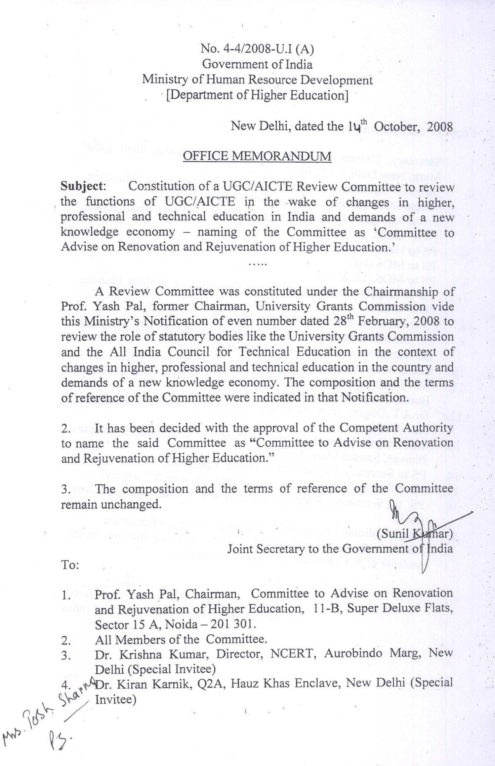
Report of ‘The Committee to Advise on Renovation and Rejuvenation of Higher Education’

89

Report of ‘The Committee to Advise on Renovation and Rejuvenation of Higher Education’

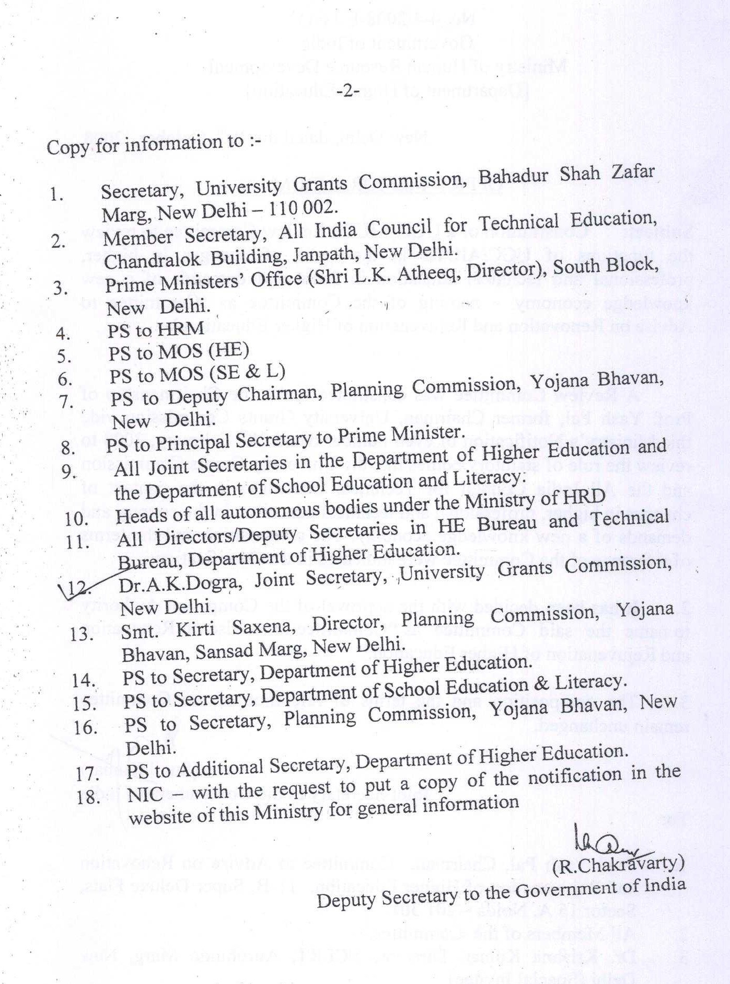

90

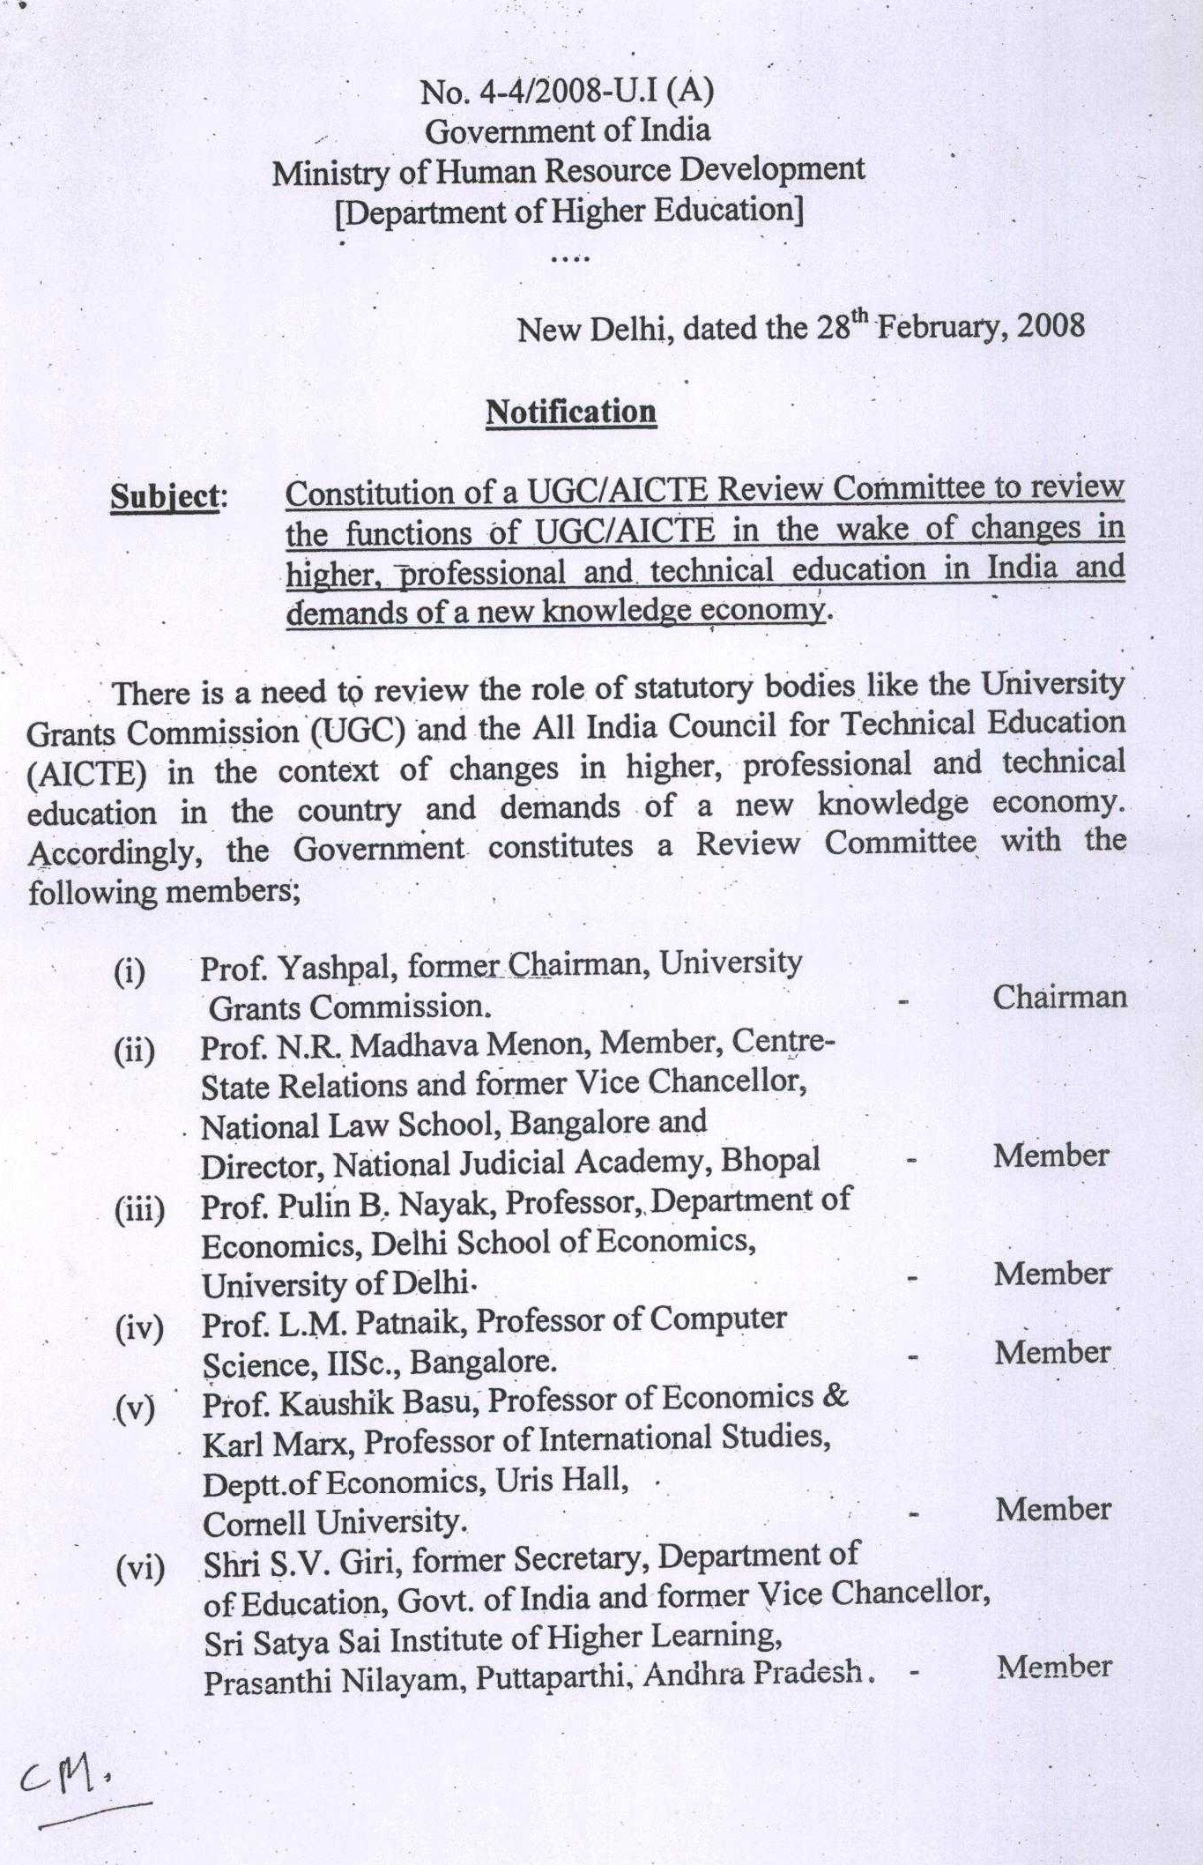
Report of ‘The Committee to Advise on Renovation and Rejuvenation of Higher Education’

91

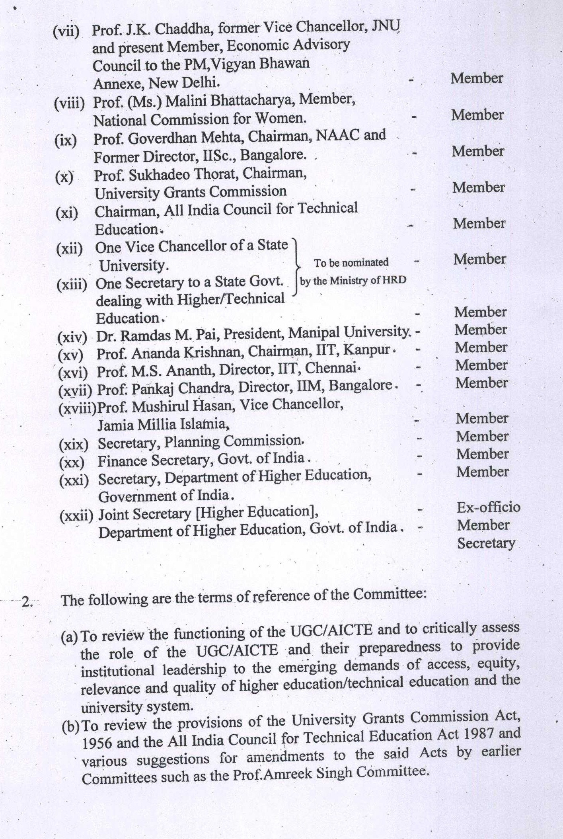
Report of ‘The Committee to Advise on Renovation and Rejuvenation of Higher Education’

92

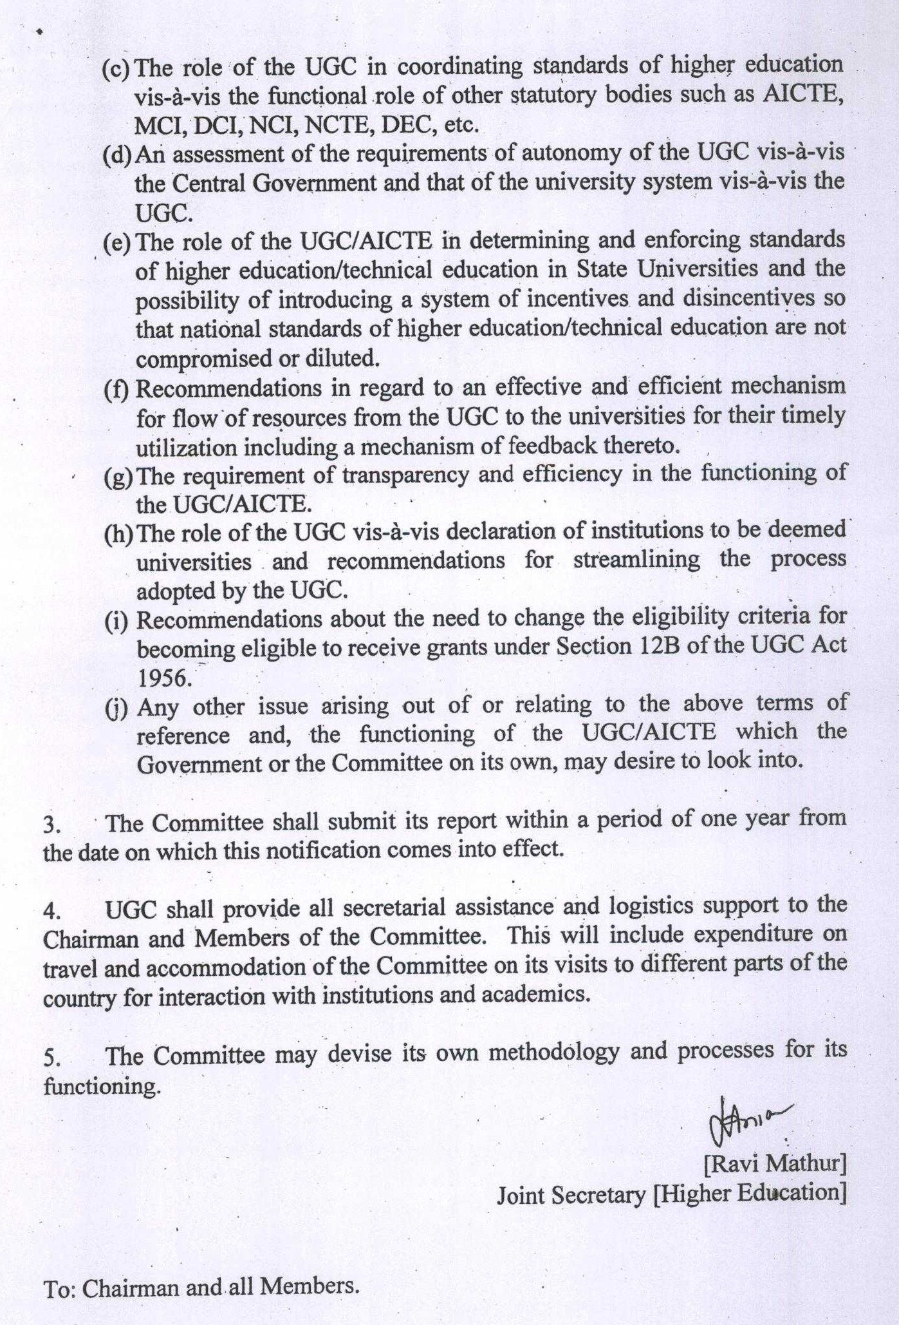
Report of ‘The Committee to Advise on Renovation and Rejuvenation of Higher Education’

93

Report of ‘The Committee to Advise on Renovation and Rejuvenation of Higher Education’

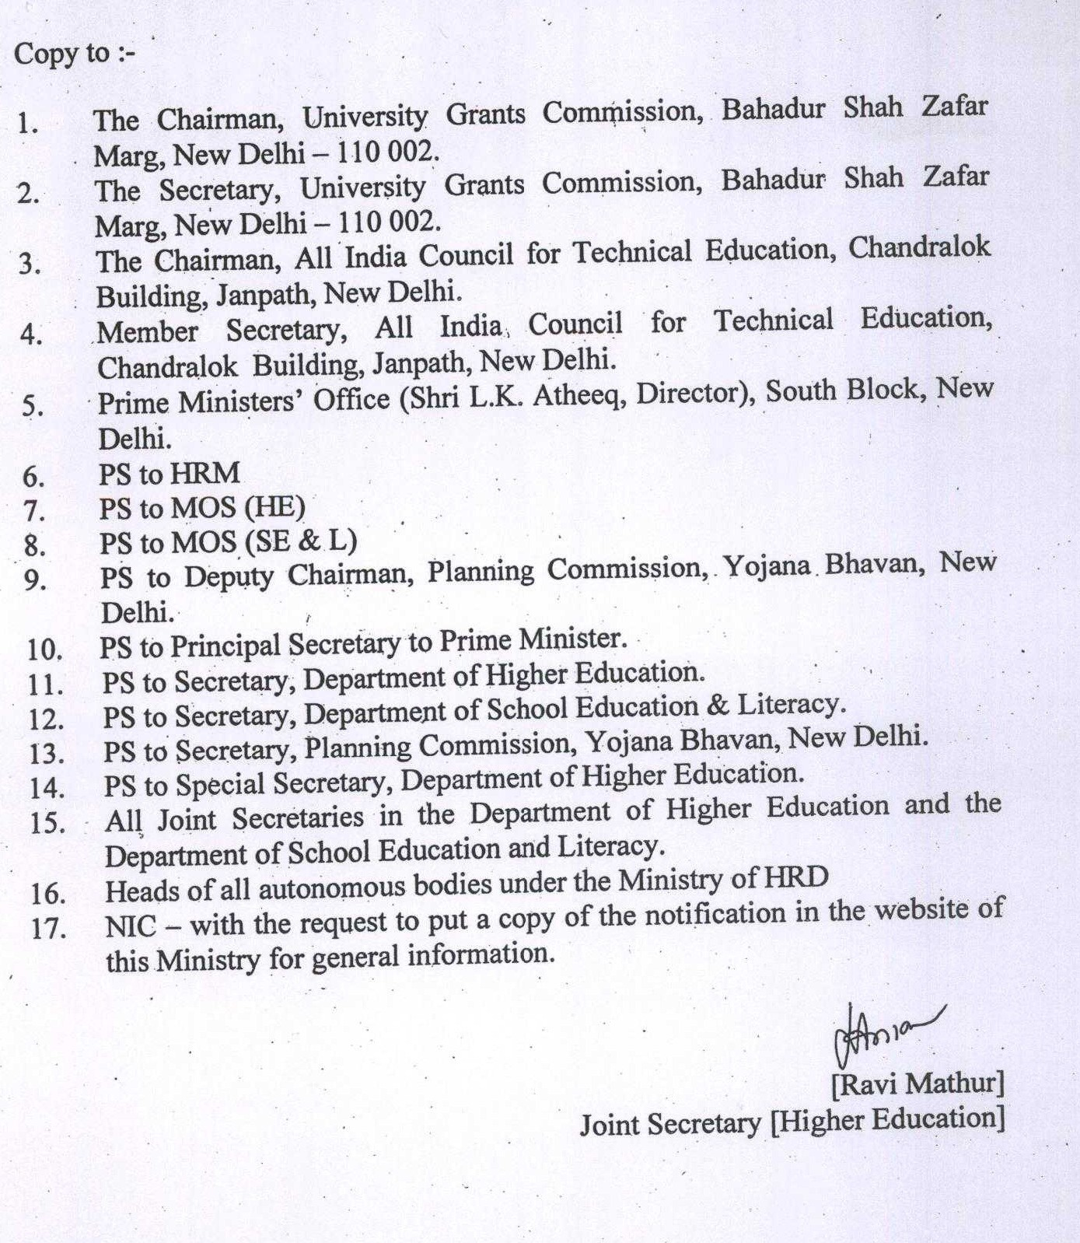

94

